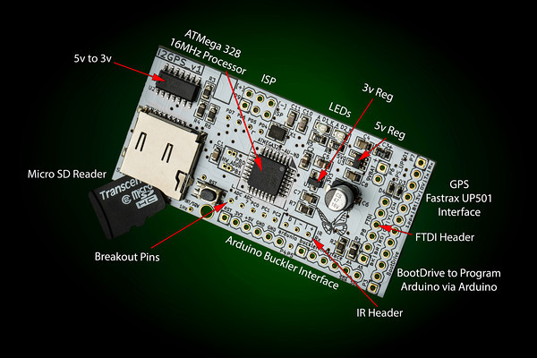

I2GPS v1

An easy to use RTC, GPS and SD memory card interface
brought to you by



Features
- micro SD card reader
- Temperature controlled, precision Real Time clock, with battery backup
- GPS interface for the Fastrax UP501 module
- Arduino compatible
- ChronoDot compatible
- Two general purpose LEDs
- IR interface
- I2C interface requires no additional pins when used on an existing I2C bus
- Unused I/O pins are available via convenient breakout pads.

Potential Uses
- Stand-alone data logger
- Simple-to-use, persistent storage
- Program loader for separate Arduino compatible
- Store events, animations, and sounds for ClockTHREE
- Automatically set the time and adjust time zones - for ClockTHREE and ClockTHREEjr

Block Diagram
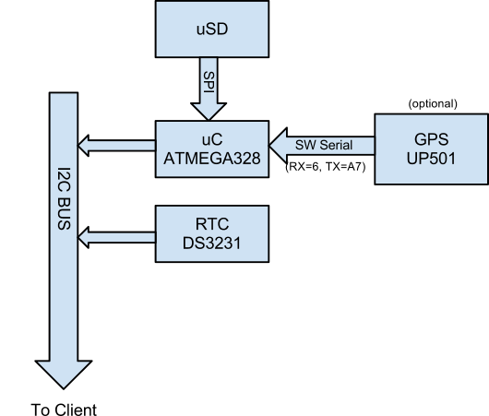

Schematic, #1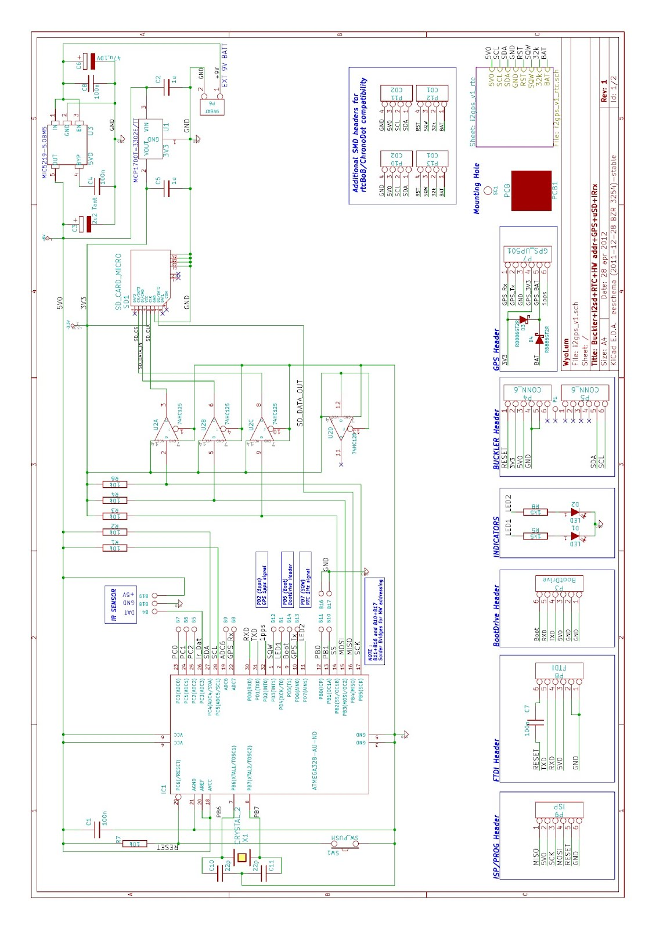

Schematic, #2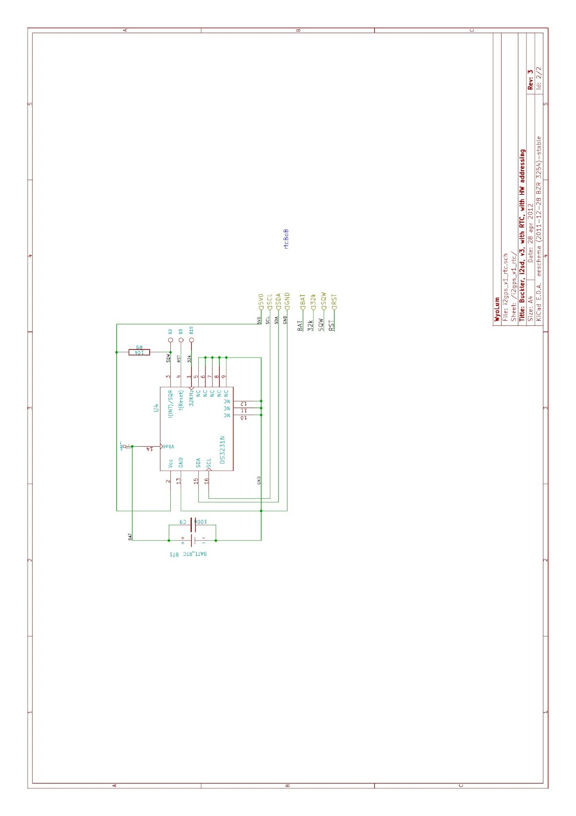

Physical Interfaces
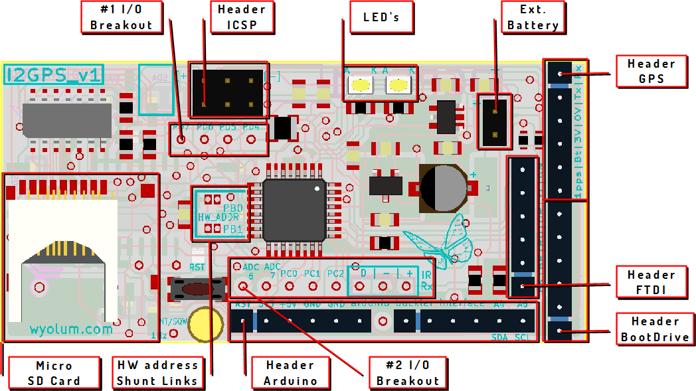

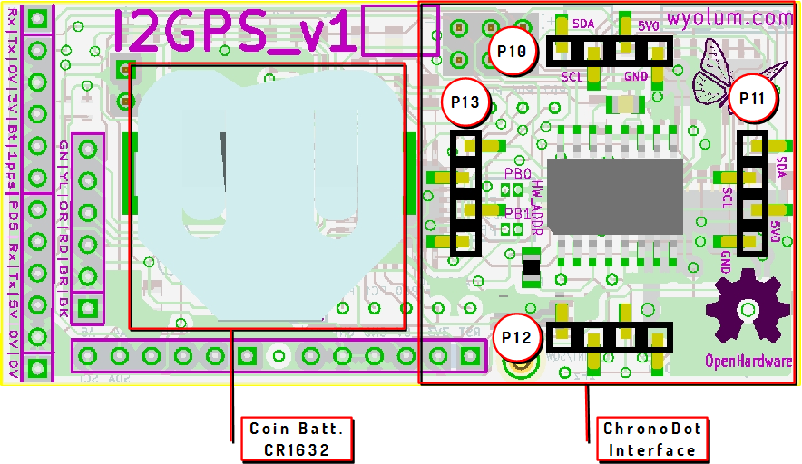

Physical Interfaces, Description
( RED Markers point to Pin # 1 of each header )

# 1 I/O Breakout
  - 1 = PD7 (Arduino digital pin 7)
  - 2 = PD6 (Arduino digital pin 6)
  - 3 = PD5 (Arduino digital pin 5)
  - 4 = PD4 (Arduino digital pin 4)

Header ICSP
  - 1 = MISO
  - 2 = 5V0
  - 3 = SCK
  - 4 = MOSI
  - 5 = RESET
  - 6 = GND

LED’s
  - D1 = PD4 (Arduino digital pin 4, Active HIGH)
  - D2 = PD7 (Arduino digital pin 7, Active HIGH)

EXT BATT
  - 1 = + 9 V max. +5.5V Min
  - 2 = GND +0V

HEADER GPS
Note: to use the SoftwareSerial libary:
#include “SoftwareSerial.h”
…
SoftwareSerial sws(6, A7);
  - 1 = GPS_Rx , ADC7 (Arduino analog pin 7, A7)
  - 2 = GPS_Tx , PD6 (Arduino digital pin 6)
  - 3 = GND
  - 4 = 3V3
  - 5 = GPS_BATT
  - 6 = 1pps , PD2

HEADER BOOTDRIVE
  - 1 = GND
  - 2 = GND
  - 3 = 5V0
  - 4 = TXD , PD1
  - 5 = RXD , PD0
  - 6 = Boot , PD5

HEADER FTDI
  - 1 = GND
  - 2 = GND
  - 3 = 5V0
  - 4 = RXD , PD0
  - 5 = TXD , PD1
  - 6 = RESET

HEADER ARDUINO (Buckler)
  - 1 = RESET (Connected to I2GPS reset and Host reset so that both reset at the same time. disconnect for independent resets)
  - 2 = 3V3
  - 3 = 5V0
  - 4 = GND
  - 5 = GND
  - 6 = NC
  - 7 = NC
  - 8 = NC
  - 9 = NC
  - 10 = NC
  - 11 = NC
  - 12 = PC4, SDA (I2C interface)
  - 13 = PC5, SCA (I2C interface)

# 2 I/O BREAKOUT
  - 1 = ADC6
  - 2 = ADC7 , GPS_Rx
  - 3 = PC0
  - 4 = PC1
  - 5 = PC2
  - 6 = Ir_Dat , PC3
  - 7 = GND
  - 8 = 5V0
    - NOTE : 6 , 7 , 8 for Ir Receiver

HW ADDRESS SHUNT LINKS
  - PB0 (Arduino Pin 8)
  - PB1 (Arduino Pin 9)
NOTE : These pins are intended to be used for changing I2C address. Default program uses 88 as the base address (although this is completely arbitrary as long as the address does not conflict with any other devices on your I2C bus.
NOTE: Use ATMEGA internal pull-ups on these pins. For instance, to set internal pull-up on pin 8 use this code snippet:
pinMode(8, INPUT);
digitalWrite(8, HIGH);
PB0 (Arduino Pin 8) | PB1 (Arduino Pin 9) | I2C Address
LOW | LOW | 88
LOW | HIGH | 89
HIGH | LOW | 90
HIGH | HIGH | 91

To change I2C Address, jumper one or both of these ports to GND

MICRO SD-CARD
Note
  - SD_CS = PB2 , SS
  - SD_DATA_IN = PB3 , MOSI
  - SC_CLK = PB5 , SCK
  - SD_DATA_OUT = PB4 , MISO

CHRONODOT INTERFACE
  - P10 , # 1 = SDA
  - P10 , # 2 = SCL
  - P10 , # 3 = 5V0
  - P10 , # 4 = GND

  - P11 , # 1 = SDA
  - P11 , # 2 = SCL
  - P11 , # 3 = 5V0
  - P11 , # 4 = GND

  - P12 , # 1 = BAT ( NOT CONNECTED )
  - P12 , # 2 = 32k
  - P12 , # 3 = SQW
  - P12 , # 4 = RST

  - P13 , # 1 = BAT
  - P13 , # 2 = 32k ( NOT CONNECTED )
  - P13 , # 3 = SQW
  - P13 , # 4 = RST ( NOT CONNECTED )

    - NOTE
      - Ref. designators are placed near Pin #1.
      - Use wire jumpers (red wires) if any “NOT CONNECTED” pin is required.
      - The four connectors allow two possible mounting positions. Lateral , using P11 and P13. Longitudinal , using P10 and P12

Software Interface Options

I2GPS (I2C interface to SD and GPS)

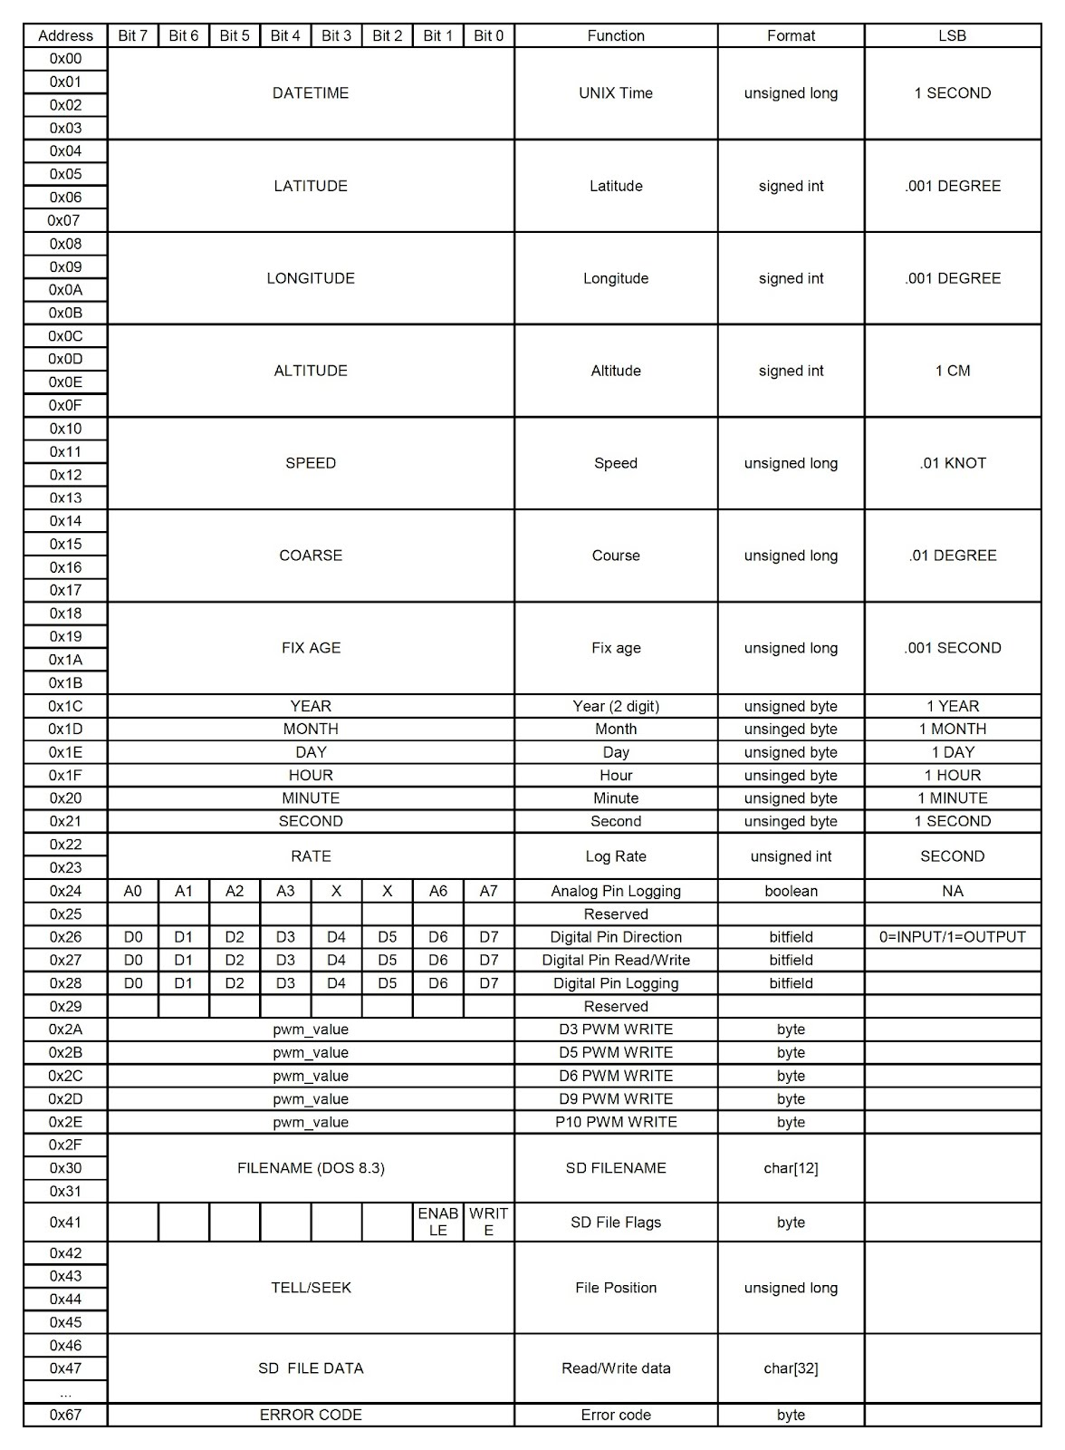

GPS INTERFACE

This interface provides time, position, and motion information when the GPS receiver is tracking without a large processing or memory burden on the host processor. The data is read from a large table stored on the I2GPS depicted above. To read from the table, send one byte of data to the I2GPS to set the starting address. Then request the desired number of bytes to read. For instance, to read latitude and longitude, start at address 0x04 and read 8 bytes. You can also log GPS data to a file open for writing. (See SD interface). Some helper functions are defined I2GPS.h. See interface below.

/*
* Read n_byte from slave starting from offset address addr.
* Store result stored in dest (which must be at least n_byte long).
* Return true if successful.
*
* Must be preceded with call to Wire.begin()
*/
void gps_raw_write(uint8_t addr, uint8_t n_byte, uint8_t *source);
/*
* write single byte
*/
void gps_raw_write1(uint8_t addr, uint8_t data_byte);
/*
* Read n_byte bytes from I2GPS starting at address addr.
* Store result in dest.
*
* Must be preceded by a call to Wire.begin()
*/
bool gps_raw_read(uint8_t addr, uint8_t n_byte, uint8_t *dest);

Example GPS over I2C usage.

Client Code | Comment
uint32_t lat;  gps_raw_read(I2GPS_LAT_ADDR, 4, (uint8_t*)&lat); | Read latitude in .001 of a degree
uint8_t gps_data[32];  gps_raw_read(0, 32, gps_data); | Read 32 bytes of GPS data starting from address 0..
uint8_t ymdhms[6];  gps_raw_read(I2GPS_YEAR_ADDR, 6, ymdhms); | Read GPS year, month, day, hour minute, second.

SD INTERFACE
The SD interface works in very much the same way but it is a little more complicated because it adds the step of opening and closing a file. There can only be one file open at a time on the I2GPS.

Client Code | Comment

Example SD file access over I2C

LINKS
- website : www.wyolum.com
- e-mail : info@wyolum.com
- forum : http://wyolum.com/forum/forumdisplay.php?fid=12
- SVN Repo : http://code.google.com/p/clockthree/
- ChronoDot : http://macetech.com/store/index.php?main_page=product_info&cPath=5&products_id=8
- Arduino : http://www.arduino.cc/

