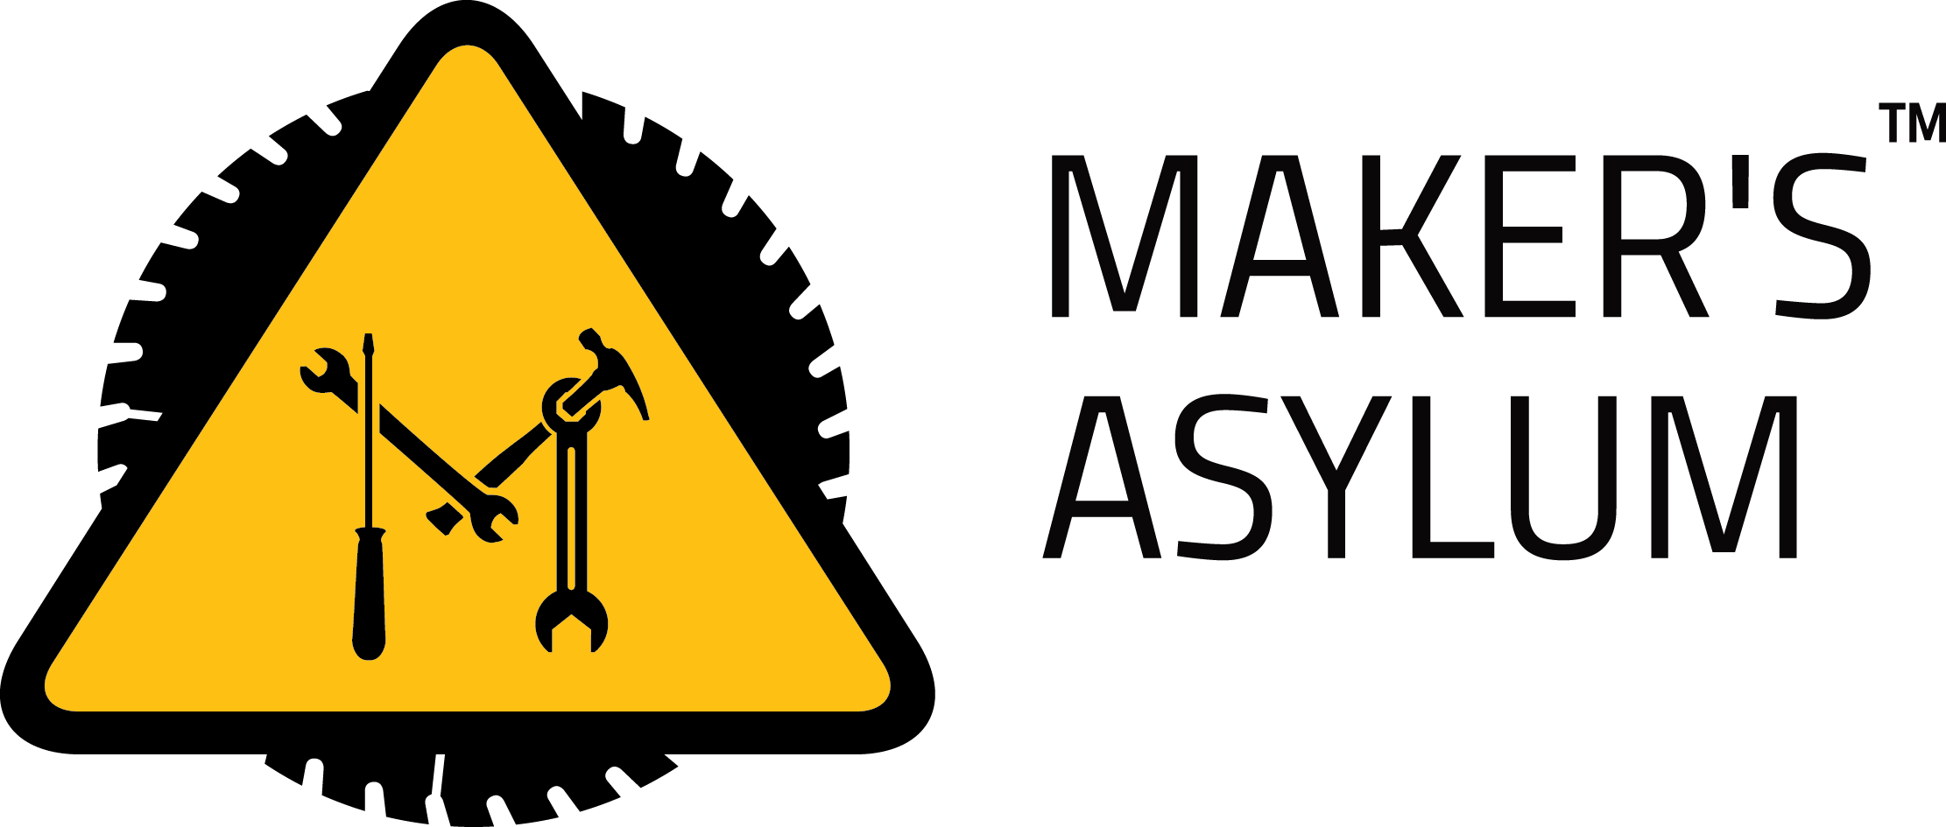
BARTENDRO – drink dispensing bot !

- COCKTAILS – errrm, sorry – MOCKTAILS (only)
  - I’m feeling lucky – what it says, you get a random drink, poured immediately!
  - Or select from the LIST
- For each drink, you can change
  - VOLUME – standard is 150 ml – BEWARE, larger volumes will overflow your glass
  - TASTE – make it sweeter or tarter
  - TASTER – get a 30 ml “taster” shot
  - POUR DRINK – get a 150 ml mocktail
- SHOTS – get a 30 ml shot of either
  - Kokum (BICHOLIM)
  - Tang Lemon (ATTAFONDEM)
  - Tang Mango (CARONA)
- TRENDING – see what’s popular !

BARTENDRO – drink dispensing bot !

- COCKTAILS – errrm, sorry – MOCKTAILS (only)
  - I’m feeling lucky – what it says, you get a random drink, poured immediately!
  - Or select from the LIST
- For each drink, you can change
  - VOLUME – standard is 150 ml – BEWARE, larger volumes will overflow your glass
  - TASTE – make it sweeter or tarter
  - TASTER – get a 30 ml “taster” shot
  - POUR DRINK – get a 150 ml mocktail
- SHOTS – get a 30 ml shot of either
  - Kokum (BICHOLIM)
  - Tang Lemon (ATTAFONDEM)
  - Tang Mango (CARONA)
- TRENDING – see what’s popular !

