Honey bee toxicity of pesticides used in United States corn and soybean production, 1998 – 2020

Andrew R. Kniss & Andrea De Stefano

DRAFT – last updated on 2023-12-04

# Introduction

The use of pesticides (herbicides, insecticides, and fungicides) is pivotal for crop protection, providing farmers with an efficient tool for controlling pests, and preventing yield losses that could threaten food security (Kudsk et al. 2018) and cause devastating economic losses (Popp et al. 2013; Tudi et al. 2021). Therefore, the use of pesticides has become a necessary agricultural practice, with one-third of agricultural products depending on their application (Tudi et al. 2021). However, pesticide use in agriculture can have detrimental side effects on non-target organisms and ecosystems, with a very small percentage of the amount applied coming in direct contact with target pests (Werf 1996). The increasing number of pesticides’ negative effects has shaped their use in accordance with changes in agricultural and pest management strategies, regulatory policies, environmental and health hazard, and public awareness.

In the United States, the use of synthetic pesticides sha increased drastically from the 1960s to the early 1980s, then stabilized according to the change in crop acreage, the development of pesticides with lower per-acre application, and the adoption of genetically engineered (GE) insect-resistant and herbicide tolerant crops (Kniss 2018; Osteen and Fernandez-Cornejo 2013). As a reflection of US Environmental Protection Agency (US EPA) regulations, the type of synthetic insecticides applied in agriculture has changed from mainly organophosphorus and N-methyl carbamate insecticides to considerably lower quantities of organophosphorus compounds, together with a considerable increase in neonicotinoids and a small increase in pyrethroids (DiBartolomeis et al. 2019). On the other hand, the use of herbicides seemed to be affected by the increased use of herbicide-tolerant crops, which led to a higher application rate (Benbrook 2016; Kim and Kim 2022). Similarly, fungicide application rate is predicted to rise because of climate change, increasing of fungicide resistance, and spread of invasive fungal species (Boxall et al. 2009; Fisher et al. 2012).

Evaluating the risk of pesticides is a necessary and complex task that requires detailed information on active ingredients, toxicity levels, application rates, routes of exposure, effects on non-target organisms, interactions, and environmental fate (DiBartolomeis et al. 2019; Greitens and Day 2007). Moreover, the assessment of pesticide risks is frequently based on partial information, making the determination of the overall risk of pesticide use difficult and, often times, subjective (Dushoff et al. 1994; Greitens and Day 2007; Peterson and Schleier 2014). Nonetheless, scientists and agencies have developed numerous methods to evaluate the environmental risks associated with pesticides use, including pesticide risk indicators based on numerous information, such as active ingredients, use rate, acute and chronic toxicity information, environmental persistence and mobility, and non-target effects (Greitens and Day 2007; Kniss 2017).

Generally, the first step in developing methods to evaluate the ecological risk of pesticides is to build a reliable database based on existing empirical toxicity data derived from literature review procedures. The ECOTOXicology Knowledgebase (ECOTOX Ver 5, www.epa.gov/ecotox) currently represents the world’s largest compilation of curated ecotoxicity data, providing data for assessments of safety and ecological research for over 12,000 chemicals and ecological species with over one million test results from over 50,000 references (Olker et al. 2022). Managed by US-EPA, it provides transparent and comprehensive information about toxicity measures and endpoints such as , , and other sublethal effects, and effects on both aquatic and terrestrial organisms.

Among terrestrial organisms, insect pollinators are widely used for environmental risk assessment procedure and regulatory agencies, such as US-EPA and European Food Safety Agency (EFSA), require the submission of insect pollinators risk toxicity data when registering pesticides because their services to terrestrial ecosystems and crop production (Farruggia et al. 2022; Reilly et al. 2020). Pollinators, in particular honey bees (*Apis mellifera*), are at risk for several reasons, including pesticides uses (Goulson et al. 2015). Honey bees represent a useful indicator species because of their importance to agriculture, the availability of standardized testing for lab and field experiments (Farruggia et al. 2022), their ability to interact with pesticides through different exposure pathways (Johnson 2015), and their sensitivity to pesticides with respect to other bee species (Arena and Sgolastra 2014). Therefore, honey bees represent the most well studied indicator of insect health in US agricultural lands, having the most comprehensive data set available for insect, and allowing to show how pesticide toxicity loadings have changed over time (DiBartolomeis et al. 2019).

The objective of this study is to combine honey bee toxicological endpoints with pesticide use data and crop yields to quantify (1) how the average toxicity of agricultural pesticides used in the United States has changed over time; and (2) determine how specific pesticides and pest targets contribute to the overall non-target insect risk. This information will benefit the general public by informing the debate on whether domestic agricultural systems have become more or less ecologically efficient and sustainable over time, and allow us to focus future efforts on pests and pesticides that contribute most to overall risk.

# Methods

## Data sources

### Pesticide usage data

Proprietary pesticide use data were obtained from the FarmTrak product maintained by [Kynetec](https://www.kynetec.com/). Data included pesticide volume applied, treated acreage, and timing of pesticide applications for corn and soybean from 1998 through 2020. Application timings from the original data were condensed into either before crop emergence (PRE) or after crop emergence (POST).

### Honey bee toxicity data

Adult acute contact values for honey bee (*Apis mellifera*) were obtained from the following sources:

* The U.S. EPA [ECOTOX](https://cfpub.epa.gov/ecotox/) database.
* Supporting Table S1 from Farruggia et al. (2022).
* Manually searching pesticide registration documents and conversations with EPA EFED personnel.

The ECOTOX database was the preferred source for all pesticide toxicity data. For each active ingredient (ai) in the Kynetec data, adult acute contact were downloaded from ECOTOX. For many active ingredients, ECOTOX reports multiple toxicity endpoints, some are exact estimates (e.g.  = 13 ug/bee). Some estimates are listed as inequalities, where the original study was unable to quantify an exact endpoint (e.g.  > 100 ug/bee). For active ingredients with multiple adult acute contact toxicity values reported, we used the following selection criteria to select a single toxicity value for each ai:

1. if there was only one *exact* estimate and one or more inequality estimates the exact estimate was selected.
2. if there were multiple exact estimates, the lowest (most toxic) value was selected.
3. if there were no exact estimates, the lowest (most toxic) inequality was selected.

After this selection criteria was applied to the ECOTOX data, the toxicity values were compared with those published by Farruggia et al. (2022). In nearly all cases, the ECOTOX values were the same as those published by Farruggia et al. For 6 pesticides, the values reported by Farruggia et al. were lower (*i.e.* more toxic) than those selected from ECOTOX; for five of those six pesticides, the Farruggia et al. values were used to ensure we used the most conservative toxicity estimates available. One estimate from Farrugia et al (2022) was determined to be an error; dicamba adult acute contact toxicity was listed correctly in ECOTOX and so that value was used. Finally, for any ai in the Kynetec data that did not have toxicity values in ECOTOX or Farruggia et al. (2022), pesticide registration documents were searched manually to obtain honey bee adult acute contact toxicity values.

In total, there were 199 unique pesticides in the Kynetec database applied to either corn or soybean during 1998 to 2020. Of those, we were unable to find a reliable toxicity estimate for 14 pesticides (Table 1). Two of those pesticides (tebupirimphos and ethalfluralin) were widely used during the study period, with total application volume of nearly 3 million kg and over 1 million kg, respectively.

**Table 1. Active ingredients for which more than 1,000 kg were applied during the period 1998 – 2020 but do not have a reliable honey bee adult acute contact .**

| Active ingredient | Pesticide type | Total volume (kg) | Total base acres treated |
| --- | --- | --- | --- |
| tebupirimphos | Insecticide | 2970000 | 51800000 |
| ethalfluralin | Herbicide | 1190000 | 2970000 |
| bacillus thuringiensis | Insecticide | 37800 | 514000 |
| flusilazole | Fungicide | 16800 | 434000 |
| phosphoric acid | Fungicide | 163000 | 377000 |
| polyhedrosis virus | Insecticide | 2220 | 158000 |
| copper hydroxide | Fungicide | 8600 | 107000 |
| reynoutria sachalinensis | Fungicide | 1730 | 69400 |
| copper sulfate | Fungicide | 71100 | 52200 |
| fentin | Fungicide | 1230 | 21700 |
| vernolate | Herbicide | 24200 | 20300 |
| petroleum oil | Fungicide | 48800 | 16600 |
| bacillus amyloliquefacien | Fungicide | 11900 | 11900 |
| tetraoxosulfate | Herbicide | 1920 | 2980 |

## Honey bee Toxicity Index

Pesticide use data were separated into pesticides applied before crop emergence (PRE) and pesticides applied after crop emergence (POST). For each ai applied to each crop in each year, an an area-adjusted toxicity index (*TI*) was calculated by dividing the total pesticide volume applied in kg () by the total planted area () for each crop to account for year-to-year changes in hectares planted to corn and soybeans. That value was then divided by the adult acute contact to derive the *TI*. *TI* can be interpreted as the number of honey bee acute values applied per hectare (in billions).

*something here about how individual pesticide contributions were divvied up*

## Pesticide Target Toxicity Index

A pesticide target toxicity index () was calculated to quantify relative impact that different pest species have on the overall risk to honey bees. For each pesticide application, FarmTrak data records which pest species were listed by survey respondents as the target for the pesticide application. For each active ingredient, the volume applied targeting a particular pest was divided by the total volume of the active ingredient applied. This proportion was then multiplied by that active ingredient’s proportion of the total toxicity index (*TI*).

## Eco-Efficiency

Eco-efficiency () was calculated for each year and application timing by dividing crop yield (ton/ha) by *TI*. can be interpreted as the tonnes of crop yield produced per honey bee applied. Higher values of suggest greater eco-efficiency.

# Results

The summed honey bee *TI* over all years from 1998 through 2020 was 3.3-times greater in corn compared to soybean (Figure 1). Relative risk to honey bees and many other pollinator species is expected to be lower if pesticides are applied before crop emergence, as there are fewer polinators expected to visit the field; 88% of the summed *TI* applied to corn was applied *before* crop emergence, whereas 94% of the summed *TI* applied to soybean was applied *after* crop emergence. For both crops, a vast majority of *TI* was driven by insecticide use, as expected. In corn, insecticides were responsible for nearly 98% of *TI*, compared to 2.2% for herbicides, and 0.018% for fungicides. In soybean, insecticides were responsible for 93% of the summed *TI*, compared to 6.5% for herbicides, and 0.045% for fungicides. In terms of total volume applied, herbicides are more heavily used in both corn and soybean; however, because *TI* accounts both for applied volume and inherent acute toxicity, the relative toxicity of insecticides to honey bees outweighs herbicide use in this metric. Because insecticides are the primary driver of overall risk to honey bees and other polinators, we will not discuss other pesticide types (herbicides and fungicides) further.

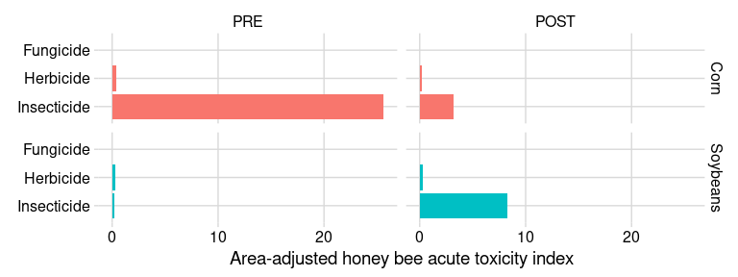

**Figure 1. Summed honey bee toxicity index applied to corn or soybean during the period 1998 through 2020 by pesticide type and application timing.**

Over time, insecticide use in corn has shifted from primarily PRE applications to a mix of PRE and POST applications (Table 2). During the period 2000 to 2005, 96% of the honey bee *TI* from insecticides was applied before crop emergence, whereas more recently, from 2015 to 2020, approximately 51% of honey bee toxicity index was applied before crop emergence. In corn, the toxicity index applied POST has increased approximately 1.8-fold, from 0.12 to 0.22. In soybeans, insecticide use was not reported before 2004, suggesting very limited use in that crop (Figure 2). Since 2005, insecticide applications in soybean have been mostly applied POST, and the honey bee acute toxicity index associated with POST applications has increased 12-fold since the early 2000s. In corn and soybean combined, during the period 2015 to 2020, approximately 1.06 billion honey bee s were applied annually, compared to 2.87 billion that were applied annually between 2000 and 2005, a reduction of 63%.

**Table 2. Area-adjusted acute toxicity index values for insecticides applied before (PRE) and after (POST) crop emergence for the periods 2000 to 2005, and from 2015 to 2020.**

| Crop | Timing | Type | 2000 - 2005 | 2015 - 2020 |
| --- | --- | --- | --- | --- |
| Corn | PRE | Insecticide | 2.70000 | 0.230 |
| Corn | POST | Insecticide | 0.12000 | 0.220 |
| Soybeans | PRE | Insecticide | 0.00089 | 0.016 |
| Soybeans | POST | Insecticide | 0.04800 | 0.590 |

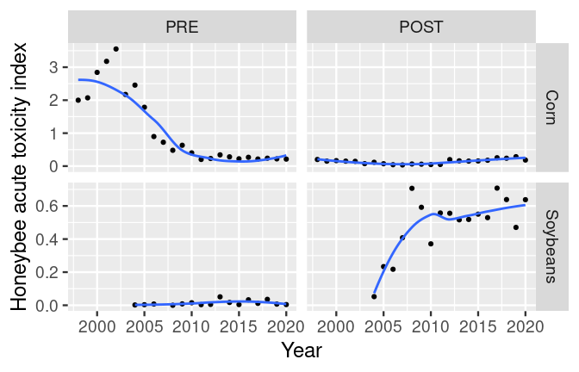

**Figure 2. Honey bee adult acute contact toxicity index for insecticides applied to corn or soybean before (PRE) or after (POST) crop emergence.**

Two pesticides, fipronil and chlorpyrifos, were responsible for a majority of the *TI* applied PRE to corn until approximately 2010 (Figure 3A). After 2010, bifenthrin became the largest contributor to *TI* in both PRE (Figure 3B) and POST (FIgure 3C) application timings in corn. Insecticide application was relatively rare in soybean before 2004. Three insecticides, bifenthrin, chlorpyrifos, and cyhalothrin-lambda, accounted for a majority of the *TI* applied POST to soybean since 2005 (Figure 3D).

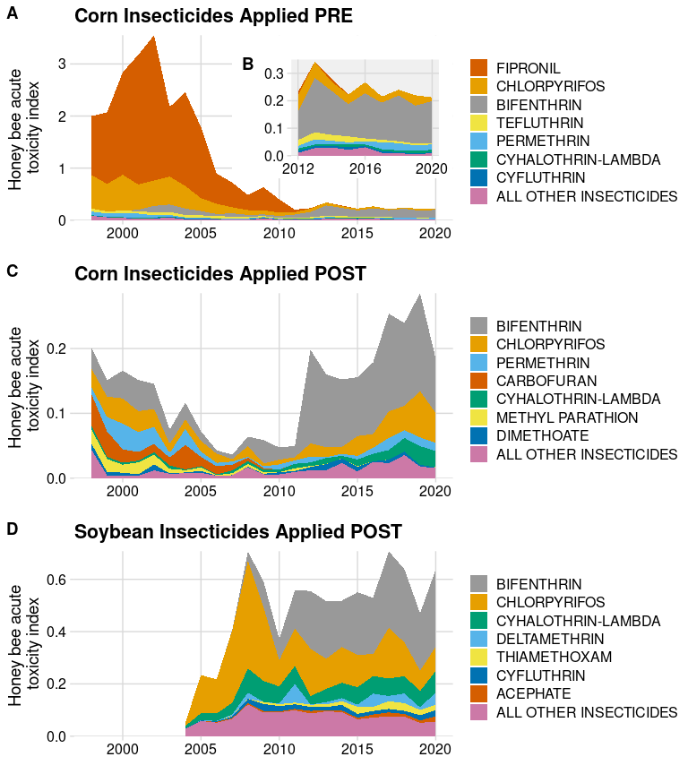

**Figure 3. Contribution of insecticide active ingredients to honey bee adult acute contact toxicity index applied PRE to corn (A, B), POST to corn (C), or POST to soybean (D). Panel B shows the period from 2012 to 2020 for corn PRE on a zoomed-in y-axis scale. The ‘All Other Insecticides’ category includes 2% of the total corn toxicity index applied PRE, 10% of the total corn toxicity index applied POST, and 13% of the total soybean toxicity index.**

## Pesticide Target Toxicity Index

In corn, insect pests from the orders Coleoptera and Lepidoptera contributed most to the overall *TI* (Figure 4), followed by Hemipteran insects and spider mites (Trombidiformes). In corn, there was a decreasing trend for Coleoptera (P < 0.001) and Lepidoptera (P < 0.001) contributions to the over time. Hemiptera increased in importance as a pesticide target over time (P = 0.001). There was an increase in the contribution of the ‘Unknown’ pest target category (P < 0.001), which included survey responses that did not answer the question of which pest species was being targeted. Temporal trends for other taxa were not statistically obvious in corn (Figure 4).

For PRE applications in corn since 2015, corn rootworm beetles, wireworms, and grubs were the most important Coleoptera pest targets, while cutworms of various species were the most important Lepidopteran pest. The *TI* from POST applications in corn was driven by corn rootworm beetles and Japanese beetles (Coleoptera) and stink bugs (Hemiptera), presumably due to potential for silk feeding. Aphids (Hemiptera) and cutworm species (Lepidoptera) were also important drivers of the corn *TI* from POST applications since 2015.

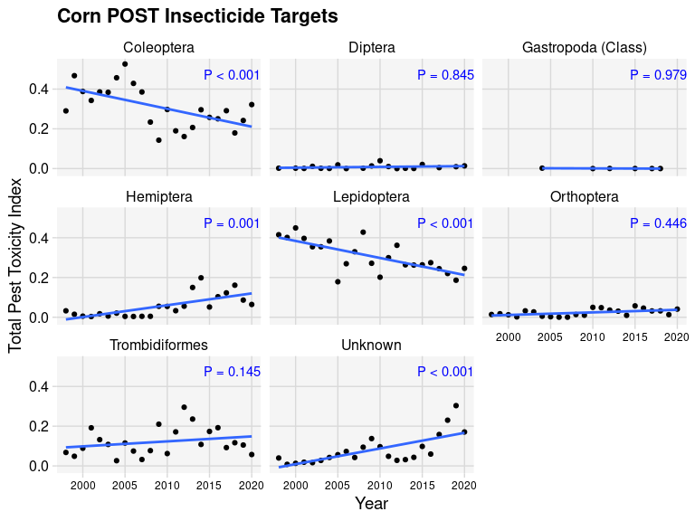

**Figure 4. Contribution of insect pests to the honey bee adult acute contact toxicity index; corn pesticides applied *after* crop emergence, 1998-2020.**

In soybean, Hemiptera pests were the greatest contributor to the overall , although there was a significant decrease in its contribution over time (P < 0.001). Stink bugs and aphid species were the greatest contributors to the *TI* among hemipteran pest species. Lepidopteran pest contribution to increased over time (P = 0.005). Since 2015, the most important Lepidoptera were various species referred to as ‘worms’ (including corn earworm and boll worm), ‘loopers’ (cabbage and soybean), and armyworms. Leaf beetles and Japanese beetles were the most important Coleoptera pest species that contributed to the *TI* from POST applications to soybean since 2015. Similar to corn, the ‘Unknown’ category also increased in importance (P < 0.001) due to survey respondents not answering the question about the targeted pest(s).

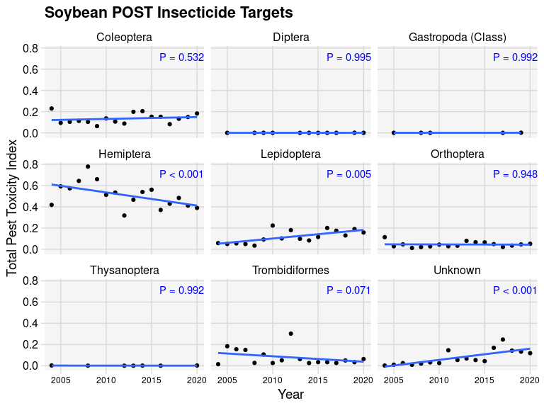

**Figure 5. Contribution of insect pests to the honey bee adult acute contact toxicity index; soybean pesticides applied *after* crop emergence, 1998-2020.**

## Eco-efficiency

Corn and soybean yields have steadily increased in the United States between 1998 and 2020 (Figure 6A, 6D). Corn production eco-efficiency for both yield (Figure 6B) and value (Figure 6C) increased substantially between 1998 through 2011, in part due to the observed yield increase. However, in 2012, a substantial drop in eco-efficiency was observed, and corn eco-efficiency decreased through 2020. In soybean production, eco-efficiency declined slowly throughout the period 2005 through 2020 (Figures 6C; 6D). Because both corn and soybean yield continued to increase throughout this period, the reduction in eco-efficiency in recent years suggests that the relative increase observed in the honey bee *TI* is out-pacing the relative increases in corn yields since 2012, at least on the national scale.

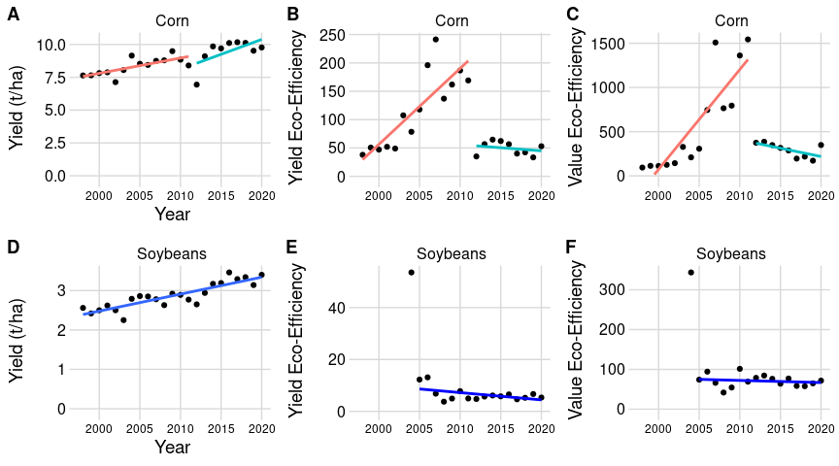

**Figure 6. Corn (A) and soybean (B) yield, and honey bee eco-efficiency index for insecticides applied to corn or soybean *after* crop emergence. Yield eco-efficiency numerator is crop yield (B, D); value eco-efficiency numerator is the farm value of crop production (E, F).**

# Discussion

Probable points to cover here:

* Important caveat that this data doesn’t include seed treatments - that is a separate source of potential risk to non-target organisms.
* There’s a lot less honey bee toxicity being applied to corn in recent years (2015-2020) compared to earlier (2000-2005). This is mostly due to a drastic decrease in PRE instecticide use over this period.
* However, there has been an overall increase in the amount of honey bee toxicity being applied POST over that time period. In corn, this was a 1.8-fold increase, from 0.12 to 0.22. In soybeans, it went from approximately zero before 2004 to 0.59. More honey bee toxicity is being applied POST in soybeans than in corn in the more recent period (2015 to 2020).
* Bifenthrin is probably the most obvious recent contributor to the increases in POST insecticide use for both crops. The pests that appear to drive the most bifenthrin risk to honeybees are:
  + spider mites, corn rootworm, and Western bean cutworm in corn.
  + stink bugs and soybean aphids in soybean.
* Given all of this, future research should be aimed at
  + investigating *why* POST insecticides are increasing; is it due to a perceived increase in pest pressure, or the cost of pesticides decreasing, or something else?
  + finding alternative pest control measures for the pest targets that contribute most to the honey bee *TI*:
    - root worm species, and other silk-eating critters, as well as cutworms in corn.
    - stink bugs and aphids in soybeans.
  + these four pest species represent a large proportion of the relative risk to honey bees in corn and soybean production in the US, so efforts to reduce the need for pesticides to control them (or education efforst on whether treatments are actually needed) would probably pay dividends in reducing non-target risks to insects like honey bees.

# Supplemental Information

*Supplemental Table: Pest species from taxa mentioned above as either being major contributors or having a significant trend up or down in the . Total from years 2015 through 2020.*

| Crop | Timing | TaxonGroup | Pest.common | pestToxIndex | TaxaPct |
| --- | --- | --- | --- | --- | --- |
| Corn | POST | Unknown | No answer | 1.0134878 | 99 |
| Corn | POST | Coleoptera | Corn Rootworm (Mexican, Northern, Southern, Western) | 0.8540475 | 55 |
| Corn | POST | Lepidoptera | Cutworm (army, black, climbing, dingy, granulate, pale western, variegated, western bean, other) | 0.7926496 | 55 |
| Corn | POST | Hemiptera | Stink bug (brown marmorated, brown, green, redbanded, redshouldered, rice, southern green) | 0.3745509 | 64 |
| Corn | POST | Coleoptera | Beetle, Japanese | 0.2854882 | 19 |
| Corn | POST | Lepidoptera | Worm (bag, boll, bud, clover, ear, horn, leaf, pin, rednecked peanut, split) | 0.2426687 | 17 |
| Corn | POST | Lepidoptera | European Corn Borer | 0.2060783 | 14 |
| Corn | POST | Hemiptera | Aphid (bean, soybean, russian wheat, root, leaf, green peach, corn leaf black, bird cherry-oat) | 0.1895746 | 32 |
| Corn | POST | Coleoptera | Beetle (non-specific) | 0.1341085 | 9 |
| Corn | POST | Coleoptera | Beetle, Corn | 0.1271878 | 8 |
| Corn | POST | Lepidoptera | Armyworm (beet, fall southern, western yellow striped, yellowstripe) | 0.0911837 | 6 |
| Corn | POST | Lepidoptera | Worm (generic) | 0.0701466 | 5 |
| Corn | PRE | Coleoptera | Corn Rootworm (Mexican, Northern, Southern, Western) | 1.6609848 | 64 |
| Corn | PRE | Lepidoptera | Cutworm (army, black, climbing, dingy, granulate, pale western, variegated, western bean, other) | 1.2135142 | 83 |
| Corn | PRE | Unknown | No answer | 1.0197718 | 100 |
| Corn | PRE | Coleoptera | Wireworm | 0.4671642 | 18 |
| Corn | PRE | Coleoptera | Grub (white, other non-specific) | 0.3940768 | 15 |
| Corn | PRE | Lepidoptera | European Corn Borer | 0.0807159 | 6 |
| Corn | PRE | Hemiptera | Aphid (bean, soybean, russian wheat, root, leaf, green peach, corn leaf black, bird cherry-oat) | 0.0285206 | 45 |
| Corn | PRE | Hemiptera | Stink bug (brown marmorated, brown, green, redbanded, redshouldered, rice, southern green) | 0.0172564 | 27 |
| Corn | PRE | Hemiptera | Bug (non-specific) | 0.0094399 | 15 |
| Corn | PRE | Hemiptera | Chinch Bug | 0.0067904 | 11 |
| Soybeans | POST | Hemiptera | Stink bug (brown marmorated, brown, green, redbanded, redshouldered, rice, southern green) | 1.2816839 | 48 |
| Soybeans | POST | Hemiptera | Aphid (bean, soybean, russian wheat, root, leaf, green peach, corn leaf black, bird cherry-oat) | 1.2454462 | 47 |
| Soybeans | POST | Unknown | No answer | 0.8329237 | 98 |
| Soybeans | POST | Coleoptera | Leaf Beetle (corn, bean, cereal) | 0.3773687 | 44 |
| Soybeans | POST | Coleoptera | Beetle, Japanese | 0.3432263 | 40 |
| Soybeans | POST | Lepidoptera | Worm (bag, boll, bud, clover, ear, horn, leaf, pin, rednecked peanut, split) | 0.2622794 | 27 |
| Soybeans | POST | Lepidoptera | Looper (cabbage, soybean) | 0.1957611 | 20 |
| Soybeans | POST | Lepidoptera | Armyworm (beet, fall southern, western yellow striped, yellowstripe) | 0.1398828 | 14 |
| Soybeans | POST | Lepidoptera | Caterpillar (alfalfa, thistle, velvetbean, other non-specific) | 0.1164138 | 12 |
| Soybeans | POST | Lepidoptera | Green Cloverworm | 0.0820042 | 8 |
| Soybeans | POST | Lepidoptera | Worm (generic) | 0.0810390 | 8 |
| Soybeans | POST | Coleoptera | Beetle (non-specific) | 0.0552165 | 7 |
| Soybeans | PRE | Unknown | No answer | 0.9216448 | 97 |
| Soybeans | PRE | Hemiptera | Aphid (bean, soybean, russian wheat, root, leaf, green peach, corn leaf black, bird cherry-oat) | 0.2703705 | 84 |
| Soybeans | PRE | Lepidoptera | Cutworm (army, black, climbing, dingy, granulate, pale western, variegated, western bean, other) | 0.1422353 | 64 |
| Soybeans | PRE | Coleoptera | Grub (white, other non-specific) | 0.0967643 | 44 |
| Soybeans | PRE | Coleoptera | Wireworm | 0.0649563 | 30 |
| Soybeans | PRE | Hemiptera | False Chinch Bug | 0.0268126 | 8 |
| Soybeans | PRE | Lepidoptera | Armyworm (beet, fall southern, western yellow striped, yellowstripe) | 0.0268126 | 12 |
| Soybeans | PRE | Lepidoptera | Caterpillar (alfalfa, thistle, velvetbean, other non-specific) | 0.0267862 | 12 |
| Soybeans | PRE | Coleoptera | Leaf Beetle (corn, bean, cereal) | 0.0194311 | 9 |
| Soybeans | PRE | Coleoptera | Corn Rootworm (Mexican, Northern, Southern, Western) | 0.0187041 | 9 |
| Soybeans | PRE | Coleoptera | Beetle, Japanese | 0.0179081 | 8 |
| Soybeans | PRE | Lepidoptera | Worm (bag, boll, bud, clover, ear, horn, leaf, pin, rednecked peanut, split) | 0.0128732 | 6 |
| Soybeans | PRE | Lepidoptera | Worm (generic) | 0.0128732 | 6 |

*Bifenthrin Pest Targets*

| Crop | Timing | TaxonGroup | Pest | pestToxIndex |
| --- | --- | --- | --- | --- |
| Corn | POST | Unknown | No Answer Insect | 0.0785026 |
| Corn | POST | Trombidiformes | MITE, SPIDER | 0.0603113 |
| Corn | POST | Coleoptera | ROOTWORM, CORN | 0.0518045 |
| Corn | POST | Lepidoptera | CUTWORM, WESTERN BEAN | 0.0480792 |
| Corn | POST | Orthoptera | GRASSHOPPER | 0.0289052 |
| Corn | POST | Hemiptera | BUG, BROWN STINK | 0.0273412 |
| Corn | POST | Coleoptera | ROOTWORM, WESTERN CORN | 0.0265845 |
| Corn | POST | Lepidoptera | WORM, CORN EAR | 0.0260311 |
| Soybeans | POST | Hemiptera | BUG, STINK | 0.0678013 |
| Soybeans | POST | Unknown | No Answer Insect | 0.0451038 |
| Soybeans | POST | Hemiptera | APHID, SOYBEAN | 0.0429406 |
| Soybeans | POST | Coleoptera | BEETLE, BEAN LEAF | 0.0319975 |
| Soybeans | POST | Hemiptera | APHID | 0.0258370 |
| Soybeans | POST | Hemiptera | BUG, BROWN STINK | 0.0214888 |
| Soybeans | POST | Lepidoptera | WORM, CORN EAR | 0.0196160 |
| Soybeans | POST | Hemiptera | BUG, REDBANDED STINK | 0.0188185 |

This is some data I pulled from USDA - it is not specific to a crop, but estimates chemical expenses and all expenses for crop production operations. I’m unsure whether non-pesticides are included in “chemicals” here (fertilizer seems to not be included). I’m also unsure whether it is useful in any way… Panel B, chemicals as a proportion of total expenses seems to show the same (inverse) pattern that one might expect given the efficiency pattern in corn; but I’m not convinced those things are related very closely. Might be best to ignore this.

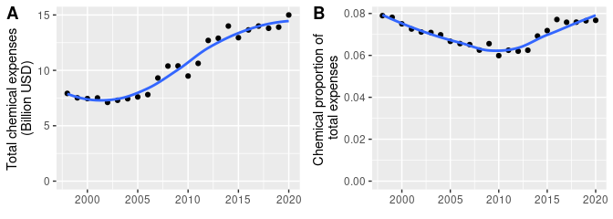

**Figure X. Chemical expenses in billion USD (A) and as a proportion of total crop production operation expenses (B).**

# **Literature Cited**

Arena M, Sgolastra F (2014) [A meta-analysis comparing the sensitivity of bees to pesticides](https://doi.org/10.1007/s10646-014-1190-1). Ecotoxicology (London, England) 23:324334

Benbrook CM (2016) [Trends in glyphosate herbicide use in the united states and globally](https://doi.org/10.1186/s12302-016-0070-0). Environmental Sciences Europe 28:3

Boxall ABA, Hardy A, Beulke S, Boucard T, Burgin L, Falloon PD, Haygarth PM, Hutchinson T, Kovats RS, Leonardi G, Levy LS, Nichols G, Parsons SA, Potts L, Stone D, Topp E, Turley DB, Walsh K, Wellington EMH, Williams RJ (2009) [Impacts of climate change on indirect human exposure to pathogens and chemicals from agriculture](https://doi.org/10.1289/ehp.0800084). Environmental Health Perspectives 117:508514

DiBartolomeis M, Kegley S, Mineau P, Radford R, Klein K (2019) [An assessment of acute insecticide toxicity loading (AITL) of chemical pesticides used on agricultural land in the united states](https://doi.org/10.1371/journal.pone.0220029). PLOS ONE 14:e0220029

Dushoff J, Caldwell B, Mohler CL (1994) Evaluating the environmental effect of pesticides: A critique of the environmental impact quotient. American Entomologist:180–184

Farruggia FT, Garber K, Hartless C, Jones K, Kyle L, Mastrota N, Milone JP, Sankula S, Sappington K, Stebbins K, Steeger T, Summers H, Thompson PG, Wagman M (2022) [A retrospective analysis of honey bee (Apis mellifera) pesticide toxicity data](https://doi.org/10.1371/journal.pone.0265962). PLOS ONE 17:e0265962

Fisher MC, Henk DA, Briggs CJ, Brownstein JS, Madoff LC, McCraw SL, Gurr SJ (2012) [Emerging fungal threats to animal, plant and ecosystem health](https://doi.org/10.1038/nature10947). Nature 484:186194

Goulson D, Nicholls E, Botías C, Rotheray EL (2015) [Bee declines driven by combined stress from parasites, pesticides, and lack of flowers](https://doi.org/10.1126/science.1255957). Science (New York, NY) 347:1255957

Greitens TJ, Day E (2007) [An alternative way to evaluate the environmental effects of integrated pest management: Pesticide risk indicators](https://doi.org/10.1017/S1742170507001755). Renewable Agriculture and Food Systems 22:213222

Johnson RM (2015) [Honey bee toxicology](https://doi.org/10.1146/annurev-ento-011613-162005). Annual Review of Entomology 60:415434

Kim BY, Kim I-J (2022) [Worldwide patent trend analysis of herbicide-resistant genes](https://doi.org/10.1007/s11816-022-00783-9). Plant Biotechnology Reports 16:509518

Kniss AR (2017) [Long-term trends in the intensity and relative toxicity of herbicide use](https://doi.org/10.1038/ncomms14865). Nature Communications 8:14865

Kniss AR (2018) [Genetically engineered herbicide-resistant crops and herbicide-resistant weed evolution in the united states](https://doi.org/10.1017/wsc.2017.70). Weed Science 66:260273

Kudsk P, Jørgensen LN, Ørum JE (2018) [Pesticide loada new danish pesticide risk indicator with multiple applications](https://doi.org/10.1016/j.landusepol.2017.11.010). Land Use Policy 70:384393

Olker JH, Elonen CM, Pilli A, Anderson A, Kinziger B, Erickson S, Skopinski M, Pomplun A, LaLone CA, Russom CL, Hoff D (2022) [The ECOTOXicology knowledgebase: A curated database of ecologically relevant toxicity tests to support environmental research and risk assessment](https://doi.org/10.1002/etc.5324). Environmental Toxicology and Chemistry 41:15201539

Osteen CD, Fernandez-Cornejo J (2013) [Economic and policy issues of U.S. agricultural pesticide use trends](https://doi.org/10.1002/ps.3529). Pest Management Science 69:10011025

Peterson RK, Schleier JJ (2014) [A probabilistic analysis reveals fundamental limitations with the environmental impact quotient and similar systems for rating pesticide risks](https://doi.org/10.7717/peerj.364). PeerJ 2:e364

Popp J, Pető K, Nagy J (2013) [Pesticide productivity and food security. A review](https://doi.org/10.1007/s13593-012-0105-x). Agronomy for Sustainable Development 33:243255

Reilly JR, Artz DR, Biddinger D, Bobiwash K, Boyle NK, Brittain C, Brokaw J, Campbell JW, Daniels J, Elle E, Ellis JD, Fleischer SJ, Gibbs J, Gillespie RL, Gundersen KB, Gut L, Hoffman G, Joshi N, Lundin O, Mason K, McGrady CM, Peterson SS, Pitts-Singer TL, Rao S, Rothwell N, Rowe L, Ward KL, Williams NM, Wilson JK, Isaacs R, Winfree R (2020) [Crop production in the USA is frequently limited by a lack of pollinators](https://doi.org/10.1098/rspb.2020.0922). Proceedings of the Royal Society B: Biological Sciences 287:20200922

Tudi M, Daniel Ruan H, Wang L, Lyu J, Sadler R, Connell D, Chu C, Phung DT (2021) [Agriculture development, pesticide application and its impact on the environment](https://doi.org/10.3390/ijerph18031112). International Journal of Environmental Research and Public Health 18:1112

Werf HMG van der (1996) [Assessing the impact of pesticides on the environment](https://doi.org/10.1016/S0167-8809(96)01096-1). Agriculture, Ecosystems & Environment 60:8196