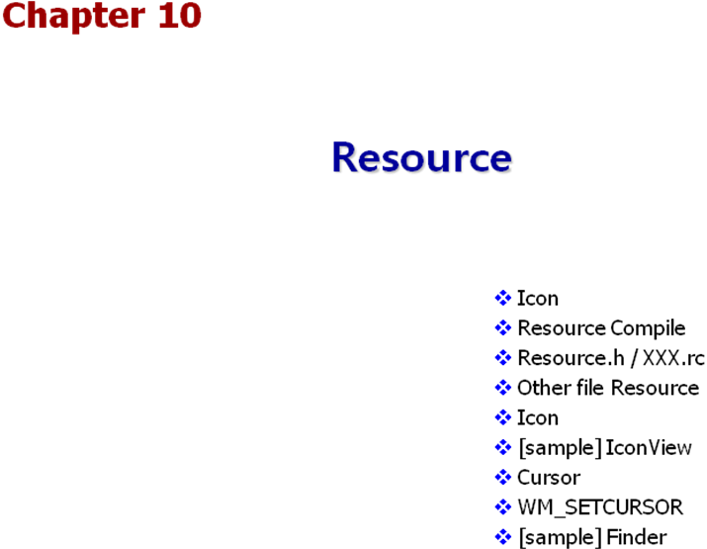

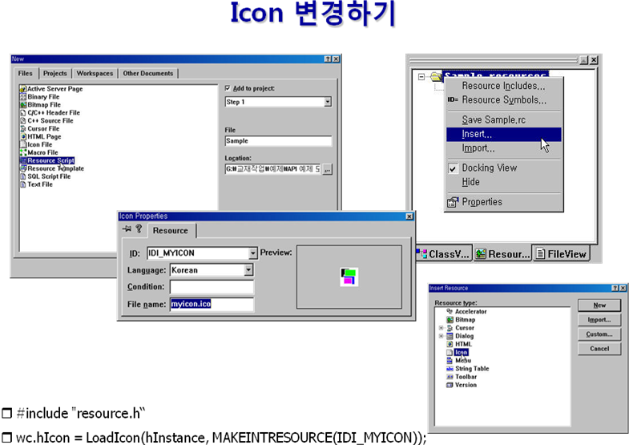

#include "resource.h"
HINSTANCE hInst;
LRESULT CALLBACK WndProc( HWND hwnd, UINT msg, WPARAM wParam, LPARAM lParam) {
switch( msg )
{
case WM_LBUTTONDOWN:
{
HDC hdc = GetDC(hwnd);
HICON hIcon = LoadIcon( hInst, "MYICON");
DrawIcon(hdc, 10, 10, hIcon);
ReleaseDC(hwnd, hdc);
}
return 0;
//…
}
int WINAPI WinMain( HINSTANCE hInstance, HINSTANCE hPrevInstance, LPSTR lpCmdLine, int nShowCmd){
// 1. 윈도우 클래스 만들기
WNDCLASS wc;
wc.hCursor = LoadCursor(0, IDC_ARROW);
wc.hIcon = LoadIcon(hInstance, MAKEINTRESOURCE(IDI_MYICON));
// LoadIcon(0, IDI_APPLICATION);
// …
return 0;
}

리소스 등록시 문자열과 ID값의 차이점 체크!

WndProc 에서 hInstance를 얻는 방법
1. 전역 변수 선언
2. WM_CREATE => ( LPCREATESTRUCT(lParam) )->hInstance;
3. GetModuleHandle(0)
4. Windows 의 객체에 있다.. GetWindowLong(hwnd, GWL_HINSTANCE)...

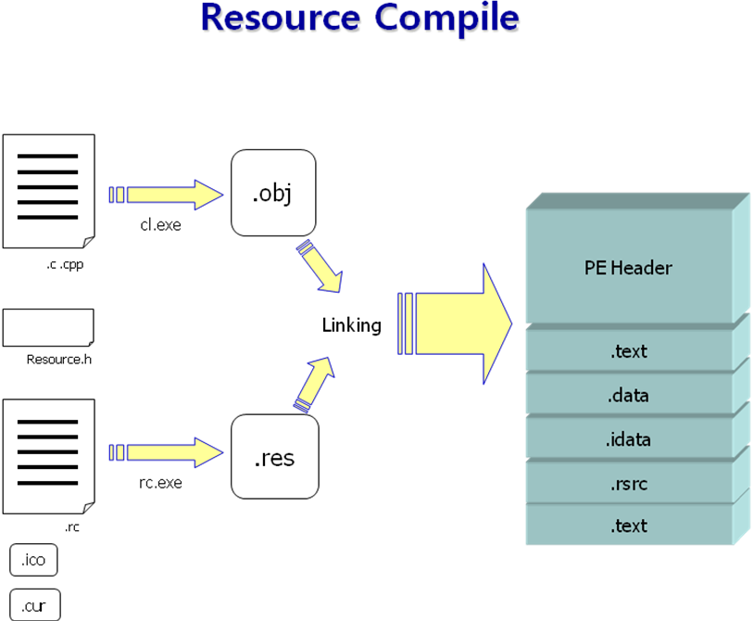

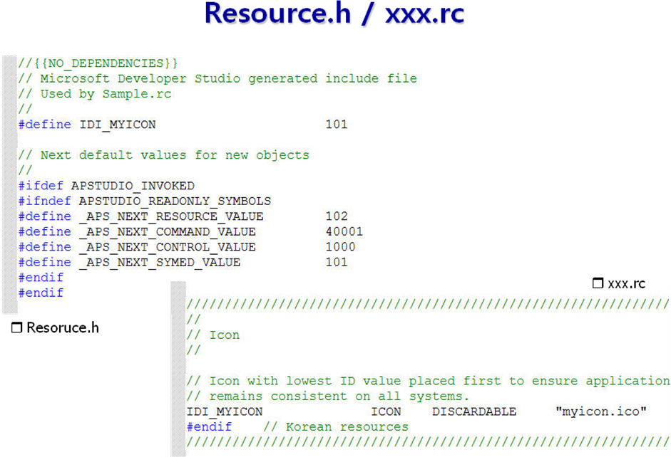

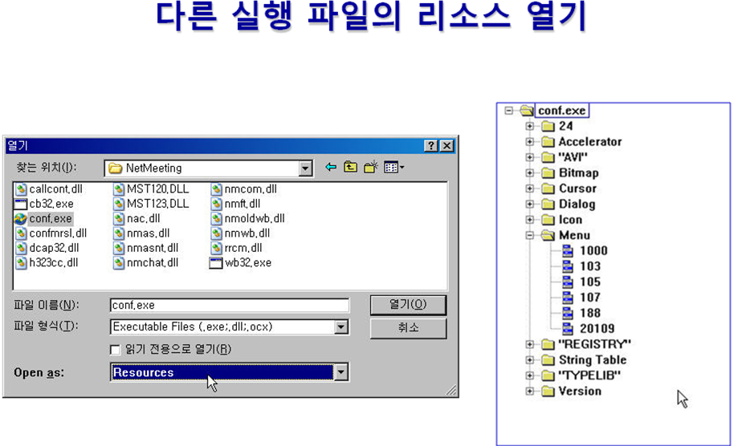

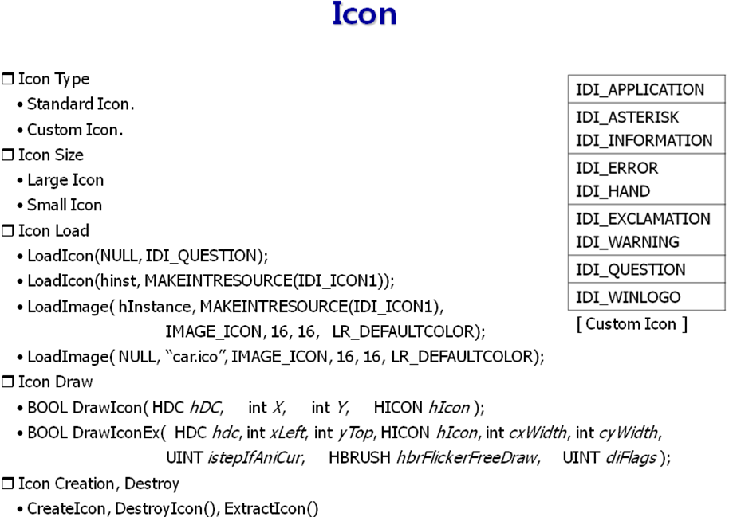

*) TrayIcon ( 그림판에 기능 추가 )
// 1. 0xF000보다 작게... 2. 16의 배수로(16진수에서 제일 뒤를 0으로)
#define IDM_SYS_TOPMOST 0x0010
LRESULT CALLBACK WndProc( HWND hwnd, UINT msg, WPARAM wParam, LPARAM lParam) {
switch( msg ) {
case WM_USER + 100 :
if( wParam == 1 ) // Icon ID {
if( lParam == WM_RBUTTONUP) {
// Context Menu 처리
}
else if( lParam == WM_LBUTTONDBLCLK) {
// 화면 복귀
ShowWindow(hwnd, SW_SHOW);
NOTIFYICONDATA nid;
nid.cbSize = sizeof(nid);
nid.hWnd = hwnd;
nid.uID = 1;
Shell_NotifyIcon(NIM_DELETE, &nid);
}
}
return 0;
case WM_SYSCOMMAND:
switch( wParam & 0xFFF0 ) { // 하위 4bit를 0으로...
case SC_MINIMIZE: {
// TrayIcon 생성
NOTIFYICONDATA nid;
nid.cbSize = sizeof(nid);
nid.hIcon = LoadIcon( 0, IDI_WINLOGO);
nid.hWnd = hwnd;
strcpy(nid.szTip, "API 예제");
nid.uCallbackMessage= WM_USER + 100;
nid.uID = 1;
nid.uFlags = NIF_ICON | NIF_TIP | NIF_MESSAGE;
Shell_NotifyIcon(NIM_ADD, &nid);
//-------------------------------------------------------
// Animation 기능을 구현하기 위한 코드
int cx = GetSystemMetrics(SM_CXSCREEN);
int cy = GetSystemMetrics(SM_CYSCREEN);
RECT rcWin;
GetWindowRect(hwnd, &rcWin);
// taskbar의 현재 크기의 개념...
RECT rcTray = { cx-50, cy-50, cx, cy };
DrawAnimatedRects(hwnd, IDANI_CAPTION, &rcWin, &rcTray);
//---------------------------------------------------------
ShowWindow(hwnd, SW_HIDE);
}
return 0;

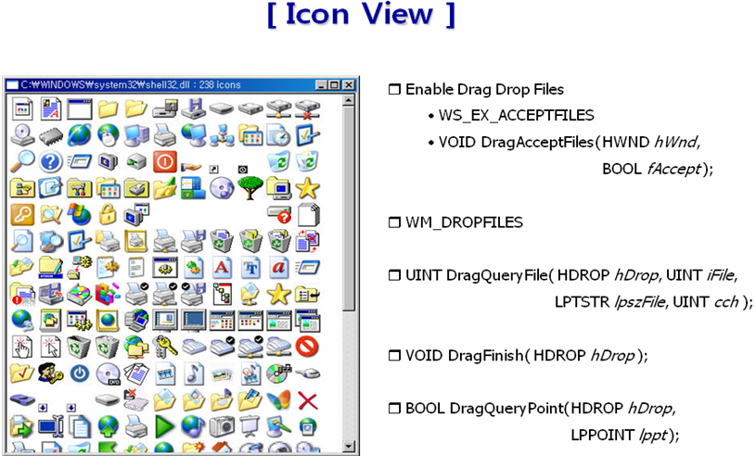

#include <windows.h>  #include <TCHAR.h>  #include <vector>  using namespace std;  #define GAP 4  #define LINESIZE 8  LRESULT CALLBACK WndProc(HWND hwnd, UINT msg, WPARAM wParam, LPARAM lParam)  {  static vector<HICON> buffer;  static TCHAR filename[256] = _T("no file");  static int cxClient, cyClient;  static int cxIcon, cyIcon;  static int vMax, vCurrentPos;  SCROLLINFO si = { sizeof(si) };  HDROP hDrop;  int nCount, i, x = GAP, y = GAP;  PAINTSTRUCT ps;  HDC hdc;  switch(msg)  {  case WM_CREATE:  DragAcceptFiles(hwnd, TRUE);  cxIcon = GetSystemMetrics(SM_CXICON) + GAP;  cyIcon = GetSystemMetrics(SM_CYICON) + GAP;  return 0; | case WM_VSCROLL:  si.fMask = SIF_ALL;  GetScrollInfo(hwnd, SB_VERT, &si);  vCurrentPos = si.nPos;  switch(LOWORD(wParam))  {  case SB_TOP: si.nPos = 0;break;  case SB_BOTTOM: si.nPos = vMax; break;  case SB_LINEUP: si.nPos -= LINESIZE; break;  case SB_LINEDOWN:si.nPos += LINESIZE;break;  case SB_PAGEUP: si.nPos -= si.nPage; break;  case SB_PAGEDOWN: si.nPos += si.nPage; break  case SB_THUMBTRACK: si.nPos = si.nTrackPos;  break;  }  si.fMask = SIF_POS;  SetScrollInfo(hwnd, SB_VERT, &si, TRUE); GetScrollInfo(hwnd, SB_VERT, &si);  if ( si.nPos != vCurrentPos)  {  ScrollWindow(hwnd, 0, vCurrentPos - si.nPos ,  0, 0);  vCurrentPos = si.nPos;  UpdateWindow(hwnd);  }  return 0;

case WM_PAINT:  hdc = BeginPaint(hwnd, &ps);  SetWindowOrgEx(hdc, 0, vCurrentPos, 0);  for (i = 0; i < buffer.size() ; i++)  {  DrawIconEx( hdc,x, y, buffer[i], 0, 0, 0, 0,  DI_NORMAL);  x += cxIcon;  if ( x > cxClient - cxIcon)  {  y += cyIcon;  x = GAP;  }  }  EndPaint(hwnd, &ps);  return 0;  case WM_DROPFILES:  hDrop = (HDROP) wParam;  if ( 1 != DragQueryFile(hDrop, -1, 0, 0) )  {  DragFinish(hDrop);  return 0;  }  DragQueryFile(hDrop, 0, filename, 256);  // empty vector  while( !buffer.empty() )  {  DestroyIcon(buffer.back());  buffer.pop_back();  }  nCount = (UINT)ExtractIcon(NULL, filename, -1);  for (i = 0; i < nCount ; i++)  {  HICON h1 = 0, h2 = 0;  ExtractIconEx( filename, i, &h1, &h2, 1);  if ( h1 != 0) buffer.push_back( h1 );  if ( h2 != 0) buffer.push_back( h2 );  };  InvalidateRect(hwnd, NULL, TRUE);  wsprintf(filename, _T("%s : %d icons"),  filename, nCount);  SetWindowText( hwnd, filename );  DragFinish(hDrop);  // Fall Through  case WM_SIZE:  if ( msg == WM_SIZE )  {  cxClient = LOWORD(lParam);  cyClient = HIWORD(lParam);  } | nCount = cxClient / cxIcon;  vMax = cyIcon * ( ( buffer.size() / nCount ) + 1);  si.fMask = SIF_PAGE | SIF_RANGE;  si.nMax = vMax;  si.nMin = 0;  si.nPage = cyClient;  SetScrollInfo(hwnd, SB_VERT, &si, TRUE);  si.fMask = SIF_POS;  GetScrollInfo(hwnd, SB_VERT, &si);  vCurrentPos = si.nPos;  return 0;  case WM_DESTROY:  // empty vector  while( !buffer.empty() )  {  DestroyIcon(buffer.back());  buffer.pop_back();  }  PostQuitMessage(0);  return 0;  }  return DefWindowProc(hwnd, msg, wParam, lParam);  }

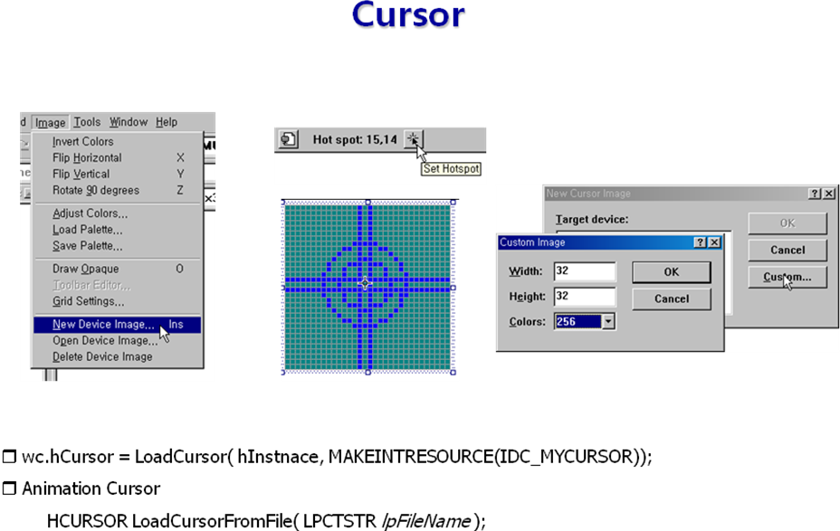

#include <windows.h>
#include "resource.h"

LRESULT CALLBACK WndProc( HWND hwnd, UINT msg, WPARAM wParam, LPARAM lParam) {
static HCURSOR h1 = LoadCursorFromFile("C:\\windows\\cursors\\sizens.ani");
static HCURSOR h2 = LoadCursorFromFile("C:\\windows\\cursors\\sizewe.ani");
static RECT rc = { 100,100,300,300}; // 클라이언트 좌표.

switch( msg )
{
case WM_SETCURSOR:
{
int code = LOWORD(lParam); // hit test code가 들어 있다.

POINT pt;
GetCursorPos(&pt); // 현재 커서의 위치(스크린 좌표)
ScreenToClient( hwnd, &pt); // 스크린 좌표를 클라이 언트 좌표로..

// 클라이언트 안에서도 특정위치에서는 다른 커서를 사용하는 방법.
if ( code == HTCLIENT && PtInRect( &rc, pt ) )
{
SetCursor( LoadCursor( 0, IDC_ARROW ) );
return TRUE;
}
//그외의 Client에서는 DefWindowProc이 변경해 줄것이다.!!!!!
//----------------------------------------------------------
if ( code == HTLEFT || code == HTRIGHT)
{
SetCursor( h2);
return TRUE; // 커서를 변경한 경우 TRUE 리턴
}
else if ( code == HTTOP || code == HTBOTTOM )
{
SetCursor( h1 );
return TRUE;
}
}
// 내가 변경하지 않은 다른 부분을 변경하기 위해 아래 함수로
// 반드시 보내야 한다.
return DefWindowProc( hwnd, msg, wParam, lParam);

case WM_DESTROY:
PostQuitMessage(0);
return 0;
}
return DefWindowProc( hwnd, msg, wParam, lParam);
}

int WINAPI WinMain( HINSTANCE hInstance, HINSTANCE , LPSTR lpCmdLine, int nShowCmd)
{
WNDCLASS wc;
wc.cbClsExtra = 0;
wc.cbWndExtra = 0;
wc.hbrBackground = (HBRUSH)GetStockObject( WHITE_BRUSH );

// 사용자가 만든 커서 사용하기
//HCURSOR hc = LoadCursor( hInstance,MAKEINTRESOURCE(IDC_CURSOR1));

// Animation 커서 사용하기 - Windows 설치시 아래 경로에 많은 animation 커서가 설치된다.
char dir[256];
GetWindowsDirectory( dir, 256); // 윈도우가 설치된 디렉토리
strcat( dir, "\\cursors\\banana.ani");

HCURSOR hc = LoadCursorFromFile( dir );

if ( hc == 0 ) // 해당 animation 커서가 없다.
{
hc = LoadCursor( 0, IDC_ARROW); // 기본 커서 사용
}
wc.hCursor = hc; //LoadCursor( 0, IDC_ARROW );

//----------------------------------------------
// …
return 0;
}

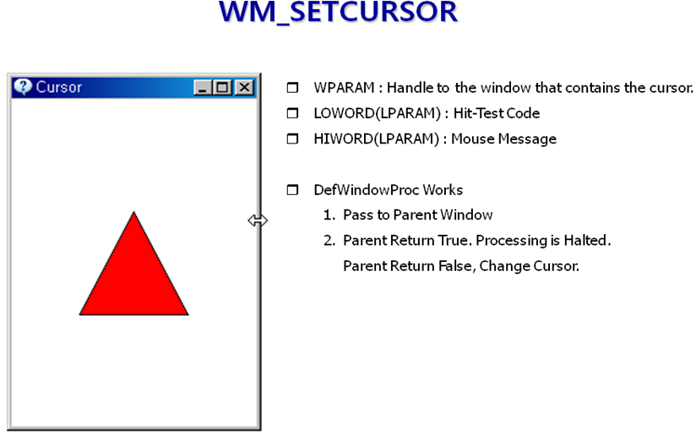

#include <windows.h>
#include <TCHAR.h>
#include "resource.h"
LRESULT CALLBACK WndProc(HWND hwnd, UINT msg, WPARAM wParam, LPARAM lParam)
{
static HCURSOR s_curArrow, s_curWE, s_curNS, s_curNWSE, s_curNESW, s_curShape, s_curDrag;
static int xCenter, yCenter;
static HBRUSH hBrush;
static HINSTANCE s_hInst;
HDC hdc;
PAINTSTRUCT ps;
POINT points[3];
HBRUSH hOldBrush;
char dir[256];
POINT pt;
switch(msg)
{
case WM_CREATE:
s_hInst = ((LPCREATESTRUCT)lParam)->hInstance;
GetWindowsDirectory(dir, 256);
lstrcat(dir, "\\cursors");
SetCurrentDirectory(dir);
s_curNS = LoadCursorFromFile("sizens.ani");
s_curWE = LoadCursorFromFile("sizewe.ani");
s_curNWSE = LoadCursorFromFile("sizenwse.ani");
s_curNESW = LoadCursorFromFile("sizenesw.ani");
s_curShape = LoadCursor(s_hInst, MAKEINTRESOURCE(IDC_FOCUS));
s_curDrag = LoadCursor(s_hInst, MAKEINTRESOURCE(IDC_DRAG));
hBrush = CreateSolidBrush( RGB(255,0,0) );

return 0;
case WM_SETCURSOR:
switch( LOWORD(lParam) ) // HitTestCode
{
case HTLEFT:
case HTRIGHT:
SetCursor(s_curWE);
return TRUE;
case HTTOP:
case HTBOTTOM:
SetCursor(s_curNS);
return TRUE;
case HTBOTTOMRIGHT:
case HTTOPLEFT:
SetCursor(s_curNWSE);
return TRUE;
case HTBOTTOMLEFT:
case HTTOPRIGHT:
SetCursor(s_curNESW);
return TRUE;
case HTCLIENT:
if ( GetAsyncKeyState(VK_LBUTTON) < 0 )
{
SetCursor(s_curDrag);
return TRUE;
}
GetCursorPos(&pt);
}
break;
case WM_SIZE:
xCenter = LOWORD(lParam) / 2;
yCenter = HIWORD(lParam) / 2;
return 0;
case WM_PAINT:
hdc = BeginPaint(hwnd, &ps);

hOldBrush = (HBRUSH)SelectObject(hdc, hBrush );
points[0].x = xCenter - 45;
points[0].y = yCenter + 45;
points[1].x = xCenter;
points[1].y = yCenter - 45;
points[2].x = xCenter + 45;
points[2].y = yCenter + 45;
Polygon(hdc, points, 3);
SelectObject(hdc, hOldBrush);
EndPaint(hwnd, &ps);
return 0;
case WM_DESTROY:
DeleteObject(hBrush);
PostQuitMessage(0);
return 0;
}
return DefWindowProc(hwnd, msg, wParam, lParam);
}

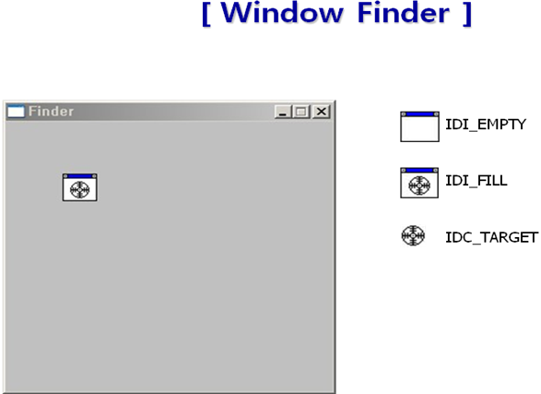
03_sample 참조
#include <windows.h>
#include <TCHAR.h>
#include "resource.h"
void DrawInvertRect( HWND hwnd )
{
RECT rc;
GetWindowRect( hwnd, &rc );
OffsetRect( &rc, -rc.left, -rc.top ); // ЅєЕ©ё° БВЗҐ->А©µµїм БВЗҐ
HDC hdc = GetWindowDC( hwnd );
SetROP2( hdc, R2_NOT);
HPEN hPen = CreatePen( PS_SOLID, 5, RGB(0,0,0));
HPEN oldPen = (HPEN)SelectObject( hdc, hPen );
HBRUSH oldBrush = (HBRUSH)SelectObject( hdc, GetStockObject( NULL_BRUSH) );
Rectangle( hdc, rc.left, rc.top, rc.right, rc.bottom);
SelectObject( hdc, oldBrush);
DeleteObject( SelectObject( hdc, oldPen) );
ReleaseDC( hwnd, hdc );
}
LRESULT CALLBACK WndProc(HWND hwnd, UINT msg, WPARAM wParam, LPARAM lParam)
{
static HICON hFill, hEmpty;
static HCURSOR hCursor;
static HINSTANCE hInst;
static RECT rc = { 50, 50, 82, 82 };
static HWND hwndPrev = (HWND)-1;
static char info[512] = "";
static RECT rcText = { 50, 100, 300, 300};
HDC hdc;
POINT pt;
PAINTSTRUCT ps;
switch(msg)
{
case WM_CREATE:
hInst = ((LPCREATESTRUCT)lParam)->hInstance;
hFill = LoadIcon( hInst, MAKEINTRESOURCE(IDI_ICON_FILL));
hEmpty = LoadIcon( hInst, MAKEINTRESOURCE(IDI_ICON_EMPTY));
hCursor = LoadCursor( hInst, MAKEINTRESOURCE(IDC_CURSOR_TARGET));
return 0;
case WM_MOUSEMOVE:
if ( GetCapture() == hwnd )
{
POINT pt;
GetCursorPos( &pt );
HWND hCur = WindowFromPoint( pt );
if ( hCur != hwnd && hCur != hwndPrev )
{
DrawInvertRect( hwndPrev );
DrawInvertRect( hCur );
hwndPrev = hCur;

char name[256];
GetClassName( hwndPrev, name, 256 );
RECT r; GetWindowRect( hwndPrev, &r);
wsprintf( info, "HWND : 0x%08X\nClass : %s\nPosition : (%d, %d)-(%d,%d)",
hwndPrev, name, r.left, r.top, r.right,r.bottom);
InvalidateRect( hwnd, &rcText, TRUE);
}
}
return 0;

case WM_LBUTTONDOWN:
pt.x = LOWORD(lParam);
pt.y = HIWORD(lParam);
if ( PtInRect( &rc, pt) )
{
SetCapture( hwnd );
HDC hdc = GetDC( hwnd );
DrawIcon( hdc, rc.left, rc.top, hEmpty );
ReleaseDC( hwnd, hdc );
SetCursor( hCursor );
}
return 0;
case WM_LBUTTONUP:
if ( GetCapture() == hwnd ) ReleaseCapture();
return 0;
case WM_CAPTURECHANGED:
InvalidateRect( hwnd, &rc, TRUE);
DrawInvertRect( hwndPrev );
hwndPrev = (HWND)-1;
return 0;
case WM_PAINT:
hdc = BeginPaint( hwnd, &ps );
DrawIcon( hdc, rc.left, rc.top, hFill);
SetBkMode( hdc, TRANSPARENT);
DrawText( hdc, info, -1, &rcText, DT_TOP|DT_LEFT);
EndPaint( hwnd, &ps );
return 0;

case WM_DESTROY:
PostQuitMessage(0);
return 0;
}
return DefWindowProc(hwnd, msg, wParam, lParam);
}

