**OpenStreetMap - Building outlines - Area (Australia) 2021**

**Description**

This dataset was extracted from OpenStreetMap (OSM) across the geographic area of Australia on 02 December 2021. Its purpose is to display all building outlines as an area (polygon) within Australia. Note, however, as this dataset is built by a community of mappers, there is no guarantee of its spatial or attribute accuracy. Use at your own risk.

For more information about the map features represented in this dataset (including their attributes), refer to the [OpenStreetMap Wiki](https://wiki.openstreetmap.org/wiki/Map_Features).

Please note:

* The original data for this dataset has been downloaded from [Geofabrik](http://download.geofabrik.de/australia-oceania/australia.html) on 02 December 2021.
* Due to changes in tagging, previous versions of OSM may not be comparable with this release.

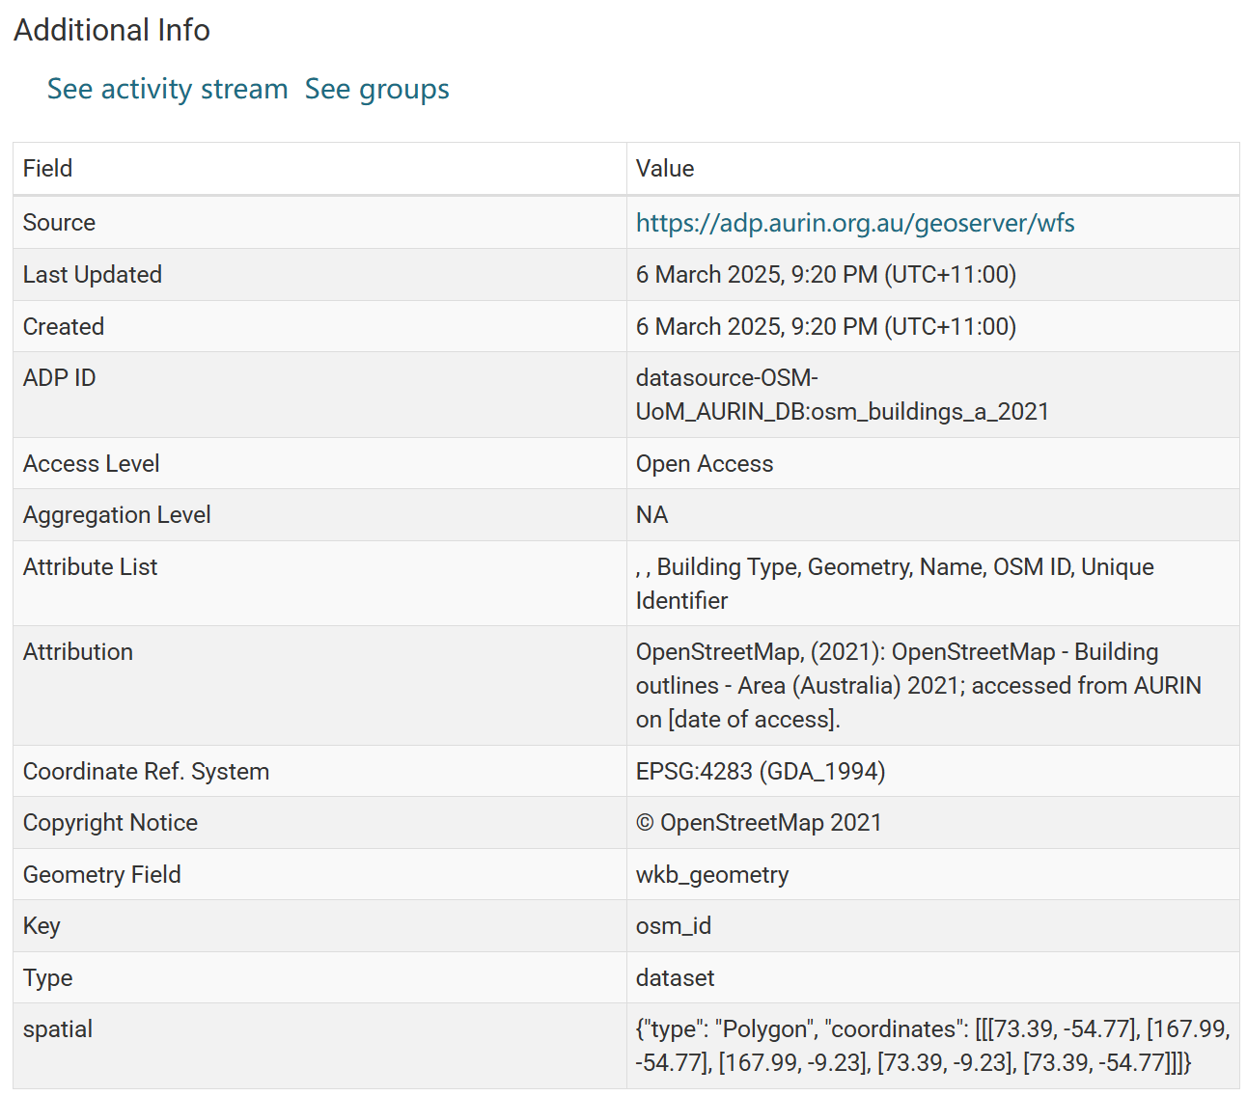

The dataset website:

<https://data.aurin.org.au/dataset/osm-osm-buildings-a-2021-na>