# 文件io操作

import xlwt

from openpyxl import *

student_score = xlwt.Workbook() #新建一个excel文件

worksheet = student_score.add_sheet('sheet')

worksheet.write(1,0,'0')

worksheet.write(2,0,'1')

worksheet.write(3,0,'2')

worksheet.write(0,1,'Name')

worksheet.write(1,1,'Zhang San')

worksheet.write(2,1,'Li Si')

worksheet.write(3,1,'Wang Wu')

worksheet.write(0,2,'Student_ID')

worksheet.write(1,2,'01')

worksheet.write(2,2,'02')

worksheet.write(3,2,'03')

worksheet.write(0,3,'Score')

worksheet.write(1,3,'80')

worksheet.write(2,3,'90')

worksheet.write(3,3,'95')

#填写表格数据

student_score.save('student score.xlsx') #保存表格原始数据

#删除第一列

student_scored = 'student score.xlsx'

wb = load_workbook(student_scored)

ws = wb.active

ws.delete_cols(1) #删除第 1 列数据

wb.save(student_scored)

# 练习

## 1.

def greeting(name):

    hello='Hello, '+name+'!'

    return hello

print(greeting('John'))

say_hello=greeting

print(say_hello)

print(say_hello('Mike'))

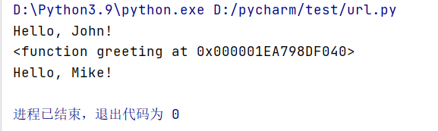

理解：say_hello=greeting 将greeting函数作为对象赋值给say_hello函数，此时say_hello函数指向greeting函数。注意函数作为对象赋给另一个变量时不能加 () ，不然函数会被执行，会将返回结果赋给变量而不是函数。如say_hello=greeting而不能写错为：say_hello=greeting()

## 2.

def add_number_creator(number):

def add_number(a):

return a+number

return add_number

add_three=add_number_creator(3)

add_five=add_number_creator(5)

print(add_three(10))

‌print(add_five(100))

‌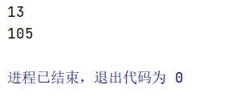

理解：在一个函数体内可以定义另一个函数并调用。add_three(10)相当于add_number_creator(3)(10)

在add_three=add_number_creator(3)中，add_number_creator(3)相当于定义add_number(a): return a+3。

10+3=13，所以add_number_creator(3)(10)返回13。

‌3.

‌def combine_two_numbers(how_to,numbers):

return how_to(numbers)

def add_two_numbers(numbers):

a,b=numbers

return a+b

def multiply_two_members(numbers):

a,b=numbers

return a*b

result1=combine_two_numbers(add_two_numbers,(3,5))

print(result1)

result2=combine_two_numbers(multiply_two_members,(4,6))

print(result2)

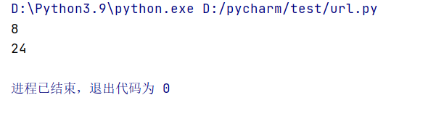

理解：在定义在外部的函数，可以在其他函数体中被调用，函数可以嵌套

在result1中用的是add_two_numbers的方法，result2中用的是multiply_two_members的方法。