|  |  |
| --- | --- |
| WYSIWYG | Synprod |
|  |  |
| 12/09/2017 | Project document |
|  | This document contains all the technical and decision of the Synprod project. |

Synprod

Project document

Table of content

Table des matières

INTRODUCTION 1

Objective 1

Core Functions 1

Description of Core Functions 1

Technical requirement 3

# INTRODUCTION

## Objective

The project’s aim is to allow the company to allow clients to use its connector by downloading it and using it to generate production reports on their premises. Therefore, by making the connector available on the internet, this project will lead to huge cost saving in terms of Transport, troubleshooting and on the other hand it will generate profit by being able to sell globally.

### Core Functions

1. Client sign up
2. Client Account
3. Payment Gateway
4. Connector download
5. Admin panel for our company

### Description of Core Functions

#### Client sign up

When the Client will visit the website. He will be presented to various packages (services) as shown below

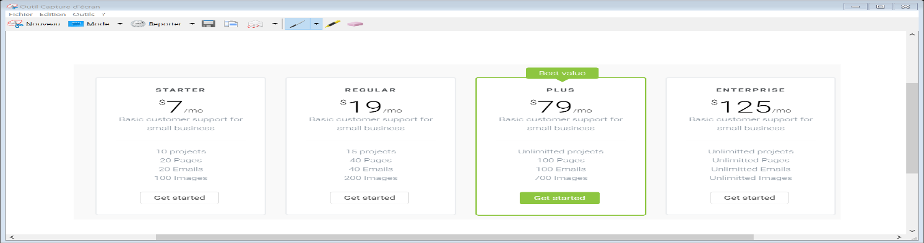

When he clicks on one of the packages he will be brought to a login page. If he has an account he will input his username and password else he will be force to sign up.

#### Client Account

The client will have a profile page where he will be able to :

1. Change his password
2. Change his details
3. Update his wallet information
4. See a history of the packages he purchased
5. Receive notification about packages going to expire.

#### Type of Client Account

We shall have 3 types of Clients

1. On premise
   1. The Client will download the connector and will use it on his premise. No interaction with Synprod will occur. This type of client can be considered as a ‘basic’ client
   2. The Client will download the connector and will have access to our online service on Synprod. Each module online is accessible by activating the module ( paying for the module)
2. Dolibarr clients online
   1. These clients will connect on our platform to use their dolibarr CMS
3. Online clients using software hosted by third party Vendors

#### Payment Gateway

Clients will be able to make purchases using several payment gateways like PayPal, Credit cart etc. The processes will look like below:

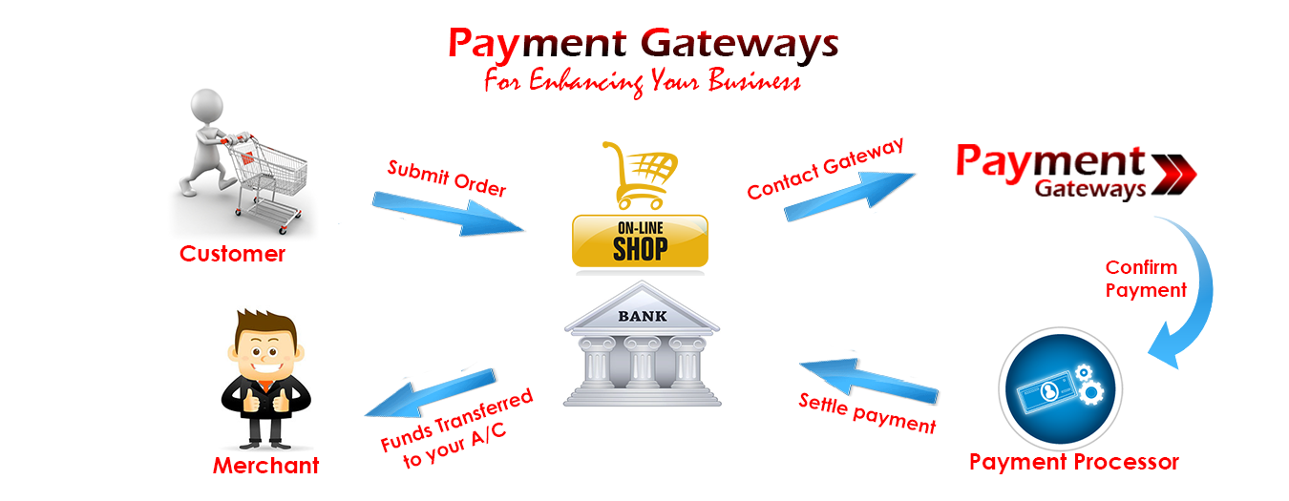

Synprod

#### Connector download

When the user payment is done he will get a unique link to download the connector. The issue might be that he shares the connector to his friend running a similar system as him. This will be a lost for us.

#### Receive notification about packages going to expire.

Connectors are not life time, they will need to be renewed. There will be an expiry date inside the main engine of the controller.

### Technical requirement

The Synprod will be run on

Apache 2.4.23

Php 5.6.25

Mysql 5.7.14

Symfony 3.1

<https://github.com/wysiwyg-team/synprod/tree/master/web>

Front End

Bootstrap 3.0

Css 3

Jquery

Font awesome.

Version control

Git

Repository : https://github.com/wysiwyg-team/synprod.git

# Design

In this section, we shall describe in detail the design of the various components

## Entity Relationship Diagram

Synprod

Client

Admin

Payment Gateway

Connector

Figure 1 system level Entity Diagram

## Entities

1. Client

The client will perform the following actions

* 1. Login
  2. Logout
  3. Signup
  4. Manage his account
  5. Purchase connector
  6. Raise ticket for issues

1. Admin

The admin will perform the following actions

* 1. Login
  2. Logout
  3. Manage client
  4. Answer issues

1. Payment Gateway

The payment gateway entity will perform the following

* 1. Handle payment request
  2. Validate payment

1. Connector

The Connector entity will perform the following

* 1. Release a specific connector to a client
  2. Validate connector request
  3. Manage connectors

## Flow chart synprod

Client

Login

Buy connector

Connector

Sign up

Not registered

Payment Gateway

Hello there there my friend