**FIFO**

可配置大小

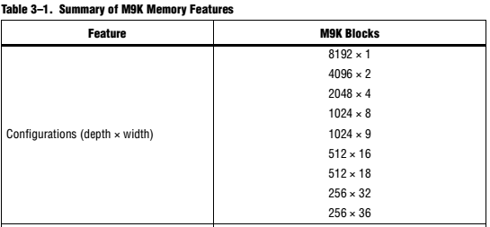

Cyclone IV devices M9K memory blocks do not support simultaneous read and write from an empty FIFO buffer.

SCFIFO and DCFIFO Functional Timing Requirements

