Project 2
飞机场模拟

班级：2012级 自动化系
自动化 智能科学
姓名：蔡 冰 学号：12350001
姓名：李东特 学号：12350029
姓名：卢秀芳 学号：12350042

【题目要求】
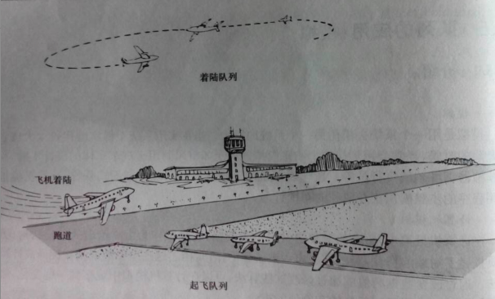
图1 飞机场
P1、将所有用于飞机场模拟的函数和方法组合成一个完整的程序。用飞机场模拟程序做若干次试运行实验，调整准备着陆和起飞的飞机数的期望值，并找出在飞机不会被拒绝服务的条件下这些数字尽可能大的近似值。如果队列的长度增加或减少，那么这些值将会有什么变化？
P2、修改模拟程序，使飞机场有两条飞机跑道，其中一条总是用来着陆，另一条总是用来起飞。比较双跑道机场能服务的总飞机数和单条飞机跑道的飞机场的相应数字，前者是否为后者的两倍？
P3、修改模拟程序，使飞机场有两条飞机跑道，其中一条总是用来着陆，另一条总是用来起飞。如果某个队列是空的，那么两条跑道都能用于其他的队列。如果着陆队列总是满的，并且另一架飞机要到达着陆，那么将停止起飞，并将两条跑道都用于清理搁置的着陆飞机。
P4、修改模拟程序，使飞机场有3条飞机跑道，其中各保留一条总是用于着陆和起飞，第三条用于着陆，但在着陆队列为空的情况下，第三条亦可用于起飞。
P5、修改最初的模拟程序（单条跑道），使得当每架飞机到达着陆时，它将有（作为它的数据成员的）一个（随机产生的）油位，以剩余的时间单元度量。如果飞机没有足够的油位在队列中等待，则允许它立即着陆。因此着陆队列里的飞机可能需要再等待附加的单元，因此可能用完自身的燃料。作为着陆函数的一部分要检查这一点，并查明在飞机由于燃料耗尽而开始坠毁前机场有多忙。
P6、写一个占位程序来代替随机函数，这个占位程序既能用于调试程序又允许用户正确地控制每一个时间单元内每个队列到达的飞机数。

【数据结构与算法】
P1：这里采用了两种输入输出方式：开始是使用cin、cout。用于处理数据较多，后来采用文件输入输出。但题P2~P6仍然使用cin、cout。
（文件输入输出）流程图如下：

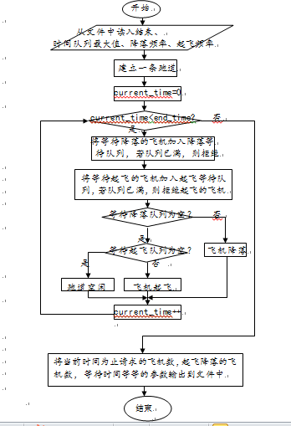

P2：
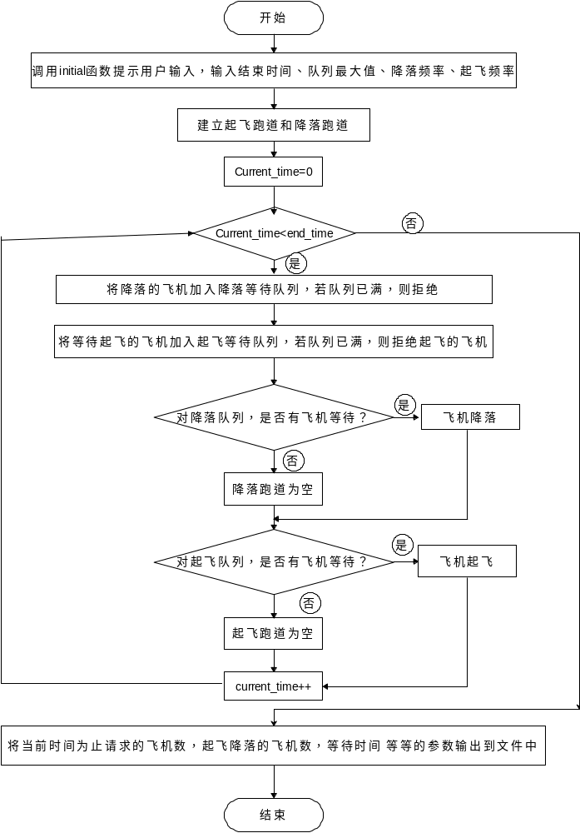
P3：
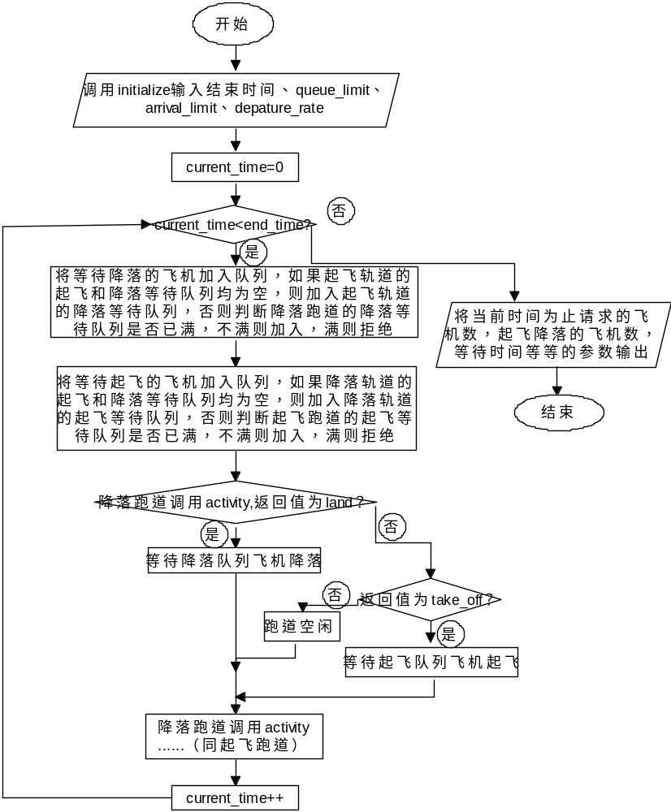
P4：
P5：
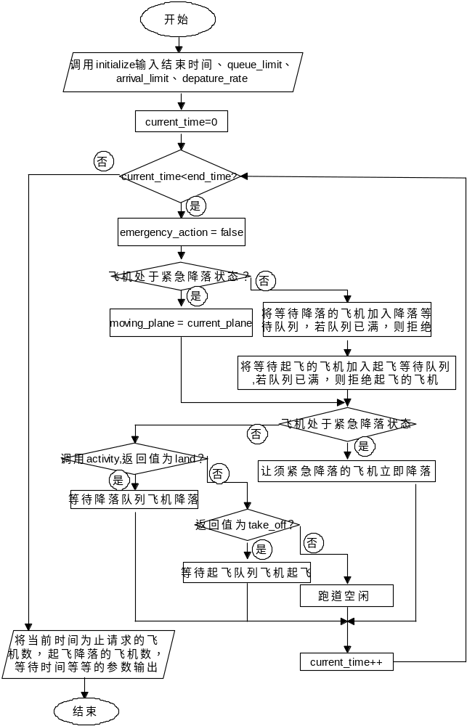

P6：
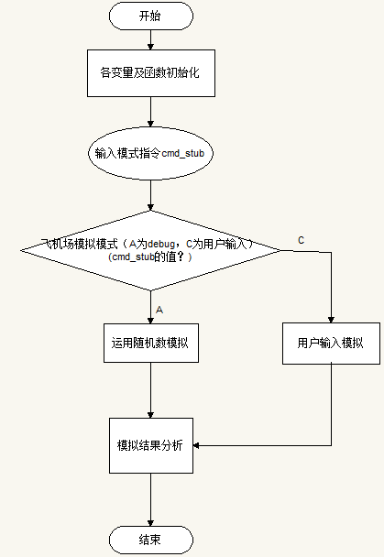
【测试数据、结果及分析】

【分工、贡献%、自我评分】

【项目总结】
1、本次实验加深了我们对于队列的理解，以及更深刻地理解了他的实际应用，可以仿真机场的调度，由此推广开，也可以仿真任何可以用于排队的场合，只要修改相应的类对象就可以实现。
2、本次实验的难度在于实验所涉及的项目非常之多，各种对象，函数非常之多，导致调试问题较多。
3、本次试验出现的技术性问题
①Plane类Runway类、队列以及Random类分别放在不同的头文件中，但相互之间有交集，存在着相互引用的现象，导致重复定义的问题。解决方法为每个类及自定义类型加上宏定义——“#ifndef #define #endif”就可以避免重定义问题。
②输入到文件中时，由于该语句是写在Runway类中的，每次测试数据都会调用到该函数 ，重复打开该输出文件，要加上iso：app语句，以便将后面测试数据的结果加到前面的结果中，否则，输出文件中只有最后的数据的结果。
③由于文件较多，要注意文件的链接问题。
4、
①本次项目在实现过程中依照课本中给的类定义及主函数实现一条跑道的问题，优先处理降落的飞机。
②而两条跑道的时候，则可以同时处理起飞和降落，可以用两个switch函数来判断，一个判断是否有降落，一个判断是否有起飞。
③同样是两条轨道的情况，但是当一条轨道为空时可用于其他用途。小组最开始讨论的结果是再加上一条队列，但是考虑到实际情况，以及该种方法可能不是最优的做法，小组放弃了这种思路。最后采用的方法的关键是给Runway函数添加两个size函数，通过size函数判断跑道现在的状态，在作出相应的响应。
④三条轨道的情况同样也没有太大的改变，只要判断出landing 轨道为空时就可以改变其用途用于起飞。
⑤将飞机燃油的情况加入考虑其实是队列优先级的一种应用。考虑飞机的燃油情况，将飞机的燃油情况加入飞机的标志中，在原来的机场调度的情况下加入了飞机优先级的考虑，通过计算判断其是否处于紧急状况，是的话则将队列中应降落的飞机设为当前的紧急飞机，改变其入队顺序。
【程序清单】
P1：用文件输入输出见附录B，用cin、cout输入输出见附录C
P2~P6：见附录C

附录说明：
附录A 类及函数实现文件
附录B P1用文件输入输出
附录C P1~P6程序清单（用cin、cout输入输出）
附录D P1运行后在屏幕上输出的结果，仅含一次输入后的结果

附录A
说明：类及函数实现文件
“p.h”
#include<iostream>
using namespace std;
#ifndef PLANE_STATUS
#define PLANE_STATUS
enum Plane_status {null, arriving, departing};
#endif

#ifndef PLANE
#define PLANE
class Plane{
public:
Plane();
Plane(int flt, int time, Plane_status status);
void refuse() const;
void land(int time) const;
void fly(int time) const;
int started() const;
private:
int flt_num;
int clock_start;
Plane_status state;
};
#endif

“q.h”
#include <iostream>
#include"p.h"
using namespace std;
#ifndef ERROR_CODE
#define ERROR_CODE

enum Error_code {success,overflow ,underflow,fail};
#endif
typedef Plane Queue_entry;
#ifndef QUEUE
#define QUEUE

class Queue
{
public:
Queue();
bool empty()const;
Error_code serve();
Error_code append(const Queue_entry &item);
Error_code retrieve(Queue_entry &item)const;
protected:
int count;
int front,rear;
Queue_entry entry[1000];
};
#endif

#ifndef EXTENDED_QUEUE
#define EXTENDED_QUEUE

class Extended_Queue:public Queue
{
public:
int size()const;
};
#endif

“r.h”
#include<iostream>
#include "q.h"
using namespace std;
#ifndef RUNWAY_ACTIVITY
#define RUNWAY_ACTIVITY

#endif
#ifndef RUNWAY
#define RUNWAY

#endif
enum Runway_activity {idle, land, take_off};
class Runway {
public:
Runway(int limit);
Error_code can_land(const Plane &current);
Error_code can_depart(const Plane &current);
Runway_activity activity(int time, Plane &moving);
void shut_down(int time) const;
private:
Extended_Queue landing;
Extended_Queue takeoff;
int queue_limit;
int num_land_requests; // 请求降落的飞机数
int num_takeoff_requests; // 请求起飞的飞机数
int num_landings; // 已经降落的飞机数
int num_takeoffs; // 已经起飞的飞机数
int num_land_accepted; // 等待降落的飞机数
int num_takeoff_accepted; // 等待起飞的飞机数
int num_land_refused; // 被拒绝降落的飞机数
int num_takeoff_refused; // 被拒绝起飞的飞机数
int land_wait; // 降落飞机等待总时间
int takeoff_wait; // 起飞等待总时间
int idle_time; // 跑道空闲总时间
};
class Random
{
public:
Random(bool pseudo=true);
int poisson(double mean);
double random_real();
private:
int seed,multiplier,add_on;
int reseed();
};

实现cpp:

#include<iostream>
#include"r.h"
#include "p.h"
#include "q.h"
#include <time.h>
#include <cmath>
#include <limits>
using namespace std;
Runway::Runway(int limit)
/*
Post: 将统计数据清零，并设置队列大小限制
*/

{
queue_limit = limit;
num_land_requests = num_takeoff_requests = 0;
num_landings = num_takeoffs = 0;
num_land_refused = num_takeoff_refused = 0;
num_land_accepted = num_takeoff_accepted = 0;
land_wait = takeoff_wait = idle_time = 0;
}
Error_code Runway::can_land(const Plane &current)
/*
Post: 若等待队列不满，将飞机current加入，否则返回overflow
更新统计数据
Uses: Extended_queue类
*/
{
Error_code result;
if (landing.size() < queue_limit)
result = landing.append(current);
else
result = fail;
num_land_requests++;
if (result != success)
num_land_refused++;
else
num_land_accepted++;

return result;
}
Error_code Runway::can_depart(const Plane &current)
{
Error_code result;
if (takeoff.size() < queue_limit)
result = takeoff.append(current);
else
result = fail;
num_takeoff_requests++;
if (result != success)
num_takeoff_refused++;
else
num_takeoff_accepted++;

return result;
}

Runway_activity Runway::activity(int time, Plane &moving)
/*
Post: 降落的优先级是优于起飞的。如果降落等待队列中有飞
机等待，则队列头Plane对象复制到moving，返回land。
否则，才考虑起飞等待队列，若不空，将其队列头Plane
对象复制到moving，返回takeoff。否则，返回idle。
更新统计数据
Uses: Extended_queue类
*/
{
Runway_activity in_progress;
if (!landing.empty()) {
landing.retrieve(moving);
land_wait += time - moving.started();
num_landings++;
in_progress = land;
landing.serve();
} else if (!takeoff.empty()) {
takeoff.retrieve(moving);
takeoff_wait += time - moving.started();
num_takeoffs++;
in_progress =take_off;
takeoff.serve();
} else {
idle_time++;
in_progress = idle;
}
return in_progress;
}
Plane::Plane(int flt, int time, Plane_status status)
/*
Post: 根据参数设置对应的数据成员
*/
{
flt_num = flt;
clock_start = time;
state = status;
cout << "Plane number " << flt << " ready to ";
if (status == arriving)
cout << "land." << endl;
else
cout << "take off." << endl;
}
Plane::Plane()
/*
Post: 数据成员设置成非法值
*/
{
flt_num = -1;
clock_start = -1;
state = null;
}
void Plane::refuse() const
/*
Post: 队列满时，拒绝飞机的请求
*/
{
cout << "Plane number " << flt_num;
if (state == arriving)
cout << " directed to another airport" << endl;
else
cout << " told to try to takeoff again later" << endl;
}
void Plane::land(int time) const
/*
Post: 处理飞机在某一时刻降落
*/
{
int wait = time - clock_start;
cout << time << ": Plane number " << flt_num << " landed after "
<< wait << " time unit" << ((wait == 1) ? "" : "s")
<< " in the takeoff queue." << endl;
}
void Plane::fly(int time) const
/*
Post: 处理飞机在某一时刻起飞
*/
{
int wait = time - clock_start;
cout << time << ": Plane number " << flt_num << " took off after "
<< wait << " time unit" << ((wait == 1) ? "" : "s")
<< " in the takeoff queue." << endl;
}
int Plane::started()const
{
return clock_start;
}

void Runway::shut_down(int time) const
/*
Post: 计算并打印统计信息
*/
{
cout << "Simulation has concluded after " << time << " time units." << endl
<< "Total number of planes processed "
<< (num_land_requests + num_takeoff_requests) << endl
<< "Total number of planes asking to land "
<< num_land_requests << endl
<< "Total number of planes asking to take off "
<< num_takeoff_requests << endl
<< "Total number of planes accepted for landing "
<< num_land_accepted << endl
<< "Total number of planes accepted for takeoff "
<< num_takeoff_accepted << endl
<< "Total number of planes refused for landing "
<< num_land_refused << endl
<< "Total number of planes refused for takeoff "
<< num_takeoff_refused << endl
<< "Total number of planes that landed "
<< num_landings << endl
<< "Total number of planes that took off "
<< num_takeoffs << endl
<< "Total number of planes left in landing queue "
<< landing.size() << endl
<< "Total number of planes left in takeoff queue "
<< takeoff.size() << endl;
cout << "Percentage of time runway idle "
<< 100.0 * (( float ) idle_time) / (( float ) time) << "%" << endl;
cout << "Average wait in landing queue "
<< (( float ) land_wait) / (( float ) num_landings) << " time units";
cout << endl << "Average wait in takeoff queue "
<< (( float ) takeoff_wait) / (( float ) num_takeoffs)
<< " time units" << endl;
cout << "Average observed rate of planes wanting to land "
<< (( float ) num_land_requests) / (( float ) time)
<< " per time unit" << endl;
cout << "Average observed rate of planes wanting to take off "
<< (( float ) num_takeoff_requests) / (( float ) time)
<< " per time unit" << endl;
}

//链式队列的实现文件
Queue::Queue()
{
count=0;
front=0;
rear=999;
}

bool Queue::empty()const
{
return count==0;
}

Error_code Queue::append(const Queue_entry &item)
{
if(count>1000)
return overflow;
count++;
rear=((rear+1)==1000)?0:(rear+1);
entry[rear]=item;
return success;
}

Error_code Queue::serve()
{
if(count<=0) return underflow;
count--;
front=((front+1)==1000)?0:(front+1);
return success;
}
Error_code Queue::retrieve(Queue_entry &item)const
{
if(count<=0) return underflow;
item=entry[front];
return success;
}

int Extended_Queue::size()const
{
return count;
}
double Random::random_real()
{
double max=INT_MAX+1.0;
double temp=reseed();
if(temp<0)temp=temp+max;
return temp/max;
}
Random::Random(bool pseudo)
{
if (pseudo)
{
seed=1;
}
else
{
seed=time(NULL)%INT_MAX;
}
multiplier=2743;
add_on=5923;
}
int Random::reseed()
{
seed=seed*multiplier +add_on;
return seed;
}
int Random::poisson(double mean)
{
double limit=exp(-mean);
double product=random_real();
int count=0;
while (product>limit)
{
count++;
product*=random_real();
}
return count;
}

附录B
说明：以下是P1的程序清单（用文件输入输出）
用于文件输入输出的程序
#include<iostream>
#include<fstream>
#include"r.h"
#include"p.h"
#include "q.h"
using namespace std;
int main()
{
ifstream infile;
ofstream outfile;
int end_time; // time to run simulation
int queue_limit; // size of Runway queues
int flight_number = 0;
double arrival_rate, departure_rate;
infile.open("test.txt");
outfile.open("result.txt");
while (infile)
{
infile>>queue_limit>>end_time>>arrival_rate>>departure_rate;
Random variable;
Runway small_airport(queue_limit);
for (int current_time = 0; current_time < end_time; current_time++) {
int number_arrivals = variable.poisson(arrival_rate);
// 请求降落飞机数
for (int i = 0; i < number_arrivals; i++) {
Plane current_plane(flight_number++, current_time, arriving); / if (small_airport.can_land(current_plane) != success)
current_plane.refuse(); //请求被拒绝
}
int number_departures= variable.poisson(departure_rate);
// 请求起飞飞机数
for (int j = 0; j < number_departures; j++) {
Plane current_plane(flight_number++, current_time, departing); if (small_airport.can_depart(current_plane) != success)
current_plane.refuse();
}
Plane moving_plane;
switch (small_airport.activity(current_time, moving_plane)) {
case land:
moving_plane.land(current_time);
break;
case take_off:
moving_plane.fly(current_time);
break;
case idle:
break;
}
}
small_airport.shut_down(end_time,arrival_rate,departure_rate);
}

infile.close();
outfile.close();
return 0;
}
同时修改了shut down函数
void Runway::shut_down(int time,double arrival_rate,double departure_rate) const
/*
Post: 计算并打印统计信息
*/
{
ifstream infile;
ofstream outfile;
outfile.open("result.txt",ios::app);

outfile <<setw(5) <<time<<setw(4)<<num_land_requests + num_takeoff_requests
<<setw(4)<<num_land_requests<<setw(4)<<num_takeoff_requests
<<setw(4) <<num_land_accepted<<setw(4) <<num_takeoff_accepted
<<setw(2) <<num_land_refused<<setw(3) <<num_takeoff_refused
<<setw(4)<<num_landings<<setw(4) <<num_takeoffs
<<setw(3) <<landing.size()<<setw(3)<<takeoff.size()
<<setw(8) <<100.0 * (( float ) idle_time) / (( float ) time) << "%"
<<setw(9) <<(( float ) land_wait) / (( float ) num_landings)
<<setw(8) <<(( float ) num_takeoff_requests) / (( float ) time)
<<setw(8) <<arrival_rate<<setw(8) <<departure_rate<<endl;
}

附录 C
P1:（输入输出用cin、cout）
#include<iostream>
#include"r.h"
#include"p.h"
#include "q.h"
using namespace std;
void initialize(int &end_time,int &queue_limit,double &arrival_rate,double &departure_rate);

int main()
{
int end_time; // time to run simulation
int queue_limit; // size of Runway queues
int flight_number = 0;
double arrival_rate, departure_rate;
initialize(end_time, queue_limit, arrival_rate, departure_rate);
Random variable;
Runway small_airport(queue_limit);
for (int current_time = 0; current_time < end_time; current_time++)
{ // 主循环
int number_arrivals = variable.poisson(arrival_rate);
// 请求降落飞机数
for (int i = 0; i < number_arrivals; i++) {
Plane current_plane(flight_number++, current_time, arriving); // 飞机加入降落等待队列
if (small_airport.can_land(current_plane) != success)
current_plane.refuse(); //请求被拒绝
}
int number_departures= variable.poisson(departure_rate);
// 请求起飞飞机数
for (int j = 0; j < number_departures; j++) {
Plane current_plane(flight_number++, current_time, departing); // 飞机加入起飞等待队列
if (small_airport.can_depart(current_plane) != success)
current_plane.refuse();
}
Plane moving_plane;
switch (small_airport.activity(current_time, moving_plane)) { // 某一时刻，只允许一架飞机使用跑道
case land:
moving_plane.land(current_time);
break;
case take_off:
moving_plane.fly(current_time);
break;
case idle:
cout<<current_time<<": The runway is idle.\n";
}
}
small_airport.shut_down(end_time);
return 0;
}

void initialize(int &end_time, int &queue_limit,
double &arrival_rate, double &departure_rate)
/*
Pre: 用户指定仿真的总时间，最大队列长度，以及飞机起飞、降落频率
Post: 函数打印帮助信息，并根据用户输入初始化各个参数
Uses: 函数user_says_yes
*/
{
cout << "This program simulates an airport with only one runway." << endl
<< "One plane can land or depart in each unit of time." << endl;
cout << "Up to what number of planes can be waiting to land "
<< "or take off at any time? " << flush;
cin >> queue_limit;

cout << "How many units of time will the simulation run?" << flush;
cin >> end_time;

bool acceptable;
do {
cout << "Expected number of arrivals per unit time?" << flush;
cin >> arrival_rate;
cout << "Expected number of departures per unit time?" << flush;
cin >> departure_rate;
if (arrival_rate < 0.0 || departure_rate < 0.0)
cerr << "These rates must be nonnegative." << endl;
else
acceptable = true;

if (acceptable && arrival_rate + departure_rate > 1.0)
cerr << "Safety Warning: This airport will become saturated. " << endl;

} while (!acceptable);
}

P2:
#include<iostream>
#include"r.h"
#include"p.h"
#include "q.h"
using namespace std;
void initialize(int &end_time,int &queue_limit,double &arrival_rate,double &departure_rate);

void run_idle(char *runway_id, int time);
int main() // Airport simulation program
/*Pre: The user must supply the number of time intervals the simulation is to run, the expected number of planes arriving,
the expected numberof planes departing per time interval, and themaximum allowed size for runway queues.
Post: The program performs a random simulation of the airport, showingthe status of the runway at each time interval,
and prints out a summary of airport operation at the conclusion.
Uses: Classes Runway, Plane, Random and functions run_idle, initialize.*/
{
int end_time; // time to run simulation
int queue_limit; // size of Runway queues
int flight_number = 0;
double arrival_rate, departure_rate;

initialize(end_time, queue_limit, arrival_rate, departure_rate);

Random variable;
Runway arrivals(queue_limit); // set up the two runways.
Runway departures(queue_limit);

for (int current_time = 0; current_time < end_time; current_time++)
{
int number_arrivals = variable.poisson(arrival_rate);
for(int i=0;i< number_arrivals; i++)
{
Plane current_plane(flight_number++, current_time, arriving);
if (arrivals.can_land(current_plane) != success)
current_plane.refuse();
}

int number_departures= variable.poisson(departure_rate);
for(int j=0;j< number_departures; j++) {
Plane current_plane(flight_number++, current_time, departing);
if (departures.can_depart(current_plane) != success)
current_plane.refuse();
}

Plane arriving_plane;
switch (arrivals.activity(current_time, arriving_plane))
{
case land:
arriving_plane.land(current_time);
break;
case take_off:
cout << "WARNING: Unexpected, catastrophic program failur"<< endl;
break;
case idle:
run_idle("Arrival", current_time);
}

Plane departing_plane;
switch (departures.activity(current_time, departing_plane))
{
case take_off:
departing_plane.fly(current_time);
break;
case land:
cout << "WARNING: Unexpected, catastrophic program failur"<< endl;
break;
case idle:
run_idle("Departure", current_time);
}
}
cout << "\n\n----Arrival Runway statistics----\n " << endl;
arrivals.shut_down(end_time);
cout << "\n\n----Departure Runway statistics----\n " << endl;
departures.shut_down(end_time);
return 0;
}

void initialize(int &end_time, int &queue_limit,
double &arrival_rate, double &departure_rate)
/*
Pre: 用户指定仿真的总时间，最大队列长度，以及飞机起飞、
降落频率
Post: 函数打印帮助信息，并根据用户输入初始化各个参数
Uses: 函数user_says_yes
*/

{
cout << "This program simulates an airport with only one runway." << endl
<< "One plane can land or depart in each unit of time." << endl;
cout << "Up to what number of planes can be waiting to land "
<< "or take off at any time? " << flush;
cin >> queue_limit;

cout << "How many units of time will the simulation run?" << flush;
cin >> end_time;

bool acceptable;
do {
cout << "Expected number of arrivals per unit time?" << flush;
cin >> arrival_rate;
cout << "Expected number of departures per unit time?" << flush;
cin >> departure_rate;
if (arrival_rate < 0.0 || departure_rate < 0.0)
cerr << "These rates must be nonnegative." << endl;
else
acceptable = true;

if (acceptable && arrival_rate + departure_rate > 1.0)
cerr << "Safety Warning: This airport will become saturated. " << endl;

} while (!acceptable);
}
void run_idle(char *runway_id, int time)
/*Post: The specified time is printed with a message that the runway is idle.*/
{
cout << time << ": " << runway_id << " Runway is idle."<< endl;
}

P3:
在r.h即Runway类的public成员中增加了：
int arrival_size();
int departure_size();
实现cpp中增加定义如下：
int Runway::departure_size()
/*Post: Returns size of the departure queue.
Uses: class Extended_queue.*/
{
return takeoff.size();
}

int Runway::arrival_size()
/*Post: Returns size of the arrival queue.
Uses: class Extended_queue.*/
{
return landing.size();
}
运行文件如下：
#include<iostream>
#include"r.h"
#include"p.h"
#include "q.h"
using namespace std;

void initialize(int &end_time,int &queue_limit,double &arrival_rate,double &departure_rate);
void run_idle(char *runway_id, int time);

int main() // Airport simulation program
/*Pre: The user must supply the number of time intervals the simulation isto run, the expected number of planes arriving,
the expected numberof planes departing per time interval, and themaximum allowed size for runway queues.
Post: The program performs a random simulation of the airport, showingthe status of the runway at each time interval,
and prints out asummary of airport operation at the conclusion.
Uses: Classes Runway, Plane, Random and functions run_idle, initialize.*/
{
int end_time; // time to run simulation
int queue_limit; // size of Runway queues
int flight_number = 0;
double arrival_rate, departure_rate;
initialize(end_time, queue_limit, arrival_rate, departure_rate);
Random variable;
Runway arrivals(queue_limit); // set up the two runways.
Runway departures(queue_limit);
for (int current_time = 0; current_time < end_time; current_time++)
{
int number_arrivals = variable.poisson(arrival_rate);
for(int i=0;i< number_arrivals; i++)
{
Plane current_plane(flight_number++, current_time, arriving);
if (departures.departure_size() == 0 &&departures.arrival_size() == 0)
departures.can_land(current_plane);//
else if (arrivals.can_land(current_plane) != success)
if (departures.can_land(current_plane) != success)
current_plane.refuse();
}
int number_departures= variable.poisson(departure_rate);
for(int j=0;j< number_departures; j++)
{
Plane current_plane(flight_number++, current_time, departing);
if (arrivals.departure_size() == 0 &&arrivals.arrival_size() == 0)
arrivals.can_depart(current_plane);
else if (departures.can_depart(current_plane) != success)
current_plane.refuse();
}
Plane moving_plane;
switch (arrivals.activity(current_time, moving_plane))
{
case land:
moving_plane.land(current_time);
break;
case take_off:
cout << "On arrival runway: ";
moving_plane.fly(current_time);
break;
case idle:
run_idle("Arrival", current_time);
}
switch (departures.activity(current_time, moving_plane))
{
case take_off:
moving_plane.fly(current_time);
break;
case land:
cout << "On departure runway: ";
moving_plane.land(current_time);
break;
case idle:
run_idle("Departure", current_time);
}
}
cout << "\n\n----Arrival Runway statistics----\n " << endl;
arrivals.shut_down(end_time);
cout << "\n\n----Departure Runway statistics----\n " << endl;
departures.shut_down(end_time);
return 0;
}

void initialize(int &end_time, int &queue_limit,
double &arrival_rate, double &departure_rate)
/*
Pre: 用户指定仿真的总时间，最大队列长度，以及飞机起飞、
降落频率
Post: 函数打印帮助信息，并根据用户输入初始化各个参数
Uses: 函数user_says_yes
*/

{
cout << "This program simulates an airport with only one runway." << endl
<< "One plane can land or depart in each unit of time." << endl;
cout << "Up to what number of planes can be waiting to land "
<< "or take off at any time? " << flush;
cin >> queue_limit;

cout << "How many units of time will the simulation run?" << flush;
cin >> end_time;

bool acceptable;
do {
cout << "Expected number of arrivals per unit time?" << flush;
cin >> arrival_rate;
cout << "Expected number of departures per unit time?" << flush;
cin >> departure_rate;
if (arrival_rate < 0.0 || departure_rate < 0.0)
cerr << "These rates must be nonnegative." << endl;
else
acceptable = true;

if (acceptable && arrival_rate + departure_rate > 1.0)
cerr << "Safety Warning: This airport will become saturated. " << endl;

} while (!acceptable);
}
void run_idle(char *runway_id, int time)
/*Post: The specified time is printed with a message that the runway is idle.*/
{
cout << time << ": " << runway_id << " Runway is idle."<< endl;
}
P4：
在r.h即Runway类的public成员中增加了：
int arrival_size();
int departure_size();
实现cpp中增加定义如下：
int Runway::departure_size()
/*Post: Returns size of the departure queue.
Uses: class Extended_queue.*/
{
return takeoff.size();
}

int Runway::arrival_size()
/*Post: Returns size of the arrival queue.
Uses: class Extended_queue.*/
{
return landing.size();
}
运行文件如下：
#include<iostream>
#include"r.h"
#include"p.h"
#include "q.h"
using namespace std;
void initialize(int &end_time,int &queue_limit,double &arrival_rate,double &departure_rate);
void run_idle(char *runway_id, int time);

int main() // Airport simulation program
/*Pre: The user must supply the number of time intervals the simulation is to run, the expected
number of planes arriving, the expected numberof planes departing per time interval, and the
maximum allowed size for runway queues.
Post: The program performs a random simulation of the airport, showing the status of the runways at each time
interval, and prints out a summary of airport operation at the conclusion.
Uses: Classes Runway, Plane, Random and functions run_idle, initialize.*/
{
int end_time; // time to run simulatio
int queue_limit; // size of Runway queues
int flight_number = 0;
double arrival_rate, departure_rate;
initialize(end_time, queue_limit, arrival_rate, departure_rate);
Random variable;
Runway arrivals(queue_limit); // set up the 3 runways.
Runway departures(queue_limit);
Runway overflow(queue_limit);
for (int current_time = 0; current_time < end_time; current_time++)
{
int number_arrivals = variable.poisson(arrival_rate);
for(int i=0;i< number_arrivals; i++) {
Plane current_plane(flight_number++, current_time, arriving);
if (arrivals.can_land(current_plane) != success)
if (overflow.can_land(current_plane) != success)
current_plane.refuse();
}
int number_departures= variable.poisson(departure_rate);
for(int j=0;j< number_departures; j++)
{
Plane current_plane(flight_number++, current_time, departing);
if (departures.can_depart(current_plane) != success)
if (overflow.arrival_size() == 0)
if (overflow.can_depart(current_plane) != success)
current_plane.refuse();
}
Plane moving_plane;
switch (arrivals.activity(current_time, moving_plane)) {
case land:
cout << "Landing runway: ";
moving_plane.land(current_time);
break;
case take_off:
cout << "Landing runway: ";
cout << "WARNING: catastophic failure!" << endl;
break;
case idle:
run_idle("Arrival", current_time);
}
switch (departures.activity(current_time, moving_plane)) {
case take_off:
cout << "Takeoff runway: ";
moving_plane.fly(current_time);
break;
case land:
cout << "Takeoff runway: ";
cout << "WARNING: catastophic failure!" << endl;
break;
case idle:
run_idle("Departure", current_time);
}
switch (overflow.activity(current_time, moving_plane)) {
case take_off:
cout << "Overflow runway: ";
moving_plane.fly(current_time);
break;
case land:
cout << "Overflow runway: ";
moving_plane.land(current_time);
break;
case idle:
run_idle("Overflow", current_time);
}
}
cout << "\n\n----Arrival Runway statistics----\n " << endl;
arrivals.shut_down(end_time);
cout << "\n\n----Departure Runway statistics----\n " << endl;
departures.shut_down(end_time);
cout << "\n\n----Overflow Runway statistics----\n " << endl;
overflow.shut_down(end_time);
return 0;
}

void initialize(int &end_time, int &queue_limit,
double &arrival_rate, double &departure_rate)
/*
Pre: 用户指定仿真的总时间，最大队列长度，以及飞机起飞、降落频率
Post: 函数打印帮助信息，并根据用户输入初始化各个参数
Uses: 函数user_says_yes
*/
{
cout << "This program simulates an airport with only one runway." << endl
<< "One plane can land or depart in each unit of time." << endl;
cout << "Up to what number of planes can be waiting to land "
<< "or take off at any time? " << flush;
cin >> queue_limit;

cout << "How many units of time will the simulation run?" << flush;
cin >> end_time;

bool acceptable;
do {
cout << "Expected number of arrivals per unit time?" << flush;
cin >> arrival_rate;
cout << "Expected number of departures per unit time?" << flush;
cin >> departure_rate;
if (arrival_rate < 0.0 || departure_rate < 0.0)
cerr << "These rates must be nonnegative." << endl;
else
acceptable = true;

if (acceptable && arrival_rate + departure_rate > 1.0)
cerr << "Safety Warning: This airport will become saturated. " << endl;

} while (!acceptable);
}
void run_idle(char *runway_id, int time)
/*Post: The specified time is printed with a message that the runway is idle.*/
{
cout << time << ": " << runway_id << " Runway is idle." << endl;
}
P5：
在”p.h”即Plane类的public成员中增加：
Plane_status get_status() const; //增加油位这个飞机状态
private成员中增加：int fuel;
p.h重新定义及实现如下：
定义：
#include<iostream>
using namespace std;
#ifndef PLANE_STATUS
#define PLANE_STATUS
enum Plane_status {null, arriving, departing,emergency};
#endif

#ifndef PLANE
#define PLANE
class Plane{
public:
Plane();
Plane(int flt, int time, Plane_status status);
void refuse() const;
void land(int time) const;
void fly(int time) const;
int started() const;
Plane_status get_status() const;
private:
int flt_num;
int clock_start;
Plane_status state;
int fuel;
};
#endif
实现：
int crashes; //用来保存坠毁的飞机数
Random dice; //产生随机数

Plane::Plane(int flt, int time, Plane_status status)
/*Post: The Plane data members flt_num, clock_start,and state are set to the values
of the parameters flt,time and status, respectively.*/
{
flt_num = flt;
clock_start = time;
state = status;
if (status == arriving)
{
fuel = dice.random_integer(0, 20);
if (fuel <= 1)
status = state = emergency;
}
cout << "Plane number " << flt << " ready to ";
if (status == arriving)
cout << "land." << endl;
else if (status == departing)
cout << "take off." << endl;
else if (status == emergency)
cout << "land in a fuel EMERGENCY." << endl;
}

Plane_status Plane::get_status() const
{
return state;
}

Plane::Plane()
/*Post: 数据成员设置成非法值*/
{
flt_num = -1;
clock_start = -1;
state = null;
}

void Plane::refuse() const
/*Post: Processes a Plane wanting to use Runway, when the Queue is full.*/
{
cout << "Plane number " << flt_num;
if (state == arriving || state == emergency)
{
cout << " directed to another airport" << endl;
if (fuel <= 3)
{
cout << "Unfortunately it didn't have enough fuel and crashed.";
cout << endl;
cout << "plane CRASH \n\n";
crashes++;
}
}
else
cout << " told to try to takeoff again later" << endl;
}

void Plane::land(int time) const
/*Post: Processes a Plane that is landing at the specified time.*/
{
int wait = time - clock_start;
if (wait > fuel)
{
cout << "\n plane CRASH \n";
cout << time << ": Plane number " << flt_num<< " ran out of fuel crashed after "
<< wait << " time unit" << ((wait == 1) ? "" : "s")<< " in the landing queue." << endl;
crashes++;
}
else
cout << time << ": Plane number " << flt_num << " landed after "<< wait << " time unit"
<< ((wait == 1) ? "" : "s")<< " in the landing queue." << endl;
}
void Plane::fly(int time) const
/*Post: Process a Plane that is taking off at the specified time.*/
{
int wait = time - clock_start;
cout << time << ": Plane number " << flt_num << " took off after "
<< wait << " time unit" << ((wait == 1) ? "" : "s")
<< " in the takeoff queue." << endl;
}

int Plane::started()const
{
return clock_start;
}
在”r.h”即Runway类的public成员中增加：
int print();
private成员中增加： int crash; //坠毁的飞机数
在实现cpp中增加定义：
int Runway::print()
{
crash=crashes;
return crash;
}
在”q.h”（包含queue类和Random类）的Random类的public成员中增加：
int random_integer(int low,int high);
在实现cpp中增加定义如下：
int Random::random_integer(int low,int high)
{
if(low>high)
return random_integer(high,low);
else
return ((int)((high-low+1)*random_real()))+low;
}
运行文件：

#include<iostream>
#include"r.h"
#include"p.h"
#include "q.h"
using namespace std;
void initialize(int &end_time,int &queue_limit,double &arrival_rate,double &departure_rate);
void run_idle(int time);

int main() // Airport simulation program
/*Pre: The user must supply the number of time intervals the simulation is to run, the expected number of planes
arriving, the expected number of planes departing per time interval, and the maximum allowed size for runway queues.
Post: The program performs a random simulation of the airport, showing the status of the runway at each time
interval, and prints out a summary of airport operation at the conclusion. Emergency measures are taken for planes without fuel.
Uses: Classes Runway, Plane, Random and functions run_idle, initialize.*/
{
int end_time; // time to run simulation
int queue_limit; // size of Runway queues
int flight_number = 0;
double arrival_rate, departure_rate;

initialize(end_time, queue_limit, arrival_rate, departure_rate);

Random variable;
Plane moving_plane;
bool emergency_action; //用来表示飞机是否处于紧急降落状态
Runway small_airport(queue_limit);
for (int current_time = 0; current_time < end_time; current_time++)
{
emergency_action = false; //首先初始化为没有处于紧急状态
int number_arrivals = variable.poisson(arrival_rate);
for(int i=0;i< number_arrivals; i++)
{
Plane current_plane(flight_number++, current_time, arriving);
if (!emergency_action && current_plane.get_status() == emergency)
{ //判断是否处于紧急降落状态，是则允许降落
cout << "EMERGENCY normal action suspended at airport " << endl;
emergency_action = true;
moving_plane = current_plane; // it can land at once
}
else if (small_airport.can_land(current_plane) != success)
current_plane.refuse();
}
int number_departures= variable.poisson(departure_rate);
for(int j=0;j< number_departures; j++)
{
Plane current_plane(flight_number++, current_time, departing);
if (small_airport.can_depart(current_plane) != success)
current_plane.refuse();
}
if (emergency_action)
moving_plane.land(current_time); //让须紧急降落的飞机立即降落
else switch (small_airport.activity(current_time, moving_plane))
{
case land:
moving_plane.land(current_time);
break;
case take_off:
moving_plane.fly(current_time);
break;
case idle:
run_idle(current_time);
}
}
cout << "\n\n------------ Runway Statistics ---------------\n" << endl;
small_airport.shut_down(end_time);
cout << "\n\n-------------------------------------------\n" << endl;
cout << "The airport allowed " << small_airport.print() << " planes to crash." << endl;
return 0;
}

void initialize(int &end_time, int &queue_limit,
double &arrival_rate, double &departure_rate)
/*
Pre: 用户指定仿真的总时间，最大队列长度，以及飞机起飞、降落频率
Post: 函数打印帮助信息，并根据用户输入初始化各个参数
Uses: 函数user_says_yes
*/

{
cout << "This program simulates an airport with only one runway." << endl
<< "One plane can land or depart in each unit of time." << endl;
cout << "Up to what number of planes can be waiting to land "
<< "or take off at any time? " << flush;
cin >> queue_limit;

cout << "How many units of time will the simulation run?" << flush;
cin >> end_time;
bool acceptable;
do {
cout << "Expected number of arrivals per unit time?" << flush;
cin >> arrival_rate;
cout << "Expected number of departures per unit time?" << flush;
cin >> departure_rate;
if (arrival_rate < 0.0 || departure_rate < 0.0)
cerr << "These rates must be nonnegative." << endl;
else
acceptable = true;

if (acceptable && arrival_rate + departure_rate > 1.0)
cerr << "Safety Warning: This airport will become saturated. " << endl;

} while (!acceptable);
}
void run_idle(int time)
/*Post: The specified time is printed with a message that the runway is idle.*/
{
cout << time << ": Runway is idle."<< endl;
}
P6：
#include<iostream>
#include"r.h"
#include"p.h"
#include "q.h"
using namespace std;
void initialize(int &end_time,int &queue_limit,double &arrival_rate,double &departure_rate);
int arrival_stub(char &cmd_stub, double &arrival_rate, Random& variable);
//function prototype
int main()
{
int end_time; // time to run simulation
int queue_limit; // size of Runway queues
int flight_number = 0;
char cmd_stub;
double arrival_rate, departure_rate;
initialize(end_time, queue_limit, arrival_rate, departure_rate);
Random variable;
Runway small_airport(queue_limit);

cout << "Which mode do you choose('A' for auto debug, 'C' for customised manipulation.): ";
cin >> cmd_stub;//选择飞机场模拟方式（A为debug，C为用户输入）
for (int current_time = 0; current_time < end_time; current_time++) { // 主循环
int number_arrivals = arrival_stub(cmd_stub, arrival_rate, variable);
// 请求降落飞机数
for (int i = 0; i < number_arrivals; i++) {
Plane current_plane(flight_number++, current_time, arriving); // 飞机加入降落等待队列
if (small_airport.can_land(current_plane) != success)
current_plane.refuse(); //请求被拒绝
}
int number_departures= variable.poisson(departure_rate);
// 请求起飞飞机数
for (int j = 0; j < number_departures; j++) {
Plane current_plane(flight_number++, current_time, departing); // 飞机加入起飞等待队列
if (small_airport.can_depart(current_plane) != success)
current_plane.refuse();
}
Plane moving_plane;
switch (small_airport.activity(current_time, moving_plane)) { // 某一时刻，只允许一架飞机使用跑道
case land:
moving_plane.land(current_time);
break;
case take_off:
moving_plane.fly(current_time);
break;
case idle:
cout<<current_time<<": The runway is idle.\n";
}
}
small_airport.shut_down(end_time);
return 0;
}
void initialize(int &end_time, int &queue_limit,
double &arrival_rate, double &departure_rate)
/*
Pre: 用户指定仿真的总时间，最大队列长度，以及飞机起飞、
降落频率
Post: 函数打印帮助信息，并根据用户输入初始化各个参数
Uses: 函数user_says_yes
*/

{
cout << "This program simulates an airport with only one runway." << endl
<< "One plane can land or depart in each unit of time." << endl;
cout << "Up to what number of planes can be waiting to land "
<< "or take off at any time? " << flush;
cin >> queue_limit;

cout << "How many units of time will the simulation run?" << flush;
cin >> end_time;

bool acceptable;
do {
cout << "Expected number of arrivals per unit time?" << flush;
cin >> arrival_rate;
cout << "Expected number of departures per unit time?" << flush;
cin >> departure_rate;
if (arrival_rate < 0.0 || departure_rate < 0.0)
cerr << "These rates must be nonnegative." << endl;
else
acceptable = true;

if (acceptable && arrival_rate + departure_rate > 1.0)
cerr << "Safety Warning: This airport will become saturated. " << endl;

} while (!acceptable);
}

int arrival_stub(char &cmd_stub, double &arrival_rate, Random& variable)
//占位函数实现
{
bool cmd_vaild=false;
int inter=0;

while(!cmd_vaild)
{
switch(cmd_stub){
case 'A': cmd_vaild=true;
inter=variable.poisson(arrival_rate);
return inter;
break;
case 'C': cmd_vaild=true;
cout << "Please enter the number of arriving planes: ";
cin >> inter;
return inter;
break;
default: cout << "Wrong Command!" << endl;
cout << "Please enter the command again: ";
cin >> cmd_stub;
break;
}
}

P.S.：以上为用户可控number_arrival，要实现number_departure可控，只需依照arrival_stub编写departure_stub即可。

附录D
说明：以下是P1用cin、cout输入输出时的结果，由于运行较快，有部分过程没能截下来

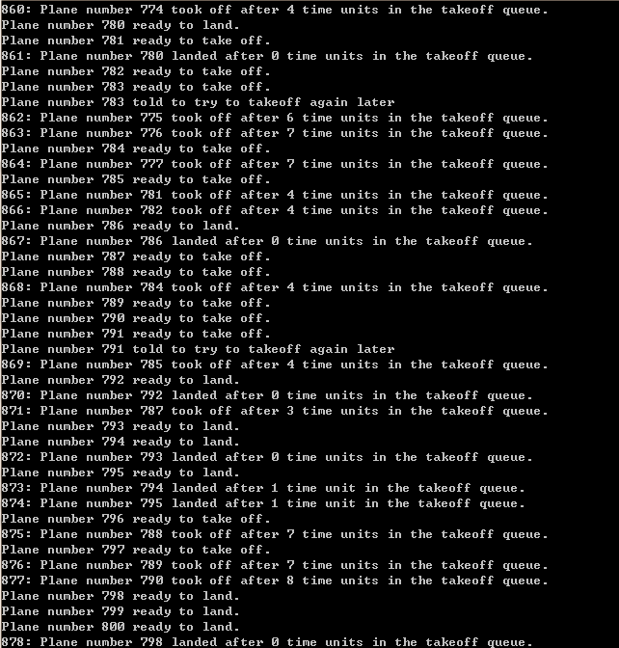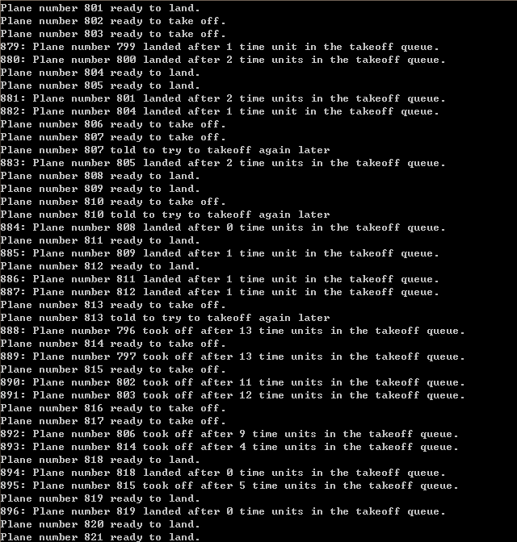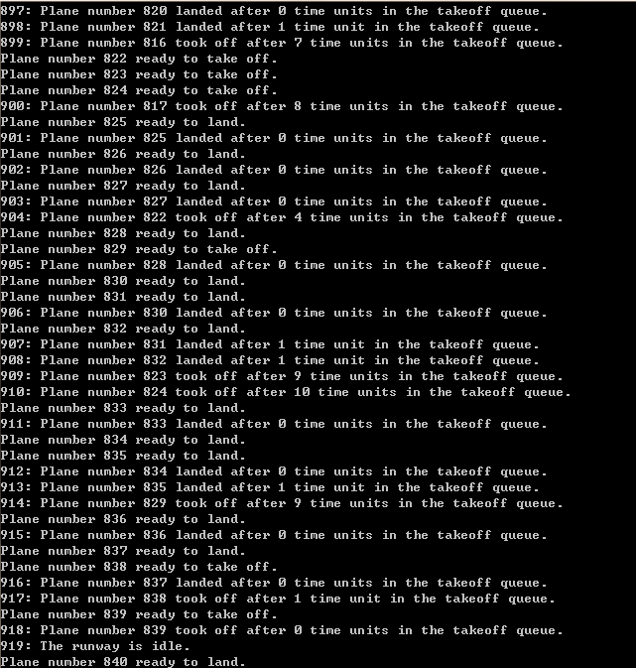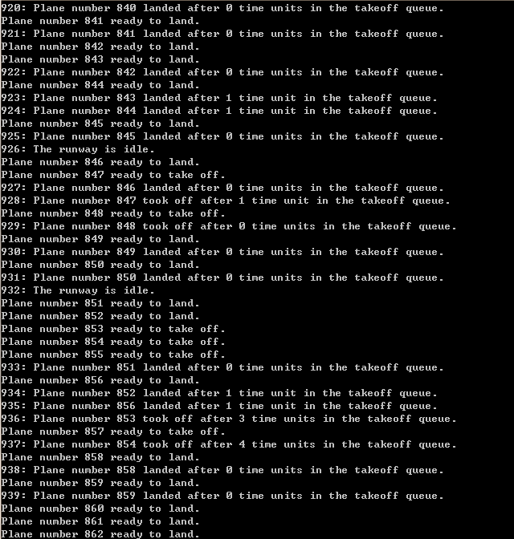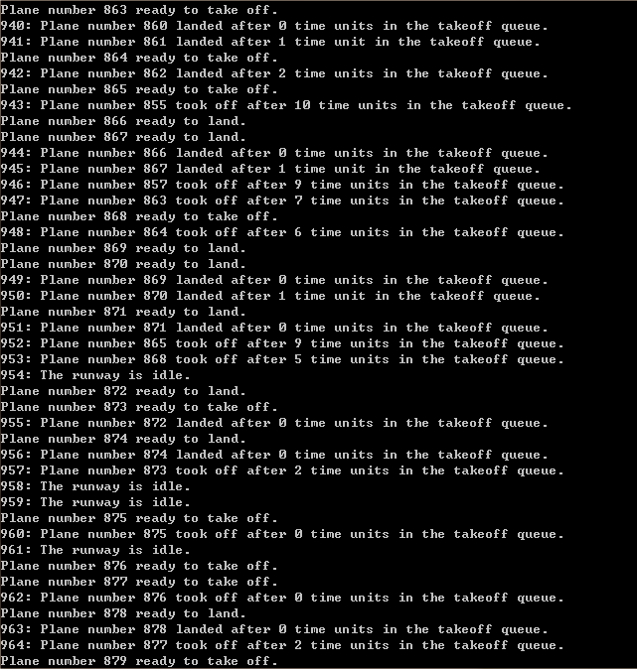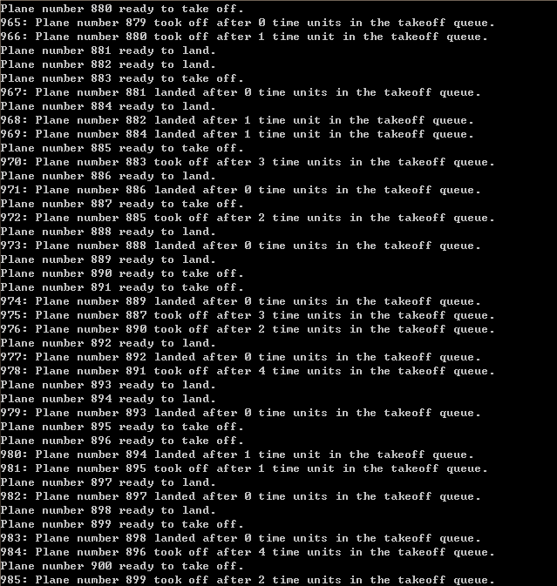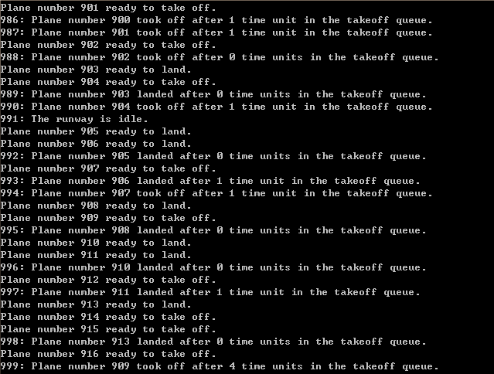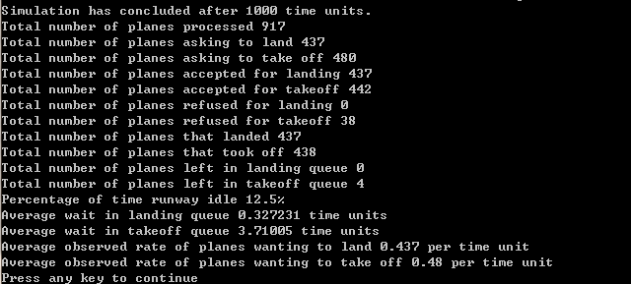

附录D

