PG库数据备份操作步骤
使用 UNLOGGED 表 + COPY 命令（推荐）

1.创建 UNLOGGED 表（目标表）：
CREATE UNLOGGED TABLE cydc_temp.dw_lget_patent_info_20250710 (LIKE public.dw_lget_patent_info INCLUDING DEFAULTS);
* `UNLOGGED` 表不会写入WAL日志，写入速度非常快，但数据在服务器崩溃或重启后会丢失。这在此阶段是可接受的，因为我们只是临时存储数据。
* `INCLUDING DEFAULTS` 确保目标表继承原表的默认值定义。

- 拷贝数据-41min。拷贝数据之前先创建表的唯一键，保证数据插入唯一

--设置主键 --6min
ALTER TABLE cydc_temp.dw_lget_patent_info_20250710
ADD CONSTRAINT pk_dw_lget_patent_info PRIMARY key(id);

insert into cydc_temp.dw_lget_patent_info_20250710 select * from public.dw_lget_patent_info;

3.重建索引和约束（非常重要）：UNLOGGED 表在创建时不会自动创建索引和外键约束。增加注释

--创建唯一索引--5min

CREATE UNIQUE INDEX bk_dw_lget_patent_info_application_code_publication_code ON cydc_temp.dw_lget_patent_info_20250710 USING btree (application_code, publication_code);
CREATE INDEX idx_dw_lget_patent_info_update_time ON cydc_temp.dw_lget_patent_info_20250710 USING btree (update_time);

--增加表注释
COMMENT ON TABLE cydc_temp.dw_lget_patent_info_20250710 IS '专利信息表';

--增加字段注释
-- Column comments

COMMENT ON COLUMN cydc_temp.dw_lget_patent_info_20250710.id IS '记录id';
COMMENT ON COLUMN cydc_temp.dw_lget_patent_info_20250710.is_delete IS '是否逻辑删除';
COMMENT ON COLUMN cydc_temp.dw_lget_patent_info_20250710.create_time IS '创建时间';
COMMENT ON COLUMN cydc_temp.dw_lget_patent_info_20250710.update_time IS '更新时间';
COMMENT ON COLUMN cydc_temp.dw_lget_patent_info_20250710.application_code IS '申请号_核心字段:1_准确率期望值:100_完整度期望值:100_安全级别:L1';
COMMENT ON COLUMN cydc_temp.dw_lget_patent_info_20250710.publication_code IS '公开(公告)号_核心字段:1_准确率期望值:100_完整度期望值:100_安全级别:L1';
COMMENT ON COLUMN cydc_temp.dw_lget_patent_info_20250710.publication_date IS '公开(公告)日_核心字段:1_准确率期望值:100_完整度期望值:100_安全级别:L1';
COMMENT ON COLUMN cydc_temp.dw_lget_patent_info_20250710.applicant IS '申请(专利权)人_核心字段:1_准确率期望值:100_完整度期望值:98_安全级别:L1';
COMMENT ON COLUMN cydc_temp.dw_lget_patent_info_20250710.application_date IS '申请日期_核心字段:1_准确率期望值:100_完整度期望值:100_安全级别:L1';
COMMENT ON COLUMN cydc_temp.dw_lget_patent_info_20250710.inventor IS '发明人_核心字段:1_准确率期望值:100_完整度期望值:97_安全级别:L1';
COMMENT ON COLUMN cydc_temp.dw_lget_patent_info_20250710.applicant_address IS '申请人地址_核心字段:_准确率期望值:_完整度期望值:_安全级别:L1';
COMMENT ON COLUMN cydc_temp.dw_lget_patent_info_20250710.title IS '发明名称_核心字段:1_准确率期望值:99_完整度期望值:100_安全级别:L1';
COMMENT ON COLUMN cydc_temp.dw_lget_patent_info_20250710.ipc_code IS 'IPC分类号_核心字段:1_准确率期望值:100_完整度期望值:99_安全级别:L1';
COMMENT ON COLUMN cydc_temp.dw_lget_patent_info_20250710.mipc_code IS 'IPC主分类号_核心字段:_准确率期望值:_完整度期望值:_安全级别:L1';
COMMENT ON COLUMN cydc_temp.dw_lget_patent_info_20250710.agent IS '代理人_核心字段:_准确率期望值:_完整度期望值:_安全级别:L1';
COMMENT ON COLUMN cydc_temp.dw_lget_patent_info_20250710.agency IS '代理机构_核心字段:_准确率期望值:_完整度期望值:_安全级别:L1';
COMMENT ON COLUMN cydc_temp.dw_lget_patent_info_20250710.cpc_code IS 'CPC分类号-(原供应商字段现无来源)_核心字段:_准确率期望值:_完整度期望值:_安全级别:L1';
COMMENT ON COLUMN cydc_temp.dw_lget_patent_info_20250710.abstract IS '摘要_核心字段:_准确率期望值:_完整度期望值:_安全级别:L1';
COMMENT ON COLUMN cydc_temp.dw_lget_patent_info_20250710.patent_code IS '文献代码-(原供应商字段现无来源)_核心字段:_准确率期望值:_完整度期望值:_安全级别:L1';
COMMENT ON COLUMN cydc_temp.dw_lget_patent_info_20250710.patent_type IS '专利类型_核心字段:1_准确率期望值:100_完整度期望值:100_安全级别:L1';
COMMENT ON COLUMN cydc_temp.dw_lget_patent_info_20250710.patent_type_code IS '专利类型编码_核心字段:1_准确率期望值:100_完整度期望值:100_安全级别:L1';
COMMENT ON COLUMN cydc_temp.dw_lget_patent_info_20250710.non_patent_literature_count IS '非专利文献数量-(原供应商字段现无来源)_核心字段:_准确率期望值:_完整度期望值:_安全级别:L1';
COMMENT ON COLUMN cydc_temp.dw_lget_patent_info_20250710.cited_patent_count IS '被引用专利数量-(原供应商字段现无来源)_核心字段:_准确率期望值:_完整度期望值:_安全级别:L1';
COMMENT ON COLUMN cydc_temp.dw_lget_patent_info_20250710.cite_patent_count IS '引用专利数量-(原供应商字段现无来源)_核心字段:_准确率期望值:_完整度期望值:_安全级别:L1';
COMMENT ON COLUMN cydc_temp.dw_lget_patent_info_20250710.fam_patent_count IS '同族专利数量-(原供应商字段现无来源)_核心字段:_准确率期望值:_完整度期望值:_安全级别:L1';
COMMENT ON COLUMN cydc_temp.dw_lget_patent_info_20250710.fam_patent_cited_count IS '同族专利被引用总数-(原供应商字段现无来源)_核心字段:_准确率期望值:_完整度期望值:_安全级别:L1';
COMMENT ON COLUMN cydc_temp.dw_lget_patent_info_20250710.ifam_patent_count IS 'INPADOC同族专利数量-(原供应商字段现无来源)_核心字段:_准确率期望值:_完整度期望值:_安全级别:L1';
COMMENT ON COLUMN cydc_temp.dw_lget_patent_info_20250710.ifam_patent_cited_count IS 'INPADOC同族专利被引用总数-(原供应商字段现无来源)_核心字段:_准确率期望值:_完整度期望值:_安全级别:L1';
COMMENT ON COLUMN cydc_temp.dw_lget_patent_info_20250710.extend_fam_patent_count IS '扩展同族专利数量-(原供应商字段现无来源)_核心字段:_准确率期望值:_完整度期望值:_安全级别:L1';
COMMENT ON COLUMN cydc_temp.dw_lget_patent_info_20250710.extend_fam_patent_cited_count IS '扩展同族专利被引用总数-(原供应商字段现无来源)_核心字段:_准确率期望值:_完整度期望值:_安全级别:L1';
COMMENT ON COLUMN cydc_temp.dw_lget_patent_info_20250710.loc_code IS 'LOC分类号_核心字段:_准确率期望值:_完整度期望值:_安全级别:L1';
COMMENT ON COLUMN cydc_temp.dw_lget_patent_info_20250710.source_url IS '专利原文链接-(原供应商字段现无来源)_核心字段:_准确率期望值:_完整度期望值:_安全级别:L1';
COMMENT ON COLUMN cydc_temp.dw_lget_patent_info_20250710.expire_date IS '期限届满日_核心字段:_准确率期望值:_完整度期望值:_安全级别:L1';
COMMENT ON COLUMN cydc_temp.dw_lget_patent_info_20250710.is_medical IS '是否医健_核心字段:_准确率期望值:_完整度期望值:_安全级别:L2';
COMMENT ON COLUMN cydc_temp.dw_lget_patent_info_20250710.pct_app_code IS '国际申请号_核心字段:_准确率期望值:_完整度期望值:_安全级别:L1';
COMMENT ON COLUMN cydc_temp.dw_lget_patent_info_20250710.pct_app_date IS '国际申请日_核心字段:_准确率期望值:_完整度期望值:_安全级别:L1';
COMMENT ON COLUMN cydc_temp.dw_lget_patent_info_20250710.pct_pub_code IS '国际公布号_核心字段:_准确率期望值:_完整度期望值:_安全级别:L1';
COMMENT ON COLUMN cydc_temp.dw_lget_patent_info_20250710.pct_pub_date IS '国际公布日_核心字段:_准确率期望值:_完整度期望值:_安全级别:L1';
COMMENT ON COLUMN cydc_temp.dw_lget_patent_info_20250710.imageurl_local IS '专利图片地址-(原供应商字段现无来源)_核心字段:_准确率期望值:_完整度期望值:_安全级别:L1';
COMMENT ON COLUMN cydc_temp.dw_lget_patent_info_20250710.applicant_now IS '当前申请(专利权)人_核心字段:1_准确率期望值:100_完整度期望值:98_安全级别:L1';
COMMENT ON COLUMN cydc_temp.dw_lget_patent_info_20250710.is_authorization IS '是否授权_核心字段:1_准确率期望值:100_完整度期望值:100_安全级别:L2';
COMMENT ON COLUMN cydc_temp.dw_lget_patent_info_20250710.patent_state IS '专利状态_核心字段:_准确率期望值:_完整度期望值:_安全级别:L1';
COMMENT ON COLUMN cydc_temp.dw_lget_patent_info_20250710.patent_state_code IS '专利状态编码_核心字段:_准确率期望值:_完整度期望值:_安全级别:L1';
COMMENT ON COLUMN cydc_temp.dw_lget_patent_info_20250710.country IS '国家_核心字段:_准确率期望值:_完整度期望值:_安全级别:L1';
COMMENT ON COLUMN cydc_temp.dw_lget_patent_info_20250710.country_code IS '国家编码_核心字段:_准确率期望值:_完整度期望值:_安全级别:L1';
COMMENT ON COLUMN cydc_temp.dw_lget_patent_info_20250710.country_code_original IS '国省代码-原始-(原供应商字段现无来源)_核心字段:_准确率期望值:_完整度期望值:_安全级别:L1';
COMMENT ON COLUMN cydc_temp.dw_lget_patent_info_20250710.province IS '省份_核心字段:1_准确率期望值:100_完整度期望值:60_安全级别:L1';
COMMENT ON COLUMN cydc_temp.dw_lget_patent_info_20250710.city IS '城市_核心字段:1_准确率期望值:100_完整度期望值:60_安全级别:L1';
COMMENT ON COLUMN cydc_temp.dw_lget_patent_info_20250710.area IS '区县_核心字段:1_准确率期望值:100_完整度期望值:60_安全级别:L1';
COMMENT ON COLUMN cydc_temp.dw_lget_patent_info_20250710.province_code IS '省份代码_核心字段:1_准确率期望值:100_完整度期望值:60_安全级别:L1';
COMMENT ON COLUMN cydc_temp.dw_lget_patent_info_20250710.city_code IS '城市代码_核心字段:1_准确率期望值:100_完整度期望值:60_安全级别:L1';
COMMENT ON COLUMN cydc_temp.dw_lget_patent_info_20250710.area_code IS '区县代码_核心字段:1_准确率期望值:100_完整度期望值:60_安全级别:L1';
COMMENT ON COLUMN cydc_temp.dw_lget_patent_info_20250710.post_code IS '邮编-(原供应商字段现无来源)_核心字段:_准确率期望值:_完整度期望值:_安全级别:L1';
COMMENT ON COLUMN cydc_temp.dw_lget_patent_info_20250710.ext_application_code IS '提取申请号_核心字段:_准确率期望值:_完整度期望值:_安全级别:L1';
COMMENT ON COLUMN cydc_temp.dw_lget_patent_info_20250710.is_transfer IS '是否转让_核心字段:_准确率期望值:_完整度期望值:_安全级别:L2';
COMMENT ON COLUMN cydc_temp.dw_lget_patent_info_20250710.upc_code IS '美国专利分类号-(原供应商字段现无来源)_核心字段:_准确率期望值:_完整度期望值:_安全级别:L1';
COMMENT ON COLUMN cydc_temp.dw_lget_patent_info_20250710.is_person IS '是否个人(2025-06-25废弃)_核心字段:_准确率期望值:_完整度期望值:_安全级别:L2';
COMMENT ON COLUMN cydc_temp.dw_lget_patent_info_20250710.applicant_country IS '申请人来源国(2025-06-25废弃)_核心字段:_准确率期望值:_完整度期望值:_安全级别:L1';
COMMENT ON COLUMN cydc_temp.dw_lget_patent_info_20250710.applicant_area IS '申请人来源地区(2025-06-25废弃)_核心字段:_准确率期望值:_完整度期望值:_安全级别:L1';
COMMENT ON COLUMN cydc_temp.dw_lget_patent_info_20250710.country_code_new IS '国省代码(2025-06-25废弃)_核心字段:_准确率期望值:_完整度期望值:_安全级别:L1';
COMMENT ON COLUMN cydc_temp.dw_lget_patent_info_20250710.is_newest IS '是否最新_核心字段:_准确率期望值:_完整度期望值:_安全级别:L2';
COMMENT ON COLUMN cydc_temp.dw_lget_patent_info_20250710.country_original IS '国家代码(原始)(2025-06-25废弃)_核心字段:_准确率期望值:_完整度期望值:_安全级别:L1';
COMMENT ON COLUMN cydc_temp.dw_lget_patent_info_20250710.docdb_patent_count IS 'docdb同族数量-(原供应商字段现无来源)_核心字段:_准确率期望值:_完整度期望值:_安全级别:L1'

--增加触发器
-- Table Triggers
create trigger trig_dw_lget_patent_info_update_time before
update
on
cydc_temp.dw_lget_patent_info_20250710 for each row execute function auto_update_timestamp();

4.将表变更为 LOGGED（持久化）：数据复制完成后，将表变更为普通日志记录状态，确保数据持久性。--71min
ALTER TABLE cydc_temp.dw_lget_patent_info_20250710 SET LOGGED;

- 数据备份完成后，进行新仓表数据初始化。可以参考任务：job_imp_pg2hive_dw_lget_patent_info。数据量比较大的（超过1千万），根据索引字段分批次抽取：
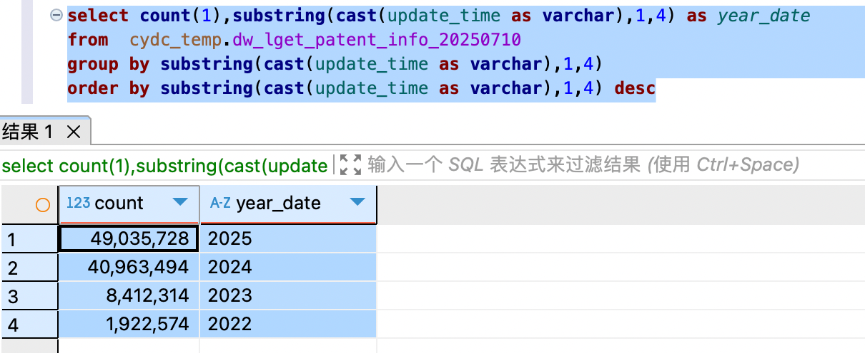
update_time>='2022-01-01' and update_time<'2023-01-01' 分区：202212
update_time>='2023-01-01' and update_time<'2023-02-01' 分区：202301
update_time>='2023-02-01' and update_time<'2023-03-01' 分区：202302

update_time>='2025-01-01'

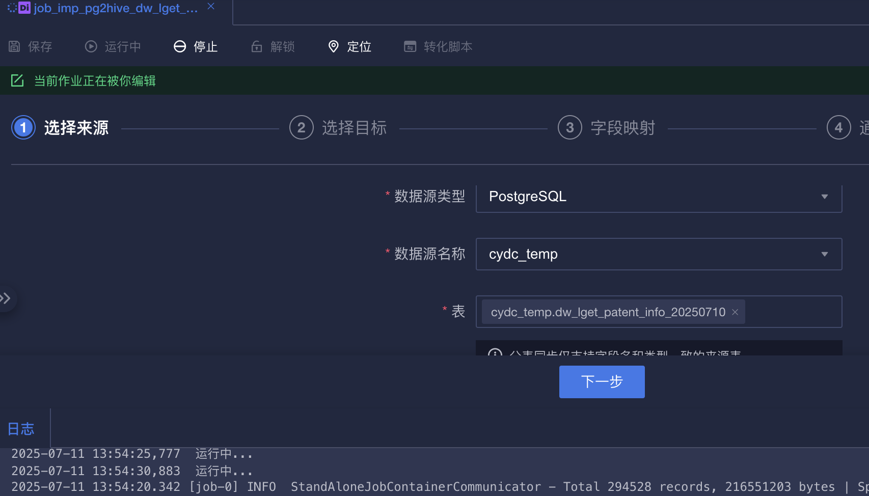

--权限相关，视情况执行
-- Permissions
-- ALTER TABLE public.dw_lget_patent_info OWNER TO bigdata;
GRANT SELECT ON TABLE public.dw_lget_patent_info TO readonly;
GRANT SELECT ON TABLE public.dw_lget_patent_info TO dm_readonly;
GRANT SELECT ON TABLE public.dw_lget_patent_info TO algori;
GRANT SELECT ON TABLE public.dw_lget_patent_info TO dw_dm_sync;
GRANT ALL ON TABLE public.dw_lget_patent_info TO chengd;
GRANT ALL ON TABLE public.dw_lget_patent_info TO bigdata;
GRANT SELECT ON TABLE public.dw_lget_patent_info TO shijx;
GRANT SELECT ON TABLE public.dw_lget_patent_info TO wangjuan;
GRANT SELECT ON TABLE public.dw_lget_patent_info TO wangyy;
GRANT ALL ON TABLE public.dw_lget_patent_info TO fanmk;
GRANT ALL ON TABLE public.dw_lget_patent_info TO lixw;
GRANT ALL ON TABLE public.dw_lget_patent_info TO zhangyy;
GRANT SELECT ON TABLE public.dw_lget_patent_info TO nmpa_crawer;
GRANT ALL ON TABLE public.dw_lget_patent_info TO dmx_sjzc;
GRANT ALL ON TABLE public.dw_lget_patent_info TO yufj;
GRANT SELECT ON TABLE public.dw_lget_patent_info TO qianx;
GRANT ALL ON TABLE public.dw_lget_patent_info TO aigt;
GRANT ALL ON TABLE public.dw_lget_patent_info TO aigt_test;
GRANT SELECT ON TABLE public.dw_lget_patent_info TO mengsr;
GRANT SELECT ON TABLE public.dw_lget_patent_info TO zhuyf;
GRANT SELECT ON TABLE public.dw_lget_patent_info TO zhuh;
GRANT SELECT ON TABLE public.dw_lget_patent_info TO zhoup;
GRANT SELECT ON TABLE public.dw_lget_patent_info TO songk;
GRANT SELECT ON TABLE public.dw_lget_patent_info TO lupx;

