Report Title

John Smith, CSSE, SZU

**Abstract**

This is a simple LATEX article template of for attendees of Summer School 2016, VCC, SZU, serving as the paper reading report guidelines. With this template, you can focus on the text without caring about the layout settings. The content of a technical paper typically contains 5 sections where you can edit each section in a separate tex file. For example, you can edit the abstract in *abstract.tex*, and the introduction in *intro.tex*. Other sections (for your informa- tion) are included in *related.tex*, *algo.tex*, *results.tex*, and *f uture.tex*. The references are managed in *re f erence.bib*. Please note that this template is build by CTex**Ver2***.***9**. You can download the software from its homepage1.

**Keywords:** Computer Graphics; Visulization; Computer Vision; Image Processing;

# Introduction

The introduction serves a twofold purpose. Firstly, it gives the background on and motivation for your research, estab- lishing its importance. Secondly, it gives a summary and outline of your paper, telling readers what they should expect to find in it.

# Related Work

Similar to the introduction, the purpose of the related work is twofold. First, it gives a list of research works that are related to your paper: necessary to show what has happened in this field. Secondly, it provides a critique of the approaches in the literature: necessary to establish the contribution and importance of your paper.

For formatting lists of references, please use BibTeX to manage your references. BibTeX makes it easy to cite sources in a consistent manner. It takes an input of .bib file(s) (such as the reference.bib in this template) constituting a database of all reference-list entries the user might ever hope to use. BibTeX chooses from the .bib file(s) only those entries specified by the .aux file (that is, those given by LATEX’s \cite or \nocite commands), and creates as output a

.bbl file containing these entries together with the formatting commands specified by the .bst file [..]. LATEX will use

the .bbl file, perhaps edited by the user, to produce the reference list. For example, the most recent work on geometric decomposition of 3D model includes[1, 2, 3].

1[*www.ctex.org/HomePage*](http://www.ctex.org/HomePage)

# Methodology

## Overview

Please first give the overview or pipeline of the algorithm. You are recommended to use figure or flow chart to illustrate the main idea of the paper. For example, Figure 1 shows the work flow of the algorithm proposed by [3].

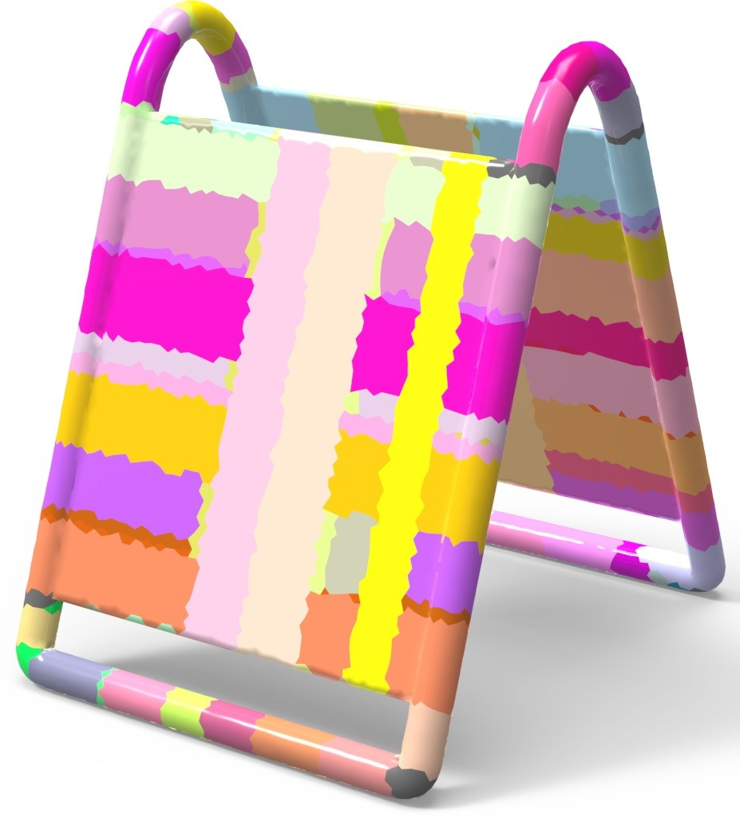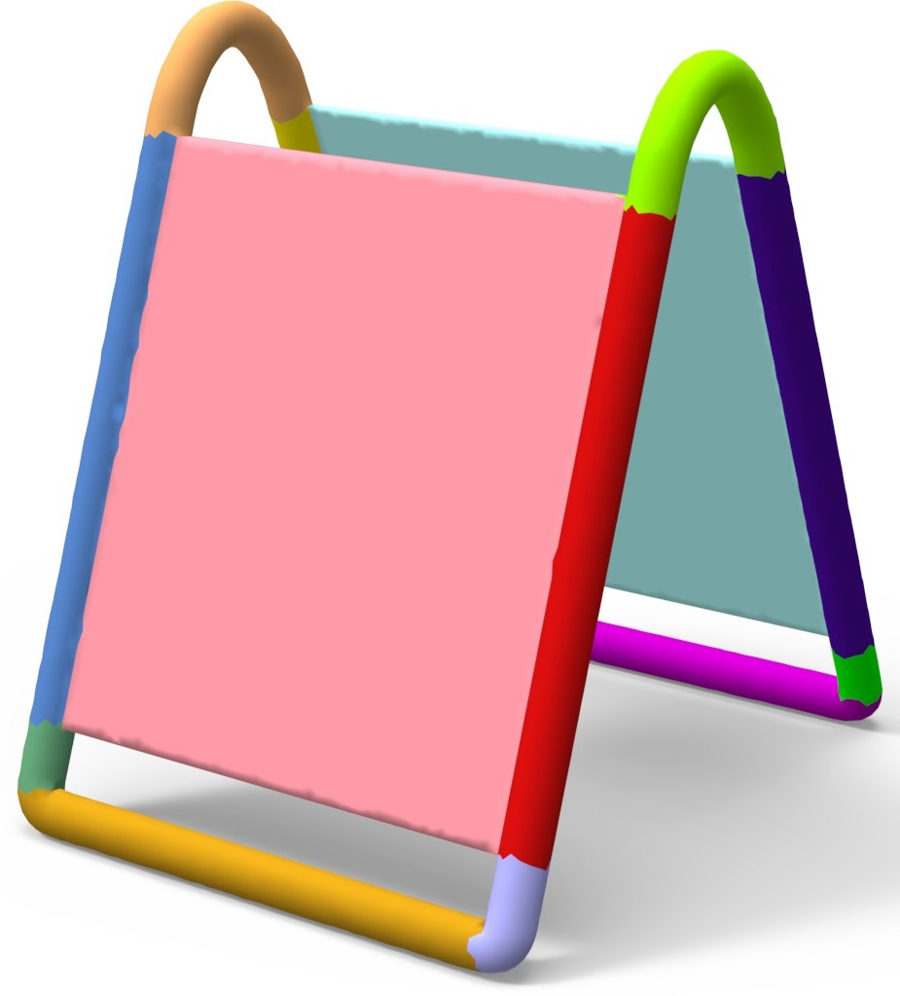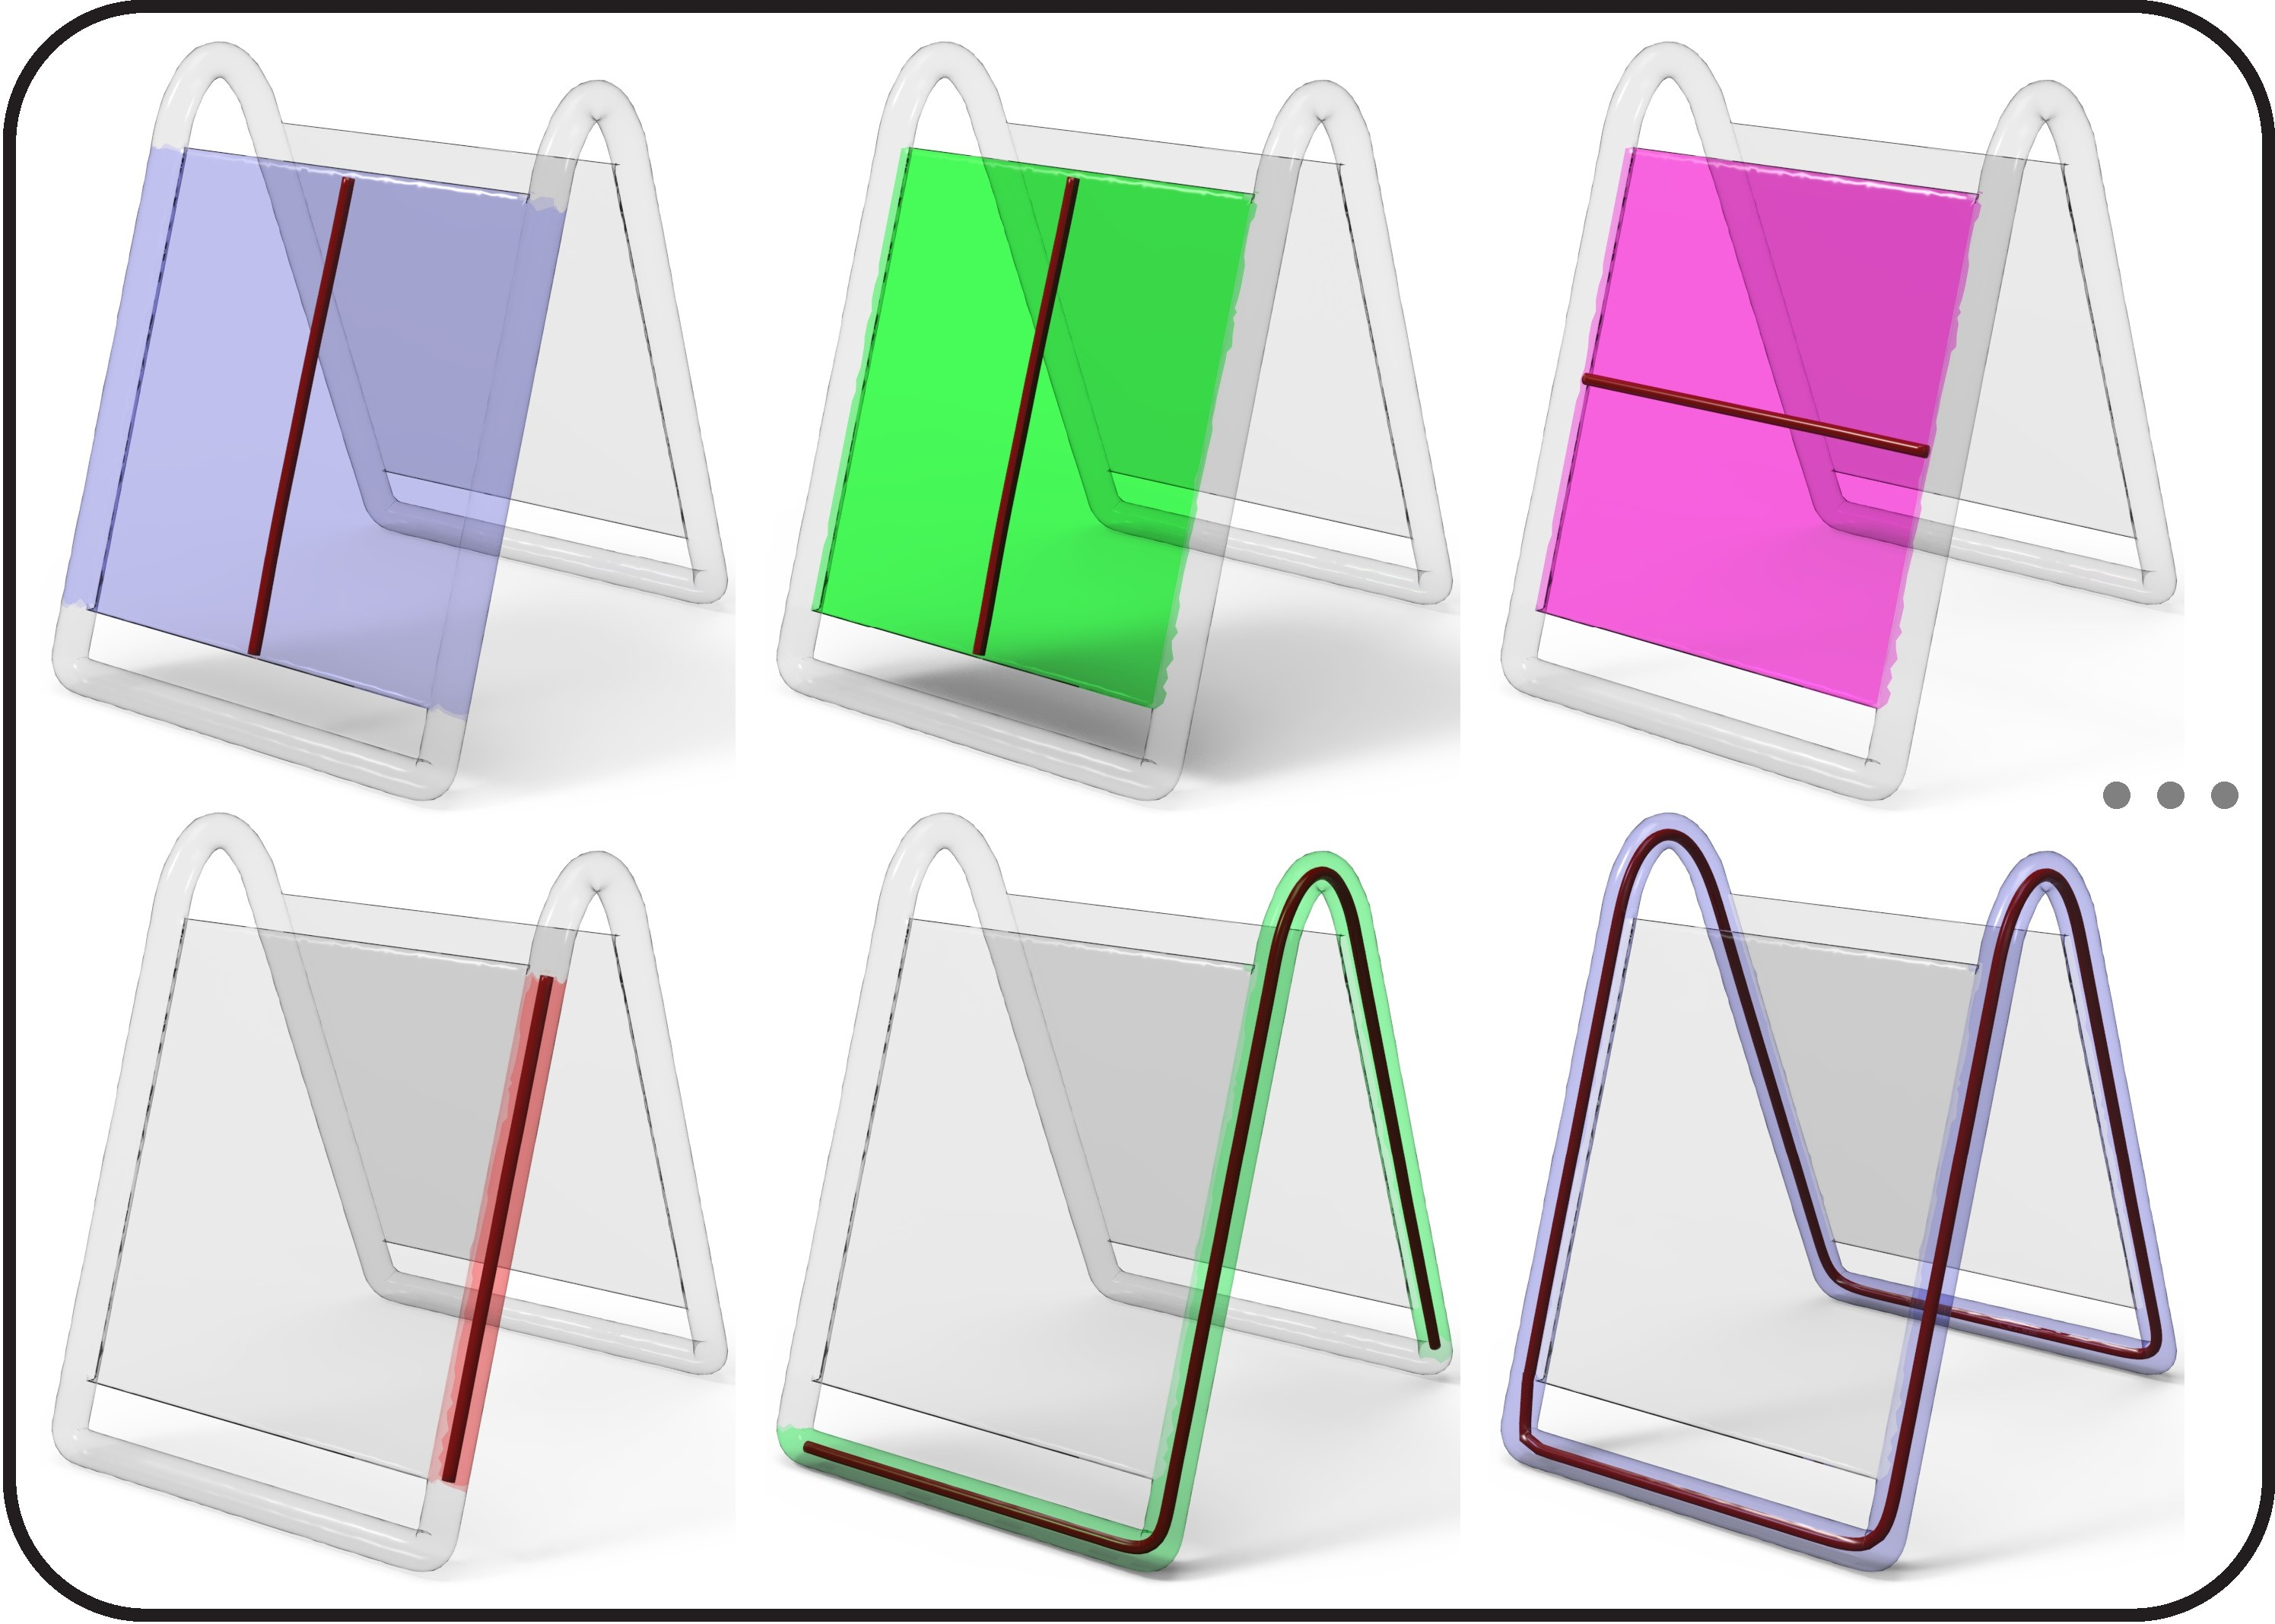

* + 1. Input (b) Local GCs (c) Non-local GCs (d) Candidate GCs for ECP (e) Final Decom.

Figure 1: Our decomposition algorithm overview: given a shape (a), we first compute its local GC set (b), and then merge the local GCs into fewer overlapping non-local GCs (c) that form an over-complete cover for the shape (a). The final decomposition (e) is obtained by solving the exact cover problem from various candidate GC combinations (d) of non-local GCs (b).

## Algorithm

Please describe the paper’s algorithm in detail, including equations, pseudo-code, etc.

LATEX is a popular means by which to typeset complex mathematical formulae; it has been noted as one of the most sophisticated digital typographical systems in the world. But beginners often don’t know what to do. Some online tools can recognize hand-drawn and convert the formulas into LATEX code, for example, on *Web Equation*2, you can write your calculations or equations as shown in Figure 2, and get the beautiful formulas like equation 1.

*ei* = cos *θ* + *i* sin *θ* (1)

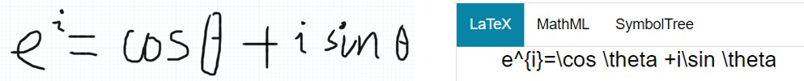

Figure 2: Web Equation

# Results

Please describe the experiment, including platform, test data, parameter, final results, etc.

2*webdemo.myscript.com/views/math.html*

Entering tables in LATEX documents can be burdensome because of the necessary formatting directives. There’re online generators which allow you to generate LATEX code that you can just copy & paste into your document’s source. For example, Table 1 shows the comparison on running time of different methods, which is generated from *tablesgenerator.com*3, as shown in Figure 3.

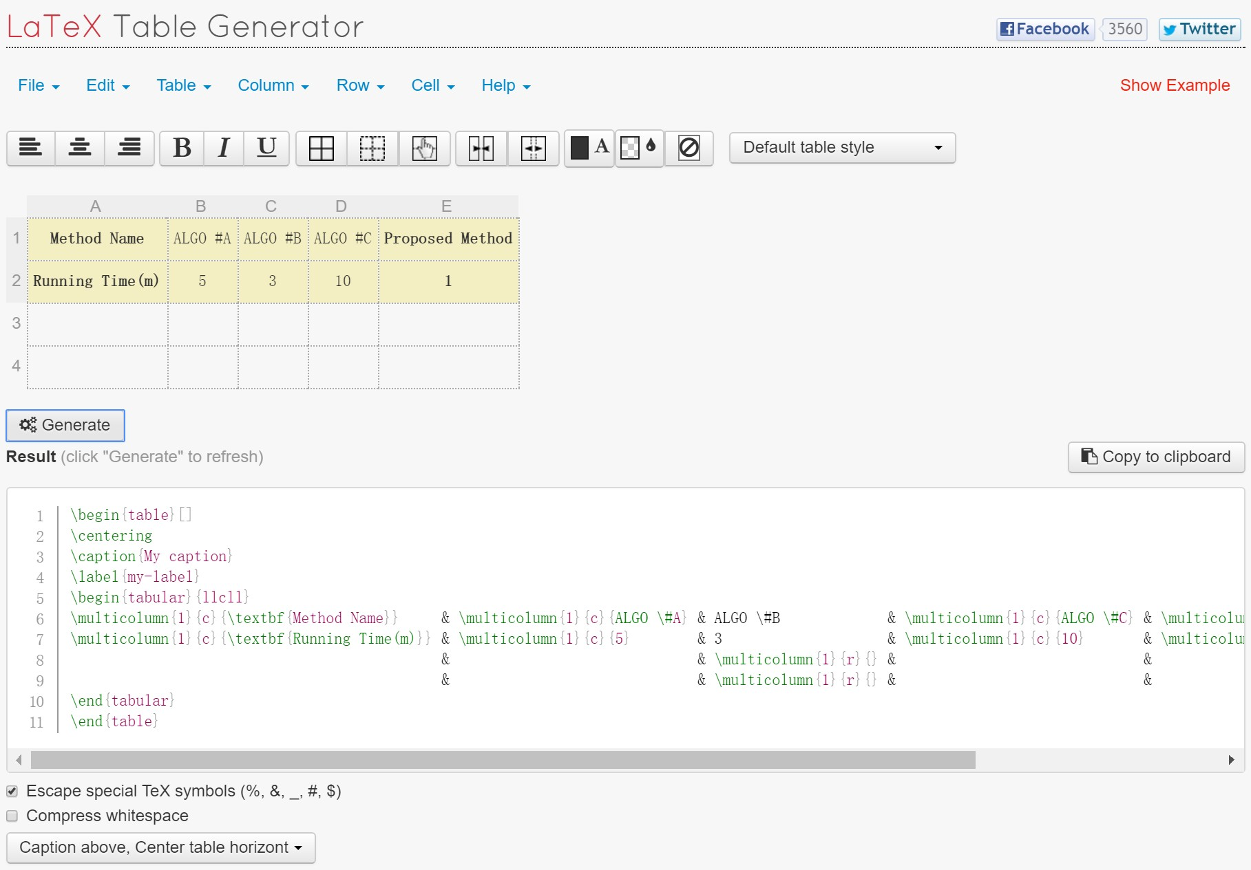

Figure 3: LATEX Table Generator

Table 1: The comparison on running time of different algorithms

|  |  |  |  |  |
| --- | --- | --- | --- | --- |
| **Method Name** | ALGO #A | ALGO #B | ALGO #C | **Proposed Method** |
| **Running Time(m)** | 5 | 3 | 10 | **1** |

# Conclusion

Conclude the contribution of the paper, discuss the limitation and future research direction.

# Acknowledgement

You may write your acknowledgement here(optional).

3[*www.tablesgenerator.com*](http://www.tablesgenerator.com/)

# References

1. Hu, R., Li, H., Zhang, H., and Cohen-Or, D. Approximate pyramidal shape decomposition. *ACM Trans. on Graphics (Proc. of SIGGRAPH Asia) 33*, 6 (2014), 213:1–213:12.
2. van Kaick, O., Fish, N., Kleiman, Y., Asafi, S., and Cohen-OR, D. Shape segmentation by approximate convexity analysis. *ACM Trans. on Graphics 34*, 1 (2014), 4:1–4:11.
3. Zhou, Y., Yin, K., Huang, H., Zhang, H., Gong, M., and Cohen-Or, D. Generalized cylinder decomposition. *ACM Trans. on Graphics (Proc. of SIGGRAPH Asia) 34*, 6 (2015), 1–14.