

DTS311TC FINAL YEAR PROJECT

Report Title

Proposal Report

In Partial Fulfillment
of the Requirements for the Degree of
Bachelor of Engineering

Student Name | : | Yuyao Wang
Student ID | : | 2251773
Supervisor | : | Jingxin Liu

School of AI and Advanced Computing
Xi’an Jiaotong-Liverpool University
November 2025

Abstract
Whole Slide Imaging (WSI) has become a core component of modern digital pathology, enabling gigapixel histopathology slides to be visualized, shared, and analyzed at scale. However, the development of deep learning models in computational pathology remains limited by the lack of efficient, standardized, and accessible WSI annotation tools. Existing platforms often require complex installation, lack browser-based accessibility, provide limited support for multi-resolution WSI navigation, or fail to generate structured outputs such as semantic masks, metadata, and patch-level datasets. This project proposes the design and development of a lightweight, browser-based WSI annotation platform supporting the three most common formats—PNG, JPG, and SVS.
The platform integrates an OpenSlide-powered backend for SVS parsing, DeepZoom tiling for multi-resolution rendering, and an OpenSeadragon-based viewer for smooth navigation. It provides annotation tools including brush, rectangle, and polygon ROI, alongside backend modules for generating pixel-wise segmentation masks, JSON/COCO metadata, and automatically extracted patches. The system aims to enhance annotation efficiency, reduce preprocessing overhead, and deliver deep-learning-ready datasets.
The proposal outlines the system architecture, methodology, experimental design, expected results, and a detailed project timeline. Upon completion, the platform is expected to offer a streamlined “upload–annotate–export” workflow, improve annotation efficiency by at least 30%, and serve as a reusable infrastructure for future computational pathology research and AI-assisted diagnostics.

Contents (This is an example)
Abstract ii
Contents (This is an example) iii
1 Introduction (font: Times New Roman; font size: 20) 1
1.1 Background and Problem Statement 1
1.2 Research Motivation and Significance 1
1.3 Scope and Objectives of the Study 2
2 Literature Review 4
2.1 Development of Whole Slide Imaging (WSI) 4
2.2 Annotation Practices and Challenges in Digital Pathology 4
2.3 Existing Tools and Platforms for WSI Annotation 4
2.4 Importance of High-quality Annotation for AI and DL 5
2.5 Annotation Standards, Workflow, and Export Requirements 5
2.6 Research Gap 6
3 Project Plan 7
3.1 Proposed Solution / Methodology 7
3.1.1 Overall System Architecture 7
3.1.2 Image Loading and Multi-Resolution Rendering 8
3.1.3 Annotation Interaction Module 8
3.1.4 Backend Mask Generation and Data Structuring 8
3.1.5 Data Export Module 9
3.2 Experimental Design 9
3.3 Expected Results 11
3.4 Progress Analysis and Gantt Chart 11
4 Conclusion 13
References 14
Appendix A. Title of Appendix 15
Appendix B. Title of Appendix 16

Introduction

Background and Problem Statement
With the advancement of digital pathology and artificial intelligence, Whole Slide Imaging (WSI) has become a fundamental data modality in histopathological research, medical education, and clinical diagnostics. WSI converts traditional glass slides into ultra-high-resolution digital images that can be zoomed, navigated, and analyzed with precision. This enables remote consultations, quantitative assessment, reproducible workflows, and computational pathology pipelines used for deep learning training [1].
Clinical studies have demonstrated that WSI can achieve diagnostic performance comparable to traditional light microscopy. A large multicenter non-inferiority trial involving 1,992 cases reported major discordance rates of 4.9% for WSI and 4.6% for microscopy, confirming the acceptable diagnostic equivalence between the two modalities [2].
Despite these advances, several challenges remain when applying WSI to deep learning and computational pathology tasks. First, WSI files are extremely large (often tens of thousands of pixels per dimension), creating substantial performance demands for loading, navigation, and annotation. Second, most existing annotation tools are designed for ordinary images and lack interfaces optimized for gigapixel, multi-resolution, pyramid-structured WSI. Third, raw WSI obtained from hospitals or research institutions often lacks annotations or machine-readable training outputs (e.g., masks, metadata), resulting in significant manual effort before the images can be used for model development. Furthermore, even when annotation tools exist, issues such as poor collaboration capabilities, inconsistent export formats, and limited interoperability slow down the entire “upload–annotate–export” workflow.
To address these limitations, this project aims to develop a dedicated WSI data annotation platform that supports efficient navigation, accurate region-of-interest (ROI) annotation, and seamless export of deep-learning-ready outputs, thereby filling a critical gap in existing digital pathology workflows.

Research Motivation and Significance
This project is motivated by several key factors:
- Enhancing annotation efficiency and usability
Annotating gigapixel WSI is time-consuming and labor-intensive. An online platform designed specifically for WSI—featuring zooming, panning, multi-level viewing, and mini-map navigation—can significantly reduce manual workload and streamline the annotation process.
- Supporting deep learning and computational pathology research
High-quality, structured annotations are essential for training segmentation, detection, and classification models in pathology. However, such datasets remain scarce. A platform capable of producing semantic masks, metadata files, and patch-level outputs can accelerate dataset construction and model development [3].
- Facilitating collaboration across hospitals and research teams
Pathology annotation workflows often suffer from installation barriers, hardware constraints, and poor cross-institution compatibility. A browser-based platform removes these obstacles, enabling lightweight access, easier collaboration, and reduced operational complexity.
- Ensuring feasibility and reducing project risk
To guarantee implementation feasibility, the platform supports only the three most common formats—PNG, JPG, and SVS. These formats are widely used in clinical and research environments. Restricting the format scope reduces engineering complexity and minimizes development risk while still meeting most practical needs.
This project provides an end-to-end “upload–visualize–annotate–export” workflow specifically tailored for WSI. It fills a critical gap left by both general-purpose and research-centric annotation tools. More importantly, it establishes a reusable infrastructure for future AI-based pathology research, lowers the entry barrier for dataset creation, improves data quality, and contributes to the broader goals of digital pathology, AI-assisted diagnostics, and precision medicine.

Scope and Objectives of the Study
Scope.
This project focuses on developing a browser-based WSI annotation platform with the following boundaries:
- Supported input formats: PNG, JPG, and SVS only. Uncommon or complex formats (e.g., NDPI, BigTIFF) are intentionally excluded to reduce development complexity.
- Frontend capabilities:
- Large image viewing directly in the browser
- Zooming, panning, multi-resolution navigation
- Mini-map–based global positioning
- Annotation tools including brush, rectangle, polygon ROI, and label/color selection
- Backend functions:
- Automatic generation of pixel-wise semantic segmentation masks
- JSON/COCO-style annotation metadata
- Patch extraction based on annotated regions
- Export features:
Downloadable packages including original images, annotations, masks, metadata, and extracted patches
- Project scope exclusions:
- The platform is intended for research and internal clinical use, not for commercial integration with Hospital Information Systems (HIS)
- Fully automated AI-based annotations are beyond the scope of this project

Objectives.
The specific objectives of this study are:
- To design and implement a browser-based interface that allows users to upload PNG/JPG/SVS files and navigate them efficiently using WSI-specific interaction features.
- To develop backend modules capable of converting user-drawn annotations (brush strokes, polygons, ROIs) into pixel-level semantic masks and structured metadata.
- To build an export module that bundles original images, annotations, masks, metadata, and patch datasets into a unified package suitable for deep learning.
- To evaluate the usability and efficiency of the platform by annotating at least 10 WSI images and demonstrating measurable workflow improvements (e.g., reducing annotation time by at least 30% compared to traditional tools).
- To document the system through technical reports and user manuals, and to explore potential future extensions (e.g., additional formats, AI-assisted annotation).

Literature Review

Development of Whole Slide Imaging (WSI)
Whole Slide Imaging (WSI) has become a cornerstone technology in digital pathology by enabling entire histopathological glass slides to be scanned into ultra-high-resolution digital images. These digitized slides allow remote consultation, quantitative analysis, reproducibility, and integration with computational pathology methods. A foundational white paper described WSI as a transformative approach that modernizes pathology workflows and provides the basis for digital diagnostics [4].
Further studies emphasize its significance in enabling multi-resolution image navigation and seamless zooming across gigapixel images, which are essential for both diagnostic and research scenarios [5].
WSI has also been validated clinically: a large-scale, multi-center diagnostic equivalency study reported that WSI achieves accuracy comparable to traditional light microscopy, showing its readiness for integration into routine practice [2].

Annotation Practices and Challenges in Digital Pathology
Annotation is a crucial step for training machine learning and deep learning models in computational pathology. However, the quality, consistency, and efficiency of annotation remain major bottlenecks.
A systematic analysis of annotation practices highlighted variability in annotator expertise, inconsistency across labs, and the lack of unified annotation protocols [6].
Evans et al. proposed the “Standardized Annotation Reporting Style (StARS)” framework, summarizing 167 commonly annotated pathology entities and stressing the importance of structured protocols, traceability, and reproducibility in WSI annotation [7].
These studies highlight that manual WSI annotation is time-consuming, resource-intensive, and prone to variability, indicating the need for efficient, standardized, and user-friendly annotation platforms.

Existing Tools and Platforms for WSI Annotation
Several software tools and platforms exist for annotating digital pathology images, though each has limitations in terms of usability, accessibility, or standardization.
Quick Annotator, an open-source tool, demonstrated dramatic improvements in annotation efficiency through semi-automated segmentation, achieving high F-scores across multiple pathology datasets [8].
The CRS4 Digital Pathology Platform (CDPP) introduces a structured annotation model supporting multi-label, protocol-driven annotation with traceable workflows [9].
However, these systems typically suffer from one or more limitations:
- Many require local installation and lack browser-based accessibility.
- Some are optimized for general medical imaging instead of ultra-large WSI.
- Few supports streamlined export to deep-learning-ready artefacts (pixel masks, metadata, patches).
- Their workflows often target expert environments rather than lightweight research use.
These limitations reveal a gap between current tool capabilities and the needs of modern computational pathology workflows.

Importance of High-quality Annotation for AI and DL
Deep learning systems in pathology rely heavily on high-quality, pixel-level annotated datasets. A recent review reported that modern AI models achieve average sensitivity of 96.3% and specificity of 93.3% on WSI-based diagnostic tasks, but emphasized that model performance is strongly limited by annotation quality and dataset structure [3].
Studies also stress that, despite advances in semi-automated methods, human-generated annotations remain essential for ground-truth creation. Annotation inconsistency, lack of standard workflows, and limited tool support for large WSI negatively affect downstream AI model reliability [10].
Therefore, efficient annotation tools that produce reproducible, structured outputs—such as segmentation masks and machine-readable metadata—directly contribute to improving computational pathology model quality.

Annotation Standards, Workflow, and Export Requirements
Workflow standardization and structured data export are essential components of modern annotation systems. The StARS framework provides a taxonomy for standardized annotation entities, emphasizing the need for consistent representation across datasets [7].
Schüffler et al. proposed systematic methods to digitize freehand pen annotations on WSI, converting them into pixel-accurate masks for computational use [11].
These works collectively highlight that annotation systems should not only facilitate drawing, but also ensure that outputs are standardized, reusable, and ready for computational analysis, an aspect still insufficiently addressed in many existing tools.

Research Gap
Despite the progress in WSI software and annotation methodologies, several gaps remain unaddressed:
- Lack of a lightweight, browser-based WSI annotation platform
Existing tools often require complex local installations and specialized hardware, making them unsuitable for quick deployment in clinical or research settings.
- Limited support for ultra-large, multi-resolution WSI in the browser
Although some platforms partially support WSI formats, few provide smooth zooming, panning, and mini-map navigation within a standard web browser.
- Absence of an integrated “upload–annotate–export” pipeline
Current tools rarely provide automated export of pixel-wise masks, JSON/COCO metadata, and deep-learning-ready patch datasets in one unified workflow.
- Overly broad format support vs. practical constraints
Many platforms attempt to handle dozens of imaging formats, but there is a lack of a focused solution tailored to the most widely used formats—PNG, JPG, and SVS—used in clinical and research practice.
A focused approach reduces implementation risk and increases actual usability.
- Insufficient emphasis on annotation efficiency
Literature repeatedly identifies manual annotation as the major bottleneck in WSI dataset creation [3], [10], yet few systems are explicitly designed with workflow efficiency as the core objective.
These gaps justify the need for a new, web-based WSI annotation platform that is lightweight, format-focused, workflow-oriented, and capable of producing standardized outputs suitable for downstream AI applications.

Project Plan

Proposed Solution / Methodology
This project aims to develop a browser-based platform for annotating Whole Slide Images (WSI). The system adopts modular architecture consisting of image processing, multi-resolution rendering, annotation interaction, data structuring, and export modules. The methodology is divided into four major components: data processing, frontend rendering, annotation workflow, and backend conversion of annotations into training-ready datasets.

Overall System Architecture
The platform follows a clear end-to-end pipeline:
Figure .1: Pipeline of this Project
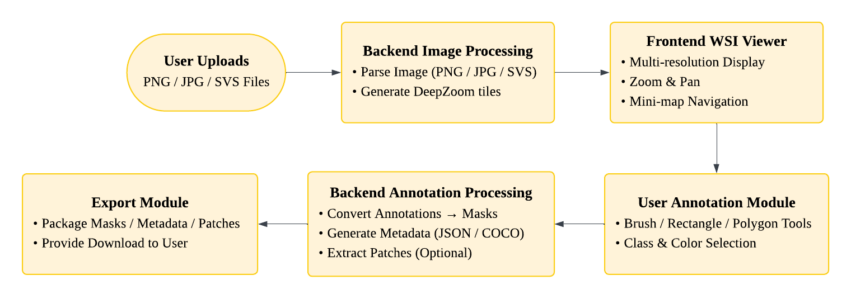
This pipeline ensures smooth coordination between image visualization, annotation operations, and final data generation.

Image Loading and Multi-Resolution Rendering
WSI—particularly SVS files—contain pyramid-structured multi-resolution levels. To enable efficient navigation, the system will:
- Use OpenSlide (Python) to read SVS pyramid levels
- Pre-generate DeepZoom tiles (256×256 or 512×512) on the backend
- Display the tiles on the frontend using OpenSeadragon, enabling:
- Smooth zooming and panning
- Real-time tile loading
- A live mini-map for spatial orientation
This approach is widely adopted in digital pathology viewers and ensures scalability for gigapixel images.

Annotation Interaction Module
The frontend provides intuitive annotation tools suitable for various pathological tasks, including:
- Brush tool (adjustable size and color)
- Rectangle / polygon ROI tools
- Label manager, allowing users to define tumor, normal, necrosis, etc.
- Undo/redo and ROI editing
All annotations are stored in vector format (points, polygons, brush strokes) to ensure precision and scalability.

Backend Mask Generation and Data Structuring
Using Python, NumPy, and OpenCV, the backend converts vector annotations into structured training data. The components and output results are shown in Table 1. Moreover, this structure ensures compatibility with deep learning frameworks such as UNet, HoverNet, and Swin-UNet.

Table 1: Backend Mask Generation and Data Structuring Components
Component | Description / Output Details
Semantic Segmentation Masks | Class encoding:  • 0 = background  • 1, 2, 3… = user-defined classes
JSON / COCO Metadata Files | Metadata generated to describe annotation structures, including:  - ROI coordinates (polygon / brush stroke vectors)  - Category names and corresponding IDs  - Image dimensions and scaling factors  - Annotation types (polygon, brush, etc.)
Automatic Patch Extraction | - Patch cropping based on annotated regions  (e.g., 256×256, 512×512).  - Exported patch images named using a structured naming convention, e.g., tumor_patch_001.png.

Data Export Module
Users will be able to download all data in one package, including:
- Original image (or thumbnail)
- Pixel-wise masks
- COCO/JSON annotation metadata
- Patch datasets
- Category statistics (e.g., tumor area percentage)
This automated export pipeline eliminates preprocessing overhead and provides researchers with deep-learning-ready datasets.

Experimental Design
The detail of experimental design is shown in Table 2, including Functional Testing, Performance Evaluation, Usability Testing, and Data Validity Evaluation, with description / evaluation items and purpose respectively.
Table 2: Details of Experimental Design
Experiment Type | Description /  Evaluation Items | Purpose
Functional Testing | • Upload PNG/JPG/SVS images  • DeepZoom tile loading & multi-resolution  navigation  • Brush, rectangle, polygon annotation tools  • Correctness of mask generation  • Accuracy & completeness of metadata export  • Patch extraction quality | Verify that all system  features operate as intended  and conform to functional  requirements.
Performance Evaluation | • Tile loading speed for large SVS  (e.g., 100k × 100k pixels)  • Frontend interaction smoothness (FPS)  • Mask generation time  • Data export time & output package size | Assess the system’s  efficiency, scalability, and  responsiveness when  handling gigapixel WSI files.
Usability  Testing | Conducted with 3–5 users to assess:  • Annotation time reduction compared to  baseline tools (e.g., ≥ 30% improvement vs. LabelMe / QuPath)  • Ease of use of annotation tools  • Clarity of exported formats  • Qualitative feedback for UI/UX refinement | Evaluate user experience, intuitiveness, and practical  workflow improvements.
Data Validity  Evaluation | • Train a small UNet using generated masks  and patches  • Confirm the training pipeline runs without errors  • Check that masks align accurately with  annotated regions | Validate that exported data  are suitable for real deep  learning tasks and produce  reliable ground-truth labels.

Expected Results
Table 3 illustrates the expected result of this proposal, creating a fully functional online WSI annotation platform with measurable performance and efficiency improvements.
Table 3: Expected Results of this Project
- A fully functional online WSI annotation platform
- Support for PNG/JPG/SVS upload
- Smooth multi-resolution WSI navigation
- Brush, polygon, and rectangle annotation tools
- Label management system
- One-click export of masks and metadata
- A complete deep-learning-ready data export pipeline
- Pixel-wise segmentation masks
- COCO/JSON metadata
- Patch datasets
- Statistical annotation reports
- Measurable performance and efficiency improvements
- ≥ 30% reduction in annotation time
- Mask generation in < 5 seconds
- Smooth WSI rendering with no major latency
- Complete documentation and report
- System architecture documentation
- API descriptions
- User manual for the annotation platform
- Final dissertation including evaluation results and improvement suggestions

Progress Analysis and Gantt Chart
At the time of this proposal, the project is in its initial planning and exploration stage. Several foundational components have already been completed, including the definition of the project topic, an initial literature review on WSI technologies and digital pathology annotation practices, the outline of the overall system architecture, and the specification of the main functional requirements and experimental design. These early preparations provide a clear technical direction for the subsequent development phases.
Figure 2 presents the monthly Gantt chart that outlines the planned progression of the project from September 2025 to May 2026. The schedule is aligned with the two-semester structure of the DTS311TC module, dividing the work into a planning phase in Semester 1 and an implementation and evaluation phase in Semester 2. The first semester (September–December 2025) is dedicated to requirement analysis, detailed literature review, backend image processing development, and the implementation of the WSI viewer. The proposal is finalized and submitted in late November, marking the completion of the preparatory stage.
Figure .2: Gantt Chart and Timeline
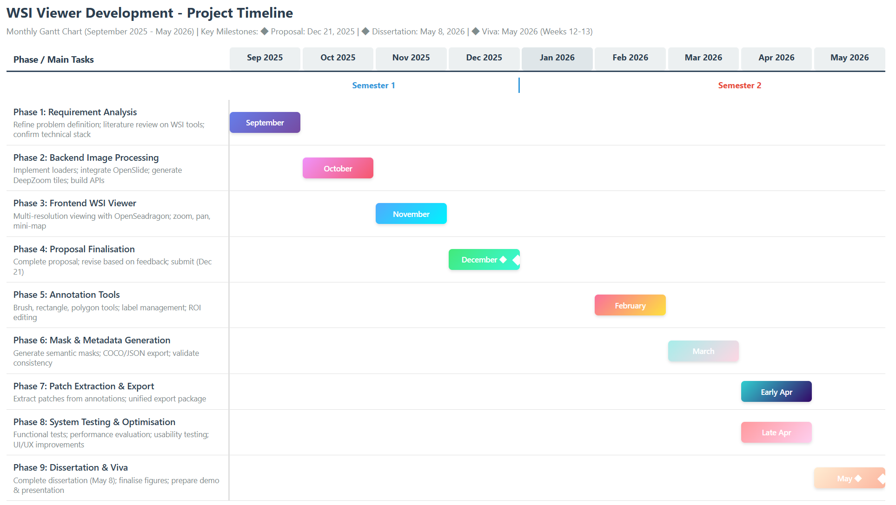
The second semester (February–May 2026) focuses on system development and validation. Annotation tools are implemented first, followed by mask and metadata generation modules, and finally the export pipeline. Comprehensive system testing—covering functionality, performance, usability, and data validity—is conducted in April to ensure the platform meets its technical objectives. The final phase, taking place in May, is dedicated to dissertation writing, preparing figures and documentation, and rehearsing the system demonstration for the viva.

Conclusion
This proposal presents a comprehensive plan for developing a browser-based WSI annotation platform that addresses the current limitations in digital pathology workflows. Through an initial review of existing technologies and annotation tools, it is evident that there remains a substantial gap in providing a lightweight, accessible, and workflow-oriented solution capable of handling multi-resolution WSI while producing structured, deep-learning-ready outputs. By focusing the scope on the most used formats (PNG, JPG, SVS) and implementing a modular system architecture, the proposed platform is both technically feasible and aligned with practical needs in research and clinical environments.
The methodology combines a high-performance backend for image processing with an intuitive frontend designed for efficient annotation. The planned experimental evaluations—including functionality, performance, usability, and data validity tests—ensure that the resulting system will be reliable, scalable, and suitable for downstream AI applications.
In conclusion, this project is expected to deliver a functional and impactful tool that streamlines WSI annotation, improves research productivity, and contributes to the broader development of computational pathology. The outcomes will not only support current AI workflows but also create a foundation for future extensions, including additional file formats and AI-assisted annotation capabilities.

References
[1] S. Masjoodi, M. H. Anbardar, M. Shokripour, and N. Omidifar, ‘Whole Slide Imaging (WSI) in Pathology: Emerging Trends and Future Applications in Clinical Diagnostics, Medical Education, and Pathology’, Iran. J. Pathol., vol. 20, no. 3, pp. 257–265, July 2025, doi: 10.30699/ijp.2025.2044210.3367.
[2] S. Mukhopadhyay et al., ‘Whole Slide Imaging Versus Microscopy for Primary Diagnosis in Surgical Pathology: A Multicenter Blinded Randomized Noninferiority Study of 1992 Cases (Pivotal Study)’, Am. J. Surg. Pathol., vol. 42, no. 1, pp. 39–52, Jan. 2018, doi: 10.1097/PAS.0000000000000948.
[3] C. McGenity et al., ‘Artificial intelligence in digital pathology: a systematic review and meta-analysis of diagnostic test accuracy’, Npj Digit. Med., vol. 7, no. 1, p. 114, May 2024, doi: 10.1038/s41746-024-01106-8.
[4] M. D. Zarella et al., ‘A Practical Guide to Whole Slide Imaging: A White Paper From the Digital Pathology Association’, Arch. Pathol. Lab. Med., vol. 143, no. 2, pp. 222–234, Feb. 2019, doi: 10.5858/arpa.2018-0343-RA.
[5] J. N. Iyengar, ‘Whole slide imaging: The futurescape of histopathology’, Indian J. Pathol. Microbiol., vol. 64, no. 1, pp. 8–13, Jan. 2021, doi: 10.4103/IJPM.IJPM_356_20.
[6] D. Montezuma et al., ‘Annotation Practices in Computational Pathology: A European Society of Digital and Integrative Pathology (ESDIP) Survey Study’, Lab. Invest., vol. 105, no. 3, p. 102203, Mar. 2025, doi: 10.1016/j.labinv.2024.102203.
[7] H. Evans et al., ‘Standardized Clinical Annotation of Digital Histopathology Slides at the Point of Diagnosis’, Mod. Pathol., vol. 36, no. 11, p. 100297, Nov. 2023, doi: 10.1016/j.modpat.2023.100297.
[8] R. Miao, R. Toth, Y. Zhou, A. Madabhushi, and A. Janowczyk, ‘Quick Annotator: an open‐source digital pathology based rapid image annotation tool’, J. Pathol. Clin. Res., vol. 7, no. 6, pp. 542–547, Nov. 2021, doi: 10.1002/cjp2.229.
[9] L. Lianas et al., ‘An open-source platform for structured annotation and computational workflows in digital pathology research’, Sci. Rep., vol. 15, no. 1, p. 28910, Aug. 2025, doi: 10.1038/s41598-025-13546-7.
[10] G. Cazzaniga et al., ‘Improving the Annotation Process in Computational Pathology: A Pilot Study with Manual and Semi-automated Approaches on Consumer and Medical Grade Devices’, J. Imaging Inform. Med., vol. 38, no. 2, pp. 1112–1119, Sept. 2024, doi: 10.1007/s10278-024-01248-x.
[11] P. J. Schüffler, D. V. K. Yarlagadda, C. Vanderbilt, and T. J. Fuchs, ‘Overcoming an Annotation Hurdle: Digitizing Pen Annotations from Whole Slide Images’, J. Pathol. Inform., vol. 12, no. 1, p. 9, Jan. 2021, doi: 10.4103/jpi.jpi_85_20.

Appendix A. Title of Appendix
Appendix Heading 1
Text of the appendix goes here

Appendix Heading 2
Text of the appendix goes here

Appendix Table and Figure Captions
In appendices, table and figure caption labels and numbers are typed in manually (e.g., Table A1, Table A2, etc.). These do not get generated into the lists that appear after the Table of Contents.

Appendix B. Title of Appendix
Text of the appendix goes here if there is only a single heading.

