**Zabbix监控docker方案**

# 一、docker监控计划

本计划主要是监控docker环境的服务状态、容器的资源占用情况，其中的监控部分，打算调用zabbix api接口来进行展示。

计划获取如下内容：

1. 获得docker stats 的状态信息



2、 获取某个主机下的所有监控项

3、 获取某个监控项的历史数据

4、 获取某个监控项的最新数据

5、 触发器阈值报警处理

计划最后展示框架如下内容（这只是值方面，其它的会再加）：

Dockerserver组1 ----docker主机1---监控项1----当前值

---监控项2----当前值

----docker主机2----监控项1----当前值

----监控项2----当前值

………………….

# 二、实际操作

## 2.1、zabbix server 和client安装

此步骤请参照zabbix服务搭建-v1.0文档，本方案的zabbix server使用此前的192.168.1.29服务器，client为192.168.8.16服务器

## 2.2、zabbix client配置

### 2.2.1、python docke api 安装

[root@hadoop16 ~]# pip install docker-py

bash: pip: command not found...

[root@hadoop16 ~]#

因默认没有安装pip，所有首先安装pip

[root@hadoop16 ~]# yum install epel-release –y #首先安装源

[root@hadoop16 ~]# yum install python-pip –y #安装pip

[root@hadoop16 ~]# pip install docker-py #安装python监控docker的api

Collecting python-py

Could not find a version that satisfies the requirement docker-py (from versions: )

No matching distribution found for docker-py

You are using pip version 8.1.2, however version 9.0.1 is available.

You should consider upgrading via the 'pip install --upgrade pip' command.

[root@hadoop16 ~]# pip install --upgrade pip #以上错误需要升级pip

[root@hadoop16 ~]# pip install docker-py

Collecting docker-py

Downloading docker_py-1.10.6-py2.py3-none-any.whl (50kB)

100% |████████████████████████████████| 51kB 203kB/s

Collecting websocket-client>=0.32.0 (from docker-py)

Downloading websocket_client-0.44.0-py2.py3-none-any.whl (199kB)

100% |████████████████████████████████| 204kB 317kB/s

Collecting backports.ssl-match-hostname>=3.5; python_version < "3.5" (from docker-py)

Downloading backports.ssl_match_hostname-3.5.0.1.tar.gz

Requirement already satisfied: ipaddress>=1.0.16; python_version < "3.3" in /usr/lib/python2.7/site-packages (from docker-py)

Requirement already satisfied: six>=1.4.0 in /usr/lib/python2.7/site-packages (from docker-py)

Requirement already satisfied: requests!=2.11.0,>=2.5.2 in /usr/lib/python2.7/site-packages (from docker-py)

Collecting docker-pycreds>=0.2.1 (from docker-py)

Downloading docker_pycreds-0.2.1-py2.py3-none-any.whl

Installing collected packages: websocket-client, backports.ssl-match-hostname, docker-pycreds, docker-py

Found existing installation: backports.ssl-match-hostname 3.4.0.2

Uninstalling backports.ssl-match-hostname-3.4.0.2:

Successfully uninstalled backports.ssl-match-hostname-3.4.0.2

Running setup.py install for backports.ssl-match-hostname ... done

Successfully installed backports.ssl-match-hostname-3.5.0.1 docker-py-1.10.6 docker-pycreds-0.2.1 websocket-client-0.44.0

[root@hadoop16 ~]#

### 2.2.2、取docker的NAMES

[root@hadoop16 zabbix-3.2.4]# cd /usr/local/bin/

[root@hadoop16 bin]# vi docker_host_status.sh

编写脚本

#!/bin/bash

# -------------------------------------------------------------------------------

# Filename: docker-status

# Revision: 1.1

# Date: 20171117

# Author: lila

# -------------------------------------------------------------------------------

# Notice

# After this state will docker stats reorder append to a file

# Auto Discovery docker stats Container Name --no-stream Execution time

###############################################################################

docker_name=`/usr/bin/docker ps -a|grep -v "CONTAINER ID"|awk '{print $NF}'`

for e in ${docker_name};do

/usr/bin/docker stats $e --no-stream |awk 'NR==2{a=$1;b=$2;c=$3$4;d=$6$7;e=$9$10;f=$12$13;g=$14$15;h=$17$18;j=$8}END{print "CONTAINER "a"\n""CPU "b"\n""MEMUSAGE "c"\n""LIMIT "d"\n""NETI-0 "e"\n""NETI-1 "f"\n""BLOCKI-0 "g"\n""BLOCKI-1 "h" \n""MEM "j}' |awk -F'%' '{print $1}' |awk '{a=/GiB/?$2*1024*1024*1024:(/M[i]?B/?$2*1024*1024:(/[Kk][Bb]/?$2*1024:(/B\>/?$2*1:$2)))}{print $1,a}' > /tmp/.$e.txt

done

把该脚本加入定时任务，每分钟执行一次

[root@hadoop16 bin]# vi /etc/crontab

*/1 * * * * sh /usr/local/bin/scripts/docker_host_status.sh

[root@hadoop16 bin]# service crond restart

循环执行docker stats将数据拿出重新排序后数值换算追加到/tmp/下以name命名

### 2.2.3、docker自动规则发现容器脚本

[root@hadoop16 zabbix-3.2.4]# cd /usr/local/bin/

[root@hadoop16 bin]# vi docker_name.py

#!/usr/bin/python

# -------------------------------------------------------------------------------

# Filename: docker_name

# Revision: 1.1

# Date: 20171117

# Author: lila

# -------------------------------------------------------------------------------

# Notice

# Automatic discovery instance name

###############################################################################

import os

import json

t=os.popen("""/usr/bin/docker ps -a|grep -v "CONTAINER ID"|awk '{print $NF}' """)

docknam = []

for dname in t.readlines():

r = os.path.basename(dname.strip())

docknam += [{'{#DOCKERNAME}':r}]

print json.dumps({'data':docknam},sort_keys=True,indent=4,separators=(',',':'))

测试脚本是否有错误

[root@hadoop16 bin]# python /usr/local/bin/docker_name.py

{

"data":[

{

"{#DOCKERNAME}":"ubuntu"

},

{

"{#DOCKERNAME}":"test"

}

]

}

[root@hadoop16 bin]#

### 2.2.4、zabbix client配置UserPrameter

[root@hadoop16 bin]# vi /usr/local/etc/zabbix_agentd.conf

添加如下内容

UserParameter=docker_status,/usr/local/bin/docker_name.py

UserParameter=docker_server[*],/usr/bin/docker top "$1"|grep "$2"|grep -v root |wc -l

UserParameter=docker_host[*],awk '/$2\>/{print $$2}' /tmp/."$1".txt

修改如下参数（因docker的运行时通过root用户，而zabbix的运行时zabbix用户，docker stats及docker top命令执行也需要root用户，使用修改如下参数，让zabbix通过root方式运行）

AllowRoot=1

User=root

[root@hadoop16 bin]# service zabbix_agentd restart

### 2.2.5、启动docker镜像便于测试

[root@hadoop16 bin]# docker run -it -d --name test centos

[root@hadoop16 bin]# docker run -it -d --name ubuntu Ubuntu

启动两个容器、容器name分别为 test、ubuntu

## 2.3、zabbix server 配置

### 2.3.1、新建docker server组

配置----主机群组----创建主机群组

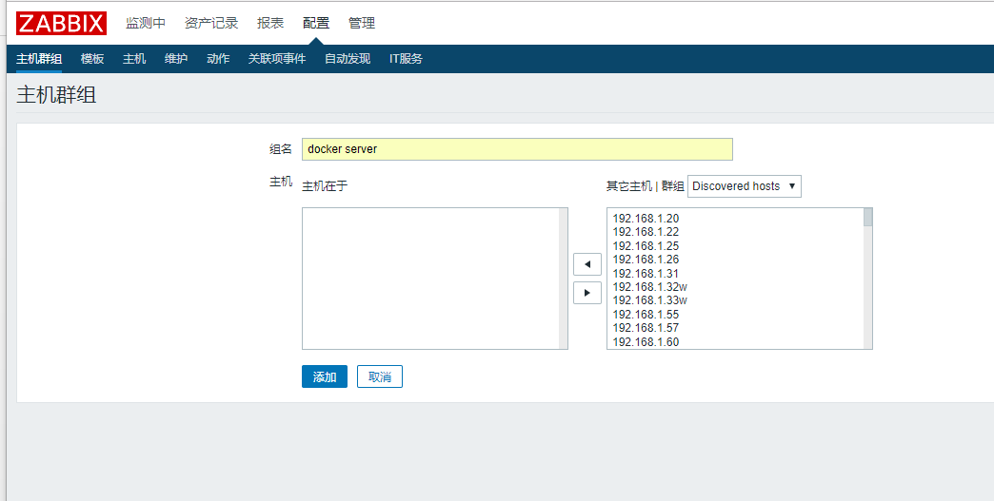

### 2.3.2、创建主机

配置----主机----创建主机

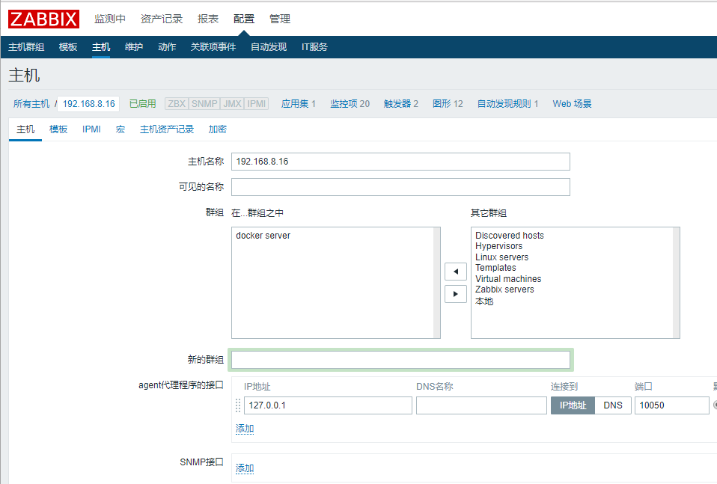

### 2.3.3、导入模板

配置----模板----创建模板

模板内容如下：

<?xml version="1.0" encoding="UTF-8"?>

<zabbix_export>

<version>3.0</version>

<date>2016-08-19T02:25:42Z</date>

<groups>

<group>

<name>Templates</name>

</group>

</groups>

<templates>

<template>

<template>Template_DocerHost_status</template>

<name>Template_DocerHost_status</name>

<description/>

<groups>

<group>

<name>Templates</name>

</group>

</groups>

<applications>

<application>

<name>docker_status</name>

</application>

</applications>

<items/>

<discovery_rules>

<discovery_rule>

<name>docker_status</name>

<type>7</type>

<snmp_community/>

<snmp_oid/>

<key>docker_status</key>

<delay>30</delay>

<status>0</status>

<allowed_hosts/>

<snmpv3_contextname/>

<snmpv3_securityname/>

<snmpv3_securitylevel>0</snmpv3_securitylevel>

<snmpv3_authprotocol>0</snmpv3_authprotocol>

<snmpv3_authpassphrase/>

<snmpv3_privprotocol>0</snmpv3_privprotocol>

<snmpv3_privpassphrase/>

<delay_flex/>

<params/>

<ipmi_sensor/>

<authtype>0</authtype>

<username/>

<password/>

<publickey/>

<privatekey/>

<port/>

<filter>

<evaltype>0</evaltype>

<formula/>

<conditions/>

</filter>

<lifetime>30</lifetime>

<description/>

<item_prototypes>

<item_prototype>

<name>{#DOCKERNAME}_BLOCK INPUT</name>

<type>7</type>

<snmp_community/>

<multiplier>0</multiplier>

<snmp_oid/>

<key>docker_host[{#DOCKERNAME},BLOCKI-0]</key>

<delay>30</delay>

<history>90</history>

<trends>365</trends>

<status>0</status>

<value_type>0</value_type>

<allowed_hosts/>

<units/>

<delta>0</delta>

<snmpv3_contextname/>

<snmpv3_securityname/>

<snmpv3_securitylevel>0</snmpv3_securitylevel>

<snmpv3_authprotocol>0</snmpv3_authprotocol>

<snmpv3_authpassphrase/>

<snmpv3_privprotocol>0</snmpv3_privprotocol>

<snmpv3_privpassphrase/>

<formula>1</formula>

<delay_flex/>

<params/>

<ipmi_sensor/>

<data_type>0</data_type>

<authtype>0</authtype>

<username/>

<password/>

<publickey/>

<privatekey/>

<port/>

<description/>

<inventory_link>0</inventory_link>

<applications>

<application>

<name>docker_status</name>

</application>

</applications>

<valuemap/>

<logtimefmt/>

<application_prototypes/>

</item_prototype>

<item_prototype>

<name>{#DOCKERNAME}_BLOCK OUTPUT</name>

<type>7</type>

<snmp_community/>

<multiplier>0</multiplier>

<snmp_oid/>

<key>docker_host[{#DOCKERNAME},BLOCKI-1]</key>

<delay>30</delay>

<history>90</history>

<trends>365</trends>

<status>0</status>

<value_type>0</value_type>

<allowed_hosts/>

<units/>

<delta>0</delta>

<snmpv3_contextname/>

<snmpv3_securityname/>

<snmpv3_securitylevel>0</snmpv3_securitylevel>

<snmpv3_authprotocol>0</snmpv3_authprotocol>

<snmpv3_authpassphrase/>

<snmpv3_privprotocol>0</snmpv3_privprotocol>

<snmpv3_privpassphrase/>

<formula>1</formula>

<delay_flex/>

<params/>

<ipmi_sensor/>

<data_type>0</data_type>

<authtype>0</authtype>

<username/>

<password/>

<publickey/>

<privatekey/>

<port/>

<description/>

<inventory_link>0</inventory_link>

<applications>

<application>

<name>docker_status</name>

</application>

</applications>

<valuemap/>

<logtimefmt/>

<application_prototypes/>

</item_prototype>

<item_prototype>

<name>{#DOCKERNAME}_CPU使用率</name>

<type>7</type>

<snmp_community/>

<multiplier>0</multiplier>

<snmp_oid/>

<key>docker_host[{#DOCKERNAME},CPU]</key>

<delay>30</delay>

<history>90</history>

<trends>365</trends>

<status>0</status>

<value_type>0</value_type>

<allowed_hosts/>

<units>%</units>

<delta>0</delta>

<snmpv3_contextname/>

<snmpv3_securityname/>

<snmpv3_securitylevel>0</snmpv3_securitylevel>

<snmpv3_authprotocol>0</snmpv3_authprotocol>

<snmpv3_authpassphrase/>

<snmpv3_privprotocol>0</snmpv3_privprotocol>

<snmpv3_privpassphrase/>

<formula>1</formula>

<delay_flex/>

<params/>

<ipmi_sensor/>

<data_type>0</data_type>

<authtype>0</authtype>

<username/>

<password/>

<publickey/>

<privatekey/>

<port/>

<description/>

<inventory_link>0</inventory_link>

<applications>

<application>

<name>docker_status</name>

</application>

</applications>

<valuemap/>

<logtimefmt/>

<application_prototypes/>

</item_prototype>

<item_prototype>

<name>{#DOCKERNAME}_LIMIT内存总大小</name>

<type>7</type>

<snmp_community/>

<multiplier>0</multiplier>

<snmp_oid/>

<key>docker_host[{#DOCKERNAME},LIMIT]</key>

<delay>30</delay>

<history>90</history>

<trends>365</trends>

<status>0</status>

<value_type>0</value_type>

<allowed_hosts/>

<units/>

<delta>0</delta>

<snmpv3_contextname/>

<snmpv3_securityname/>

<snmpv3_securitylevel>0</snmpv3_securitylevel>

<snmpv3_authprotocol>0</snmpv3_authprotocol>

<snmpv3_authpassphrase/>

<snmpv3_privprotocol>0</snmpv3_privprotocol>

<snmpv3_privpassphrase/>

<formula>1</formula>

<delay_flex/>

<params/>

<ipmi_sensor/>

<data_type>0</data_type>

<authtype>0</authtype>

<username/>

<password/>

<publickey/>

<privatekey/>

<port/>

<description/>

<inventory_link>0</inventory_link>

<applications>

<application>

<name>docker_status</name>

</application>

</applications>

<valuemap/>

<logtimefmt/>

<application_prototypes/>

</item_prototype>

<item_prototype>

<name>{#DOCKERNAME}_MEMUSAGE使用的内存</name>

<type>7</type>

<snmp_community/>

<multiplier>0</multiplier>

<snmp_oid/>

<key>docker_host[{#DOCKERNAME},MEMUSAGE]</key>

<delay>30</delay>

<history>90</history>

<trends>365</trends>

<status>0</status>

<value_type>0</value_type>

<allowed_hosts/>

<units/>

<delta>0</delta>

<snmpv3_contextname/>

<snmpv3_securityname/>

<snmpv3_securitylevel>0</snmpv3_securitylevel>

<snmpv3_authprotocol>0</snmpv3_authprotocol>

<snmpv3_authpassphrase/>

<snmpv3_privprotocol>0</snmpv3_privprotocol>

<snmpv3_privpassphrase/>

<formula>1</formula>

<delay_flex/>

<params/>

<ipmi_sensor/>

<data_type>0</data_type>

<authtype>0</authtype>

<username/>

<password/>

<publickey/>

<privatekey/>

<port/>

<description/>

<inventory_link>0</inventory_link>

<applications>

<application>

<name>docker_status</name>

</application>

</applications>

<valuemap/>

<logtimefmt/>

<application_prototypes/>

</item_prototype>

<item_prototype>

<name>{#DOCKERNAME}_MEM内存使用比率</name>

<type>7</type>

<snmp_community/>

<multiplier>0</multiplier>

<snmp_oid/>

<key>docker_host[{#DOCKERNAME},MEM]</key>

<delay>30</delay>

<history>90</history>

<trends>365</trends>

<status>0</status>

<value_type>0</value_type>

<allowed_hosts/>

<units>%</units>

<delta>0</delta>

<snmpv3_contextname/>

<snmpv3_securityname/>

<snmpv3_securitylevel>0</snmpv3_securitylevel>

<snmpv3_authprotocol>0</snmpv3_authprotocol>

<snmpv3_authpassphrase/>

<snmpv3_privprotocol>0</snmpv3_privprotocol>

<snmpv3_privpassphrase/>

<formula>1</formula>

<delay_flex/>

<params/>

<ipmi_sensor/>

<data_type>0</data_type>

<authtype>0</authtype>

<username/>

<password/>

<publickey/>

<privatekey/>

<port/>

<description/>

<inventory_link>0</inventory_link>

<applications>

<application>

<name>docker_status</name>

</application>

</applications>

<valuemap/>

<logtimefmt/>

<application_prototypes/>

</item_prototype>

<item_prototype>

<name>{#DOCKERNAME}_NET网卡Input</name>

<type>7</type>

<snmp_community/>

<multiplier>0</multiplier>

<snmp_oid/>

<key>docker_host[{#DOCKERNAME},NETI-0]</key>

<delay>30</delay>

<history>90</history>

<trends>365</trends>

<status>0</status>

<value_type>0</value_type>

<allowed_hosts/>

<units/>

<delta>0</delta>

<snmpv3_contextname/>

<snmpv3_securityname/>

<snmpv3_securitylevel>0</snmpv3_securitylevel>

<snmpv3_authprotocol>0</snmpv3_authprotocol>

<snmpv3_authpassphrase/>

<snmpv3_privprotocol>0</snmpv3_privprotocol>

<snmpv3_privpassphrase/>

<formula>1</formula>

<delay_flex/>

<params/>

<ipmi_sensor/>

<data_type>0</data_type>

<authtype>0</authtype>

<username/>

<password/>

<publickey/>

<privatekey/>

<port/>

<description/>

<inventory_link>0</inventory_link>

<applications>

<application>

<name>docker_status</name>

</application>

</applications>

<valuemap/>

<logtimefmt/>

<application_prototypes/>

</item_prototype>

<item_prototype>

<name>{#DOCKERNAME}_NET网卡Output</name>

<type>7</type>

<snmp_community/>

<multiplier>0</multiplier>

<snmp_oid/>

<key>docker_host[{#DOCKERNAME},NETI-1]</key>

<delay>30</delay>

<history>90</history>

<trends>365</trends>

<status>0</status>

<value_type>0</value_type>

<allowed_hosts/>

<units/>

<delta>0</delta>

<snmpv3_contextname/>

<snmpv3_securityname/>

<snmpv3_securitylevel>0</snmpv3_securitylevel>

<snmpv3_authprotocol>0</snmpv3_authprotocol>

<snmpv3_authpassphrase/>

<snmpv3_privprotocol>0</snmpv3_privprotocol>

<snmpv3_privpassphrase/>

<formula>1</formula>

<delay_flex/>

<params/>

<ipmi_sensor/>

<data_type>0</data_type>

<authtype>0</authtype>

<username/>

<password/>

<publickey/>

<privatekey/>

<port/>

<description/>

<inventory_link>0</inventory_link>

<applications>

<application>

<name>docker_status</name>

</application>

</applications>

<valuemap/>

<logtimefmt/>

<application_prototypes/>

</item_prototype>

<item_prototype>

<name>{#DOCKERNAME}_Nginx Running</name>

<type>7</type>

<snmp_community/>

<multiplier>0</multiplier>

<snmp_oid/>

<key>docker_server[{#DOCKERNAME},nginx]</key>

<delay>30</delay>

<history>90</history>

<trends>365</trends>

<status>0</status>

<value_type>0</value_type>

<allowed_hosts/>

<units/>

<delta>0</delta>

<snmpv3_contextname/>

<snmpv3_securityname/>

<snmpv3_securitylevel>0</snmpv3_securitylevel>

<snmpv3_authprotocol>0</snmpv3_authprotocol>

<snmpv3_authpassphrase/>

<snmpv3_privprotocol>0</snmpv3_privprotocol>

<snmpv3_privpassphrase/>

<formula>1</formula>

<delay_flex/>

<params/>

<ipmi_sensor/>

<data_type>0</data_type>

<authtype>0</authtype>

<username/>

<password/>

<publickey/>

<privatekey/>

<port/>

<description/>

<inventory_link>0</inventory_link>

<applications>

<application>

<name>docker_status</name>

</application>

</applications>

<valuemap/>

<logtimefmt/>

<application_prototypes/>

</item_prototype>

<item_prototype>

<name>{#DOCKERNAME}_php-fpm Running</name>

<type>7</type>

<snmp_community/>

<multiplier>0</multiplier>

<snmp_oid/>

<key>docker_server[{#DOCKERNAME},php-fpm]</key>

<delay>30</delay>

<history>90</history>

<trends>365</trends>

<status>0</status>

<value_type>0</value_type>

<allowed_hosts/>

<units/>

<delta>0</delta>

<snmpv3_contextname/>

<snmpv3_securityname/>

<snmpv3_securitylevel>0</snmpv3_securitylevel>

<snmpv3_authprotocol>0</snmpv3_authprotocol>

<snmpv3_authpassphrase/>

<snmpv3_privprotocol>0</snmpv3_privprotocol>

<snmpv3_privpassphrase/>

<formula>1</formula>

<delay_flex/>

<params/>

<ipmi_sensor/>

<data_type>0</data_type>

<authtype>0</authtype>

<username/>

<password/>

<publickey/>

<privatekey/>

<port/>

<description/>

<inventory_link>0</inventory_link>

<applications>

<application>

<name>docker_status</name>

</application>

</applications>

<valuemap/>

<logtimefmt/>

<application_prototypes/>

</item_prototype>

</item_prototypes>

<trigger_prototypes>

<trigger_prototype>

<expression>{Template_DocerHost_status:docker_server[{#DOCKERNAME},nginx].last()}=0</expression>

<name>nginx is not running</name>

<url/>

<status>0</status>

<priority>5</priority>

<description/>

<type>0</type>

<dependencies/>

</trigger_prototype>

</trigger_prototypes>

<graph_prototypes>

<graph_prototype>

<name>{#DOCKERNAME}_BLOCK</name>

<width>900</width>

<height>200</height>

<yaxismin>0.0000</yaxismin>

<yaxismax>100.0000</yaxismax>

<show_work_period>1</show_work_period>

<show_triggers>1</show_triggers>

<type>0</type>

<show_legend>1</show_legend>

<show_3d>0</show_3d>

<percent_left>0.0000</percent_left>

<percent_right>0.0000</percent_right>

<ymin_type_1>0</ymin_type_1>

<ymax_type_1>0</ymax_type_1>

<ymin_item_1>0</ymin_item_1>

<ymax_item_1>0</ymax_item_1>

<graph_items>

<graph_item>

<sortorder>0</sortorder>

<drawtype>5</drawtype>

<color>000099</color>

<yaxisside>0</yaxisside>

<calc_fnc>2</calc_fnc>

<type>0</type>

<item>

<host>Template_DocerHost_status</host>

<key>docker_host[{#DOCKERNAME},BLOCKI-0]</key>

</item>

</graph_item>

<graph_item>

<sortorder>1</sortorder>

<drawtype>5</drawtype>

<color>CCCC00</color>

<yaxisside>0</yaxisside>

<calc_fnc>2</calc_fnc>

<type>0</type>

<item>

<host>Template_DocerHost_status</host>

<key>docker_host[{#DOCKERNAME},BLOCKI-1]</key>

</item>

</graph_item>

</graph_items>

</graph_prototype>

<graph_prototype>

<name>{#DOCKERNAME}_CPU/MEM%</name>

<width>900</width>

<height>200</height>

<yaxismin>0.0000</yaxismin>

<yaxismax>100.0000</yaxismax>

<show_work_period>1</show_work_period>

<show_triggers>1</show_triggers>

<type>0</type>

<show_legend>1</show_legend>

<show_3d>0</show_3d>

<percent_left>0.0000</percent_left>

<percent_right>0.0000</percent_right>

<ymin_type_1>0</ymin_type_1>

<ymax_type_1>0</ymax_type_1>

<ymin_item_1>0</ymin_item_1>

<ymax_item_1>0</ymax_item_1>

<graph_items>

<graph_item>

<sortorder>0</sortorder>

<drawtype>5</drawtype>

<color>111111</color>

<yaxisside>0</yaxisside>

<calc_fnc>2</calc_fnc>

<type>0</type>

<item>

<host>Template_DocerHost_status</host>

<key>docker_host[{#DOCKERNAME},CPU]</key>

</item>

</graph_item>

<graph_item>

<sortorder>1</sortorder>

<drawtype>5</drawtype>

<color>880000</color>

<yaxisside>0</yaxisside>

<calc_fnc>2</calc_fnc>

<type>0</type>

<item>

<host>Template_DocerHost_status</host>

<key>docker_host[{#DOCKERNAME},MEM]</key>

</item>

</graph_item>

</graph_items>

</graph_prototype>

<graph_prototype>

<name>{#DOCKERNAME}_NETWORK</name>

<width>900</width>

<height>200</height>

<yaxismin>0.0000</yaxismin>

<yaxismax>100.0000</yaxismax>

<show_work_period>1</show_work_period>

<show_triggers>1</show_triggers>

<type>0</type>

<show_legend>1</show_legend>

<show_3d>0</show_3d>

<percent_left>0.0000</percent_left>

<percent_right>0.0000</percent_right>

<ymin_type_1>0</ymin_type_1>

<ymax_type_1>0</ymax_type_1>

<ymin_item_1>0</ymin_item_1>

<ymax_item_1>0</ymax_item_1>

<graph_items>

<graph_item>

<sortorder>0</sortorder>

<drawtype>5</drawtype>

<color>2774A4</color>

<yaxisside>0</yaxisside>

<calc_fnc>2</calc_fnc>

<type>0</type>

<item>

<host>Template_DocerHost_status</host>

<key>docker_host[{#DOCKERNAME},NETI-0]</key>

</item>

</graph_item>

<graph_item>

<sortorder>1</sortorder>

<drawtype>5</drawtype>

<color>A54F10</color>

<yaxisside>0</yaxisside>

<calc_fnc>2</calc_fnc>

<type>0</type>

<item>

<host>Template_DocerHost_status</host>

<key>docker_host[{#DOCKERNAME},NETI-1]</key>

</item>

</graph_item>

</graph_items>

</graph_prototype>

<graph_prototype>

<name>{#DOCKERNAME}_Nginx Thread</name>

<width>900</width>

<height>200</height>

<yaxismin>0.0000</yaxismin>

<yaxismax>100.0000</yaxismax>

<show_work_period>1</show_work_period>

<show_triggers>1</show_triggers>

<type>0</type>

<show_legend>1</show_legend>

<show_3d>0</show_3d>

<percent_left>0.0000</percent_left>

<percent_right>0.0000</percent_right>

<ymin_type_1>0</ymin_type_1>

<ymax_type_1>0</ymax_type_1>

<ymin_item_1>0</ymin_item_1>

<ymax_item_1>0</ymax_item_1>

<graph_items>

<graph_item>

<sortorder>0</sortorder>

<drawtype>5</drawtype>

<color>1A7C11</color>

<yaxisside>0</yaxisside>

<calc_fnc>2</calc_fnc>

<type>0</type>

<item>

<host>Template_DocerHost_status</host>

<key>docker_server[{#DOCKERNAME},nginx]</key>

</item>

</graph_item>

</graph_items>

</graph_prototype>

<graph_prototype>

<name>{#DOCKERNAME}_php Thread</name>

<width>900</width>

<height>200</height>

<yaxismin>0.0000</yaxismin>

<yaxismax>100.0000</yaxismax>

<show_work_period>1</show_work_period>

<show_triggers>1</show_triggers>

<type>0</type>

<show_legend>1</show_legend>

<show_3d>0</show_3d>

<percent_left>0.0000</percent_left>

<percent_right>0.0000</percent_right>

<ymin_type_1>0</ymin_type_1>

<ymax_type_1>0</ymax_type_1>

<ymin_item_1>0</ymin_item_1>

<ymax_item_1>0</ymax_item_1>

<graph_items>

<graph_item>

<sortorder>0</sortorder>

<drawtype>0</drawtype>

<color>F63100</color>

<yaxisside>0</yaxisside>

<calc_fnc>2</calc_fnc>

<type>0</type>

<item>

<host>Template_DocerHost_status</host>

<key>docker_server[{#DOCKERNAME},php-fpm]</key>

</item>

</graph_item>

</graph_items>

</graph_prototype>

<graph_prototype>

<name>{#DOCKERNAME}_内存(Memory)</name>

<width>900</width>

<height>200</height>

<yaxismin>0.0000</yaxismin>

<yaxismax>100.0000</yaxismax>

<show_work_period>1</show_work_period>

<show_triggers>1</show_triggers>

<type>0</type>

<show_legend>1</show_legend>

<show_3d>0</show_3d>

<percent_left>0.0000</percent_left>

<percent_right>0.0000</percent_right>

<ymin_type_1>0</ymin_type_1>

<ymax_type_1>0</ymax_type_1>

<ymin_item_1>0</ymin_item_1>

<ymax_item_1>0</ymax_item_1>

<graph_items>

<graph_item>

<sortorder>0</sortorder>

<drawtype>1</drawtype>

<color>5A2B57</color>

<yaxisside>0</yaxisside>

<calc_fnc>2</calc_fnc>

<type>0</type>

<item>

<host>Template_DocerHost_status</host>

<key>docker_host[{#DOCKERNAME},LIMIT]</key>

</item>

</graph_item>

<graph_item>

<sortorder>1</sortorder>

<drawtype>5</drawtype>

<color>7EC25C</color>

<yaxisside>0</yaxisside>

<calc_fnc>2</calc_fnc>

<type>0</type>

<item>

<host>Template_DocerHost_status</host>

<key>docker_host[{#DOCKERNAME},MEMUSAGE]</key>

</item>

</graph_item>

</graph_items>

</graph_prototype>

</graph_prototypes>

<host_prototypes/>

</discovery_rule>

</discovery_rules>

<macros/>

<templates/>

<screens/>

</template>

</templates>

</zabbix_export>

3、主机添加模板

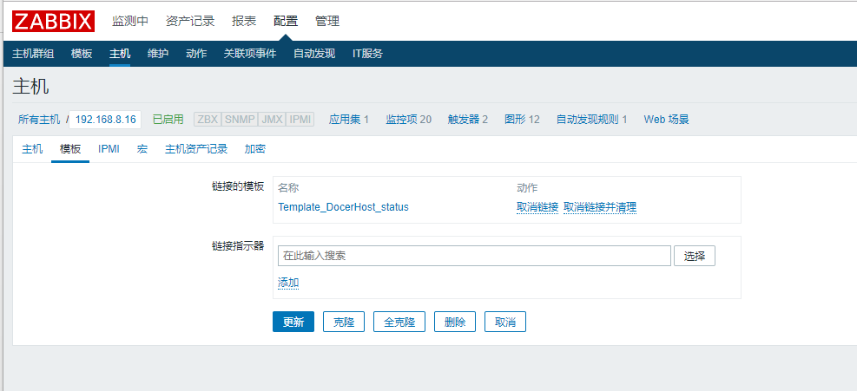

### 2.3.4、聚合图形展示

