HTML5开发知识
- 查看浏览器版本对HTML5支持的详尽情况
网站：www.caniuse.com
- 显示用户浏览器对HTML5规范支持的详尽情况
网站：www.html5test.com
- 对于canvas标签IE不支持的情况
如果IE版本不支持HTML5，想使用canvas则可以使用开源框架。
网址：http://code.google.com/p/explorercanvas
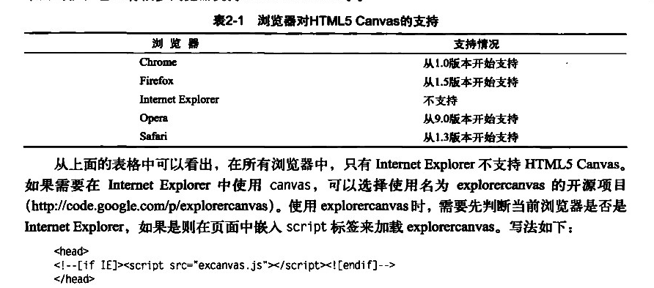
夹包在百度云盘web文件中
- 使用canvas
<script type="text/javascript">

function drawLine(){
//取得canvas元素及绘图上下文
var canvas = document.getElementById("draw");
var context = canvas.getContext("2d");

//用绝对坐标来绘制一条路径
context.beginPath();
context.moveTo(70,140);
context.lineTo(140,70);
//将线条绘制到canvas
context.stroke();
}
window.addEventListener("load", drawLine, true);
</script>
</head>
<body >
<div class="imgObj">hello word!</div>
<canvas id="draw"></canvas>
</body>
</html>
效果：
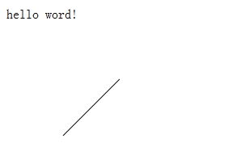
- Websocket实现浏览器和服务器的实时通信
Html文件：
<!DOCTYPE html>
<html>
<head>
<title>Testing websockets</title>
</head>
<body>
<div>
<input type="submit" value="Start" onclick="start()" />
</div>
<div id="messages"></div>
<script type="text/javascript">
var webSocket =
new WebSocket('ws://localhost:8080/testTime/websocket');

webSocket.onerror = function(event) {
onError(event)
};

webSocket.onopen = function(event) {
onOpen(event)
};

webSocket.onmessage = function(event) {
onMessage(event)
};

function onMessage(event) {
document.getElementById('messages').innerHTML
+= '<br />' + event.data;
}

function onOpen(event) {
document.getElementById('messages').innerHTML
= 'Connection established';
}

function onError(event) {
alert(event.data);
}

function start() {
webSocket.send('hello');
return false;
}
</script>
</body>
</html>
Java文件：
package com.gh.test;

import java.io.IOException;

import javax.websocket.OnClose;
import javax.websocket.OnMessage;
import javax.websocket.OnOpen;
import javax.websocket.Session;
import javax.websocket.server.ServerEndpoint;
@ServerEndpoint("/websocket")
public class WebSocketTest {

@OnMessage
public void onMessage(String message, Session session)
throws IOException, InterruptedException {

// Print the client message for testing purposes
System.out.println("Received: " + message);

// Send the first message to the client
session.getBasicRemote().sendText("This is the first server message");

// Send 3 messages to the client every 5 seconds
int sentMessages = 0;
while(sentMessages < 3){
Thread.sleep(5000);
session.getBasicRemote().
sendText("This is an intermediate server message. Count: "
+ sentMessages);
sentMessages++;
}

// Send a final message to the client
session.getBasicRemote().sendText("This is the last server message");
}

@OnOpen
public void onOpen () {
System.out.println("Client connected");
}

@OnClose
public void onClose () {
System.out.println("Connection closed");
}
}
源代码请见百度云盘目录：项目名称testTTime
- Web Workers的使用
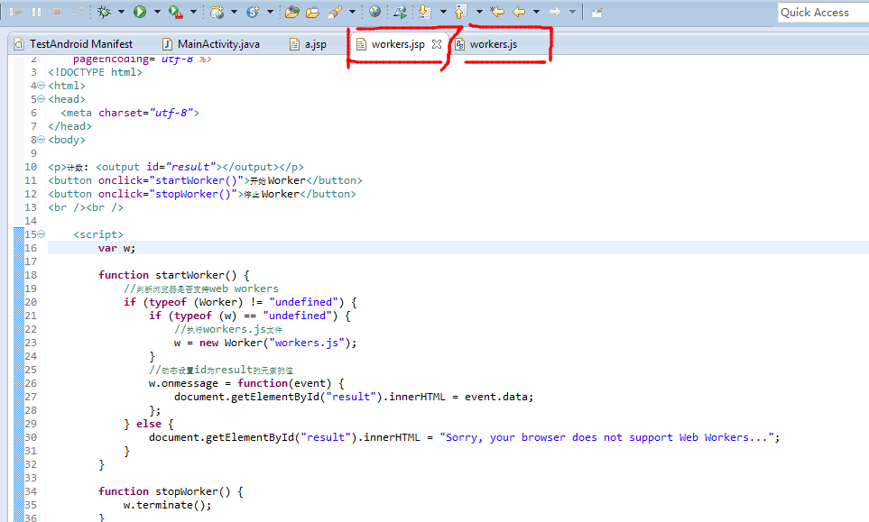
workers.jsp文件:
<%@ page language="java" contentType="text/html; charset=utf-8"
pageEncoding="utf-8"%>
<!DOCTYPE html>
<html>
<head>
<meta charset="utf-8">
</head>
<body>

<p>计数: <output id="result"></output></p>
<button onclick="startWorker()">开始 Worker</button>
<button onclick="stopWorker()">停止 Worker</button>
<br /><br />

<script>
var w;

function startWorker() {
//判断浏览器是否支持web workers
if (typeof (Worker) != "undefined") {
if (typeof (w) == "undefined") {
//执行workers.js文件
w = new Worker("workers.js");
}
//动态设置id为result的元素的值
w.onmessage = function(event) {
document.getElementById("result").innerHTML = event.data;
};
} else {
document.getElementById("result").innerHTML = "Sorry, your browser does not support Web Workers...";
}
}

function stopWorker() {
w.terminate();
}
</script>

</body>
</html>
Workers.js文件：
var i=0;

function timedCount()
{
i=i+1;
postMessage("a"+i);
setTimeout("timedCount()",500);
}
//必须有这句话，要不然jsp无法调用该方法
timedCount();
- 保存信息到本地，localStorage(手机应用开发)
第一步：将需要保存的信息放到localStorage
如下是将account、password字符串保存到本地，至于localStorage点后面的变量名根据自己喜好来取名。
localStorage.account = 'account';
localStorage.password = 'password';
第二步：下次启动程序的时候就直接从localStorage里面取值，并将值赋给文本框，代码如下：
$('#login-input ul li').find('input')[0].value = localStorage.account;
$('#login-input ul li').find('input')[1].value = localStorage.password;

注意：localStorage取得的是字符串，如果你保存的是boolean型的变量值，那么取得只是boolean型的字符串,而不是boolean型，因此在取得boolean型值后不能使用true或者false去判断。应该是匹配这个字符串，比如下面，变量loginRememberFlag就是boolean型的：
loginRememberFlag = localStorage.loginRememberFlag;
//如果有保存值，则显示本地保存的值
if(loginRememberFlag=='true'){
$('#login-input ul li').find('input')[0].value = localStorage.account;
$('#login-input ul li').find('input')[1].value = localStorage.password;
$('#remember-login').prop('checked',true);
}

