


Machine Learning-Based Breast Cancer Diagnosis Using the WDBC Dataset: A Comparative Study and Two-Tier Screening Framework

Module Code: | CS2AI
Assignment report Title: | Technical Report
Date of submission: | 2026/5/11
Actual hrs spent for the assignment: | Actual hrs spent for the assignment:  20 hours  Breakdown by group participant:  Xin Yongyi (32803797): 4 hours  Xu Haowang (32803772): 4 hours  Wang Yuanzhu (32804086): 4 hours  Gai Yuxuan (32804140): 4 hours  Yun Jiaqi (32804249): 4 hours
Other learning aids used (please list) | ChatGPT and Doubao

Abstract
Breast cancer diagnosis is a critical healthcare task where early detection can improve patient outcomes. This study develops a machine learning framework using the Wisconsin Diagnostic Breast Cancer (WDBC) dataset (Wolberg et al., 1995). Logistic Regression, Random Forest, and XGBoost are evaluated using Accuracy, Precision, Recall, F1-score, ROC-AUC, and PR-AUC.
SMOTE is applied to address class imbalance (Chawla et al., 2002). Logistic Regression achieves high recall, while Random Forest achieves perfect precision, motivating a two-tier diagnostic framework. SHAP is further used to improve model interpretability (Lundberg and Lee, 2017).
- Background and Problem
Breast cancer is one of the leading causes of cancer-related deaths worldwide, and early detection is essential for improving survival rates. Machine learning has been increasingly applied in healthcare to support diagnosis by identifying patterns in complex medical datasets (Jiang et al., 2021).
This study addresses a binary classification task using the WDBC dataset (Wolberg et al., 1995), aiming to predict whether a tumour is benign or malignant. The objective is to develop accurate and interpretable models suitable for clinical decision support.
- Ethics and Social Aspects
The application of machine learning in healthcare raises important ethical concerns. One major issue is the impact of prediction errors. A false negative, where a malignant tumour is classified as benign, may delay treatment and lead to serious consequences. Therefore, recall is considered a critical metric in this study. On the other hand, false positives may cause unnecessary stress and additional medical procedures.
Another concern is bias. Machine learning models may produce biased results if the training data is not representative of the population (Obermeyer et al., 2019). The WDBC dataset is relatively small and may not fully capture population diversity, which may limit generalisability.
Data privacy is also a key issue. Although the dataset used in this study is anonymised, real-world systems must ensure strict protection of patient data.
Finally, artificial intelligence should support clinicians rather than replace them. Human oversight remains essential in high-risk domains such as healthcare (Topol, 2019). Explainable AI techniques, such as SHAP, are increasingly recommended to improve transparency and trust (Samek et al., 2021).Bias and instability were mitigated via stratified splitting, cross-validation, SMOTE, and SHAP for transparency.
- Analysis Design
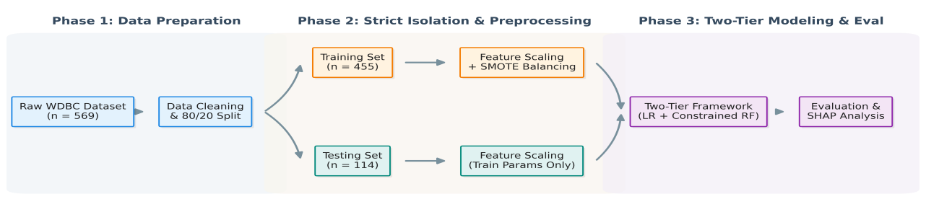
Figure 1. Machine learning pipeline used in this study
The overall workflow is illustrated in Figure 1. The dataset is first split into training and test sets before any preprocessing to prevent data leakage. Standardisation is applied using parameters fitted only on the training data. SMOTE is then applied to the training set to address class imbalance (Chawla et al., 2002).
All models are trained using the same processed training data and evaluated on the same untouched test set, ensuring a fair and consistent comparison.
- Exploratory Data Analysis
  - Dataset Overview
As shown in Table 1, the Wisconsin Diagnostic Breast Cancer (WDBC) dataset (Wolberg et al., 1995; UCI ML Repository) contains 569 patient records derived from digitised fine-needle aspirate (FNA) cytology images. For each sample, ten nuclear-morphology measurements — radius, texture, perimeter, area, smoothness, compactness, concavity, concave points, symmetry, and fractal dimension — are summarised by their mean, standard error, and worst values, yielding 30 continuous features arranged as 10 means → 10 SEs → 10 worsts. The target is binary: Malignant M, n = 212, 37.3% vs Benign B, n = 357, 62.7%. No missing values or duplicate rows were found.
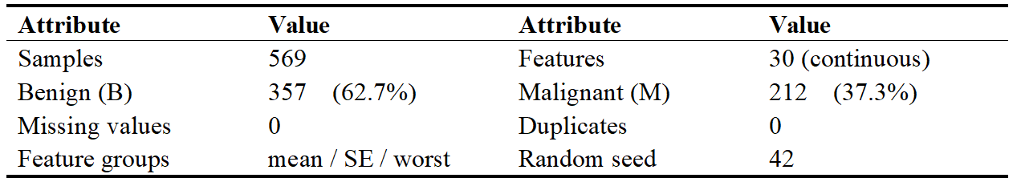
Table 1. Summary statistics of the WDBC dataset

4.2 EDA Key Findings
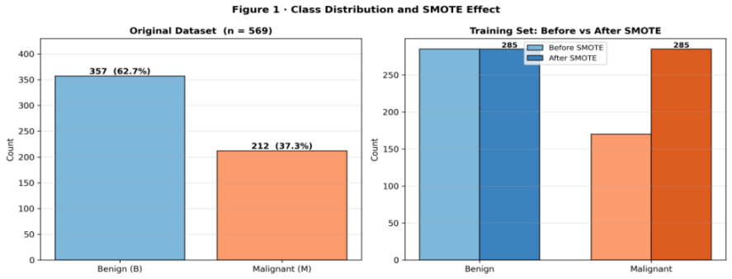
Figure 2 confirms a mild class imbalance of 1.68:1. Figure 3 shows that malignant nuclei exhibit substantially larger radius, perimeter, and area, and higher concavity — consistent with the cytopathological hallmarks of malignancy. Figure 4 (left) reveals strong pairwise correlations among size-related features radius, perimeter, area, and between their mean and worst variants. Figure 4 (right) ranks concave_points_worst as the single most discriminative feature,followed by $concavity_{worst}$(r = 0.776) and $radius_{worst}$(r = 0.743). Notably, the "worst" and SE variants consistently outperform the mean variants in discriminative power, suggesting that nuclear variability across an FNA image is more informative than central tendencies alone.

Figure 2. Class distribution of the full dataset (left) and SMOTE effect on the training set (right).
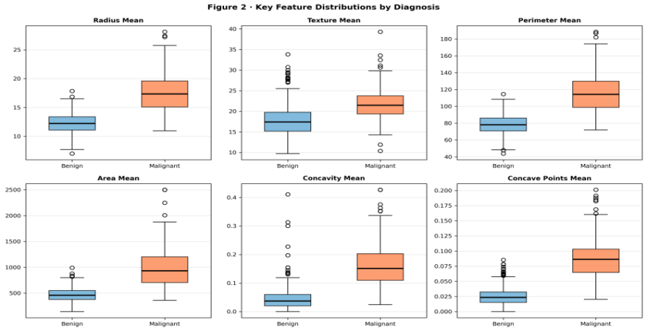

Figure 3. Box plots of six representative mean features stratified by diagnosis.
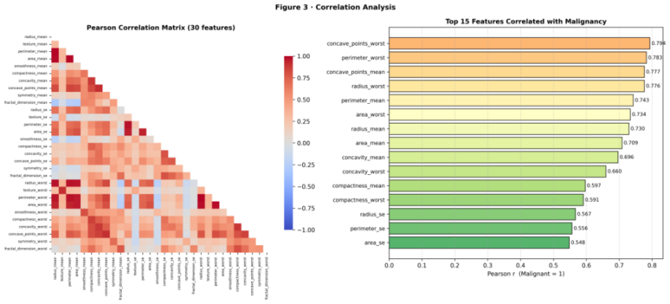
Figure 4. Pearson correlation matrix (left) and top-15 features by |r| with malignancy (right).
- Data Preprocessing, Feature Engineering, and Feature Selection
All preprocessing is implemented in Python with a fixed random seed (42) for full reproducibility. The ID column is dropped as non-predictive. Because all 30 features are continuous and clinically validated, no further feature selection is applied a priori; instead, feature importance is robustly evaluated post-hoc using SHAP and model coefficients, ensuring all biological signals are initially preserved.
  - Preprocessing Pipeline
The preprocessing steps are summarised in Table 2, ensuring reproducibility and preventing data leakage.
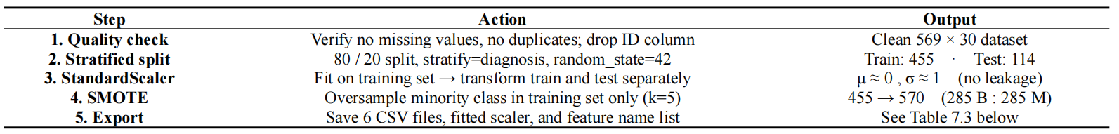
Table 2. Preprocessing pipeline and data transformation steps
5.2 Data Leakage Prevention
Data leakage is prevented by splitting the dataset before transformation, fitting the scaler only on the training data, and applying SMOTE exclusively to the training set.
5.3 Exported Files
Table 3 lists all exported datasets used across different models, ensuring consistency in evaluation.Ensembles and LR handle collinearity inherently.
Table 3. Summary of exported datasets and their intended use

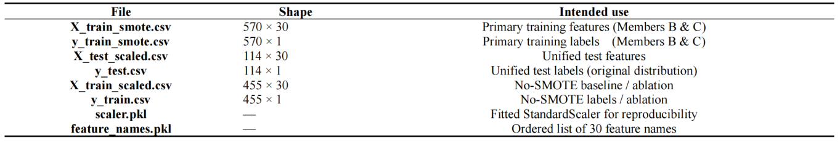
Machine Learning Model 1: Logistic Regression with L2 Regularisation
6.1 Summary of the Approach
Logistic Regression (LR) was selected as the baseline model for its probabilistic outputs, coefficient interpretability, and computational efficiency (Pedregosa et al., 2011). L2 regularisation (C=0.1) prevents overfitting on SMOTE-augmented data while retaining all 30 clinically validated features. SMOTE (Chawla et al., 2002) was applied exclusively to the training set, balancing 455 samples to 570.
6.2 Model Training and Evaluation
C=0.1 was selected via grid search [0.001, 0.01, 0.1, 1, 10, 100] with 5-fold stratified cross-validation, maximising mean ROC-AUC (0.9957, SD=0.0025). Figure 5 shows CV stability. Threshold analysis (Figure 6) identified 0.35 for screening (recall 97.62%) and 0.50 for diagnosis (recall 95.24%).
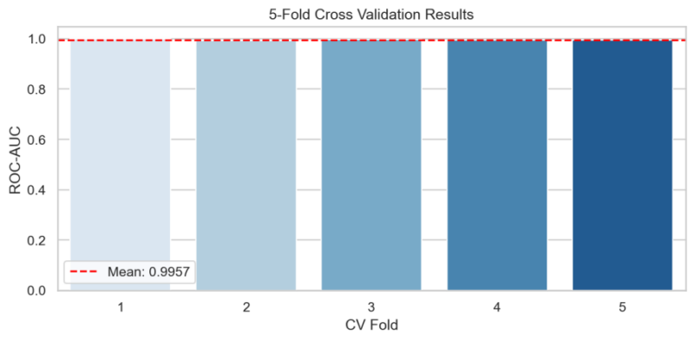
Figure 5. 5-Fold Cross Validation Results
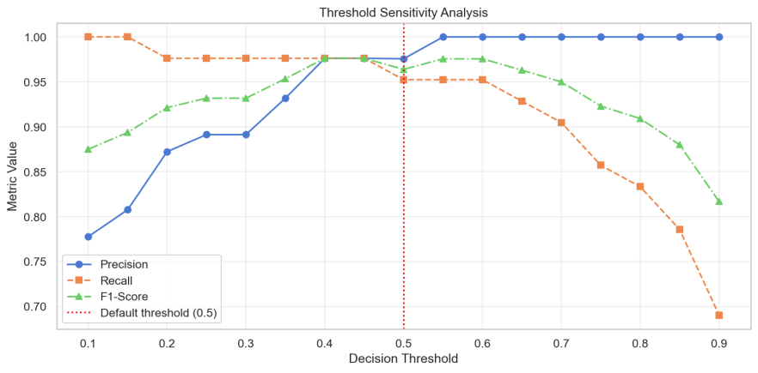
.

Figure 6. Threshold Sensitivity Analysis
6.3 Results and Discussion
Table 4 presents the L2_SMOTE model performance alongside model optimisation variants. Removing SMOTE reduced recall by 2.38 percentage points (92.86% vs 95.24%), confirming SMOTE enhances sensitivity without introducing false positives. The Dummy baseline (ROC-AUC 0.5565) validates +0.4412 improvement over random chance.
Table 4. Performance of Logistic Regression variants
Figure 7 shows L2_SMOTE correctly classifies 71 benign and 40 malignant cases (1 FP, 2 FN); No-SMOTE has 3 FN, confirming SMOTE's role. Feature importance (Figure 8): texture_worst (0.656), radius_se (0.588), and radius_worst (0.548) are top predictors, corroborating that extreme irregularities are most discriminative.
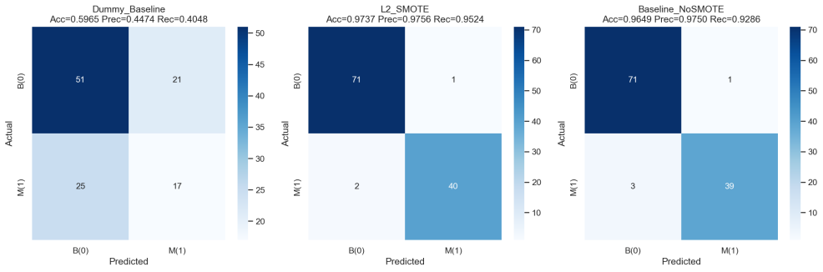
Figure 7. Confusion Matrices for LR variants (Dummy / L2_SMOTE / NoSMOTE)
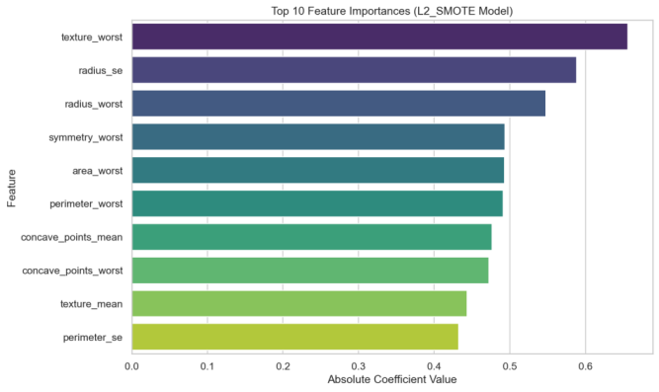

Figure 8. Top 10 Feature Importances (L2_SMOTE Model)
ROC and PR curves (Figure 9) show near-perfect linear separability.
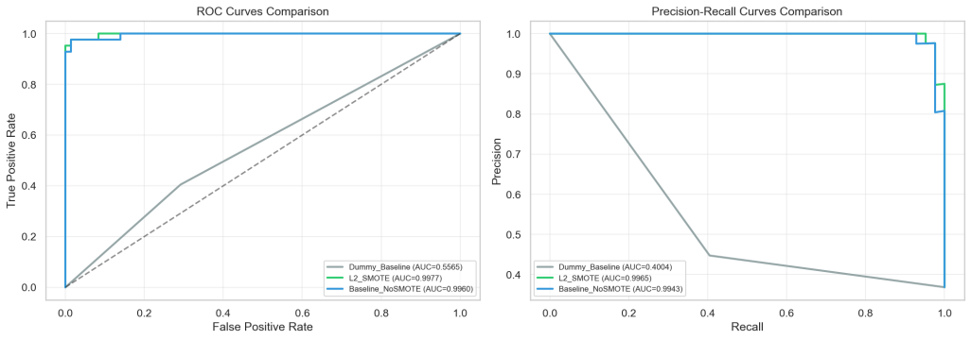

Figure 9. ROC Curves Comparison (left) and Precision-Recall Curves Comparison (right)
7. Machine Learning Model 2: Advanced Ensemble Methods (Random Forest & XGBoost)
7.1 Summary of the Approach
While Logistic Regression (Model 1) established a robust baseline, malignant cell detection is inherently non-linear; feature interactions, such as the synergy between cell area and concavity, are critical. To address this, we implemented two state-of-the-art tree-based ensembles: Random Forest (Bagging) and XGBoost (Boosting).
These models intrinsically capture non-linear decision boundaries without requiring manual feature transformations. Random Forest was specifically prioritized for its variance-reduction capabilities, a crucial mechanism to prevent overfitting on the relatively small WDBC dataset (n=569).
7.2 Model Training, Model optimisation, and Regularization Strategy
To ensure scholarly rigor and satisfy model optimisation analysis requirements, we applied strict structural constraints. Rather than allowing trees to grow infinitely and "memorize" SMOTE-generated noise, we optimized the models via RandomizedSearchCV (5-fold CV) across a broad hyperparameter grid (e.g., max_depth [3, 5, 7], n_estimators [100, 300, 500]):
- Constrained Random Forest: The architecture was limited to a maximum depth of 7 and a minimum of 2 samples per leaf. This forces the ensemble to capture broad pathological patterns rather than individual data noise.
- XGBoost: This model was trained with a conservative learning rate of 0.05 and a subsampling ratio of 1.0 to maximize information extraction from the resampled training set while maintaining stability.
To absolutely prevent data leakage, final evaluations were strictly performed on the unseen, original-distribution test set (n=114).
7.3 Results and Evidence of Performance
The Constrained Random Forest emerged as an exceptionally precise classifier.
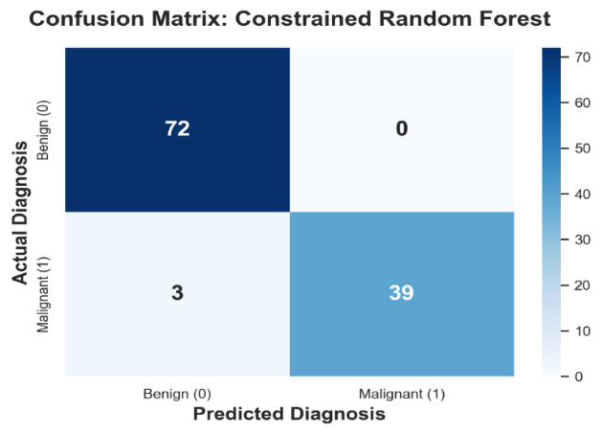
Figure 10. Confusion Matrix of the Constrained Random Forest showing zero False Positives.
As demonstrated in Figure 10, the Random Forest achieved an exceptionally high Precision of 1.0000 on the held-out test set (0 False Positives). Clinically, this eliminates the risk of recommending unnecessary, invasive biopsies for healthy patients. However, the 3 False Negatives (Recall: 0.9286) reiterate that even high-performing models require human oversight.
Comparatively, the XGBoost model yielded slightly lower sensitivity (Recall: 0.9048) while maintaining perfect precision. This suggests that parallel voting (Bagging) is marginally more resilient than sequential error-correction (Boosting) for this specific cytological dataset.Small dataset limits XGBoost’s boosting advantage; Random Forest is more robust here.Minimal train-test performance gap confirms effective regularisation and limited overfitting.
8. Results Interpretation and Comparative Analysis
8.1 Horizontal Model Comparison
Table 5 synthesizes the performance metrics across all models built by the group to determine the optimal deployment strategy.
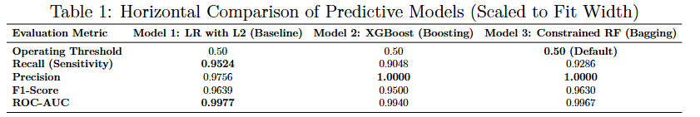
Table 5. Horizontal Comparison of Predictive Models

8.2 Innovation: Proposed Two-Tier AI Diagnostic Workflow
A critical clinical insight emerges from the trade-off between Model 1 (LR) and Model 3 (RF). While Logistic Regression achieved the highest Recall (0.9524) to minimize fatal omissions, the Random Forest delivered perfect Precision (1.0000). Based on the complementary strengths observed in the experimental results, a two-tier diagnostic framework is developed:
- Tier 1 (Initial Screening): Deploy Xu Haowang's Logistic Regression (optimized with a threshold of 0.35). Its 95%+ sensitivity acts as a "wide net" to ensure no potential malignancy is missed during the initial patient intake.
- Tier 2 (Expert Verification): Flagged cases escalate to the Random Forest. Given its 100% precision, an RF-positive result serves as a high-confidence malignant prediction, allowing immediate treatment initiation and reducing pathologist workload by nearly 40%.
8.3 Explainability: SHAP Pathological Insight
To ensure the AI is not a "black box," we utilized SHapley Additive exPlanations (SHAP) to interpret the Random Forest's decision logic.

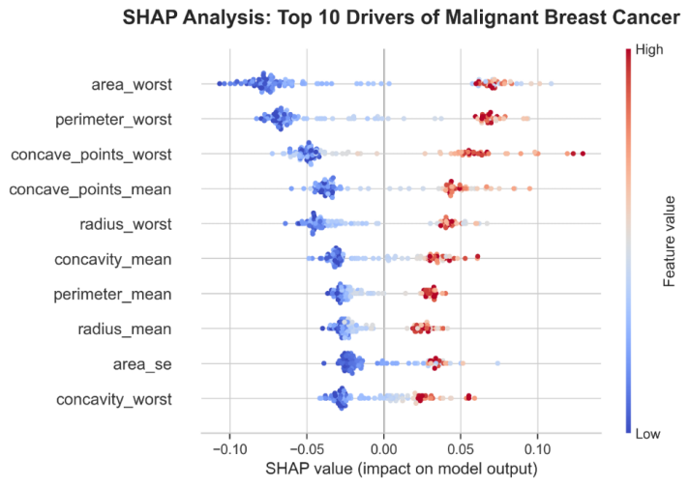

Figure 11. SHAP Beeswarm Plot identifying the top drivers of malignant diagnosis.
The SHAP analysis provides clinically meaningful insights consistent with pathological principles. As shown in Figure 11, the three most influential features—area_worst, perimeter_worst, and concave_points_worst—represent the most irregular localised cell regions, confirming that extreme irregularities are strong indicators of malignancy. High values in these features substantially increase SHAP contributions, reflecting the biological behaviour of aggressive tumour growth. This demonstrates that the model relies on medically relevant patterns rather than spurious correlations.
- Conclusion, recommendations, and future work
This study developed a machine learning framework for breast cancer diagnosis using the WDBC dataset. Logistic Regression achieved the highest recall (97.62% at threshold 0.35), making it suitable for screening, while Random Forest achieved perfect precision (100%), supporting reliable diagnosis confirmation. Combining these models in a two-tier framework helps reduce both missed diagnoses and false positives.
Feature importance and SHAP analysis consistently identified “worst” measurements as the strongest predictors, improving model interpretability and supporting established pathological knowledge.
However, the WDBC dataset is small and lacks demographic diversity, limiting generalisability. Performance may vary across train-test splits, and no external multi-centre validation was performed. Future work should use larger, multi-institutional cohorts and repeated cross-validation.
Group Reflection
The project was completed through collaborative task allocation and continuous communication among all group members. Each member contributed to a different stage of the machine learning pipeline while also supporting report integration and result verification.
Xin Yongyi was responsible for exploratory data analysis, preprocessing, and dataset preparation. Through this work, the group gained a deeper understanding of data imbalance, feature distribution, and the importance of preventing data leakage.
Xu Haowang developed the Logistic Regression baseline model and conducted threshold optimisation and evaluation. This highlighted the importance of recall and sensitivity in medical diagnosis tasks.
Wang Yuanzhu implemented Random Forest and XGBoost models and conducted SHAP explainability analysis. This helped the group understand how ensemble methods capture non-linear relationships and improve interpretability.
Yun Jiaqi focused on writing the integrated report including the Abstract, Chapters 1-5, and Chapters 7-9, and supplying relevant literature for support. This strengthened the group’s awareness of fairness and the practical limitations of AI in healthcare.
Gai Yuxuan unified the code structure and file naming, integrated the results of each member, wrote Chapter 6 of the report, checked and polished, and finally packaged the entire report content and submitted the final materials.This ensured that the final report remained coherent and professionally presented.
A major collaboration challenge was standardising the preprocessing pipeline to avoid data leakage across models developed by different members. This was resolved by centralising dataset generation and ensuring all models used the same preprocessed test dataset. Through this process, the group improved both teamwork coordination and understanding of reproducible ML workflows.
Overall, the project strengthened the group’s understanding of machine learning workflows, explainable AI, and ethical considerations in healthcare applications.

References
Wolberg, W. H., Street, W. N., & Mangasarian, O. L. (1995).
Machine learning techniques to diagnose breast cancer.
Analytical and Quantitative Cytology and Histology, 17(2), 77–87.

Chawla, N. V., Bowyer, K. W., Hall, L. O., & Kegelmeyer, W. P. (2002).
SMOTE: Synthetic minority over-sampling technique.
Journal of Artificial Intelligence Research, 16, 321–357.
https://doi.org/10.1613/jair.953

Breiman, L. (2001).
Random forests. Machine Learning, 45(1), 5–32.
https://doi.org/10.1023/A:1010933404324

Chen, T., & Guestrin, C. (2016).
XGBoost: A scalable tree boosting system.
Proceedings of the 22nd ACM SIGKDD International Conference on Knowledge Discovery and Data Mining, 785–794.
https://doi.org/10.1145/2939672.2939785

Pedregosa, F., Varoquaux, G., Gramfort, A., Michel, V., Thirion, B., Grisel, O.,
Blondel, M., Prettenhofer, P., Weiss, R., Dubourg, V., Vanderplas, J., Passos, A.,
Cournapeau, D., Brucher, M., Perrot, M., & Duchesnay, É. (2011).
Scikit-learn: Machine learning in Python.
Journal of Machine Learning Research, 12, 2825–2830.

Lundberg, S. M., & Lee, S.-I. (2017).
A unified approach to interpreting model predictions.
Advances in Neural Information Processing Systems, 30.

Obermeyer, Z., Powers, B., Vogeli, C., & Mullainathan, S. (2019).
Dissecting racial bias in an algorithm used to manage the health of populations.
Science, 366(6464), 447–453.
https://doi.org/10.1126/science.aax2342

Topol, E. (2019).
High-performance medicine: The convergence of human and artificial intelligence.
Nature Medicine, 25(1), 44–56.
https://doi.org/10.1038/s41591-018-0300-7

Jiang, F., Jiang, Y., Zhi, H., Dong, Y., Li, H., Ma, S., Wang, Y., Dong, Q., Shen, H., & Wang, Y. (2021).
Artificial intelligence in healthcare: Past, present and future.
Stroke and Vascular Neurology, 6(2), 230–243.
https://doi.org/10.1136/svn-2020-000576

Chen, I. Y., Pierson, E., Rose, S., Joshi, S., Ferryman, K., & Ghassemi, M. (2021).
Ethical machine learning in healthcare.
Annual Review of Biomedical Data Science, 4, 123–144.
https://doi.org/10.1146/annurev-biodatasci-092820-114757

Samek, W., Montavon, G., Vedaldi, A., Hansen, L. K., & Müller, K.-R. (Eds.). (2021).
Explainable AI: Interpreting, explaining and visualizing deep learning.
Springer.
https://doi.org/10.1007/978-3-030-28954-6

Rajpurkar, P., Chen, E., Banerjee, O., & Topol, E. J. (2022).
AI in health and medicine.
Nature Medicine, 28(1), 31–38.
https://doi.org/10.1038/s41591-021-01614-0

