|  |  |  |
| --- | --- | --- |
|  | **Rochester Institute of Technology**  **Golisano College of Computing and Information Sciences**  **School of Interactive Games and Media**  **2145 Golisano Hall – (585) 475-7680** |  |

**Data Structures & Algorithms for Games & Simulation II**

**IGME 309, 2015 Fall**

**E06: LERP**

For this ICE I will ask you to use ReEngine, you may use your own solution if you want as well, but part of this ICE will evaluate the ability to create a new project solution in it. There is NO start code for this ICE but you may use the Sandbox project as startup and it is available at: <https://github.com/labigm/ReEngineApp_2015s> under **00_Sandbox** project.

This project will generate a random number of spheres in increasing color.

In order to use it, you will need to:

1. Duplicate the project under windows (copy paste it in the same folder)
2. Rename it to E06_Lerp
3. Rename the following files to E06_Lerp as well
   1. 00_Sandbox.vcxproj 🡪 E06_Lerp.vcxproj
   2. 00_Sandbox.vcxproj.filters 🡪 E06_Lerp.vcxproj.filters
   3. 00_Sandbox.vcxproj. user 🡪 E06_Lerp.vcxproj. user
4. Edit E06_Lerp.vcxproj in notepad++ (or any other text editor) and change the following line:

<ProjectName>Sandbox</ProjectName>

To

<ProjectName>E06_Lerp</ProjectName>

1. Right-click on the project solution and add an existing project

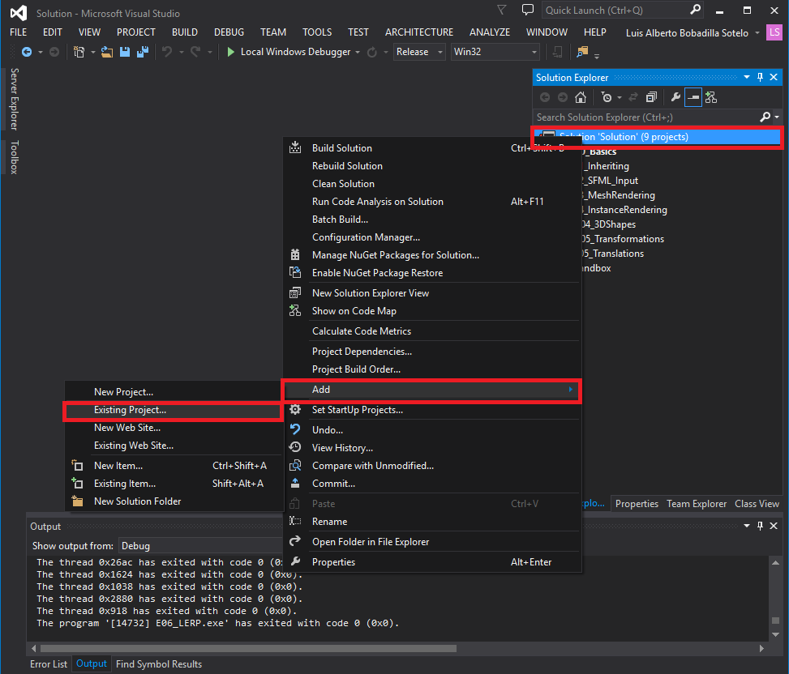

1. Browse for the file E06_Lerp.vcxproj and add it.

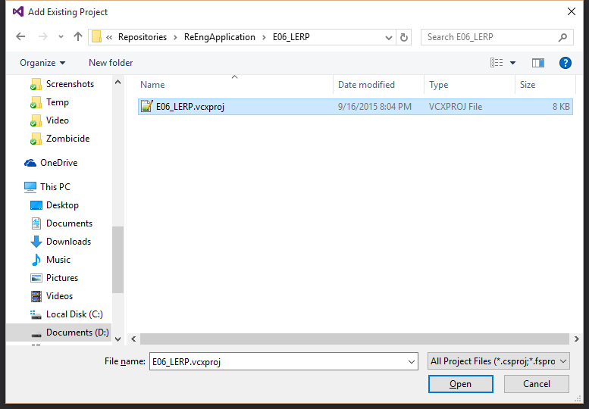

1. Right-click on the project and set it up as the StartUp project:

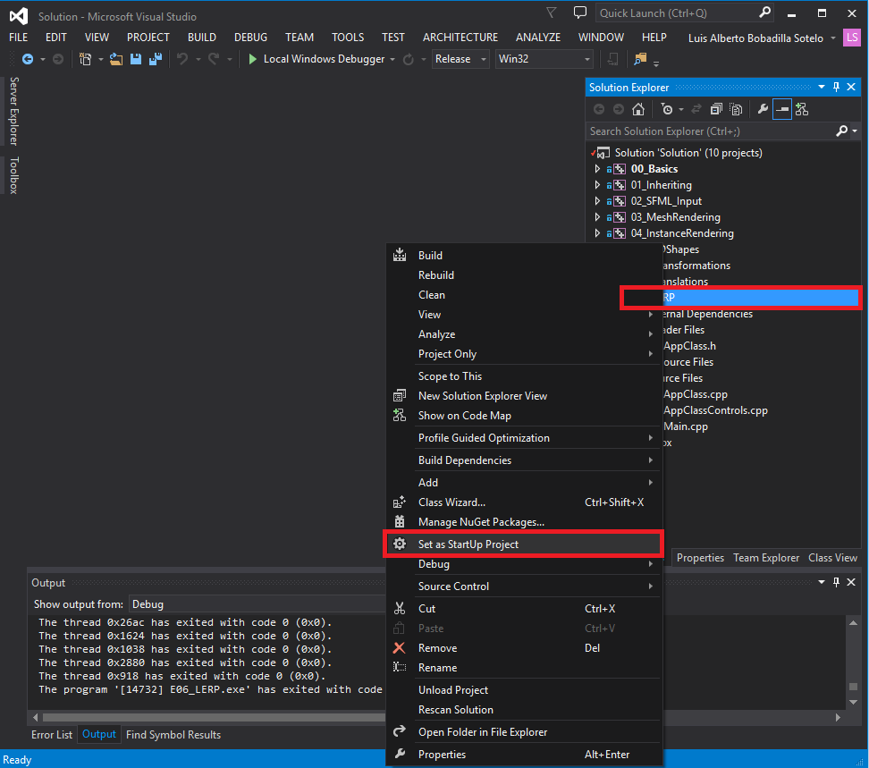

1. Making sure you are in the AppClass.h of E06_Lerp add the following variables, they will count the number of objects on the scene, will hold their info and their matrices.
   1. int m_nObjects;
   2. PrimitiveClass* m_pSphere = nullptr;
   3. matrix4* m_pMatrix = nullptr;
2. in InitVariables set a new camera position:

m_pCameraMngr->SetPosition(vector3(0.0f, 0.0f, 35.0f));

1. Initialize the m_nObjects variable to a random number using rand():

srand(time(NULL));

m_nObjects = rand() % 23 + 5;

1. Make a couple of start and end vectors like so:

vector3 v3Start = vector3(-m_nObjects, 0.0f, 0.0f);

vector3 v3End = vector3(m_nObjects, 0.0f, 0.0f);

1. Initialize the m_pSphere variable and the m_pMatrix variable to a new set of appropriate variables using m_nObjects as the quantity as in a list of pointers:

ObjectPointer = new ObjectType[quantity];

1. In a for loop that goes from the first to the last sphere add a MapValue function call that will generate a percentage of the lerp like this:

float fPercent = MapValue(static_cast<float>(nSphere), 0.0f, static_cast<float>(m_nObjects), 0.0f, 1.0f);

A more in depth description of the MapValue method can be found at the end of this document.

1. Inside of the same for loop generate every Primitive as a new sphere of radius 1, with a subdivision level of 5 and a new vector3(fPercent, 0.0f, 0.0f) as the color.
2. Inside of the same for loop update the position of each matrix to a translated vector of the return of the linear interpolation from v3Start and v3End according to the fPercent
3. In Display render all of the spheres (using their respective matrices)
4. In Release deallocate the memory you reserved for m_pSphere and m_pMatrix remember that they reserved memory as an array []

If everything went according to plan you should have a program like the one exemplified under _Binary as E06_Lerp DEMO that will generate a random number of spheres each time:

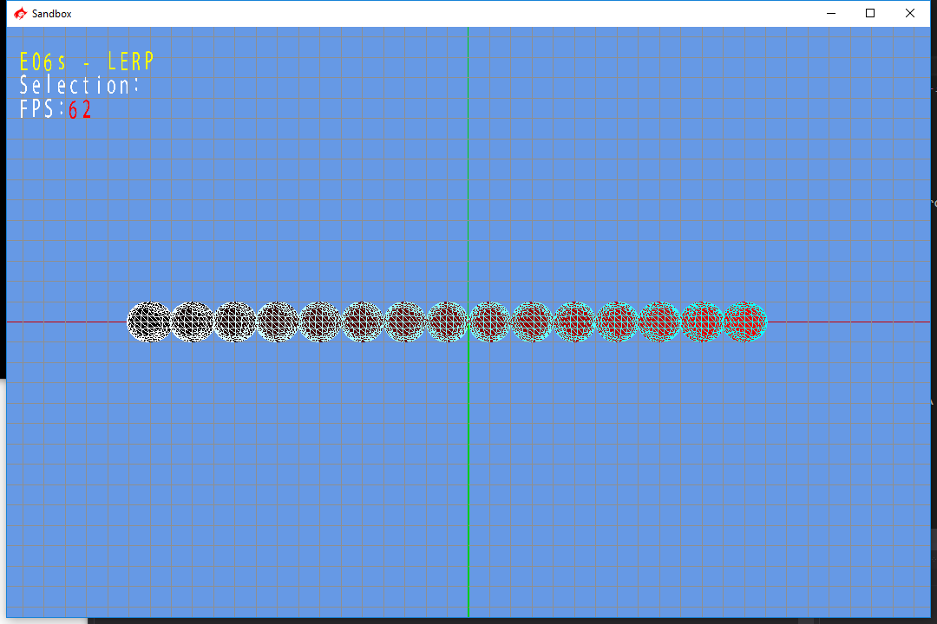

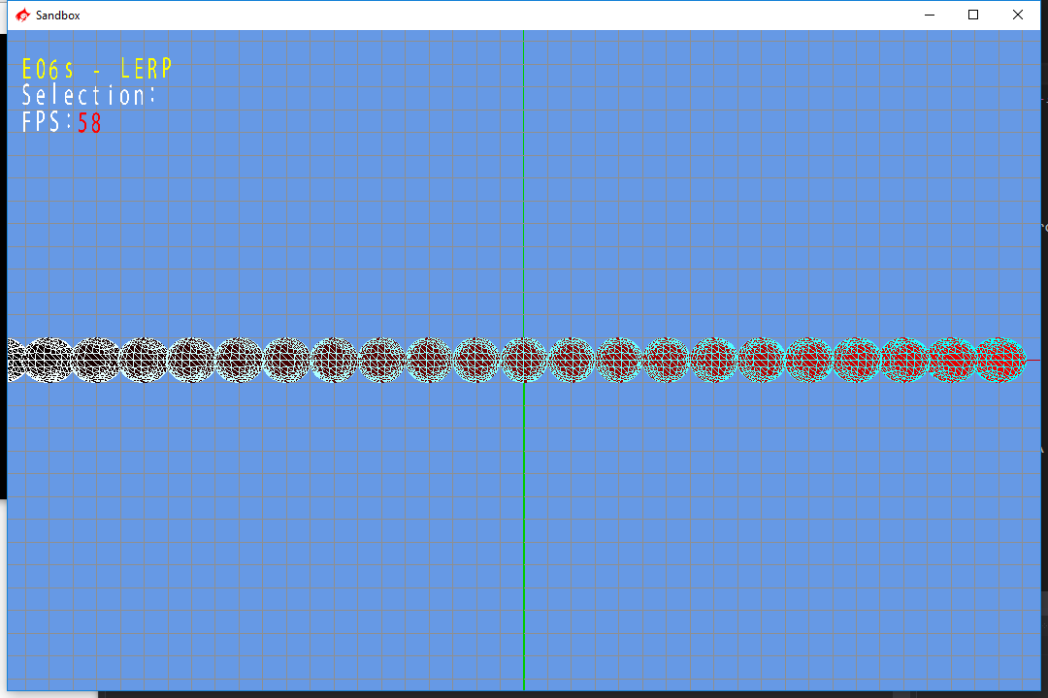

Show this to the professor or TA and submit to the dropbox labeled E06 Lerp.

For your submission you only need to zip the folder E06 – LERP, nothing else is required, and the file size should not be larger than 100kb, rename your zip file as the naming convention E06 LastName.