TEXTURE PACKING
Group 14——
Wang Yiheng [3160104987]
Wang Yinzhao [3160101569]
Zou Ziyu [3170103064]

Chapter 1: Introduction
Texture Packing is to pack multiple rectangle shaped textures into one large texture. The resulting texture must have a given width and a minimum height.
This project requires you to design an approximation algorithm that runs in polynomial time. You must generate test cases of different sizes (from 10 to 10,000) with different distributions of widths and heights. A thorough analysis on all the factors that might affect the approximation ratio of your proposed algorithm is expected.
The items may neither overlap nor be rotated. We describe here a list of efficient (off-line) packing algorithms. A common approach is level-oriented, the items are packed from left to right, in rows forming levels. Within the same level, all items are packed so that their bottoms align. The first level is the bottom of the strip and subsequent levels are defined by the height of the tallest item on the previous level. Some algorithms start by sorting the items by non-increasing height, they are usually named Decreasing Height (DH). The first three DH algorithms reviewed below are level-oriented. Given an approximation algorithm A, let A(I) and OPT(I) denote the height used by A and the optimal algorithm, respectively, for an instance I. The asymptotic bounds stated below assume that the width of the strip and the items is normalized so that the strip is of width 1.
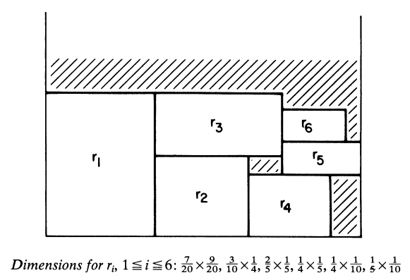
Fig：one example of texture packing

Chapter 2: Algorithm Specification
Now we will specifically describe the implementation of the above algorithms.(the symbol ‘*’ represents our own algorithm,they are NFFDH and all online algorithm)
OFFLINE
1.First-Fit Decreasing Height (FFDH) algorithm
At any point in the packing sequence,the next rectangle to be packed is placed left-justified on the first (i.e., lowest) level on which it will fit. If none of the current levels will accommodate this rectangle, a new level is started as in the NFDH algorithm.
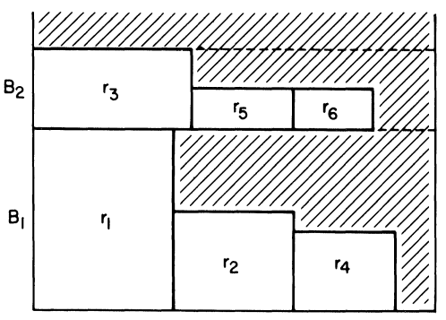
Fig: FFDH algorithms applied to the list L (r1, r2, r3, r4, r5, r6,)
Time complexity of FFDH: O(n·log n)
Approximation ratio: FFDH(I)<=(17/10)·OPT(I)+1; the asymptotic bound of 17/10 is tight.
Proof：The proof is based on the analogous proof for the First-Fit algorithm of one-dimensional bin-packing [5], [9]. We begin by defining the following weighting function.
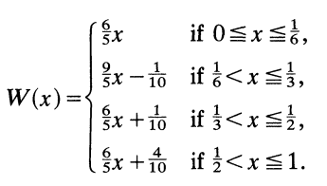
We extend this function to rectangles r by writing W(r)= W(w(r)), and set
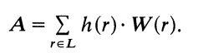
It is proved that no collection of numbers x summing to 1 or less can have W(x) summing to more than 1.7. We can apply this result to our case by cutting the optimal packing into horizontal slices, formed by drawing a line through the top and bottom of each rectangle. Summing over all the slices, we have A <- 1.7 OPT(L).
2.Next-Fit Decreasing Height (NFDH) algorithm
With this algorithm, rectangles are packed left-justified on a level until there is insufficient space at the right to accommodate the next rectangle. At that point, the next level is defined, packing on thecurrent level is discontinued, and packing proceeds on the new level.
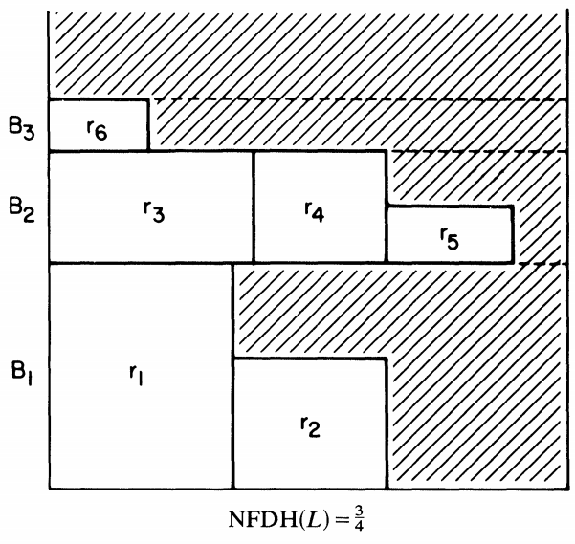
Fig: NFDH algorithms applied to the list L (r1, r2, r3, r4, r5, r6,)
Time complexity: O(n·log n)
Approximation ratio: NFDH(I) <= 2·OPT(I)+1; the asymptotic bound of 2 is tight.
Proof : Consider the NFDH packing of such a list L, with blocks B1, B2,..., Bt. For each i, let Xi be the width of the first rectangle in Bi, and Yi be the total width of rectangles in Bi. For each i< t, the first rectangle in B[i+l] does not fit in Bi. Therefore Yi + X[i+1] > 1, 1 < i < t. Since each rectangle in Bi has height at least H[i+1], and the first rectangle in Bi+l has height Hi+l, Ai+A[i+l]>=H[i+l](Yi+X[i+l])>H[i+l]. Therefore, if A denotes the total area of all the rectangles,which is the desired bound.
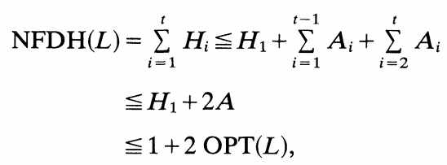
Examples showing that the coefficient of 2 is smallest possible are derived trivially from the corresponding examples for the Next-Fit algorithm of one-dimensional bin-packing. The list L has n rectangles, where n is a multiple of 4. All the rectangles have height 1, the odd numbered ones have width 1/2, and the even numbered ones have width e, for a suitably small e > 0. The optimum and NFDH packings of L are shown in Fig. 3. In this case we have NFDH(L)= n/2 and OPT(L)= n/4+ 1, so the ratio NFDH(L)/OPT(L) can be made arbitrarily close to 2 by choosing n suitably large and esuitably small.
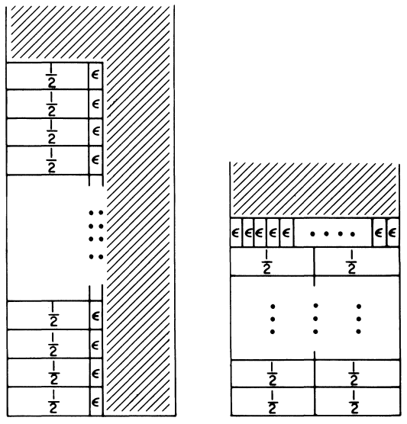
Fig：the worst example and the best example
3.Best-Fit Decreasing Height (BFDH) algorithm
BFDH packs the next item R (in non-increasing height) on the level, among those that can accommodate R, for which the residual horizontal space is the minimum. If no level can accommodate R, a new level is created.
Time complexity of BFDH: O(n·log n)
Approximation ratio: L(I) < 1.7·OPT(I)+1(but it is not strict)
BFDH is an optimization on FFDH that adds an extra space check to the insertion. Due to the existence of this check, we need an extra space overhead S(n) to store the remaining space for each level, and an extra time overhead T(n) to determine the insertion.
*4. Next-First-Fit Decreasing Height(NFFDH) Algorithm
Firstly, sort the items by non-decreasing order. When in a level, we define rest-width as the total width subtracting the width already taken. We choose the first fitting item at the bottom of the level and as left as possible. And update the rest-width. Then for this item, we define rest-height as the level-height subtracting the height of the item. So the area upon the item in the level forms a column, and while there exists an item which can be put in the column, put it in and update the rest-height. Repeat the operation on the bottom of the level. Start a new level.
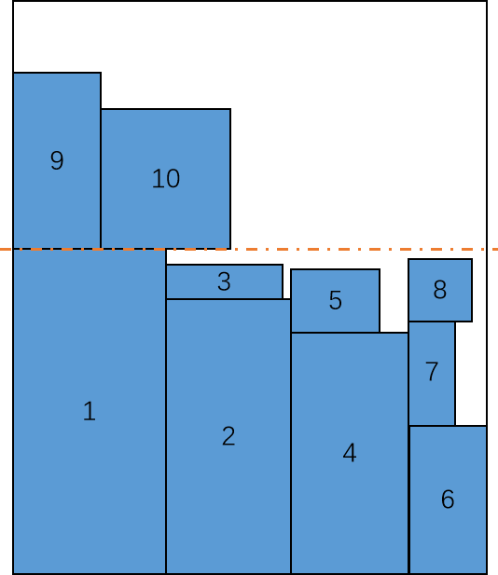
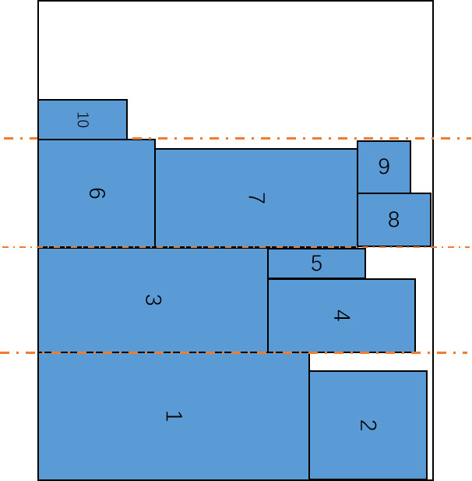
Fig1：Next-First Fit Decreasing Height Fig2：Next-First Fit Decreasing Height
Without rotation With rotation
Time complexity: O(n²)
Approximation ratio: NFFDH(I)<=3·OPT(I)

ONLINE
*1.First-Fit online algorithm（ordinary）
Compared with the offline FFDH algorithm, the underlying principle is basically the same. After selecting the online algorithm, its algorithm efficiency is much higher than offline (the efficiency here refers to space utilization), but at the cost of it, its time and space complexity is higher because it is completed. The inspection will be more complicated.
The difference between the online algorithm and the previous offline FFDH is:
1. You can choose whether the box can be rotated. If it can be rotated, it can be rotated when the width of the box is read. The longer one is wide, so that the width of the box must be greater than or equal to the height, and the height is the lowest.
2. When loading, if there is room for the space to meet the rotation of the box, and the total height after the rotation is satisfied, we will rotate the box and load
3. After a box is filled with one layer, the following Space can no longer be installed. That is,After a box is loaded, the space below it is equivalent to being occupied!
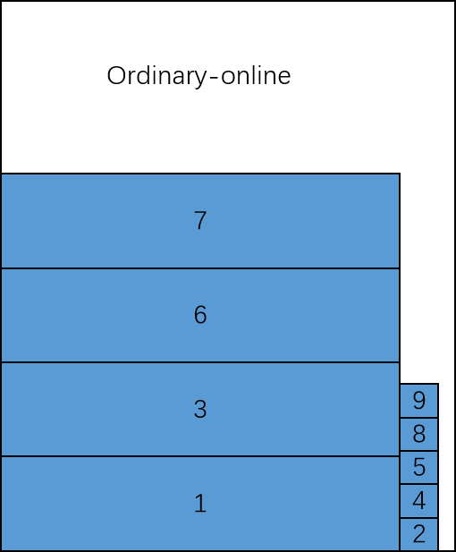
Time complexity of FFDH: O(n·log n)
*2.First-Fit online algorithm（faster）
The algorithm is an improvement of the previous algorithm. It does not start from the bottom layer, but starts from the higher level of the baseline.
The main idea of online-faster is that when a box is loaded, the space utilization of the line loaded by the box, if it exceeds a threshold, then the line is considered as baseline, that is, the space below this line is considered to be fully utilized! Then, when you traverse the search, you only need to start from the baseline, which can save a lot of time. For example, when the box is loaded, the utilization of the layer is calculated. If it is greater than 0.9, the baseline is updated.
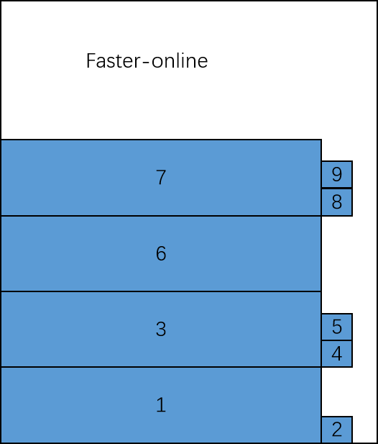
Time complexity of FFDH: O(n·log n)
In the online algorithm, we specifically added rotation to improve the space utilization of the algorithm.In this way, some locations that could not be inserted can be put down after rotation, further improving space utilization.
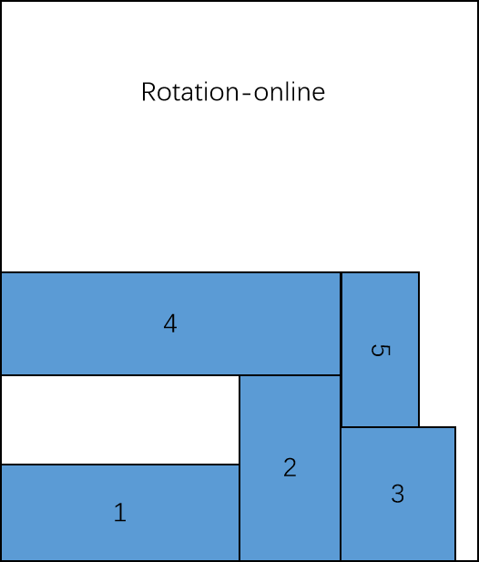
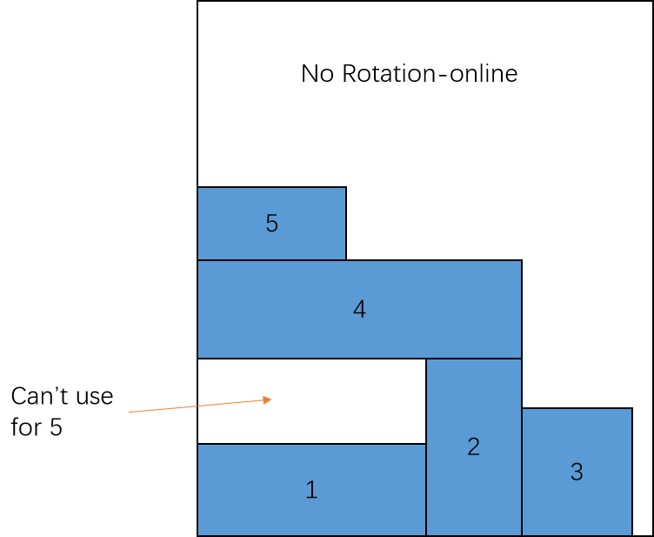
If it can be rotated, first adjust all the boxes to be wider than high, then the first position must be satisfied before the rotation can be installed, but only after the rotation is loaded without increasing the minimum height will be considered for rotation loading, otherwise it will not be considered.

Chapter 3: Testing Results
OFFLINE PART
Case1:Exactly identical rectangles
Texture width:100
The number of rectangle:10000
The size of every rectangle(height*width):1*1
The optimal storage height = 10000
The result storage height = 10000
The space utilization(Ratio of all rectangles to total utilization space) = 1
The approximate ratio = 1
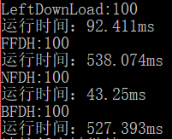
Texture width:100
The number of rectangle:10000
The size of every rectangle(height*width):7*7
The optimal storage height = 5005
The result storage height = 5005
The space utilization = 7*7*10000/(5005*100) = 0.9790
The approximate ratio = 1
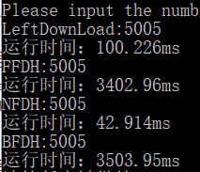
Texture width:100
The number of rectangle:10000
The size of every rectangle(height*width):50*50
The optimal storage height = 250000
The result storage height = 250000
The space utilization = 100%
The approximate ratio = 1
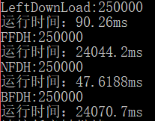
Case 2:Special staggered loop rectangles
Texture width:100
The number of rectangle:10000
The size of every rectangle(height*width):30*30、20*20...(loop)
The optimal storage height = 70010(actually,the minimum is 66690)
The result storage height = 70010(20*20 is a group of 5, and 30*30 is a group of 3)
The space utilization = (20*20*5000+30*30*5000)/(70010*100) = 0.9284
The approximate ratio = 1
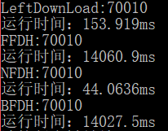
The following is a special example that will make different algorithms make different responses.
Texture width:100
The number of rectangle:7
The size of every rectangle(height*width):30*20 30*20 10*50...(loop)
The optimal storage height = 40
The result storage height = 40(30*20 is a group of 5, and 10*50 is a group of 2)
The space utilization = 1
The approximate ratio = 1
The result is very abnormal, different algorithms actually made the same reaction.We will put the specific analysis in a later module.
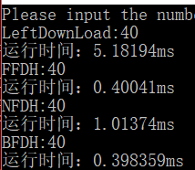
Texture width:100
The number of rectangle:10000
The size of every rectangle(height*width):30*20 10*50 20*25...(loop)
The optimal storage height = 53350 (666*30+1666*10+833*20+30+20)
The result storage height = 53350
The space utilization ≈ 1
The approximate ratio = 1
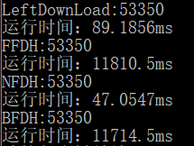
Case 3:Random rectangles
To test the accuracy of the set, we tested each N at least 10 times (smaller N tests more than 10 times) to minimize accidental errors. Below we only show some time consuming during the test.
(a)Given width =100 while the random range is (0,100) for height and width
N=10
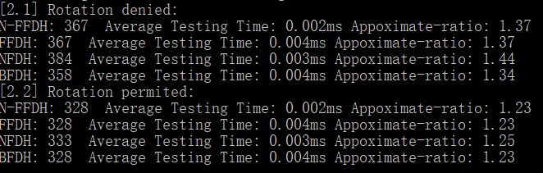
N=100
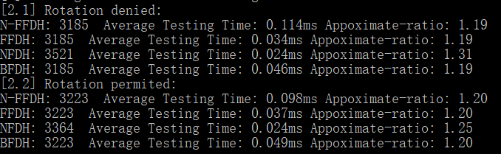
N=500
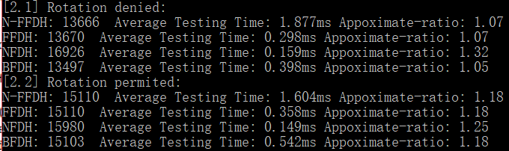

N=1000
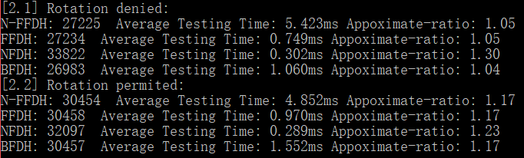

N=2000
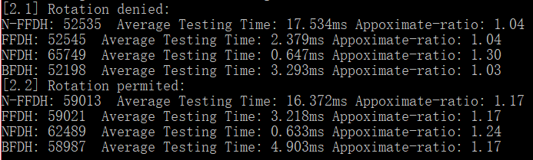

N=5000
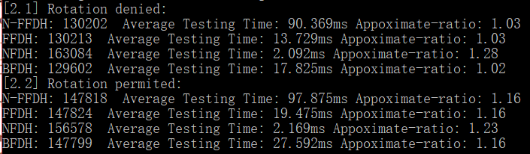

N=10000
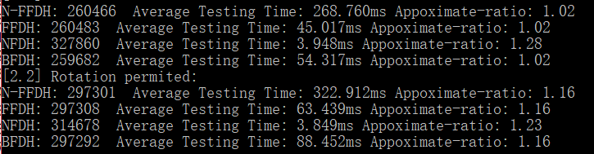
N=50000
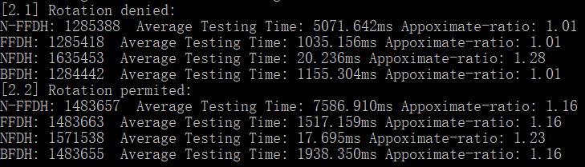
N=100000
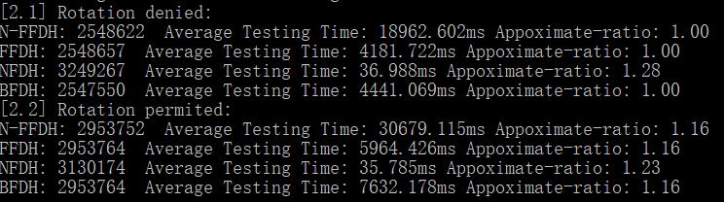
(b)Given width =1000 while the random range is (0,30) for height and width
N=10
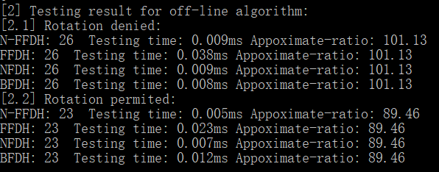
N=100
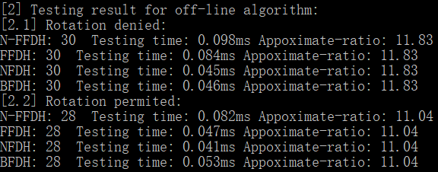
N=500
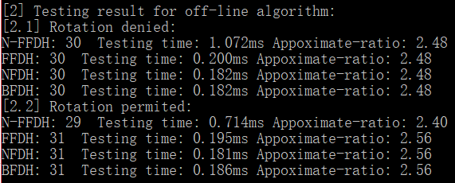
N=1000
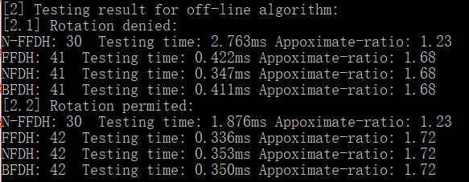

N=2000
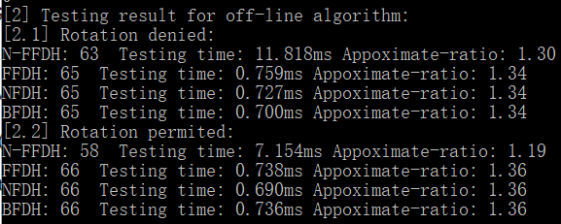

N=5000
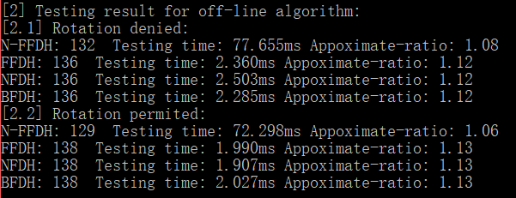

N=10000
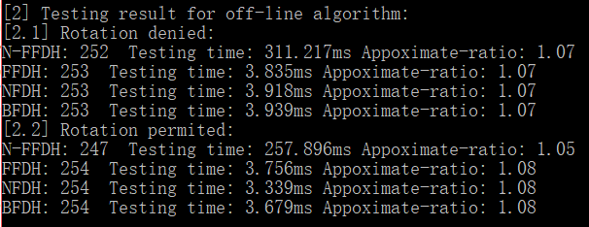
N=50000
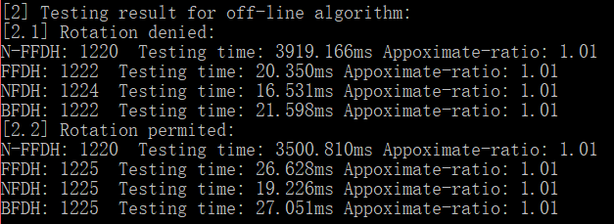
N=100000
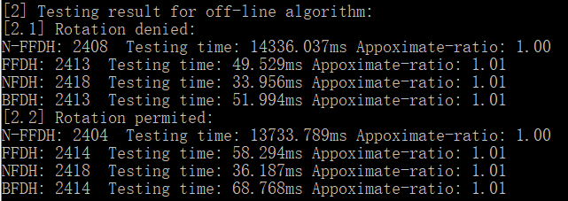

ONLINE PART
Case 1:Special staggered loop rectangles
The number of rectangle:7
The size of every rectangle(height*width):30*20 30*20 10*50...(loop)
The optimal storage height = 40
The result storage height = 50
The space utilization = (30*20*5+10*50*2)/5000=0.8
The approximate ratio = 50/40=1.25

1
2
3
4
5
6
7

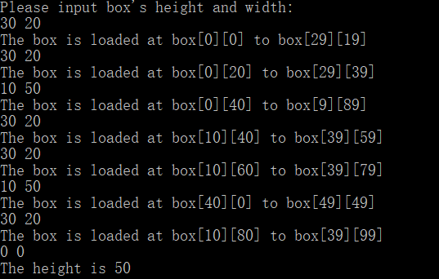
Case 2:Random rectangles
Given width = 1000 while the random range is (0,30) for height and width
online-ordinary&online-faster

N=10
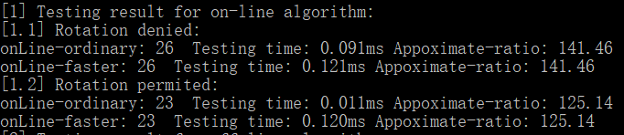
N=100
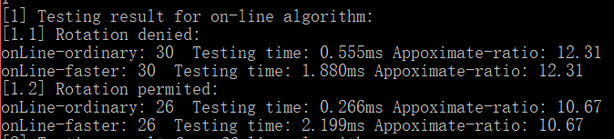
N=500
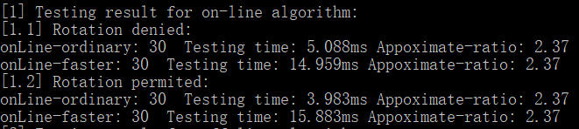
N=1000
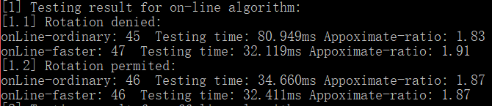

N=2000
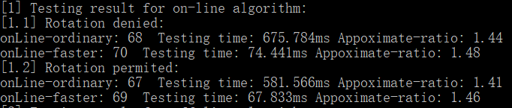
N=5000
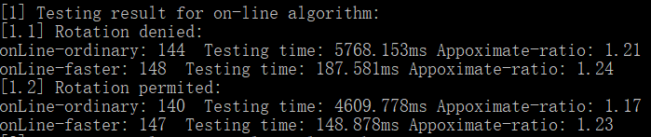
N=10000
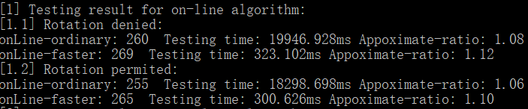
Chapter 4: Analysis
The next two result of given_width = 100 and range of size of box is (1,1) to (100,100)
Through the testing of the examples in various cases, we found multiple impact factors that affect the efficiency and running time of certain algorithms.
Through extensive testing and final error elimination, the NFDH algorithm runs at the fastest rate. When n is large enough (between 2000 and 10000), the running time begins to branch significantly. Although the time complexity of NFDH is the same as FFDH(O(n) = n*logn), the idea of the algorithm is to exchange time for the cost of space, which leads to it is very fast, but the space utilization is also low (the worst space utilization rate is 0.5+e).
However, we found that just changing the given width and the range of the input box width is different from the example tested next. Observing the curve, FFDH and BFDH start to rise at a certain stage, and although NFFDH is a well-defined curve (its time complexity is n²), for the same N, its time cost is much larger.
When we checked the results, we found that the minimum heights of the outputs of all offline algorithms are consistent, which means they are always optimal. Secondly, we compare the width of each box with the maximum width given, and their average ratio is not small, which means that the possibility of bad is greatly increased, as long as a "bulk" box appears, then A level is almost occupied. So we infer that in addition to the algorithm itself, the parameters passed in will also affect the time cost.
The following two charts show the relationship between time overhead and the number of boxes in both cases of rotation(R) and non-rotation(NR).
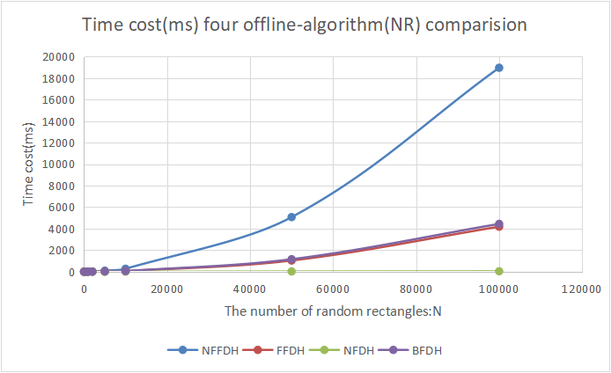
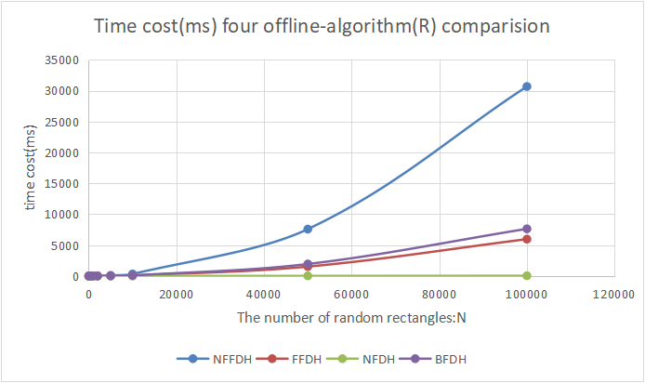

The following results’ given_width = 1000 and range of size of box is (1,1) to (30,30)
However, it is clear that there is a significant difference in time overhead and time complexity in the above tests, which is not in line with expectations. Therefore, we chose to expand the given width and further define the length and width of the box. This time is in line with expectations.
So we conclude that the second factor affecting the time overhead is the ratio of the height and width of the box to the given width.This also shows that if we tend to divide the box into smaller pieces rather than a large piece, then the algorithm will run faster and better. In fact, texture packaging uses a small set of graphs stored as large maps, and then each region is rendered multiple times.
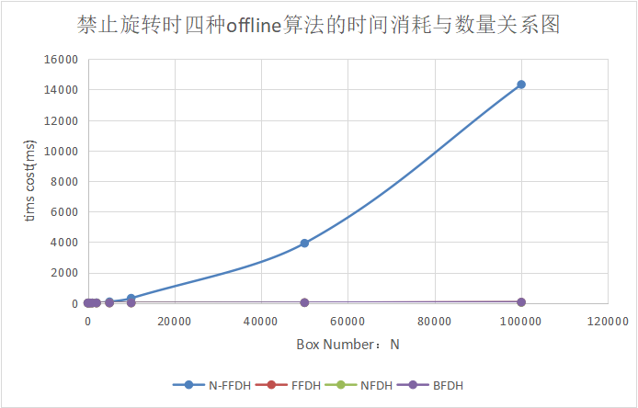
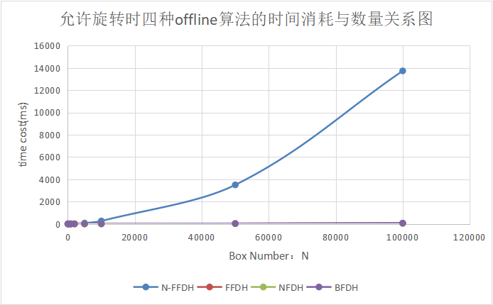
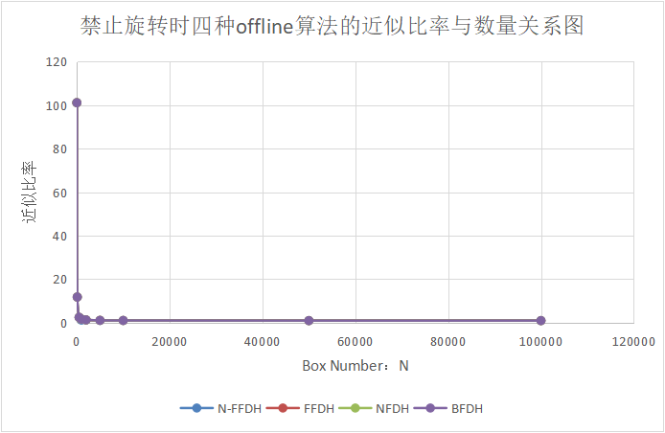
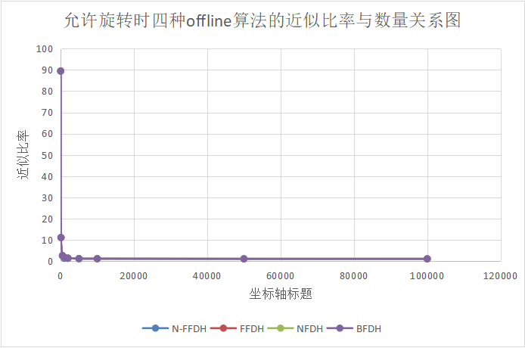
Next, we fit the test set and the theoretical time complexity of each algorithm to observe their fitness.
(1)NFFDH
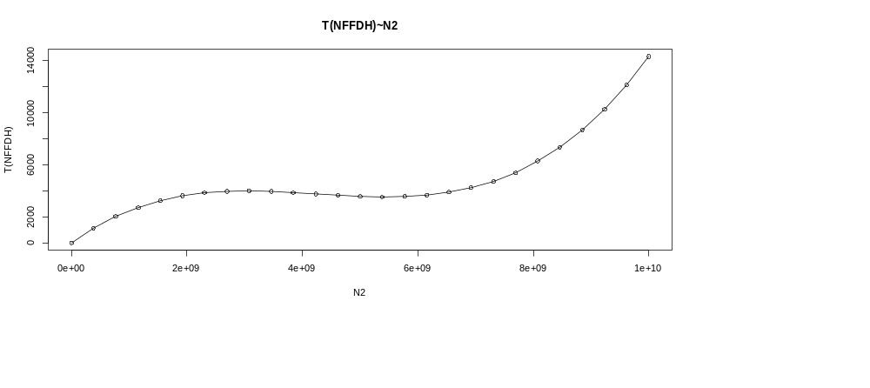
(2)FFDH
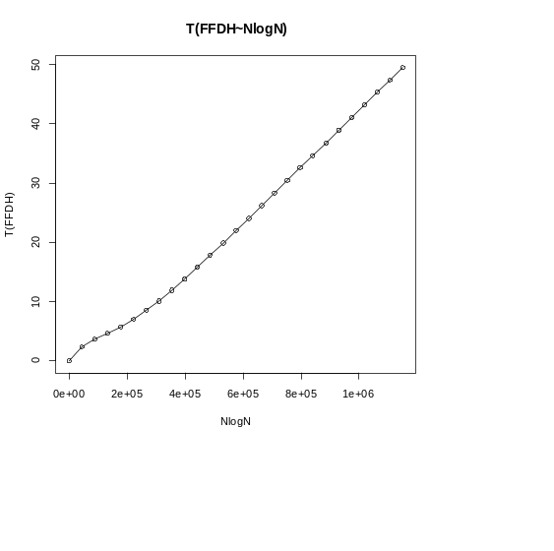
(3)NFDH
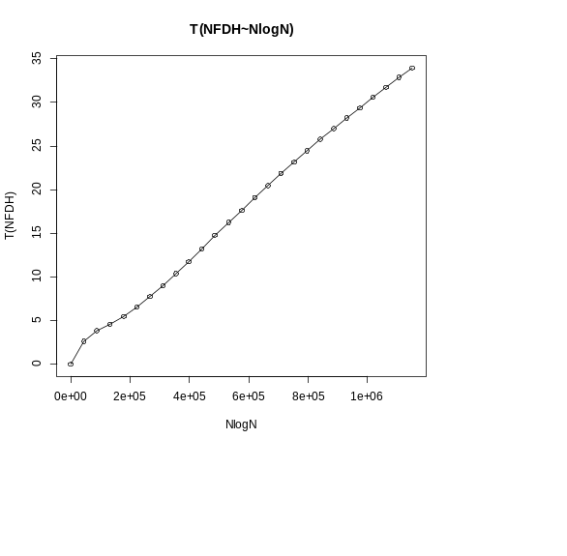
(4)BFDH
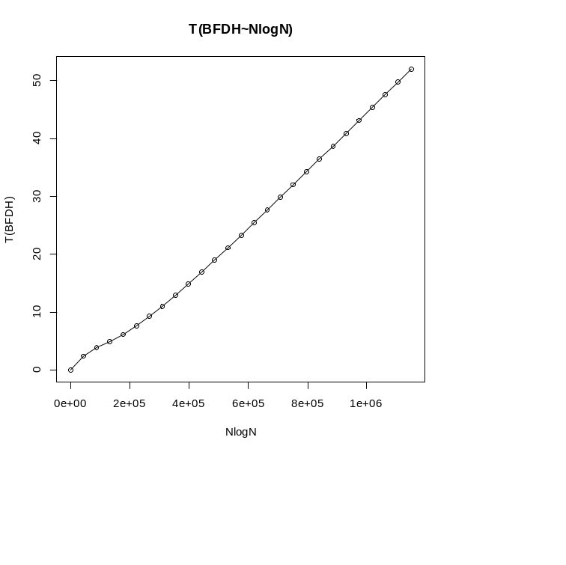
(5)FF-Online-ordinary
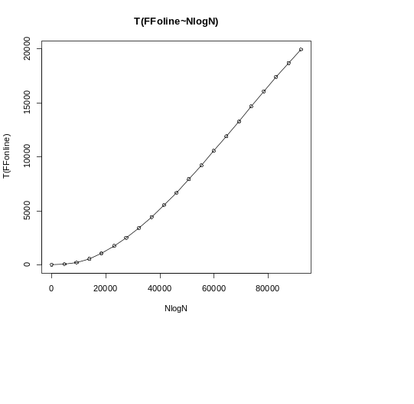
（6）FF-online-faster
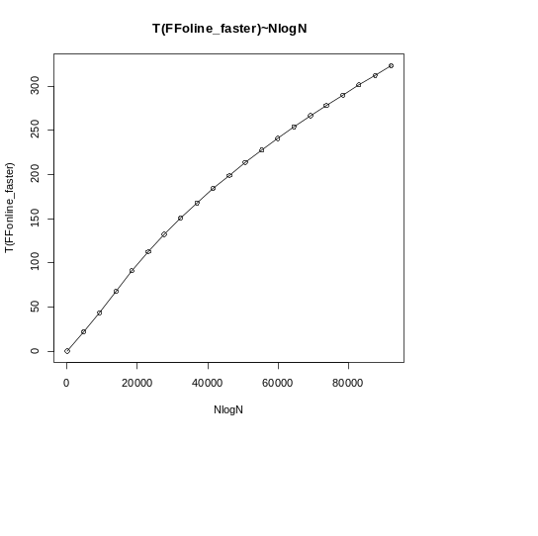
Appendix: Source Code (in C++)
Our source codes include texture_packing.cpp. Thus you can click on the above file to view the source code, so it won't go into details here.
References
[1]B.S. Baker, D.J. Brown, and H.P. Katseff. A 5/4 algorithm for two-dimensional packing. Journal of Algorithms, 2:348--368, 1981.
[2]J.O. Berkey and P.Y. Wong. Two dimensional finite bin packing algorithms. Journal of Operational Research Society, 2:423--429, 1987.
[3]B. Chazelle. The bottom-left bin packing heuristic: An efficient implementation. IEEE Transactions on Computers, 32:697--707, 1983.
[4]F.K.R. Chung, M.R. Garey, and D.S. Johnson. On packing two-dimensional bins. SIAM J. Algebraic Discrete Methods, 3:66--76, 1982.
[5]J.B. Frenk and G.G. Galambos. Hybrid next-fit algorithm for the two-dimensional rectangle bin-packing problem. Computing, 39:201--217, 1987.
[6]E.G. Coffman Jr and M.R. Garey and D.S. Johnson and R.E. Tarjan. Performance bounds for level-oriented two-dimensional packing algorithms.SIAM Journal on Computing, 9:808--826, 1980.
[7]A. Lodi and S. Martello and D. Vigo. Neighborhood search algorithm for the guillotine non-oriented two-dimensional bin packing problem. In S. Voss and S. Martello and I.H. Osman and C. Roucairol, editors, Meta-Heuristics: Advances and Trends in Local Search Paradigms for optimization, pages 125--139. Kluwer Academic Publishers, Boston, 1998.
[8]A. Lodi and S. Martello and D. Vigo. Approximation algorithms for the oriented two-dimensional bin packing problem. Journal of Operational Research Society, 112:158--166, 1999.
[9]A. Lodi and S. Martello and D. Vigo. Heuristic and metaheuristic approaches for a class of two-dimensional bin packing problems. INFORMS Journal on Computing, 11:345--357, 1999.
[10]I. Schiermeyer. Reverse-fit: A 2-optimal algorithm for packing rectangles. In Proceedings of 2nd European Symposium on Algorithms, pages 290--299, Utrecht, The Netherlands, August 1994.
[11]D.D. Sleator. A 2.5 times optimal algorithm for packing in two dimensions. Information Processing Letters, 10(1):37--40, 1980.
[12]A. Steinberg. A strip-packing algorithm with absolute performance bound 2. SIAM Journal on Computing, 9:401--409, 1997.
Author List
Programmer: Wang Yinzhao
Tester&Report Writer: Zou Ziyu
PPT&Presentation:Wang Yiheng

