**CS584 Assignment 1 Report**

**Weilun Zhao; A20329942**

**Department of Computer Science**

**Illinois Institute of Technology**

**February 16, 2016**

# Abstract

In this assignment, there were two parts of regression problems implemented by techniques for parametric regression with Python. In the first single regression part, data were plot and fitted to linear regression and polynomial models. To evaluate the result, using train data sets got the parameters of regression formula, then test data sets were fitted into the hypothesis formula to get difference with the true value. In the second multivariate regression part, loading multiple feature data sets, mapping them to higher dimensional feature space, and testing the result with different data sets.

# Single variable regression

## a). Load data sets and plot the data

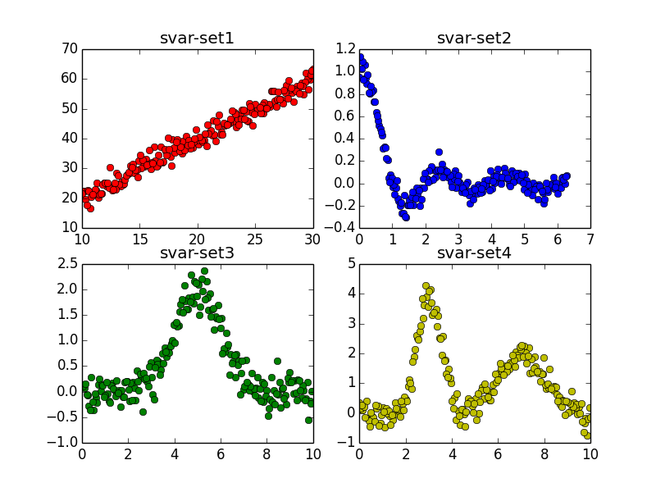

Figure 1

### Analysis:

|  |  |  |
| --- | --- | --- |
| Data Set | Expect Degree | Analysis Idea |
| svar-set1 | 1 | The data points is similar with a line |
| Svar-set2 | 3 or more | Data points neither form line or bow curve |
| Svar-set3 | 2 | Data points look like a bow curve |
| Svar-set4 | 3 or more | Data points neither form a line or bow curve |

## b) Plot train set data and Calculate MSE

### Test set data plot

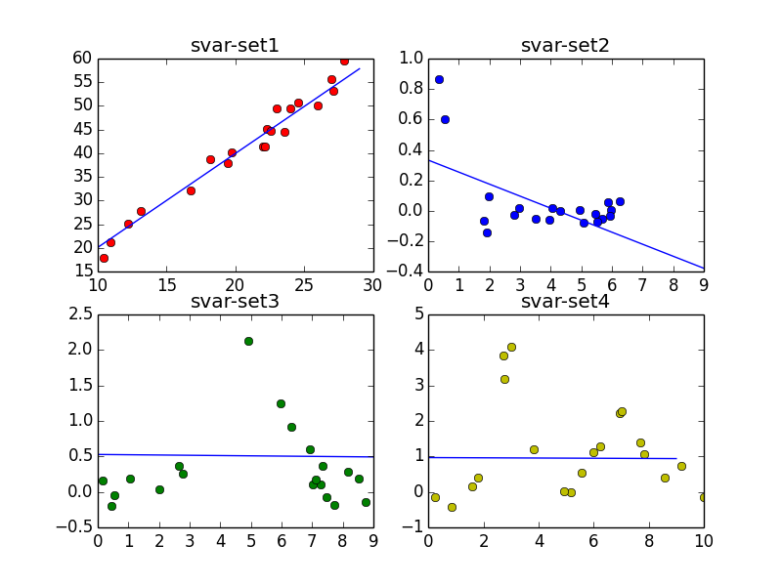

Figure 2

### Train and testing set error in the linear model

The general formula of linear regression: y = a0 * x + a1

The train data size is 180; the test data size is 20

|  |  |  |  |  |
| --- | --- | --- | --- | --- |
| Data Set | A0 | A1 | MSE in train set | MSE in test set |
| Svar-set1 | 1.97734961 | 0.42373779 | 4.23343919 | 4.2521169 |
| Svar-set2 | -0.07891878 | 0.33283915 | 0.06196014 | 0.03825547 |
| Svar-set3 | -0.0038674 | 0.52697054 | 0.51830252 | 0.32597774 |
| Svar-set4 | -0.00315079 | 0.96590264 | 1.14315024 | 1.72445474 |

## c) Compare my results with the results from ready made Python function

### My function theory:

The hypothesis formula is :

$${\hat{y}}_{i}=h_{θ}\left(x_{i}\right)= θ_{0}+θ_{1}*x_{i}$$

The residual sum of squares:

$$J= \sum_{i=1}^{m}{(y_{i}-(}θ_{0}+θ_{1}*x_{i}))^{2}$$

To get the minimum RSS, derivative the RSS formula:

$$∇J=0$$

$$\frac{∂J}{∂θ_{0}}= \sum_{i=1}^{m}{(y_{i}-(}θ_{0}+θ_{1}*x_{i}))*1$$

$$\frac{∂J}{∂θ_{1}}= \sum_{i=1}^{m}{(y_{i}-(}θ_{0}+θ_{1}*x_{i}))*x_{i}$$

Expand the formula above:

$$mθ_{0}+\sum_{i=1}^{m}{x_{i}}*θ_{1}- \sum_{i=1}^{m}{y_{i}}=0$$

$$\sum_{i=1}^{m}{x_{i}*θ_{0}}+\sum_{i=1}^{m}{{(x_{i})}^{2}}*θ_{1}- \sum_{i=1}^{m}{{x_{i}*y}_{i}}=0$$

Basing on the svar-set data, I can get the $\sum_{i=1}^{m}{x_{i}}$, $\sum_{i=1}^{m}{y_{i}}$, $\sum_{i=1}^{m}{{(x_{i})}^{2}}$, and $\sum_{i=1}^{m}{{x_{i}*y}_{i}}$. Then solve the Expand formula of partial derivative of RSS and get coefficient of the linear regression.

### The coefficient of the linear regression:

|  |  |
| --- | --- |
| Data set | Coefficient |
| Svar-set1 | [ 1.97734961 0.42373779] |
| Svar-set2 | [-0.07891878 0.33283915] |
| Svar-set3 | [-0.0038674 0.52697054] |
| Svar-set4 | [-0.00315079 0.96590264] |

*comment: in the coefficient array, the coefficient[0] is $θ_{1}$; coefficient[1] is $θ_{0}$

### The python function:

import statsmodels.api as sm

def data_Anaylsis(xdata, ydata):

x = sm.add_constant(xdata)

est = sm.OLS(ydata, x).fit()

print est.summary()

Using the summary to get coefficient for the linear regression formula with different data sets.

The coefficient result of my theory is same ready made python function.

## d) Test different polynomial models

In this part, the data sets are fitted into different degree models and test the MSE to evaluate the result of fitness

### Data plant

|  |  |  |  |
| --- | --- | --- | --- |
| Data set | Degree | MSE of train set data | MSE of test set data |
| Svar-set1 | 1 | 4.23343919 | 4.2521169 |
|  | 2 | 4.2331114 | 4.24934548 |
|  | 3 | 4.17233278 | 4.11927854 |
|  | 4 | 4.10154024 | 4.53085946 |
|  | 5 | 4.09383144 | 4.54046111 |
| Svar-set2 | 1 | 0.06196014 | 0.03825547 |
|  | 2 | 0.041162 | 0.01675475 |
|  | 3 | 0.02126954 | 0.01268473 |
|  | 4 | 0.0120708 | 0.00662936 |
|  | 5 | 0.01162945 | 0.00647401 |
| Svar-set3 | 1 | 0.51830252 | 0.32597774 |
|  | 2 | 0.25512431 | 0.24631473 |
|  | 3 | 0.25508276 | 0.24752208 |
|  | 4 | 0.12957968 | 0.10322223 |
|  | 5 | 0.12943639 | 0.10140347 |
| Svar-set4 | 1 | 1.14315024 | 1.72445474 |
|  | 2 | 0.87498088 | 1.41351243 |
|  | 3 | 0.87024017 | 1.37029609 |
|  | 4 | 0.80784537 | 1.24375014 |
|  | 5 | 0.76140198 | 1.20543009 |

svar-set1: MSE of train and test set data l is least data in the 3 degree polynomial model

svar-set2: MSE of train and test set data l is least data in the 5 degree polynomial model

svar-set3: MSE of train and test set data l is least data in the 5 degree polynomial model

svar-set4: MSE of train and test set data l is least data in the 5 degree polynomial model

### The plot graph

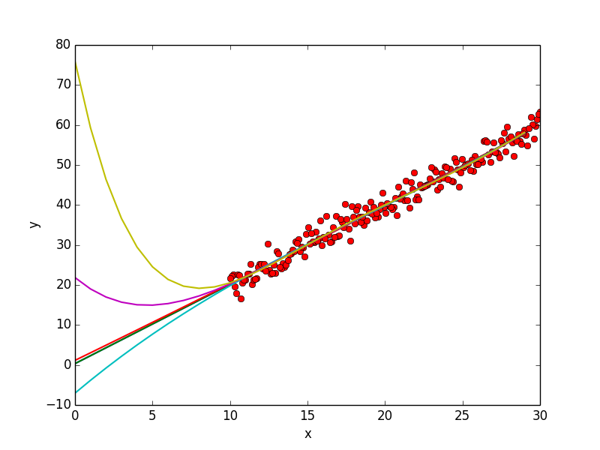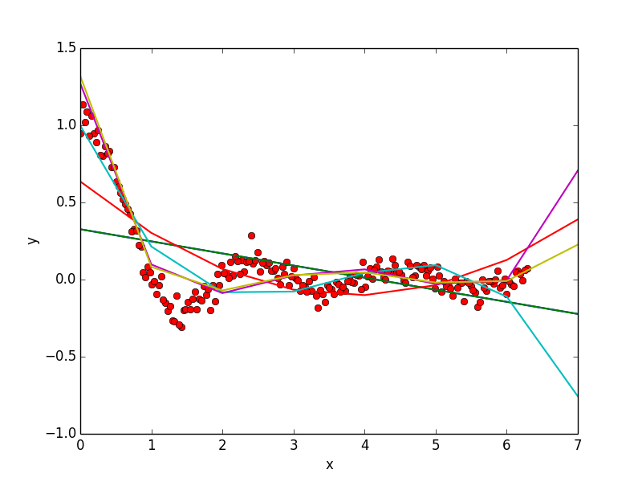

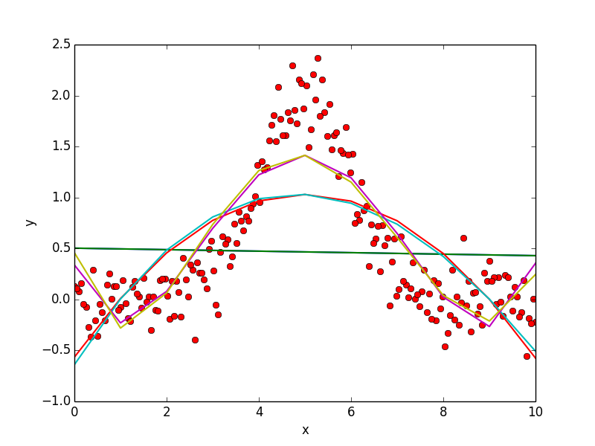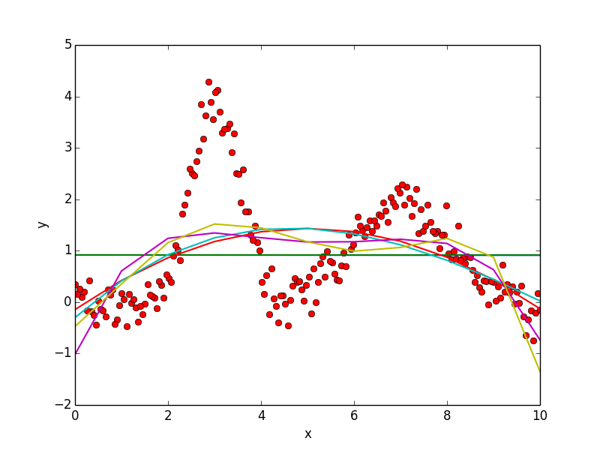

comment: Green like is one degree; red is for two degree; cyan is for 3 degree; purple is for 4 degree; yellow is for 5 degree

## e) Reduce the amount of training data and observe the effect of performance

The train data size is 150; the test data size is 50

## Data plant

|  |  |  |  |
| --- | --- | --- | --- |
| Data set | Degree | MSE of train set data | MSE of test set data |
| Svar-set1 | 1 | 4.22038643 | 4.29856341 |
|  | 2 | 4.21587319 | 4.34355935 |
|  | 3 | 4.17893242 | 4.21425175 |
|  | 4 | 4.14667685 | 4.17825535 |
|  | 5 | 4.1386093 | 4.17958162 |
| Svar-set2 | 1 | 0.06182678 | 0.05311341 |
|  | 2 | 0.04134559 | 0.03135766 |
|  | 3 | 0.0211801 | 0.01896487 |
|  | 4 | 0.01179757 | 0.0108183 |
|  | 5 | 0.01153065 | 0.00994813 |
| Svar-set3 | 1 | 0.47699844 | 0.56679837 |
|  | 2 | 0.23802506 | 0.29984929 |
|  | 3 | 0.23721062 | 0.30493155 |
|  | 4 | 0.12312189 | 0.14093139 |
|  | 5 | 0.12145707 | 0.14646803 |
| Svar-set4 | 1 | 1.0816912 | 1.57115126 |
|  | 2 | 0.85272863 | 1.18469433 |
|  | 3 | 0.84918374 | 1.16235166 |
|  | 4 | 0.78452564 | 1.07263819 |
|  | 5 | 0.75065473 | 0.99141371 |

### Observe

There is no apparent difference of MSE, if reduce the amount of train data. However, MSE of test set data increase in a small certain degree based on the observation of comparison with original MSE of data set

# Multivariate regression

## a) Load the multiple feature data sets, and map into higher dimension

### Data load

The data of mvar-set1 and mvar-set2 can be plot into 3 dimension graph, but mvar-set3 and mvar-set4 have 6 columns data and cannot display in graph.

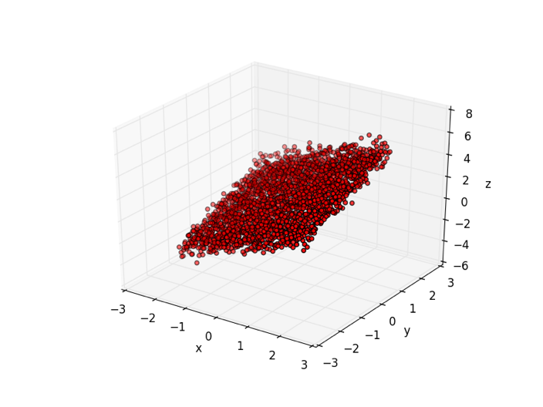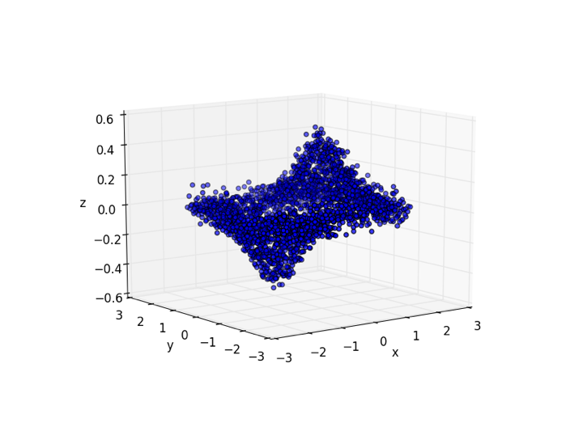

### Data linear regression

Mvar-set1 and mvar-set2 linear hypothesis formula:

$$y=a_{0}+a_{1}*x_{0}+a_{2}*x_{1}$$

Mvar-set3 and mvar-set4 linear hypothesis formula:

$$y=a_{0}+a_{1}*x_{0}+a_{2}*x_{1}+a_{3}*x_{2}+a_{4}*x_{3}+a_{5}*x_{4}$$

### Mapping data into higher dimension

Mvar-set1 and mvar-set2 higher dimensional hypothesis formula:

$$y=a_{0}+a_{1}*x_{0}+a_{2}*x_{1}+a_{3}*x_{0}^{2}+ a_{4}*x_{0}*x_{1}+a_{5}*x_{1}^{2}$$

Mvar-set3 and mvar-set4 higher dimensional hypothesis formula:

$$y=a_{0}+a_{1}*x_{0}+a_{2}*x_{1}+a_{3}*x_{2}+a_{4}*x_{3}+a_{5}*x_{4}+a_{6}*x_{0}^{2}+a_{7}*x_{1}^{2}+a_{8}*x_{2}^{2}+a_{9}*x_{3}^{2}+a_{10}*x_{4}^{2}$$

## b) Perform linear regression in the higher dimensional space

### Linear regression coefficient and MSE

In the linear regression model of mvar-set1 and mvar-set2:

$$y=a_{0}+a_{1}*x_{0}+a_{2}*x_{1}$$

|  |  |  |  |  |
| --- | --- | --- | --- | --- |
| Data Set | A0 | A1 | A2 | MSE |
| Mvar-set1 | 0.9959 | 0.9975 | 0.9905 | 0.258702892151 |
| Mvar-set2 | 0.0009 | 0.0646 | -0.0006 | 0.0199118768693 |

In the linear regression model of mvar-set3 and mvar-set4:

$$y=a_{0}+a_{1}*x_{0}+a_{2}*x_{1}+a_{3}*x_{2}+a_{4}*x_{3}+a_{5}*x_{4}$$

|  |  |  |  |  |  |  |  |
| --- | --- | --- | --- | --- | --- | --- | --- |
| Data Set | A0 | A1 | A2 | A3 | A4 | A5 | MSE |
| Mvar-set3 | 0.9989 | 0.9979 | 1.0008 | 0.9988 | -0.0012 | 1.9998 | 0.250743148719 |
| Mvar-set4 | 0.0101 | 4.668e-05 | 0.0001 | 3.952e-05 | 0.0002 | -1.837e-06 | 0.00418917439966 |

### Higher regression result with MSE

Mapping data into higher dimensional follow the formula below:

* Mvar-sert1, Mvar-set2: $y=a_{0}+a_{1}*x_{0}+a_{2}*x_{1}+a_{3}*x_{0}^{2}+ a_{4}*x_{0}*x_{1}+a_{5}*x_{1}^{2}$
* Mvar-sert3, Mvar-set4: $y=a_{0}+a_{1}*x_{0}+a_{2}*x_{1}+a_{3}*x_{2}+a_{4}*x_{3}+a_{5}*x_{4}+a_{6}*x_{0}^{2}+a_{7}*x_{1}^{2}+a_{8}*x_{2}^{2}+a_{9}*x_{3}^{2}+a_{10}*x_{4}^{2}$

|  |  |  |  |  |
| --- | --- | --- | --- | --- |
| Data Set | Amount of train data | Amount of test data | Train set MSE | Test set MSE |
| Mvar-set1 | 2450 | 50 | 0.25800120516 | 0.281907095552 |
| Mvar-set2 | 2450 | 50 | 0.0200158719878 | 0.0147231540775 |
| Mvar-set3 | 99900 | 100 | 14.4838115942 | 12.3854983595 |
| Mvar-set4 | 99900 | 100 | 0.00395142847316 | 0.00319633351941 |

## c) Solve the regression problem using explicit solution and iterative solution

### Explicit solution

#### The Explicit Solution Theory:

The hypothesis formula is :

$${\hat{y}}_{i}=h_{θ}\left(x_{i}\right)= θ^{T}Z_{i}$$

The residual sum of squares:

$$J= \sum_{i=1}^{m}{{(θ^{T}Z_{i}-y_{i})}^{2}}$$

To get the minimum RSS, we need figure out the coefficient of parameter

$$θ^{*}=\arg{min}J(θ)$$

$$J={\left(Zθ-Y\right)}^{T}(Zθ-Y)$$

Partial derivative for the RSS to get the minimum value of RSS:

$$∇J(θ)=0$$

$$2Z^{T}(Zθ-Y)=0$$

$$Z^{T}Zθ=Z^{T}Y$$

$$θ={(Z^{T}Z)}^{-1}Z^{T}Y$$

#### The Explicit Solution Result

Mvar-set1 and Mvar-set2 hypothesis formula:

$$y=a_{0}*x_{0}+a_{1}*x_{1}$$

|  |  |  |  |  |
| --- | --- | --- | --- | --- |
| Data Set | A0 | A1 | MSE_train | MSE_test |
| Mvar-set1 | 0.99752589 | 0.99048461 | 1.2504733 | 1.25109853 |
| Mvar-set2 | 0.06458313 | -0.00060792 | 0.01991267 | 0.01995297 |

Mvar-set3 and mvar-set4 hypothesis formula:

$$y=a_{0}*x_{0}+a_{1}*x_{1}+a_{2}*x_{2}+a_{3}*x_{3}+a_{4}*x_{4}$$

|  |  |  |  |  |  |  |  |
| --- | --- | --- | --- | --- | --- | --- | --- |
| Data Set | A0 | A1 | A2 | A3 | A4 | MES_train | MSE_test |
| Mvarset3 | 9.98888180e-01 | 1.00066063e+00 | 9.98744225e-01 | -1.59114109e-03 | 1.99987699e+00 | 1.24861541 | 1.24851603 |
| Mvar-set4 | 5.29559018e-05 | 1.10912497e-04 | 3.81903871e-05 | 2.38354477e-04 | -3.53383038e-06 | 0.00429159 | 0.00429166 |

### Iterative solution

#### Iterative solution theory: (gradient descent)

Using iterative equation to decrease the MSE at each step to get the approximate result which is very close the actual result.

The residual sum of squares:

$$J= \sum_{i=1}^{m}{{(θ^{T}Z_{i}-y_{i})}^{2}}={\left(Zθ-Y\right)}^{T}(Zθ-Y)$$

$$∇J\left(θ\right)= Z^{T}(Zθ-Y)$$

In the gradient descent:

$θ_{i}= θ_{i-1}- η \left(Z^{T}\left(Zθ-Y\right)\right)$; $η$ is the length of step

#### Iterative solution result

Mvar-set1 and mvar-set2 linear hypothesis formula:

$$y=a_{0}+a_{1}*x_{0}+a_{2}*x_{1}$$

|  |  |  |  |  |  |  |
| --- | --- | --- | --- | --- | --- | --- |
| Data Set | Num_iteration | learning rate | A0 | A1 | A2 | MSE |
| Mvar-set1 | 1000 | 0.001 | 0.86136909 | 0.93560181 | 0.92899764 | 0.28736327 |
| Mvar-set2 | 1000 | 0.000001 | 0.00198976 | 0.00276481 | 0.00274529 | 0.025232 |

Mvar-set3 and mvar-set4 linear hypothesis formula:

$$y=a_{0}+a_{1}*x_{0}+a_{2}*x_{1}+a_{3}*x_{2}+a_{4}*x_{3}+a_{5}*x_{4}$$

|  |  |  |  |  |  |  |  |  |  |
| --- | --- | --- | --- | --- | --- | --- | --- | --- | --- |
| Data Set | Num  Iteration | Learning rate | A0 | A1 | A2 | A3 | A4 | A5 | MSE |
| Mvar-set3 | 100 | 0.1 | 0.99909956 | 0.99955968 | 1.00165288 | 0.99814789 | -0.00136831 | 0.66673759 | 3.21724785 |
| Mvarset4 | 100 | 0.01 | 0.00877825 | 4.67960439e-05 | 0.00010606 | 3.78883215e-05 | 0.00023086 | 0.00022281 | 0.00419106 |

## d) Gaussian kernel function

### Gaussian kernel Theory:

The Gaussian density formula:

$$K\left(X, Y\right)= exp⁡(-\frac{{\left||x-y|\right|}^{2}}{2r^{2}})$$

Matrix G is Gaussian kernel Gram matrix:

$$G= \left[\begin{matrix}K\left(X_{1},X_{1} \right) & ⋯ & K\left(X_{1},X_{m} \right) \\ ⋮ & ⋱ & ⋮ \\ K\left(X_{m},X_{1} \right) & ⋯ & K\left(X_{m},X_{m} \right)\end{matrix}\right]$$

$$α=G^{-1}Y$$

$$h_{α}\left(X\right)= \sum_{i=1}^{m}{αK(X, X^{i})}$$

### Gaussian kernel result:

|  |  |  |
| --- | --- | --- |
| Data Set | Train set MSE | Test set MSE |
| Mvar-set1 | -0.000592494783072 | 0.114285660424 |
| Mvar-set2 | 0.000329163130249 | -0.0163264909216 |
| Mvar-set3 | -1.19652527498e-05 | -0.654729722302 |
| Mvar-set4 | -2.46044821317e-05 | 0.22851579077 |

# Conclude

Test set MSE is increase with the data set degree and the train set MSE is extremely small than the model above. As a result, Gaussian kernel regression have a relative good result with less MSE in all the model. And The set data can be unpredictable, but it still fit the linear and polynomial regression formula got from the train set data.

# Reference:

<http://docs.scipy.org/doc/numpy-1.10.1/index.html>

<http://docs.scipy.org/doc/scipy-0.16.0/reference/generated/scipy.stats.norm.html>

<http://stackoverflow.com/questions/29731726/how-to-calculate-a-gaussian-kernel-matrix-efficiently-in-numpy>