CS 584 Assignment 2

Weilun Zhao; A20329942

Skin segmentation data set

**Number of Instances**

245057

avg1: 113.869875538

avg2: 127.997481951

ri_cov: 3875.76629985

TP: 27174 119725

FN: 23685 74473

FP: 74473 23685

TN: 119725 27174

TotTp: 146899

TotFN: 98158

TotFP: 98158

TotTN: 146899

Accurcy 1 0.599448291622

Precision 1 0.267336960264

Recall 1 0.534300713738

Fmeasure 1 0.356366306899

Accurcy 2 0.599448291622

Precision 2 0.834844153127

Recall 2 0.616509953759

Fmeasure 2 0.709254520035

Accurcy tot 0.599448291622

Precision tot 0.599448291622

Recall tot 0.599448291622

Fmeasure tot 0.599448291622

Seeds data set

numFeature: 7

data size: 140

avg1

[ 14.33442857 14.29428571 0.88007 5.50805714 3.24462857

2.66740286 5.08721429]

avg2

[ 18.33428571 16.13571429 0.88351714 6.14802857 3.67741429 3.6448

6.0206 ]

cov

[[ 5.79076145e+00 2.62458597e+00 1.01168268e-02 9.19557150e-01

6.49095733e-01 9.15269469e-01 1.18693293e+00]

[ 2.62458597e+00 1.20781367e+00 2.63444964e-03 4.32234892e-01

2.85092194e-01 4.23453014e-01 5.55819748e-01]

[ 1.01168268e-02 2.63444964e-03 2.52383627e-04 -1.64414111e-04

2.24618863e-03 5.73399506e-04 4.61209815e-05]

[ 9.19557150e-01 4.32234892e-01 -1.64414111e-04 1.65437192e-01

9.36524163e-02 1.44279791e-01 2.08303616e-01]

[ 6.49095733e-01 2.85092194e-01 2.24618863e-03 9.36524163e-02

7.99114600e-02 1.05177027e-01 1.21504355e-01]

[ 9.15269469e-01 4.23453014e-01 5.73399506e-04 1.44279791e-01

1.05177027e-01 1.61799141e+00 2.15866469e-01]

[ 1.18693293e+00 5.55819748e-01 4.61209815e-05 2.08303616e-01

1.21504355e-01 2.15866469e-01 2.85896747e-01]]

TP: 68 70

FN: 2 0

FP: 0 2

TN: 70 68

TotTp: 138

TotFN: 2

TotFP: 2

TotTN: 138

Accurcy 1 0.985714285714

Precision 1 1.0

Recall 1 0.971428571429

Fmeasure 1 0.985507246377

Accurcy 2 0.985714285714

Precision 2 0.972222222222

Recall 2 1.0

Fmeasure 2 0.985915492958

Accurcy tot 0.985714285714

Precision tot 0.985714285714

Recall tot 0.985714285714

Fmeasure tot 0.985714285714

Threshold = 0.1

TP: 56 70

FN: 14 0

FP: 0 14

TN: 70 56

TotTp: 126

TotFN: 14

TotFP: 14

TotTN: 126

Accurcy 1 0.9

Precision 1 1.0

Recall 1 0.8

Fmeasure 1 0.888888888889

Accurcy 2 0.9

Precision 2 0.833333333333

Recall 2 1.0

Fmeasure 2 0.909090909091

Accurcy tot 0.9

Precision tot 0.9

Recall tot 0.9

Fmeasure tot 0.9

Threshold = 0.2

TP: 64 70

FN: 6 0

FP: 0 6

TN: 70 64

TotTp: 134

TotFN: 6

TotFP: 6

TotTN: 134

Accurcy 1 0.957142857143

Precision 1 1.0

Recall 1 0.914285714286

Fmeasure 1 0.955223880597

Accurcy 2 0.957142857143

Precision 2 0.921052631579

Recall 2 1.0

Fmeasure 2 0.958904109589

Accurcy tot 0.957142857143

Precision tot 0.957142857143

Recall tot 0.957142857143

Fmeasure tot 0.957142857143

Threshold = 0.3

TP: 67 70

FN: 3 0

FP: 0 3

TN: 70 67

TotTp: 137

TotFN: 3

TotFP: 3

TotTN: 137

Accurcy 1 0.978571428571

Precision 1 1.0

Recall 1 0.957142857143

Fmeasure 1 0.978102189781

Accurcy 2 0.978571428571

Precision 2 0.958904109589

Recall 2 1.0

Fmeasure 2 0.979020979021

Accurcy tot 0.978571428571

Precision tot 0.978571428571

Recall tot 0.978571428571

Fmeasure tot 0.978571428571

Threshold = 0.4

TP: 68 70

FN: 2 0

FP: 0 2

TN: 70 68

TotTp: 138

TotFN: 2

TotFP: 2

TotTN: 138

Accurcy 1 0.985714285714

Precision 1 1.0

Recall 1 0.971428571429

Fmeasure 1 0.985507246377

Accurcy 2 0.985714285714

Precision 2 0.972222222222

Recall 2 1.0

Fmeasure 2 0.985915492958

Accurcy tot 0.985714285714

Precision tot 0.985714285714

Recall tot 0.985714285714

Fmeasure tot 0.985714285714

Red line for class 1; green line for class 2;

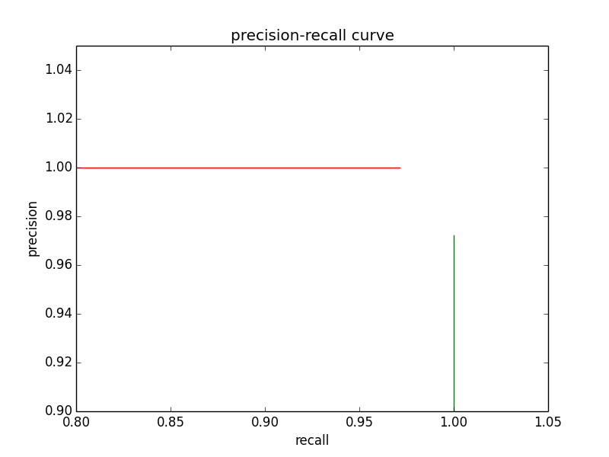

Feature1:

Accurcy 1 0.914285714286

Precision 1 0.881578947368

Recall 1 0.957142857143

Fmeasure 1 0.917808219178

Accurcy 2 0.914285714286

Precision 2 0.953125

Recall 2 0.871428571429

Fmeasure 2 0.910447761194

Accurcy tot 0.914285714286

Precision tot 0.914285714286

Recall tot 0.914285714286

Fmeasure tot 0.914285714286

Feature 2:

TP: 66 63

FN: 4 7

FP: 7 4

TN: 63 66

TotTp: 129

TotFN: 11

TotFP: 11

TotTN: 129

Accurcy 1 0.921428571429

Precision 1 0.904109589041

Recall 1 0.942857142857

Fmeasure 1 0.923076923077

Accurcy 2 0.921428571429

Precision 2 0.940298507463

Recall 2 0.9

Fmeasure 2 0.919708029197

Accurcy tot 0.921428571429

Precision tot 0.921428571429

Recall tot 0.921428571429

Fmeasure tot 0.921428571429

Feature 3:

TP: 51 16

FN: 19 54

FP: 54 19

TN: 16 51

TotTp: 67

TotFN: 73

TotFP: 73

TotTN: 67

Accurcy 1 0.478571428571

Precision 1 0.485714285714

Recall 1 0.728571428571

Fmeasure 1 0.582857142857

Accurcy 2 0.478571428571

Precision 2 0.457142857143

Recall 2 0.228571428571

Fmeasure 2 0.304761904762

Accurcy tot 0.478571428571

Precision tot 0.478571428571

Recall tot 0.478571428571

Fmeasure tot 0.478571428571

Feature 4:

TP: 65 64

FN: 5 6

FP: 6 5

TN: 64 65

TotTp: 129

TotFN: 11

TotFP: 11

TotTN: 129

Accurcy 1 0.921428571429

Precision 1 0.915492957746

Recall 1 0.928571428571

Fmeasure 1 0.921985815603

Accurcy 2 0.921428571429

Precision 2 0.927536231884

Recall 2 0.914285714286

Fmeasure 2 0.920863309353

Accurcy tot 0.921428571429

Precision tot 0.921428571429

Recall tot 0.921428571429

Fmeasure tot 0.921428571429

Feature5:

TP: 60 62

FN: 10 8

FP: 8 10

TN: 62 60

TotTp: 122

TotFN: 18

TotFP: 18

TotTN: 122

Accurcy 1 0.871428571429

Precision 1 0.882352941176

Recall 1 0.857142857143

Fmeasure 1 0.869565217391

Accurcy 2 0.871428571429

Precision 2 0.861111111111

Recall 2 0.885714285714

Fmeasure 2 0.87323943662

Accurcy tot 0.871428571429

Precision tot 0.871428571429

Recall tot 0.871428571429

Fmeasure tot 0.871428571429

Feature6:

TP: 51 43

FN: 19 27

FP: 27 19

TN: 43 51

TotTp: 94

TotFN: 46

TotFP: 46

TotTN: 94

Accurcy 1 0.671428571429

Precision 1 0.653846153846

Recall 1 0.728571428571

Fmeasure 1 0.689189189189

Accurcy 2 0.671428571429

Precision 2 0.693548387097

Recall 2 0.614285714286

Fmeasure 2 0.651515151515

Accurcy tot 0.671428571429

Precision tot 0.671428571429

Recall tot 0.671428571429

Fmeasure tot 0.671428571429

Feature7:

TP: 69 68

FN: 1 2

FP: 2 1

TN: 68 69

TotTp: 137

TotFN: 3

TotFP: 3

TotTN: 137

Accurcy 1 0.978571428571

Precision 1 0.971830985915

Recall 1 0.985714285714

Fmeasure 1 0.978723404255

Accurcy 2 0.978571428571

Precision 2 0.985507246377

Recall 2 0.971428571429

Fmeasure 2 0.978417266187

Accurcy tot 0.978571428571

Precision tot 0.978571428571

Recall tot 0.978571428571

Fmeasure tot 0.978571428571

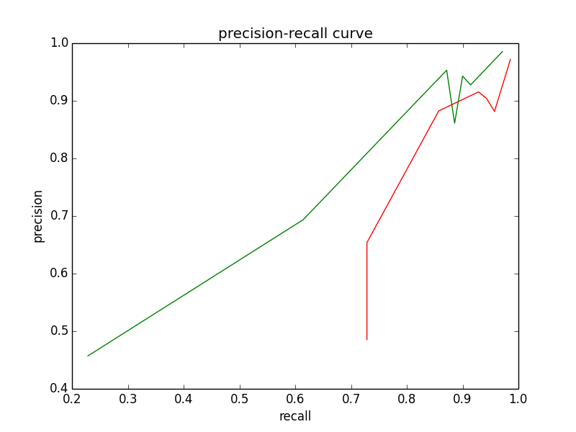

The area for class 1:

0.21519380214

The precision-recall area for class 2:

0.527496830108

Data Set: Iris

Using first colume data, (sepal length in cm)

Iris-setosa = 1

Iris-versicolor =2

Iris-virginica=3

(150,)

avg1: 5.006

avg2: 5.936

avg3: 6.588

ri_cov: 0.685693512304

threshold: 1/2

TP: 45 30 37

FN: 5 20 13

FP: 7 17 14

TN: 93 46 11

TotTp: 112

TotFN: 38

TotFP: 38

TotTN: 150

Accurcy 1 0.92

Precision 1 0.865384615385

Recall 1 0.9

Fmeasure 1 0.882352941176

Accurcy 2 0.672566371681

Precision 2 0.63829787234

Recall 2 0.6

Fmeasure 2 0.618556701031

Accurcy 3 0.64

Precision 3 0.725490196078

Recall 3 0.74

Fmeasure 3 0.732673267327

Accurcy tot 0.775147928994

Precision tot 0.746666666667

Recall tot 0.746666666667

Fmeasure tot 0.746666666667

Data set iris : (3class, 4features)

numFeature: 4

data size: 150

TP: 49 42 39

FN: 1 8 11

FP: 0 12 8

TN: 100 49 1

TotTp: 130

TotFN: 20

TotFP: 20

TotTN: 150

Accurcy 1 0.993333333333

Precision 1 1.0

Recall 1 0.98

Fmeasure 1 0.989898989899

Accurcy 2 0.81981981982

Precision 2 0.777777777778

Recall 2 0.84

Fmeasure 2 0.807692307692

Accurcy 3 0.677966101695

Precision 3 0.829787234043

Recall 3 0.78

Fmeasure 3 0.80412371134

Accurcy tot 0.875

Precision tot 0.866666666667

Recall tot 0.866666666667

Fmeasure tot 0.866666666667

Date set spame email:

Naïve Bayes with Bernoulli features

numFeature: 57

data size: 4601

(4601, 57)

(4601, 58)

1813.0

2788.0

0.394044772875

[ 1. 1. 1. ..., 0. 0. 0.]

1668

TP: 1478 2598

FN: 335 190

FP: 190 335

TN: 2598 1478

Accurcy 1 0.885894370789

Precision 1 0.886091127098

Recall 1 0.815223386652

Fmeasure 1 0.84918126975

Accurcy 2 0.885894370789

Precision 2 0.885782475281

Recall 2 0.931850789096

Fmeasure 2 0.908232826429

Naïve Bayes with Binomial feature:

**Attribute Information:**

Class Values:   
  
unacc, acc, good, vgood   
  
Attributes:   
  
buying: vhigh, high, med, low.   
maint: vhigh, high, med, low.   
doors: 2, 3, 4, 5more.   
persons: 2, 4, more.   
lug_boot: small, med, big.   
safety: low, med, high.

numFeature: 6

data size: 1728

(1728, 6)

[ 1210. 384. 69. 65.]

[ 0.70023148 0.22222222 0.03993056 0.03761574]

0.0

[[1, 2, 3, 4] [1, 2, 3, 4] [2, 3, 4, 5] [2, 4, 5] [1, 2, 3] [1, 2, 3]]

[ 4. 4. 4. ..., 1. 1. 1.]

[ 1450. 110. 34. 134.]

TP: 932 0 0 0

FN: 278 384 69 65

FP: 518 110 34 134

TN: 0 1234 494 0

Accurcy 1 0.539351851852

Precision 1 0.64275862069

Recall 1 0.770247933884

Fmeasure 1 0.700751879699

Accurcy 2 0.71412037037

Precision 2 0.0

Recall 2 0.0

Fmeasure 2 0

Accurcy 3 0.827470686767

Precision 3 0.0

Recall 3 0.0

Fmeasure 3 0

Accurcy 4 0.0

Precision 4 0.0

Recall 4 0.0

Fmeasure 4 0

[ 1726. 2. 0. 0.]

TP: 1209 0 0 0

FN: 1 384 69 65

FP: 517 2 0 0

TN: 1 1342 385 0

Accurcy 1 0.700231481481

Precision 1 0.700463499421

Recall 1 0.999173553719

Fmeasure 1 0.823569482289

Accurcy 2 0.77662037037

Precision 2 0.0

Recall 2 0.0

Fmeasure 2 0

Accurcy 3 0.848017621145

Precision 3 0

Recall 3 0.0

Fmeasure 3 0

Accurcy 4 0.0

Precision 4 0

Recall 4 0.0

Fmeasure 4 0