Course: CS55700

Semester Progress Report 1

Name: Weijian Zheng

For the first two weeks of my semester project, I did the following two things. Firstly, I read the paper more carefully and designed the procedure of my prototype algorithm. Secondly, I implemented the prototype of my algorithm. In this report, the major achievements and problems will be showed.

As mentioned in project proposal, some domain knowledge of the deep learning neural networks is needed for this project. After more carefully reading of the paper, I now have a better understanding of this work. To simplify my prototype work, I made several modifications as follows:

1. In the work of paper, they modified many different kinds of well-defined convolutional neural networks to generate new fully-convolutional neural network. For my prototype work, I only selected one kind of neural network and try it first.
2. In the paper, they used more than one dataset to verify their algorithm. For my prototype work, I just used the VOC2012 dataset.
3. In the paper, they used some metrics to evaluate their accuracy. In my prototype work, I just showed my predicted label

The second major progress I did is to implement the prototype work. In the following report, I will show several major steps of my prototype work.

1. Read the dataset and label. Different from regular image classification task, the label in this dataset is given as follow:

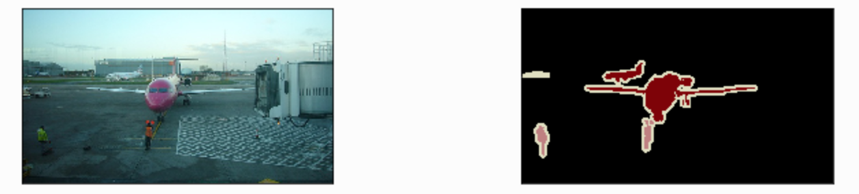

As showed above, the left image is the original image. The right side image is the label image. In this image, different objects are denoted using different colors. Thus, to read the training data, we need to define a color map to find the label for each pixel.

1. In this step, I modified the ResNet18 to form the new network. For the mxnet, ResNet18 is already pre-defined and can be load directly from model_zoo. After load ResNet18, I did the following modifications of this network to define my own model.
   1. Firstly, I removed the last two layers of ResNet18. Those two layers are global pooling layer and the fully-connected layer.
   2. Secondly, I added another convolution layer. For this convolution layer, the convolution kernel size is 1-by-1.
   3. Lastly, a layer called transposed convolutional layer was added. The aim of this layer is to produce the end-to-end same size output.

We can see that after above several modifications, there is no fully-connected layer in our new network. In another word, all the layers here can be called the convolutional layer. Thus, our new neural network is also called full-convolutional neural network (FCN).

1. After defining of the new neural network, we can train our model using the training dataset. In here, a problem is that we need to tune the value of batch size. Batch size here is used to control how many data points we will read and train the model at same time. Theoretically, larger batch size should have a faster training time. However, since we only have limited memory, our machine cannot handle too large batch size. To accelerate the training time, I use a GPU card to train my model. The memory size of my graphic card is 6G and the largest batch size I can use is 32.
2. The last step is to test my model using some images. As mentioned before, I can just show the label image now.

For my current prototype work, there are still some problems. Also, some improvements are needed. In the next few weeks, I will address some problems as follows.

1. For my current work, I tried to modify only one kind of neural network. In the next few weeks, I will try to use more kinds of neural networks.
2. In my future work, I will use more metrics to verify my testing result.
3. Some improvement of the whole process will be done since now computation.

Another thing I will do for next progress report is to give more details of my current implementation. In next few weeks, I will test more images and produce more results to verify the correctness of my implementation.