开启http服务代码如下：
WFHttpServer http_server(__http_process);
http_server.start("127.0.0.1", 8811);

分析一下：
WFHttpServer是类模板WFServer的一个实例
using WFHttpServer = WFServer<protocol::HttpRequest, protocol::HttpResponse>;
继承关系如图：
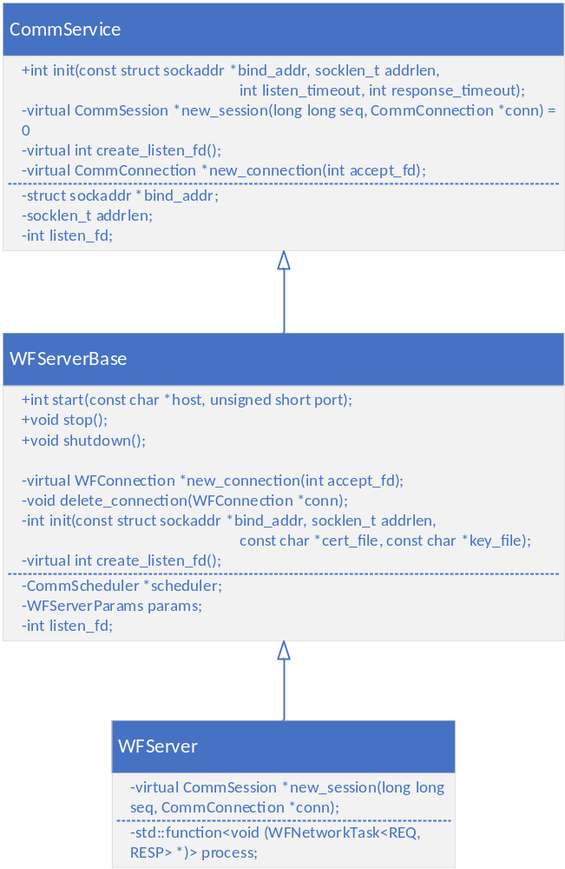
WFServerBase在构造时保存了服务参数。主要功能在start()函数，在start中调用init函数，init函数做了两件事情，(1)调用了基类的init；(2)创建了CommScheduler。CommScheduler类似一个包装器，它包装了Communicator，Communicator是个很关键的东西，它是整个epoll的调度核心，它内部逻辑如下：

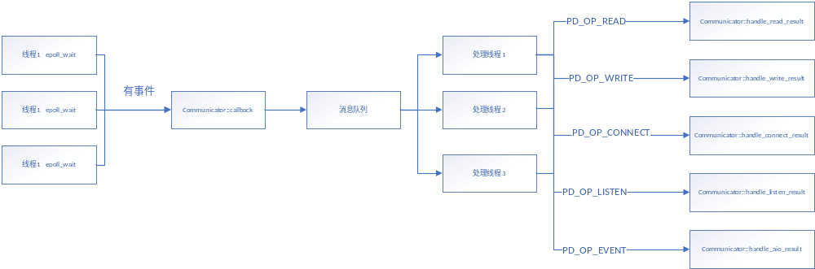
Communicator有一个mpoller结构体变量，结构体定义为：
struct __mpoller
{
void **nodes_buf; //创建了max_open_files个指针数组，用来保存__poller_node*
unsigned int nthreads;
poller_t *poller[1];//动态数组，创建了nthreads个poller_t*
};

struct __poller
{
size_t max_open_files;
void (*cb)(struct poller_result *, void *);//epoll_wait的线程会调用该回调函数
void *ctx;//上下文，保存Communicator的消息队列msgqueue*

pthread_t tid;//线程id
int pfd; //epoll句柄
int timerfd;
int pipe_rd;
int pipe_wr;
int stopped;
struct rb_root timeo_tree;
struct rb_node *tree_first;
struct rb_node *tree_last;
struct list_head timeo_list;
struct list_head no_timeo_list;
struct __poller_node **nodes;//指向nodes_buf
pthread_mutex_t mutex;
char buf[POLLER_BUFSIZE];
};

struct __poller_node
{
int state;
int error;
struct poller_data data;
#pragma pack(1)
union
{
struct list_head list;
struct rb_node rb;
};
#pragma pack()
char in_rbtree;
char removed;
int event;
struct timespec timeout;
struct __poller_node *res;//回复
};

struct poller_data
{
#define PD_OP_READ 1
#define PD_OP_WRITE 2
#define PD_OP_LISTEN 3
#define PD_OP_CONNECT 4
#define PD_OP_SSL_READ PD_OP_READ
#define PD_OP_SSL_WRITE PD_OP_WRITE
#define PD_OP_SSL_ACCEPT 5
#define PD_OP_SSL_CONNECT 6
#define PD_OP_SSL_SHUTDOWN 7
#define PD_OP_EVENT 8
#define PD_OP_NOTIFY 9
#define PD_OP_TIMER 10
short operation;
unsigned short iovcnt;
int fd;
SSL *ssl;
union
{
poller_message_t *(*create_message)(void *);
int (*partial_written)(size_t, void *);
void *(*accept)(const struct sockaddr *, socklen_t, int, void *);//有新连接时回调
void *(*event)(void *);
void *(*notify)(void *, void *);
};
void *context;//bind阶段保存的CommService*
union
{
poller_message_t *message;
struct iovec *write_iov;
void *result;
};
};

回到WFServerBase::start，初始化成功后调用Communicator::bind，在这里创建套接字->设置套接字为非阻塞模式->套接字绑定本地地址和端口->监听。完成这些后，将一些数据（比如套接字、操作类型、上下文等）保存到struct poller_data，再把poller_data放入struct __poller_node，最后node作为用户数据加入到epoll。
有新连接时，在epoll_wait线程accept，然后回调到Communicator::callback，callback将信息放入消息队列，处理线程handler_thread_routine会从消息队列取。然后进入handle_listen_result处理。

连接成功，开始监听可读取事件。
void Communicator::handle_listen_result(struct poller_result *res)
{
CommService *service = (CommService *)res->data.context;
struct CommConnEntry *entry;
entry = this->accept_conn(target, service);

res->data.operation = PD_OP_READ;
res->data.create_message = Communicator::create_request;
res->data.message = NULL;
timeout = target->response_timeout;

res->data.fd = entry->sockfd;
res->data.ssl = entry->ssl;
res->data.context = entry;
if (mpoller_add(&res->data, timeout, this->mpoller) >= 0)
{
if (this->stop_flag)
mpoller_del(res->data.fd, this->mpoller);
break;
}
}
在handle_listen_result中，首先创建CommConnEntry* entry，它将作为poller_data的context上下文，data.operation设置为读数据(PD_OP_READ)，data.create_message赋值为Communicator::create_request，然后将连接套接字加入epoll。
create_message是函数指针，定义如下：
poller_message_t *(*create_message)(void *)

有可读事件到来时，读取内容到buf，然后调用__poller_append_message()组装消息。
static void __poller_handle_read(struct __poller_node *node,
poller_t *poller)
{
while(1)
{
nleft = read(node->data.fd, p, POLLER_BUFSIZE);
do
{
n = nleft;
if (__poller_append_message(p, &n, node, poller) >= 0)
{
nleft -= n;
p += n;
}
else
nleft = -1;
} while (nleft > 0);
}
}

__poller_append_message()调用了create_message，也就是Communicator::create_request。
static int __poller_append_message(const void *buf, size_t *n,
struct __poller_node *node,
poller_t *poller)
{
poller_message_t *msg = node->data.message;
msg = node->data.create_message(node->data.context); //(1)

res = (struct __poller_node *)malloc(sizeof (struct __poller_node));
node->data.message = msg;
node->res = res;

ret = msg->append(buf, n, msg);//(2)
If(ret > 0) {
res->data = node->data;
res->error = 0;
res->state = PR_ST_SUCCESS;
poller->cb((struct poller_result *)res, poller->ctx);//(3)
node->data.message = NULL;
node->res = NULL;
}
}

- create_request()创建了CommSession* session，它实际是WFHttpServerTask*。session->in是CommMessageIn*类型，message_in()在WFServerTask重写，返回的是它的一个成员变量REQ req，对于http来说，就是HttpRequest。
poller_message_t *Communicator::create_request(void *context)
{
struct CommConnEntry *entry = (struct CommConnEntry *)context;
CommService *service = entry->service;
CommTarget *target = entry->target;
CommSession *session;

session = service->new_session(entry->seq, entry->conn);
session->passive = 1;
entry->session = session;
session->target = target;
session->conn = entry->conn;
session->seq = entry->seq++;
session->out = NULL;
session->in = NULL;

session->in = session->message_in();
if (session->in)
{
session->in->poller_message_t::append = Communicator::append_request;
session->in->entry = entry;
}

return session->in;
}

new_session()在WFHttpServer中重写了，它返回的是WFHttpServerTask*。将append函数指针设置成Communicator::append_request
- append()，调用的是Communicator::append_request，append_request()又调用了in->append(buf, size)，in上面说了是HttpRequest，所以调用到了int HttpRequest::append(const void *buf, size_t *size)，在里面解析了http头，http_parser_append_message()返回0表示没有接受完，要继续接受数据，返回1表示完成，其它失败
- 将消息回调出去，到达Communicator::callback，callback把消息发到消息队列，处理现场取消息处理Communicator::handle_read_result，里面调用了session->handle()，即WFHttpServerTask::handle()，内部调用了基类的handle即void WFServerTask<REQ, RESP>::handle(int state, int error)，handle里先创建Series对象，然后调用内部类的processor.dispatch()，dispatch回调了process函数，process是在构造WFServer时的参数

序列过程如下：
