Workflow内部使用线程池，线程池在Executor::init中创建。线程池结构定义如下：
struct __thrdpool
{
msgqueue_t *msgqueue; //消息队列
size_t nthreads; //线程数
size_t stacksize; //栈大小
pthread_t tid; //线程id
pthread_mutex_t mutex;
pthread_key_t key;
pthread_cond_t *terminate; //终止条件
};
线程池的任务都来自消息队列，Executor::request会向ExecQueue添加任务，若ExecQueue为空，就立刻提交到消息队列。
int Executor::request(ExecSession *session, ExecQueue *queue)
{
struct ExecSessionEntry *entry;

session->queue = queue;
entry = (struct ExecSessionEntry *)malloc(sizeof (struct ExecSessionEntry));
if (entry)
{
entry->session = session;
entry->thrdpool = this->thrdpool;
pthread_mutex_lock(&queue->mutex);
/*将任务添加到子队列的末尾*/
list_add_tail(&entry->list, &queue->session_list);
/*如果添加后，子队列只有一个元素，就立刻提交到消息队列*/
if (queue->session_list.next == &entry->list)
{
struct thrdpool_task task = {
.routine = Executor::executor_thread_routine,
.context = queue
};
if (thrdpool_schedule(&task, this->thrdpool) < 0)
{
list_del(&entry->list);
free(entry);
entry = NULL;
}
}

pthread_mutex_unlock(&queue->mutex);
}

return -!entry;
}

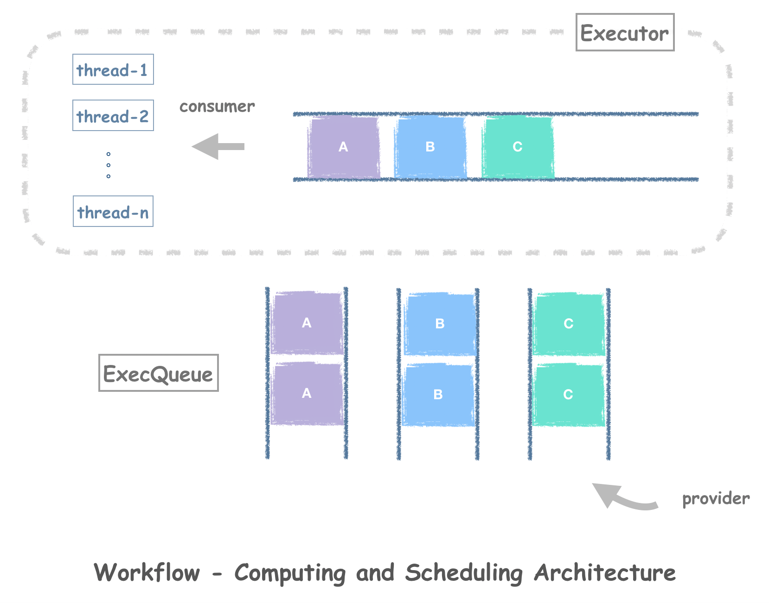
图1 调度逻辑图

__thrdpool_routine是线程处理函数，它从消息队列取消息
static void *__thrdpool_routine(void *arg)
{
thrdpool_t *pool = (thrdpool_t *)arg;
struct __thrdpool_task_entry *entry;
void (*task_routine)(void *);
void *task_context;
pthread_t tid;

pthread_setspecific(pool->key, pool);
while (!pool->terminate)
{
entry = (struct __thrdpool_task_entry *)msgqueue_get(pool->msgqueue);
if (!entry)
break;

task_routine = entry->task.routine;
task_context = entry->task.context;
free(entry);
/*调用真正的处理函数*/
task_routine(task_context);

if (pool->nthreads == 0)
{
/* Thread pool was destroyed by the task. */
free(pool);
return NULL;
}
}

/* One thread joins another. Don't need to keep all thread IDs. */
pthread_mutex_lock(&pool->mutex);
tid = pool->tid;
pool->tid = pthread_self();
if (--pool->nthreads == 0)
pthread_cond_signal(pool->terminate);

pthread_mutex_unlock(&pool->mutex);
if (memcmp(&tid, &__zero_tid, sizeof (pthread_t)) != 0)
pthread_join(tid, NULL);

return NULL;
}
task_routine()实际调用的就是Executor::executor_thread_routine(queue)

void Executor::executor_thread_routine(void *context)
{
ExecQueue *queue = (ExecQueue *)context;
struct ExecSessionEntry *entry;
ExecSession *session;

pthread_mutex_lock(&queue->mutex);
/*将指针偏移后转为ExecSessionEntry* */
entry = list_entry(queue->session_list.next, struct ExecSessionEntry, list);
list_del(&entry->list);
session = entry->session;
if (!list_empty(&queue->session_list))
{
/*如果队列不为空，继续把队列中的*/
struct thrdpool_task task = {
.routine = Executor::executor_thread_routine,
.context = queue
};
__thrdpool_schedule(&task, entry, entry->thrdpool);
}
else
free(entry);

pthread_mutex_unlock(&queue->mutex);
session->execute();
session->handle(ES_STATE_FINISHED, 0);
}

