cfRNA-BrainTrace: hierarchical brain-origin candidate ranking from RNA expression profiles with a primate transcriptomic atlas
Article type: Application Note
Category: Gene expression
Authors and affiliations: Author information to be supplied in the submission system
Corresponding author: [CORRESPONDING AUTHOR EMAIL REQUIRED BEFORE SUBMISSION]

Abstract

Summary
cfRNA-BrainTrace is a Python and Streamlit application for hierarchical brain-origin candidate ranking from RNA expression profiles. The locked route projects query profiles into a Bo2023-like variance-stabilized space to generate a broad 10-class macaque functional-anatomical Network Top3 beam, then uses logCPM-compatible local expression for resolution-group and exploratory exact-region reranking. The software reports ranked candidates, marker coverage, entropy, margins, route identifiers and scope warnings. In internal validation, Network Top3 accuracy reached 92.38% in leave-one-sample-out and 91.21% in leave-one-monkey-out evaluation, with lower accuracy at resolution-group and exact-region levels. AHBA mapped-label validation supported coarse cross-species transfer, whereas TCGA/BraTS and unlabeled biofluid analyses defined transfer limitations. cfRNA-BrainTrace is intended for reproducible coarse candidate ranking and resolution-limit auditing, not stand-alone clinical localization from unlabeled biofluid RNA.

Availability and Implementation
Implemented in Python 3.11+ with command-line and Streamlit interfaces. The development repository is https://github.com/wz7717/cfrna-brain-tracing and contains README documentation, installation instructions, a command-line entry point, Streamlit entry points, tests, lightweight model artifacts and validation/benchmark scripts. The manuscript version is archived at [ZENODO DOI REQUIRED BEFORE SUBMISSION]. A live demonstration is available at [STABLE WEB SERVICE URL REQUIRED BEFORE SUBMISSION]. The software is released under [LICENSE REQUIRED BEFORE SUBMISSION]. Public example input/output files are [EXAMPLE INPUT/OUTPUT REQUIRED BEFORE SUBMISSION].

Contact
[CORRESPONDING AUTHOR EMAIL REQUIRED BEFORE SUBMISSION]

Supplementary information
Supplementary data are available online.

Text

Motivation
RNA expression profiles can retain tissue-of-origin information, but within-brain source tracing is limited by transcriptional similarity among neighbouring regions, atlas granularity and domain shifts between reference tissue, tumour tissue and biofluid RNA. These constraints are central to atlas-based brain RNA tracing: a stable broad candidate may be recoverable even when exact-region localization is not. A single exact-region output can therefore imply more anatomical resolution than the data support. cfRNA-BrainTrace addresses this problem by returning a hierarchy of Network, resolution-group and exact-region candidates together with confidence, coverage and scope diagnostics.

System and methods
The locked production route was selected from validation evidence rather than from a single modelling assumption. First, projected variance-stabilized expression representation was consistently useful for broad Network candidate generation, where Network denotes the 10-class macaque functional-anatomical source space used by the Bo2023 reference. Second, direct exact-region scoring in projected-VSD space was not consistently superior to native or logCPM-based alternatives. Third, local reranking within the Network beam improved the interpretability of downstream anatomical outputs. The resulting default scoring route is therefore a hybrid route: projected-VSD expression is used for broad candidate generation, while logCPM-compatible expression is used for downstream local ranking.
Operationally, cfRNA-BrainTrace normalizes the uploaded expression table into logCPM- or logTPM-compatible space and aligns genes to the reference panel. A reference-fitted linear projector maps the query to Bo2023-like VSD space using stored gene-wise slope, intercept and clipping parameters; the default route does not use target-cohort labels or target-cohort distribution information. The projected representation is used only for Network scoring. The top three Networks form a candidate beam, and candidate regions outside this beam are excluded from downstream regional ranking. Within the retained beam, resolution groups are reranked using local logCPM-compatible expression, and exact regions are then reranked as lower-confidence local candidates. This route uses the Bo2023 macaque brain transcriptomic reference without converting the atlas into a new projected atlas.

Implementation
The Network projection and scoring route is implemented in core/network_tracing.py, and the three-tier regional route is implemented in core/bo2023_region_tracing.py. The command-line interface (cli.py) and Streamlit entry points (streamlit_app.py, app/) call the same scoring core to avoid interface-specific divergence. Model artifacts include marker order, Network centroids, anatomical dictionaries, route parameters and warning metadata. The repository includes unit tests under tests/ and validation/benchmark scripts under scripts/ and benchmark_runner.py, supporting reproducible reruns of the analyses reported here.

Validation
Validation was matched to the resolution supported by available labels. Internal experiments first tested whether projected-VSD query representation was appropriate for generating the broad Network candidate beam. In fold-local leave-one-sample-out Network validation, projected VSD achieved Top1/Top3 accuracy of 58.00%/91.58%, exceeding logCPM baseline and native VSD routes. In strict leave-one-monkey-out validation, projected VSD reached 53.72%/91.33%. Direct exact-region projected-VSD scoring was lower and less stable, especially in leave-one-monkey-out evaluation, so exact-region scoring was not used as the sole endpoint.
The complete validation then tested the locked three-tier procedure end to end: projected-VSD Network Top3 beam generation, logCPM-compatible resolution-group reranking and logCPM-compatible exact-region reranking. This route achieved Network Top3 accuracy of 92.38% in leave-one-sample-out validation and 91.21% in leave-one-monkey-out validation. Resolution-group Top3 accuracy was 72.36% and 69.09%, respectively, whereas exact-region Top3 was 45.33% and 42.36%. The accuracy gradient across levels supports Network Top3 as the primary endpoint and resolution group as the more defensible region-level output. Exact-region results are retained as exploratory local candidate rankings rather than deterministic localization.
In AHBA mapped-label external validation, the hybrid route achieved Network Top1/Top3 accuracy of 74.68%/94.42%, resolution-group Top1/Top3 accuracy of 36.26%/67.03% and exact Top1/Top3 accuracy of 24.18%/42.86%; hybrid exact Top3 exceeded both logCPM baseline and projected-VSD-only scoring, supporting the use of projected VSD for the broad beam and logCPM expression for local reranking. In TCGA/BraTS glioma tissue RNA-seq with MRI-derived labels, results support only coarse anatomical consistency because MRI truth labels are human atlas labels rather than Bo2023 macaque exact-region identifiers. In that setting, hybrid Network Top3 was 40.00% and broad-anatomy Top3 was 64.62%. GSE189919 and other biofluid datasets without anatomical truth were treated as projection-feasibility or transfer stress tests rather than localization-accuracy validation.

Use and limitations
The intended use of cfRNA-BrainTrace is coarse brain-origin candidate ranking from RNA expression profiles and assessment of whether a sample supports Network-level, resolution-group-level or only low-confidence output. The software exports warnings for sparse input profiles, low marker coverage, high entropy, low score margins, out-of-scope anatomical spaces and domain shift. It is not intended for deterministic exact-region localization, clinical cfRNA localization without independent anatomical truth, or localization of cerebellar/posterior-fossa samples outside the current reference space. The cfRNA name reflects the intended prospective research setting; the current evidence does not establish clinical liquid-biopsy localization.

Funding
[FUNDING INFORMATION REQUIRED BEFORE SUBMISSION]

Conflict of Interest
None declared.

Data availability
The Bo2023 macaque transcriptomic atlas, Allen Human Brain Atlas, TCGA/BraTS and GEO datasets are available from their original repositories under their original access conditions. Processed non-sensitive evaluation tables and figure source data will be archived at [DOI REQUIRED BEFORE SUBMISSION] and must be available before submission.

References
Bakas,S. et al. (2017) Advancing The Cancer Genome Atlas glioma MRI collections with expert segmentation labels and radiomic features. Sci. Data, 4, 170117.
Bo,T. et al. (2023) Brain-wide and cell-specific transcriptomic insights into MRI-derived cortical morphology in macaque monkeys. Nat. Commun., 14, 1283.
Hawrylycz,M.J. et al. (2012) An anatomically comprehensive atlas of the adult human brain transcriptome. Nature, 489, 391-399.
Vorperian,S.K. et al. (2022) Cell types of origin of the cell-free transcriptome. Nat. Biotechnol., 40, 855-861.

Figure 1
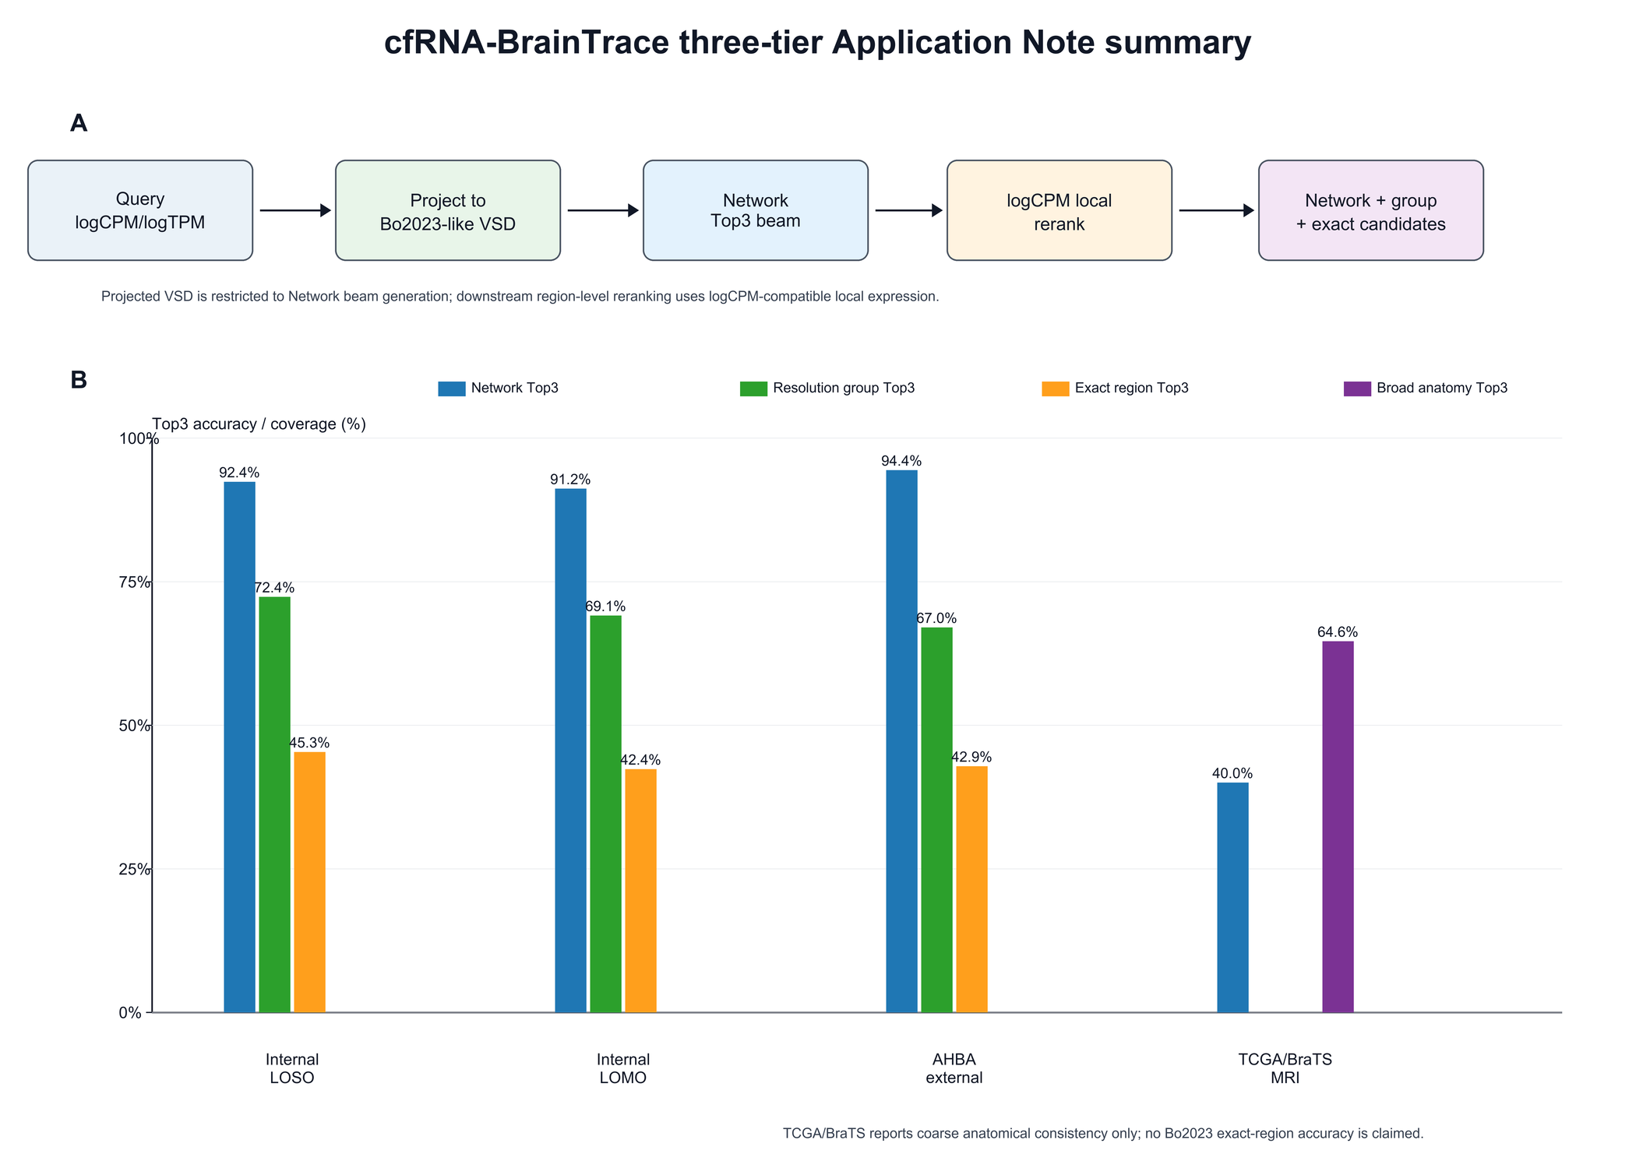
Figure 1. cfRNA-BrainTrace three-tier route and validation evidence. The query is projected into Bo2023-like VSD space only for Network Top3 beam generation; downstream resolution-group and exact-region reranking is performed in logCPM-compatible local expression space. Internal validation shows the expected resolution gradient, with high Network Top3 accuracy and lower resolution-group and exact-region accuracy. AHBA provides mapped-label external validation, whereas TCGA/BraTS supports only coarse anatomical consistency because its MRI truth labels are human atlas labels rather than Bo2023 macaque exact-region identifiers.
Alt text: Multi-panel figure summarizing the cfRNA-BrainTrace workflow and validation. A workflow diagram shows query preprocessing, projected-VSD Network Top3 beam generation and logCPM local reranking. Bar charts show Network Top3 near 92% in internal validation, resolution-group Top3 around 69%-72% and lower exact-region Top3 around 42%-45%. External panels show AHBA Network Top3 of 94.42% and TCGA/BraTS broad-anatomy Top3 of 64.62%.

