In the ZUXTS table :
From creation step :

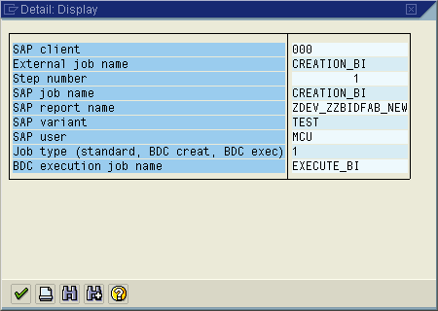

From execution step :

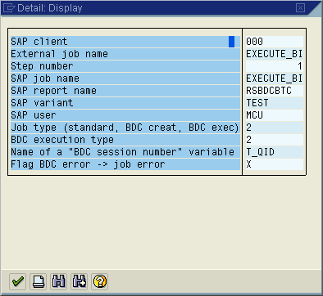

The T_QID is defined in the TVARV table. When the job completed, the QID will be filed in.

Defining a new variant for the creation program

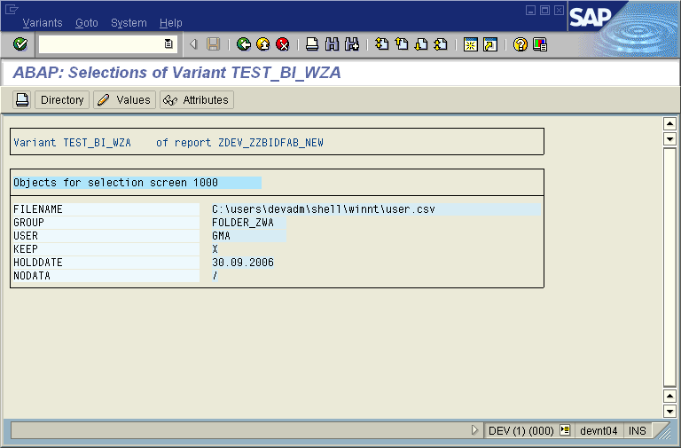

SM35 to see all of batch input :

