To disable and enable DQM on Windows

Purpose
The purpose of this document is to demonstrate how to disable and enable DQM on Windows. It applies only if DQM has been installed on your Windows host.

Overview
DQM is independent of Dollar Universe Company. A Dollar Universe Company can work with or without DQM. If a DQM server is enabled, the Dollar Universe Company will submit its jobs to the DQM server instead of its internal job queue.

To disable DQM

By default, if a DQM server is installed with a Dollar Universe Company, it will be started and used by the Dollar Universe Company. To disable DQM, you need to

Shutdown the Dollar Universe Company,

Modify the following 3 files:
- %UXMGR%\uxsetenv.bat
Find the following line:
set UNIVERSE_DQM_'CompanyName'=yes
and change it to
set UNIVERSE_DQM_'CompanyName'=no

- %UXEXEC\UNIVERSE.def and %UXEXEC\'CompanyName'.def
Find the following line:
UNIVERSE_DQM_'CompanyName' yes
and change it to
UNIVERSE_DQM_'CompanyName' no

Start the Dollar Universe Company.
You will see that the DQM server will not be started any more.

To enable DQM

The procedure is similar to above, just to modify those 3 files. Change the negative answers to positive, for example "no" to "yes". Then, restart the company.
After you have a DQM server enabled, don't forget to create at least one physical queue and start it.
PS: By default the jobs are submitted to the SYS_BATCH queue, so it is recommended to create this one as a physical queue first.

Creating Logical and Physical queues

Adding DQM to the Windows GUI (desktop).

If the DQM queues is not shown in the Windows GUI. First, let's add the items to the Windows GUI:

Creating the holder
Right click on the User Desktop --> Object folder --> DQM --> Dqm queue (see Figure 1)

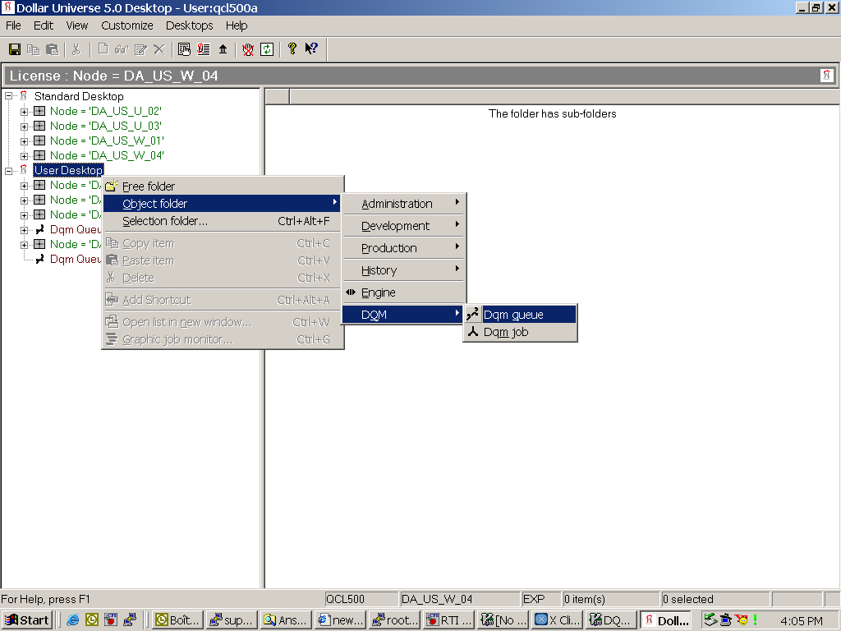

Figure 1: Adding DQM to Windows GUI

Selecting the nodes
Right click on the just created "Dqm Queue" item --> Selection folder --> Node --> select the nodes where the DQM servers will run (see Figure 2). If you want to do load balancing, you should have all of the involved nodes selected.

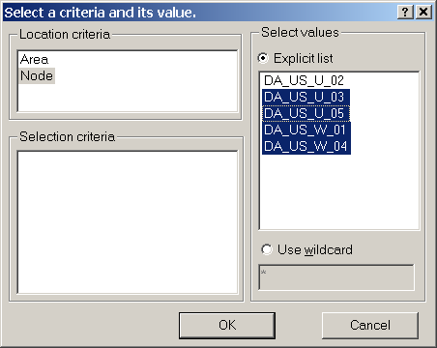

Figure 2: Selecting the nodes where DQM servers are located

Selecting the areas
Right click on the just created "node" item --> Selection folder --> Area --> select the area to monitor (see Figure 3)

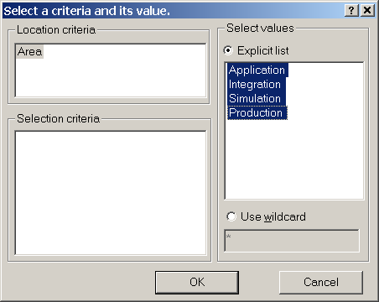

Figure 3: Selecting areas to monitor

Displaying the queues
Left click on one of the just added areas, for example: Application area, you may see something like Figure 4. If your panel on the right side is empty, don't worry, that means you haven't create any queue yet. We will create some together in the next section.

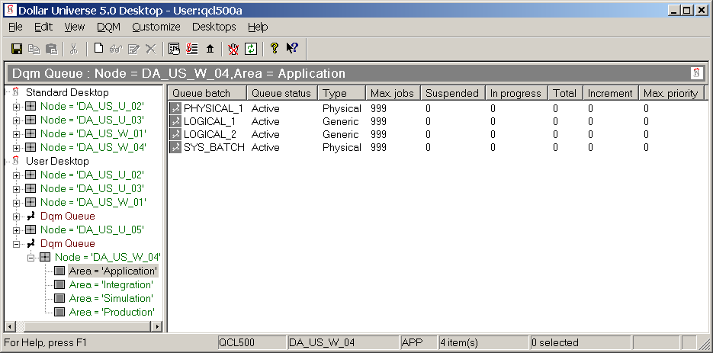

Figure 4: The resulted queue list

Creating queues

Creating a physical queue

Creating the Queue
Select an area, for example, the production area, then right click on the right panel; (see Figure 5) then select "Create".

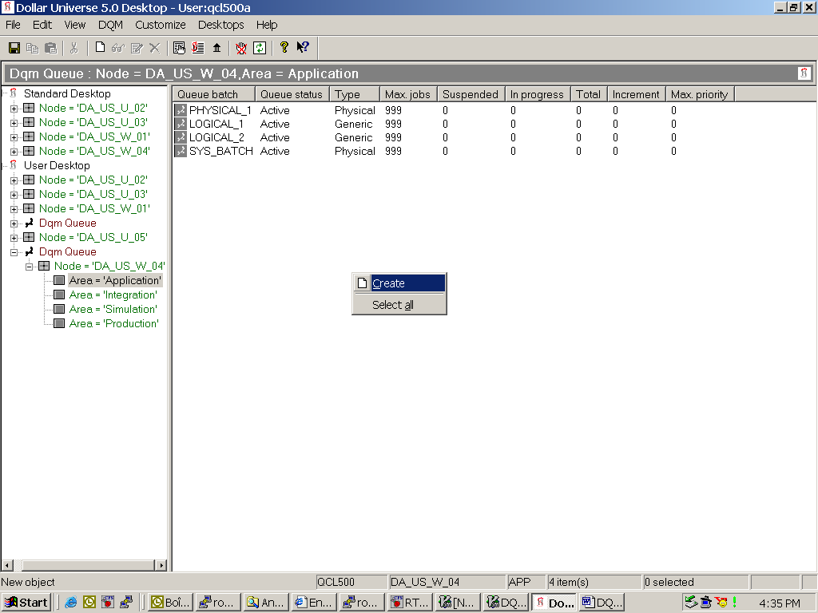

Figure 5: Creating a queue

Specifying the parameters
You should get a window like in the Figure 6. In this Window, you can specify the parameters for the queue. For now, all you need to do is to enter a name for the queue. You should have the following parameters for the queue.
Name: 'some_queue_name'
State: Stopped
Node: Specifying the node where the queue is located
Type: Physical
Maximum number of ... : 999

Save the changes.

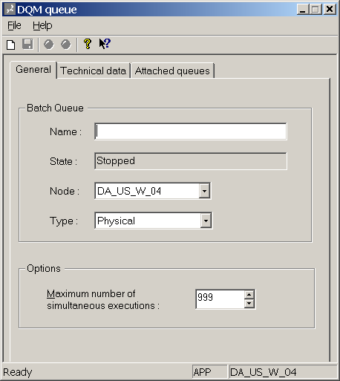

Figure 6: Specifying parameters for the queue

Starting the queue
Now you should have the just created queue shown on the right panel. Right click on the queue name and select "Start" from the drop down menu.
OK, so far we have created and started a physical queue.

Creating a logical queue
Before we start, let's take a look at the defination of a logical queue.

The definition of logical queue
Quoted from the "DQM Manual"
"A logical queue does not allow direct execution of a job.
It enables the jobs submitted to be dynamically distributed across its associated physical queues in order to optimize the machine occupancy rate." For more information, please check the "DQM Manual"

Creating the queue
At the beginning, follow the same steps as creating a physical queue. Then, specifying the "Type" as "Generic" and save, but do not close the window.

Attaching physical queues
Selecting the "Attached queues" tab (see Figure 7)
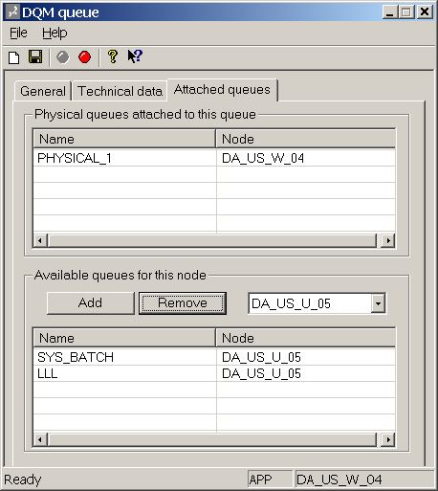

Figure 7: Attaching physical queues to the logical queue

From the drop down list, select the node names that you need to balance load with; and then, attach the physical queues from that node with the add button. Finally, save and close the window. OK, now you have your logical queue ready.

