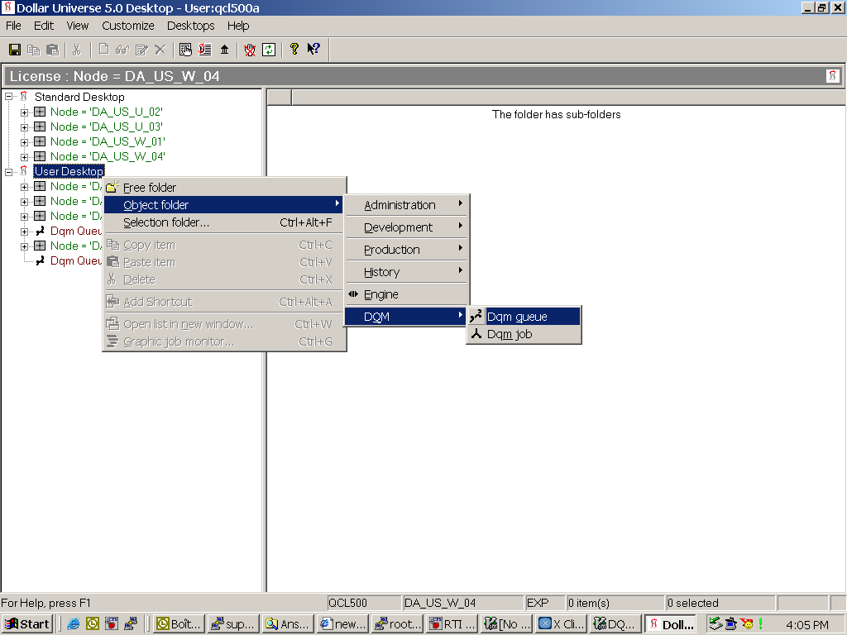

Figure 1: Adding DQM to Windows GUI

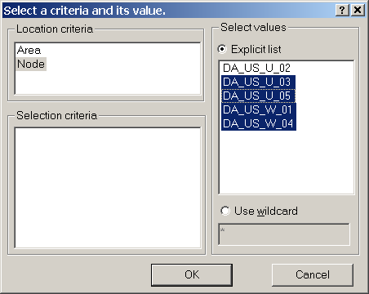
Figure 2: Selecting the nodes where DQM servers are located

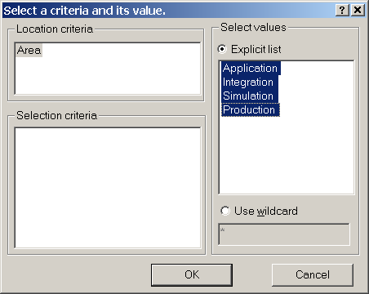

Figure 3: Selecting areas to monitor

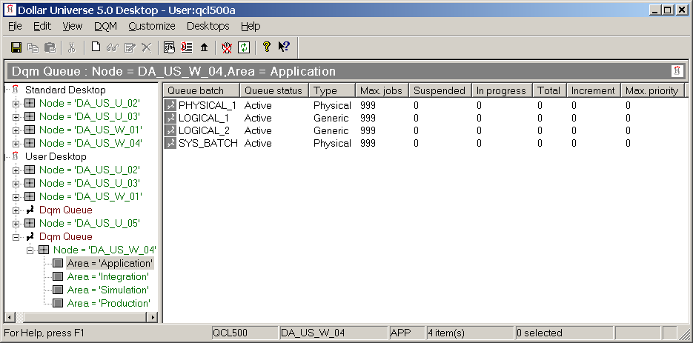

Figure 4: The resulted queue list

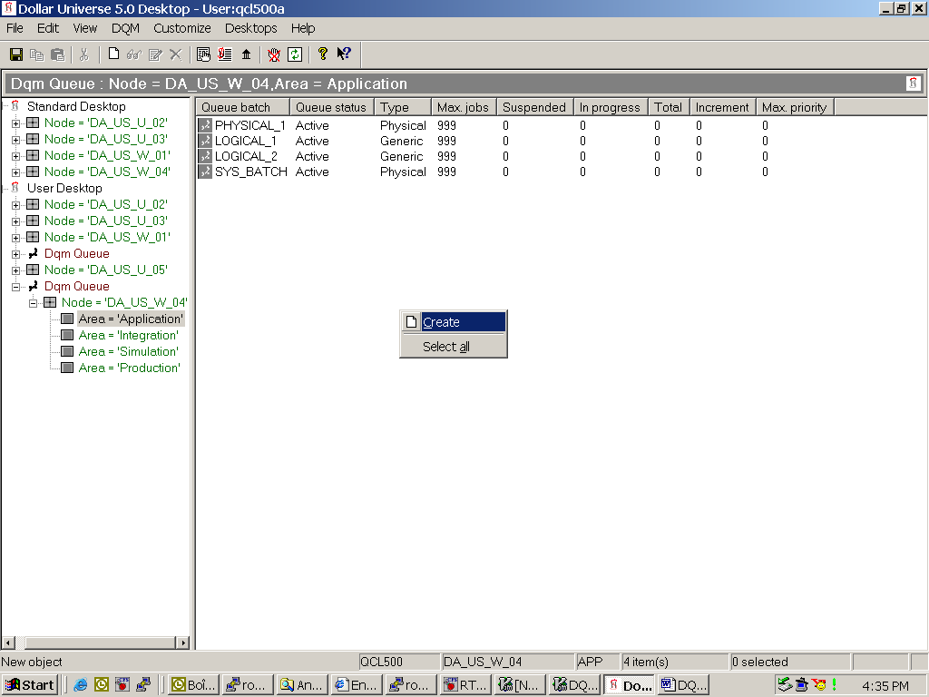

Figure 5: Creating a queue

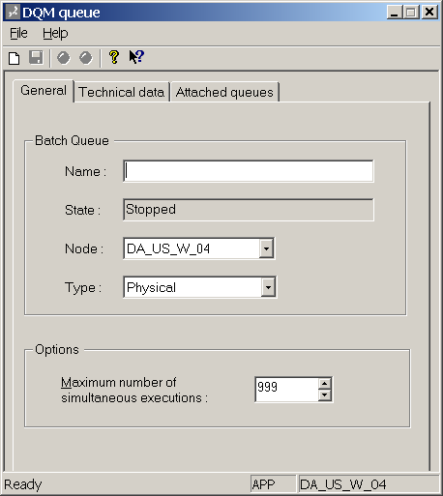

Figure 6: Specifying parameters for the queue

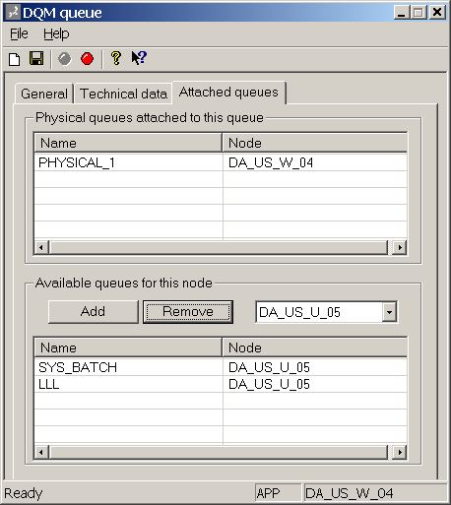

Figure 7: Attaching physical queues to the logical queue

