/nso23

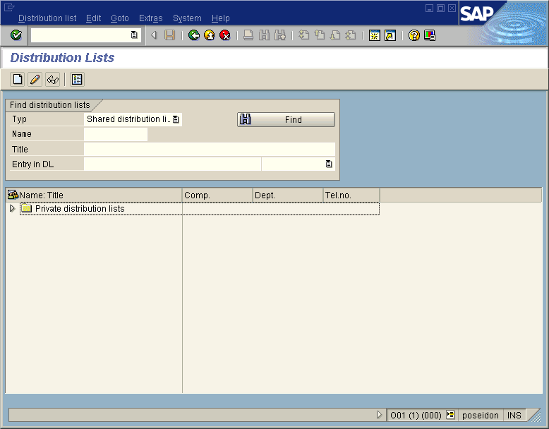

Click on the “Create button”, and fill in information as below.

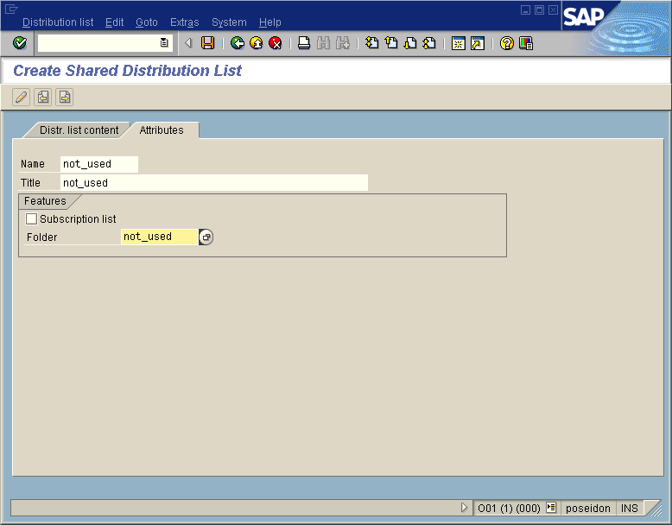

Then, click on the round button next to the “Folder” name; and fill in the Folder name and Folder title. Select “Create folder”.

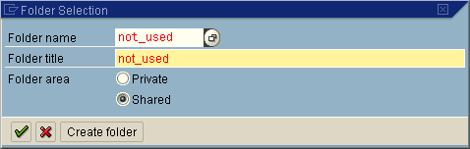

The following window pops up. Check the info inside and confirm it.

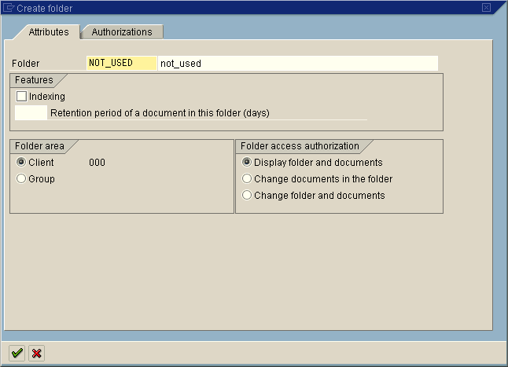

select the “Dist. list content” tab. Fill in the recipient info. For example for email address, it looks like the following:

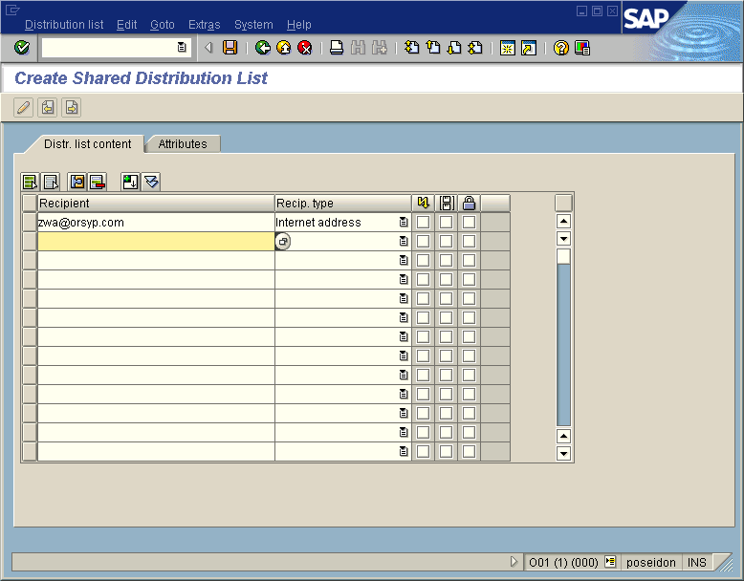

Then, save it, it is done.

