SAP HELP

Agent SAP for $U
Communication $U ⬄ Agent :
- $UX_SAP_HOSTS_FILE/uxsapagt.host
- n de port : etc/services
Communication Agent ⬄ Sap : uxsaprfc.ini (mgr de l’agt)

Transaction

Data description : se11 – consulter/modifier le format des tables.
Data browser : se16 – consulter le contenu des tables.
Maintain Table vews : sm31 – modifier le contenu des tables
Define Background Job : sm36 – créer un job sap
Batch Input : session overview : sm35 – voir le queue id d’un dossier de creation d’un batch input
Overview of job selection : sm37 – suivi d’execution des jobs
Edit/Display Event : sm62
Trigger Event : sm64
Function builder : se37
ABAP Editor : se38 – consulter les reports ABAP , leurs variantes et variables.
Transport : stms
Support Package manager : spam – consulter le niveau de patch SAP
Batch Input monitor : sm35

System Log: sm21
Connection list : smgw
Rz15 milagraw
Transactional RFC : sm58

Tables développées par ORSYP

Pour atteindre les objets SAP, $U utilise UX_JOBNAME et UX_VARIABLENAME. Les correspondances entre ces variables et les objets SAP sont dans les tables ZUXTS et ZUXTV.

Table name | Access key (used by $U) | Containt (SAP object)
ZUXTS | UX_JOBNAME | Jobname + ReportName + Variant +SapUser + StepLangue + SapHost
ZUXTV | UX_JOBNAME + UX_VARIABLENAME | Variable_name.

Table SAP

Table name | Access key (used by $U) | Containt (SAP object)
TVARV | variable_name | Variable value

api Mode / abap mode

ABAP mode: SAP uses UXZTS and UXZTV to define the job, thus $U user only need to know the external name of the job (UX_JOBNAME)

example 1: to run the SAP job JOBDETEST , the $U user just has to pass the following command (in command or inside an uproc):
$UXEXE/uxstr SAP JOBNAME="JOBDETEST
NB : JOBDETEST must have an entry in ZUXTS

exemple 2: : to run the SAP job JOBDETEST and in the same time to set the value FFR and DODO to the parameter YYYn passant respectivement les valeurs FFR et DODO aux paramètres YYY1 et YYY2, the $U user just has to pass the following command (in command or inside an uproc):
$UXEXE/uxstr SAP JOBNAME="JOBDETEST" PARAM="(YYY1=FFR, YYY2=DODO)"
NB :
- JOBDETEST must have an entry in ZUXTS
- YYY1 et YYY2 must be defined in ZUXTV as associated to JOBDETEST

API mode: $U user must entirely define the job (Jobname + ReportName + Variant +SapUser + StepLangue + SapHost )
- JobName is name that will take the SAP job
- the declared Variant must be a variant of the program ReportName (cf following §)

uxstr sap api

Template mode: You need to fill in all of the parameter yourself.

XBP2 type: can browse in SAP graphically when building template uproc for the API mode.
Notions Report/Variant/Variable

A « Repor » is a SAP program
Report_1

…
Variant_1

…
Variable_n
Variable_1
Variant_n

...
Variable_n
Variable_1
Report_n

…
Variant_1

…
Variable_n
Variable_1
Variant_n

...
Variable_n
Variable_1
Each variant is private for each repart : Variant_1 of Report_1 and Variant_1 of Report _n can have the same name. They will design to distinct variants (they can contain different variables)
Each variable is private for each variant : Variable_1 of Variant_1 et Variable_1 of Variant_n can have the same name. They will design to distinct variables (they can have 2 differnet values)

Type Table variable

How to know the list of a variable that contains a variant of report (on SAP)?
- transaction se38
- fill the name of the report and the name of the variant
- sélectionnate : « values »
- click on « display »
- The window displays the list of the variable of the variant, their values and their type (« Visible » or not, « Table » or not)

Example : variables of the TEST variant from RSBDCBTC report
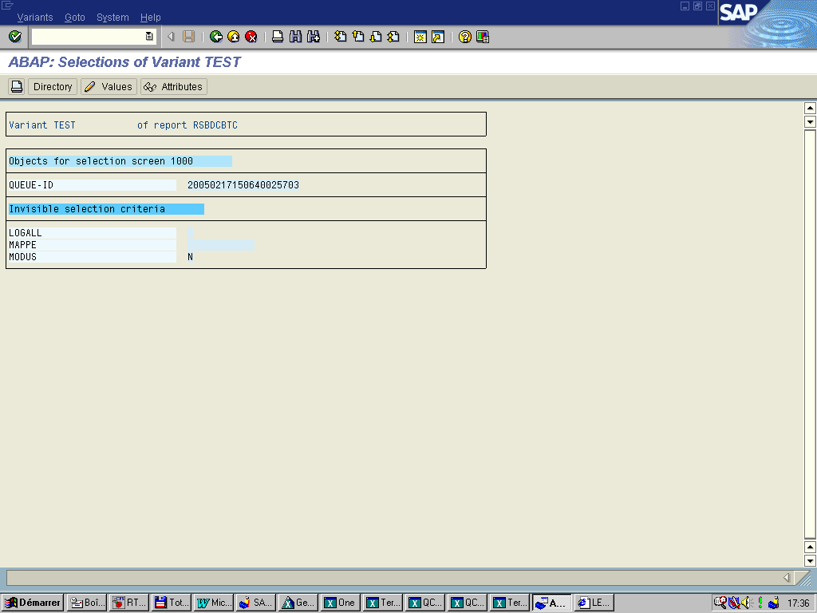

It is possible for a variable of variant to point to a variable of the TVARB table. Several variables of variant can point to a single variable from TVARV.

