- After specified a problem ID, and “Open”, it would be nice to have the problem No. shows in the page.

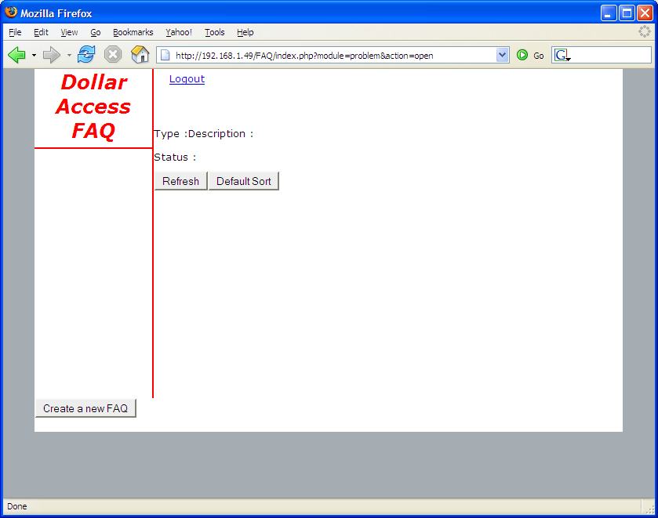

- Need problem No. too on this page. The “dsf” on the top left corner is the user name?

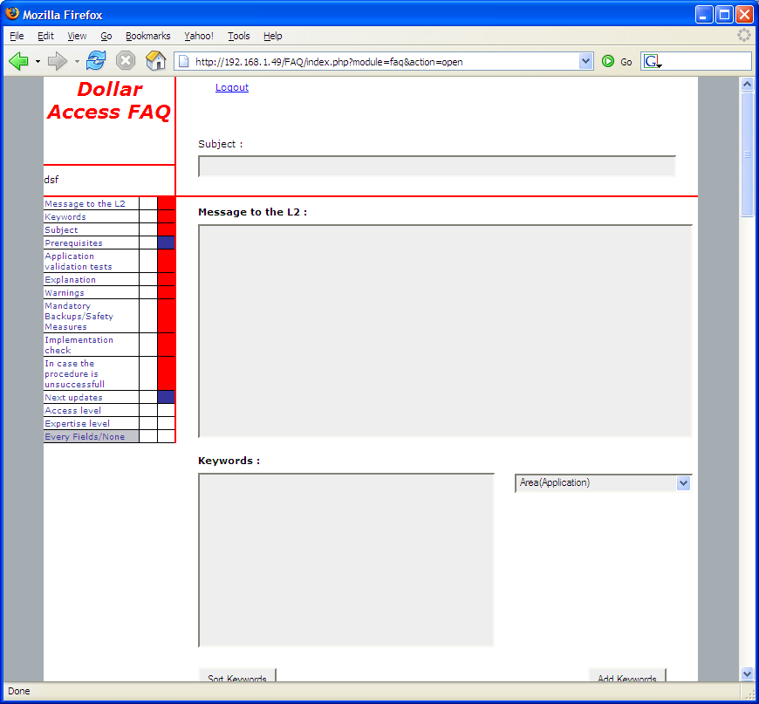

- Does not seem to be displayed properly in firefox, but seem to be OK in IE.

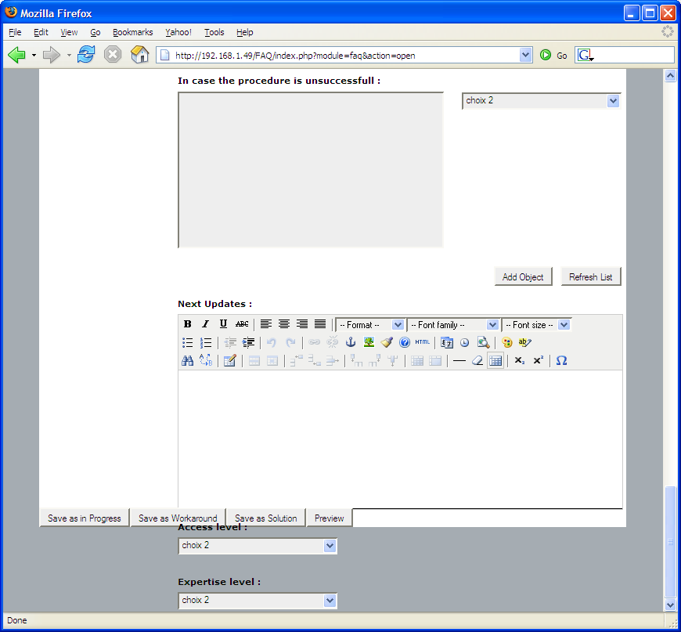

- Some codes show in both firefox and IE.
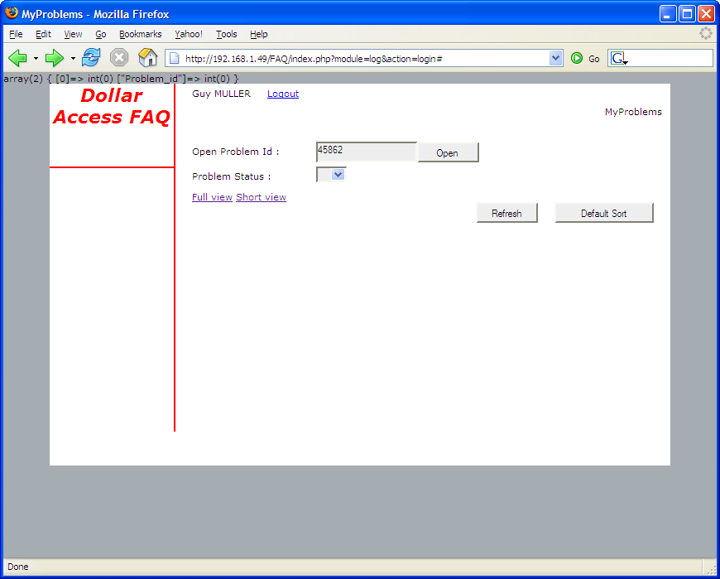

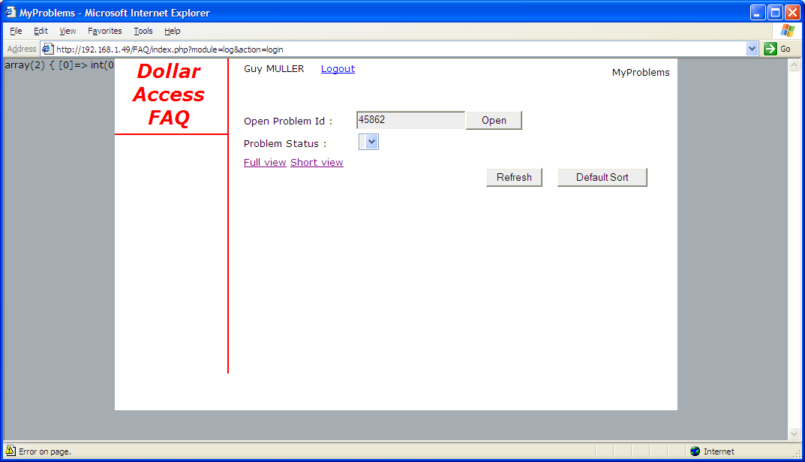

- In IE, all of the working area is limited into a small box. Maybe it is better to have the text boxes listed in a whole page like in the firefox?

