Infectivity of human norovirus in live challenge trials: a systematic review and meta-analysis

W. Zane Billings1, Anne Marie Dye2, and Andreas Handel1

2021-12-13

Human norovirus is the most common cause of acute gastroenteritis and food-borne illness in the United States. A low infectious viral load, high environmental persistence, potential for aerosolization, and long-term induction of viral shedding work in tandem to make norovirus extremely transmissible. However, norovirus outbreaks are often self-limiting, and the wide variety of potential routes of exposure make estimates of transmissibility from outbreak data somewhat unreliable. In contrast, human challenge studies involve a controlled inoculation, after which subjects are closely monitored for the duration of inducted illness. Such challenge studies provide the opportunity to control factors like inoculum strain, inoculum dose, and participant histo-blood group. Recall bias is also less likely to influence the result of challenge studies. Thus, using challenge studies to explore norovirus infectivity is less prone to bias than challenge studies, even if the results are not always generalizable to natural outbreaks. We conducted a systematic review of the literature in order to find all studies which report using norovirus challenge data, and from these studies, we abstract data to obtain unique challenge cohort data. From unique cohorts, we conduct a meta-analysis of the proportion of individuals infected during each study, including subgroup analyses by study risk of bias, inoculum genogroup, and FUT2 participant genotype control. We find a high degree of heterogeneity among studies, which is somewhat explained by outliers, and not explained by any abstracted covariates. Our results suggest that either proportion of infected individuals in a norovirus challenge study is naturally heterogeneous, or is influenced primarily by unmeasured covariates. As potential infection rates may be dependent on several characteristics of research protocols, norovirus inoculum, research staff, and study participants, our results seem reasonable.

1 Department of Epidemiology and Biostatistics, College of Public Health, University of Georgia  
2 Department of Environmental Health, College of Public Health, University of Georgia

# Introduction

Human norovirus (NoV) is a small, round-structured, unenveloped, positive-sense single-strand RNA virus with a linear, unsegmented genome, belonging to the caliciviridae family [CITE THIS]. NoV was first isolated in .

# Methods

We conducted a systematic review of papers using data from norovirus challenge studies, and from the included reports, we identified unique studies. Then, we abstracted data on the proportion of infected individuals from each study, and conducted a meta-analysis of these data.

## Literature search

We searched two databases to find literature:

* PubMed [(https://www.ncbi.nlm.nih.gov/pubmed/)](https://www.ncbi.nlm.nih.gov/pubmed/) and
* Web of Science [(https://www.webofscience.com/)](https://www.webofscience.com/).

The search terms, included in Table 1, contained terms for norovirus, terms related to human studies, and terms related to the challenge (or volunteer) study design. The databases were searched on September ##, 2021, with no filter for date used during the search.

Table 1: Search strings for the two databases searched.

| **database** | **search strategy** |
| --- | --- |
| PubMed | ("norovirus" [MeSH Major Topic]) AND ("norovirus" OR "Norwalk virus" OR "snow mountain virus" OR  "Norwalk agent" OR "nonbacterial gastroenteritis" OR  "viral gastroenteritis" [Title/Abstract]) AND (human OR challenge OR experimental OR infect* OR volunteer OR  vaccin* OR adult OR clinical OR randomized OR  individual [Title/Abstract]) NOT ("mouse" or "murine" or "mice" [Title]) |
| WoS | (TS=("norovirus" OR "Norwalk virus" OR "snow mountain virus" OR  "Norwalk agent" OR "nonbacterial gastroenteritis" OR  "viral gastroenteritis")) AND (TS=(human OR man OR adult OR volunteer)) AND (TS=(volunteer OR challenge OR experimental OR infect* OR vaccin* OR  inoculum)) |

Reports were selected for inclusion if they referenced a human norovirus challenge study with controlled inoculation of participants. No other inclusion criteria (location, date, study design, etc.) were used. Reports were excluded from the review if they were not primary research articles (i.e. reviews or letters to the editor), not written in English, or not available to the authors. Two reviewers (WZB and AMD) independently reviewed titles and abstracts, with disagreements being resolved by a third reviewer (AH). The reviewers repeated the process for the full-text review.

From the included reports, the reviewers identified unique studies by examining citations for data sources. We created a directed acyclic graph (DAG) based on citations in reference sections of papers–in this format, the end notes of the DAG are studies with original populations. Only reports which appeared to discuss original data collection and did not cite their data as coming from a previous report were considered to be unique studies.

## Data abstraction

From each study (only reports which included original data collection), one author (WZB) abstracted the following information:

1. Reference information including name of the first author and the year of publication;
2. Study design for the challenge portion of the study (either case series or randomized trial);
3. Demographic information reported for each study including age range, percentage of male participants, percentage of white participants, and location of the study site;
4. Whether the study controlled for participant FUT2 genotype;
5. Any other eligibility criteria for study enrollment;
6. Inoculum dose and genotype;
7. Criteria for reporting infection and illness; and
8. For each combination of FUT2 status, dose, and other study sub-samples (e.g. vaccine vs. placebo in vaccine trials), the number of participants challenged, number of participants with confirmed infection, and the number of participants with confirmed illness.

Reported inoculum strains were standardized to modern nomenclature where possible, criteria for infection and illness were standardized, and inoculum dose was converted to genome equivalent copies (1 RT-PCR unit = 400 genome equivalent copies).1

## Study quality assessment

Study quality was assessed using a modification of the JBI critical appraisal tool for case series studies.2 All included studies were evaluated on this scale by one author (WZB). Studies were assessed on seven domains: clear inclusion criteria, reliability of infection assessment, validity of infection assessment, whether all participants were drawn from the same cohort, complete reporting of relevant demographic information, complete reporting of relevant clinical information, and reporting of study site information. The full rubric for assessing studies is included in the appendix.

## Statistical methods

We fit an overall meta-analysis model for the proportion of infected individuals (proportion infected) by pooling together all subgroups reported within each study. We used a generalized linear mixed-effected modeling approach with logit-transformed proportions (log-odds) as the outcome.3,4 The method of maximum likelihood was used to estimate (between-study heterogeneity). Confidence intervals for pooled effects were calculated using the Knapp-Hartung adjustment,5,6 which is typically sensible.4,7,8 The GLMM method with log-odds as the outcome has been previously recommended in the literature for the meta-analysis of proportions.9 When using a GLMM approach, no weights are estimated for each study, and (the estimate of between-study heterogeneity) can only be estimated through the method of maximum likehood, and a confidence interval for cannot be obtained.4

*A priori* subgroup analyses were conducted to examine the effect of study risk of bias (high risk of bias vs. other studies), norovirus genogroup (GI, GII, or unknown), and whether FUT2 was controlled for in the study. For subgroup analyses, we use the so-called “fixed-effects (plural)” model with the -test for between-subgroup differences.4,10,11 Estimated between-study heterogeneity () was assumed to be different for all subgroups, and models within-subgroups were fit used the random-effects GLMM method as previously described.

Influence of individual studies on the overall result was analyzed *post-hoc* using three methods. First, we used a simple method which classifies studies as outliers if the estimate confidence interval for the individual study does not overlap with the confidence interval for the pooled estimate.4 Second, we used a leave-one-out approach and manually identified outliers using a Baujat plot12 and diagnostics.13 Third, we used the GOSH (Graphical display Of Study Heterogeneity) method, wherein we fit 1,000,000 models with random subsets of studies included. Then, we plotted the estimated heterogeneity vs. the estimated effect size of all random subset analyses.14 From the GOSH results, we applied three unsupervised clustering algorithms: -means,15 DBSCAN,16 and Gaussian mixture modeling.17 Study over-representation within clusters is used to determine which studies have an undue effect on heterogeneity.4 Overall, outliers were detected by consensus–if any two of the three methods flagged a particular study, that study was designated as an outlier.

Finally, since we have more than 10 studies,18 we assessed publication bias graphically using a contour-enhanced funnel plot19 and numerically using Peters’ test.19 Peters’ test accounts for dependence between the effect size and standard error for effect sizes based on binary outcome data. The common method, Egger’s test,20 does not, so Peters’ test has a lower false positive rate in comparison.4,19

## Software

Reference management was conducted using both EndNote21 for deduplication and searching for missing reference fields, and Zotero22 for archival purposes. Data abstraction and review of reports was conducted using Microsoft Excel 365 (Microsoft Corporation, Santa Rosa, CA, USA) and Google Sheets (Google, Mountain View, CA, USA).

All analyses were conducted using R version 4.1.1.23 The packages meta,24,25 metafor,26,27 and dmetar4,28 were used for meta-analysis. Figures were generated using the analysis packages, robvis,29 and PRISMA2020.30–32 Tables were generated using the package flextable.33 This report was generated using R Markdown with the packages rmarkdown,34–36 knitr,37–39 and bookdown.40,41 Several additional packages were used for data cleaning and wrangling, and for miscellaneous tasks.42–47 A complete printout of the R session information can be found in the Appendix.

# Results

## Identification of studies

Overall, 5301 non-duplicate records were obtained from searching PubMed and Web of Science. After reviewing the titles and abstracts of records, 98 reports were sought for retrieval. Of those, two reports could not be obtained, and so 96 reports were retrieved for full-text review. After applying the eligibility criteria, we selected 65 reports for inclusion in the study. The PRISMA diagram for study inclusion is shown in Figure 1.

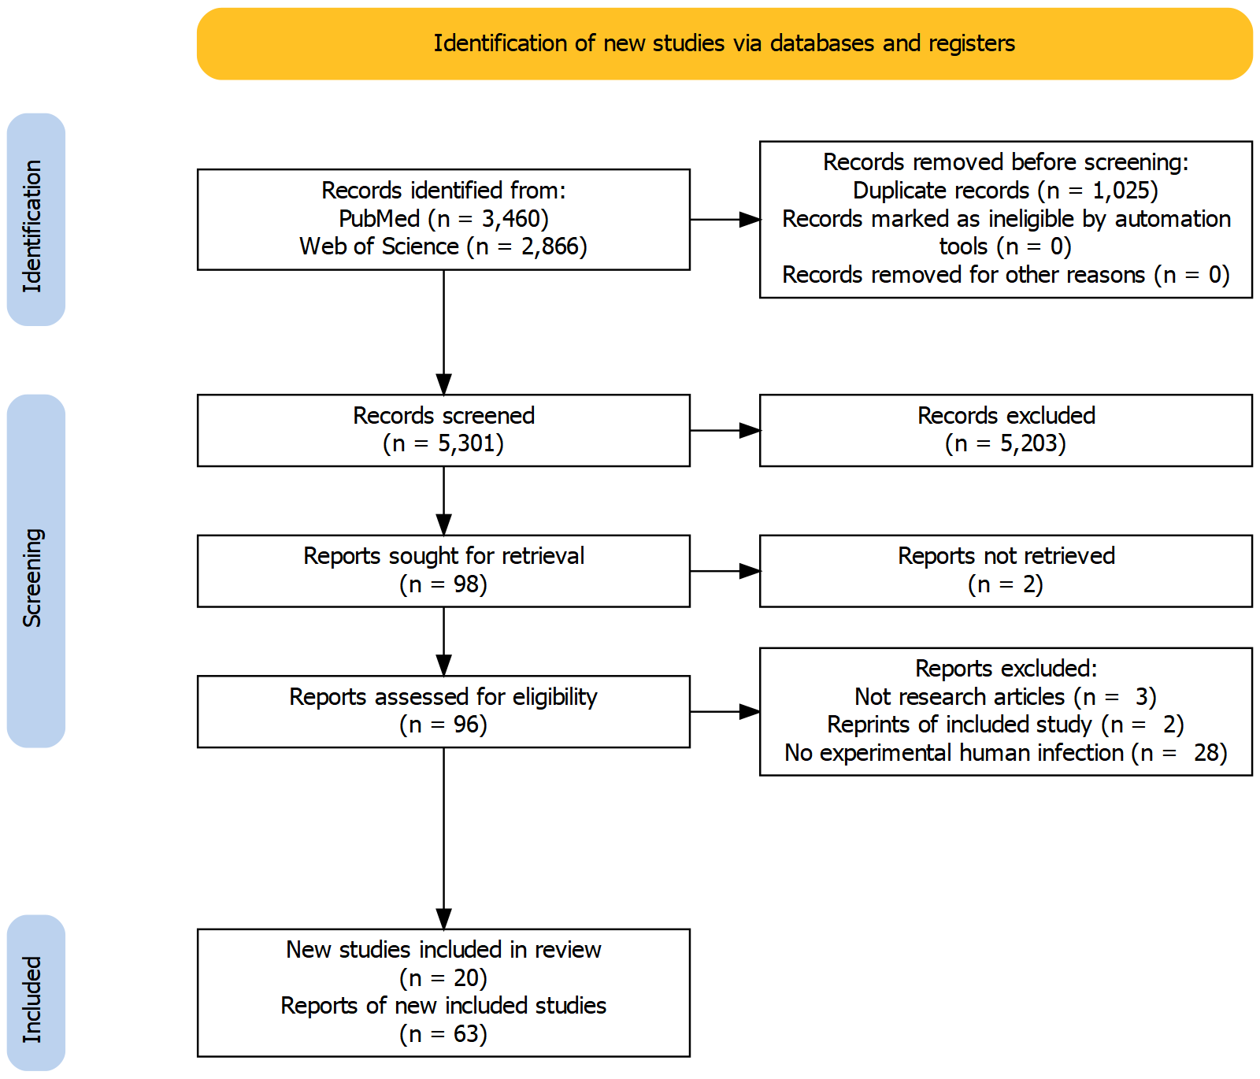

Figure 1: PRISMA 2020 flow diagram showing how many records and reports were identified at each stage of the review process.

From the list of included reports, we determined the reports which reflect original data collection by examining the methods reported in the paper. A DAG showing citations pointing to original data sources is shown in Figure 2. In total, 20 papers reflecting original sources of data were selected for inclusion in synthesis results.1,48–66 Of the 65 reports included,1,48–111 7 appeared to reflect original sources of data, but either did not provide the results necessary for synthesis, or provided the results in a format that was not usable for data extraction.80,81,91,93,94,98,102

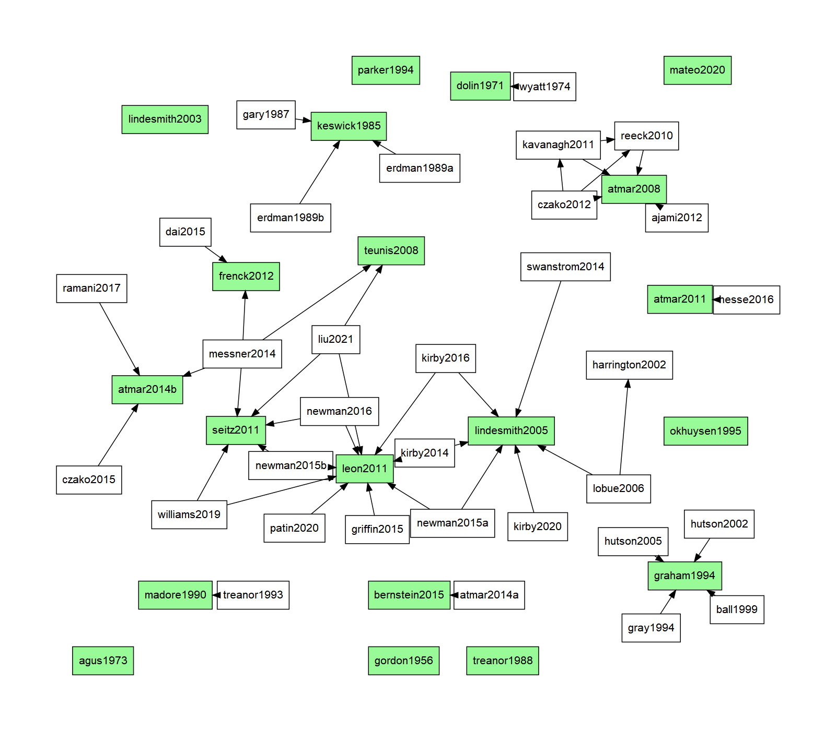

Figure 2: DAG showing citations which indicated the terminal study as the source of the data. The end notes colored in green are the reports which were identified as original data collection studies.

## Study characteristics

The abstracted study characteristics for the 20 included papers are shown in Table 2. The earliest study was conducted in 1956, and the most recent study was conducted in 2020, with 15/20 of the studies conducted in 1990 or later, and 11/20 of the studies conducted in 2000 or later. Most studies (15/20) reported information on the age range of participants, and all studies only included adults, as expected for challenge studies. The three oldest studies only included male subjects, but later studies tended to include an equal balance of male and female participants, where reported. Racial diversity in cohorts was reported in less than half of the included studies, and varied significantly by study. Half of the included studies (10/20) either reported results stratified by FUT2 (secretor) genotype or only recruited participants with FUT2+ genotype. Three studies only included participants with A or O blood types. Only one study (Frenck 2012) reported low pre-challenge titer as an eligibility criterion for subject recruitment. Note that the two oldest studies recruited participants at least partially from incarcerated populations–while the studies claim that the subjects are volunteers, neither study reports methods for preventing coercive recruiting, nor mentions how incarcerated subjects were compensated. These studies likely fail to meet modern ethical guidelines, but we chose to include the data in our synthesis in the hopes that some good can come out of past scientific misconduct.

Table 2: Abstracted demographic information and other study characteristics for the 20 unique original data collection studies which were identified.

| **study** | **n1** | **e2** | **RoB** | **age** | **% male** | **% white** | **setting** | **FUT23** | **other** |
| --- | --- | --- | --- | --- | --- | --- | --- | --- | --- |
| Gordon 1956 | 42 | 31 | High | 21 - 30 | 100 |  | NY | No | Incarcerated subjects |
| Dolin 1971 | 16 | 10 | High | 18 - 45 | 100 |  | MD | No | Incarcerated subjects |
| Agus 1973 | 7 | 4 | Med | 19 - 21 | 100 |  | MD | No |  |
| Keswick 1985 | 32 | 19 | High |  |  |  | TX | No |  |
| Treanor 1988 | 10 | 9 | High | adults |  |  | NY | No |  |
| Madore 1990 | 61 | 51 | High | 18 - 35 |  |  | NY | No |  |
| Graham 1994 | 50 | 41 | High | 19 - 39 | 41 | 84 | TX | No |  |
| Parker 1994 | 14 | 11 | High | adults |  |  | multiple | Yes |  |
| Okhuysen 1995 | 72 | 47 | High | adults |  |  | TX | No |  |
| Lindesmith 2003 | 15 | 9 | High | 20 - 49 | 49 | 71 | NC | Yes |  |
| Lindesmith 2005 | 77 | 34 | High | 21 - 54 | 47 | 73 | NC | Yes |  |
| Atmar 2008 | 84 | 62 | High | 18 - 50 |  |  | TX | Only + |  |
| Teunis 2008 | 108 | 40 | High |  |  |  | NY | No |  |
| Atmar 2011 | 16 | 16 | Low | 18 - 50 | 59 |  | TX | Only + | Blood group O/A only |
| Leon 2011 | 44 | 16 | Low | 18 - 48 | 48 | 34 | GA | No |  |
| Seitz 2011 | 13 | 10 | Med | 18 - 50 |  |  | GA | Yes |  |
| Frenck 2012 | 40 | 17 | Low | 19 - 48 | 48 | 23 | OH | Yes | < 1600 reciprocal titer at start |
| Atmar 2014 | 49 | 31 | Low | 20 - 50 | 54 | 53 | TX | Only + | Blood group O/A only |
| Bernstein 2015 | 132 | 57 | Med | 18 - 49 | 52 | 25 | multiple | Only + |  |
| Mateo 2020 | 16 | 11 | Low | 18 - 49 | 47 | 47 | CA | Only + | Blood group O/A only |
| 1Sample size | | | | | | | | | |
| 2Number of events | | | | | | | | | |
| 3Whether subject FUT2 genotype status was measured | | | | | | | | | |

The majority of the studies (11/20) were judged to be at high risk of bias. A summary plot of the risk of bias for the included studies is shown in Figure 3. The most common issue was whether the recruited participants were from the same underlying cohort (or if the study stratified results by cohort) and whether inclusion criteria were clearly reported. Note that there are no high risk of bias studies which were conducted after 2010–many older studies lacked the same standardized reporting which is now commonplace, and so have a higher risk of bias. Furthermore, older reports often tended to report the results of multiple challenge studies simultaneously, without stratifying results by cohort. Risk of bias domain assessments for each study are shown in Figure 4.

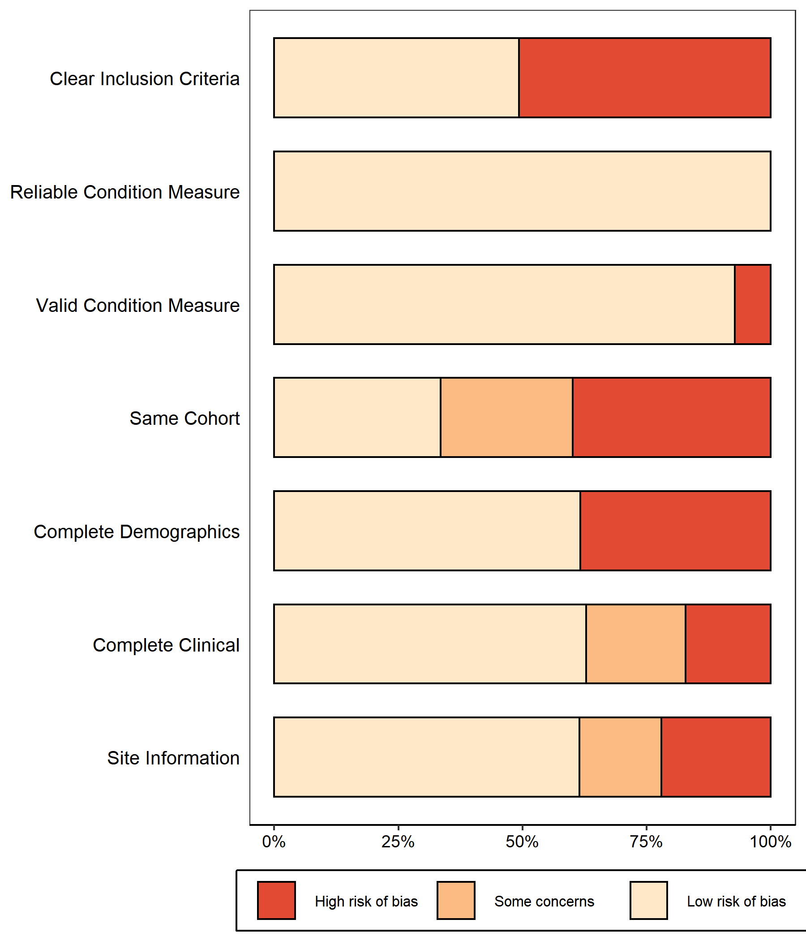

Figure 3: Summary risk of bias estimates for each domain across the entire set of included studies. Percentages are weighted by study size.

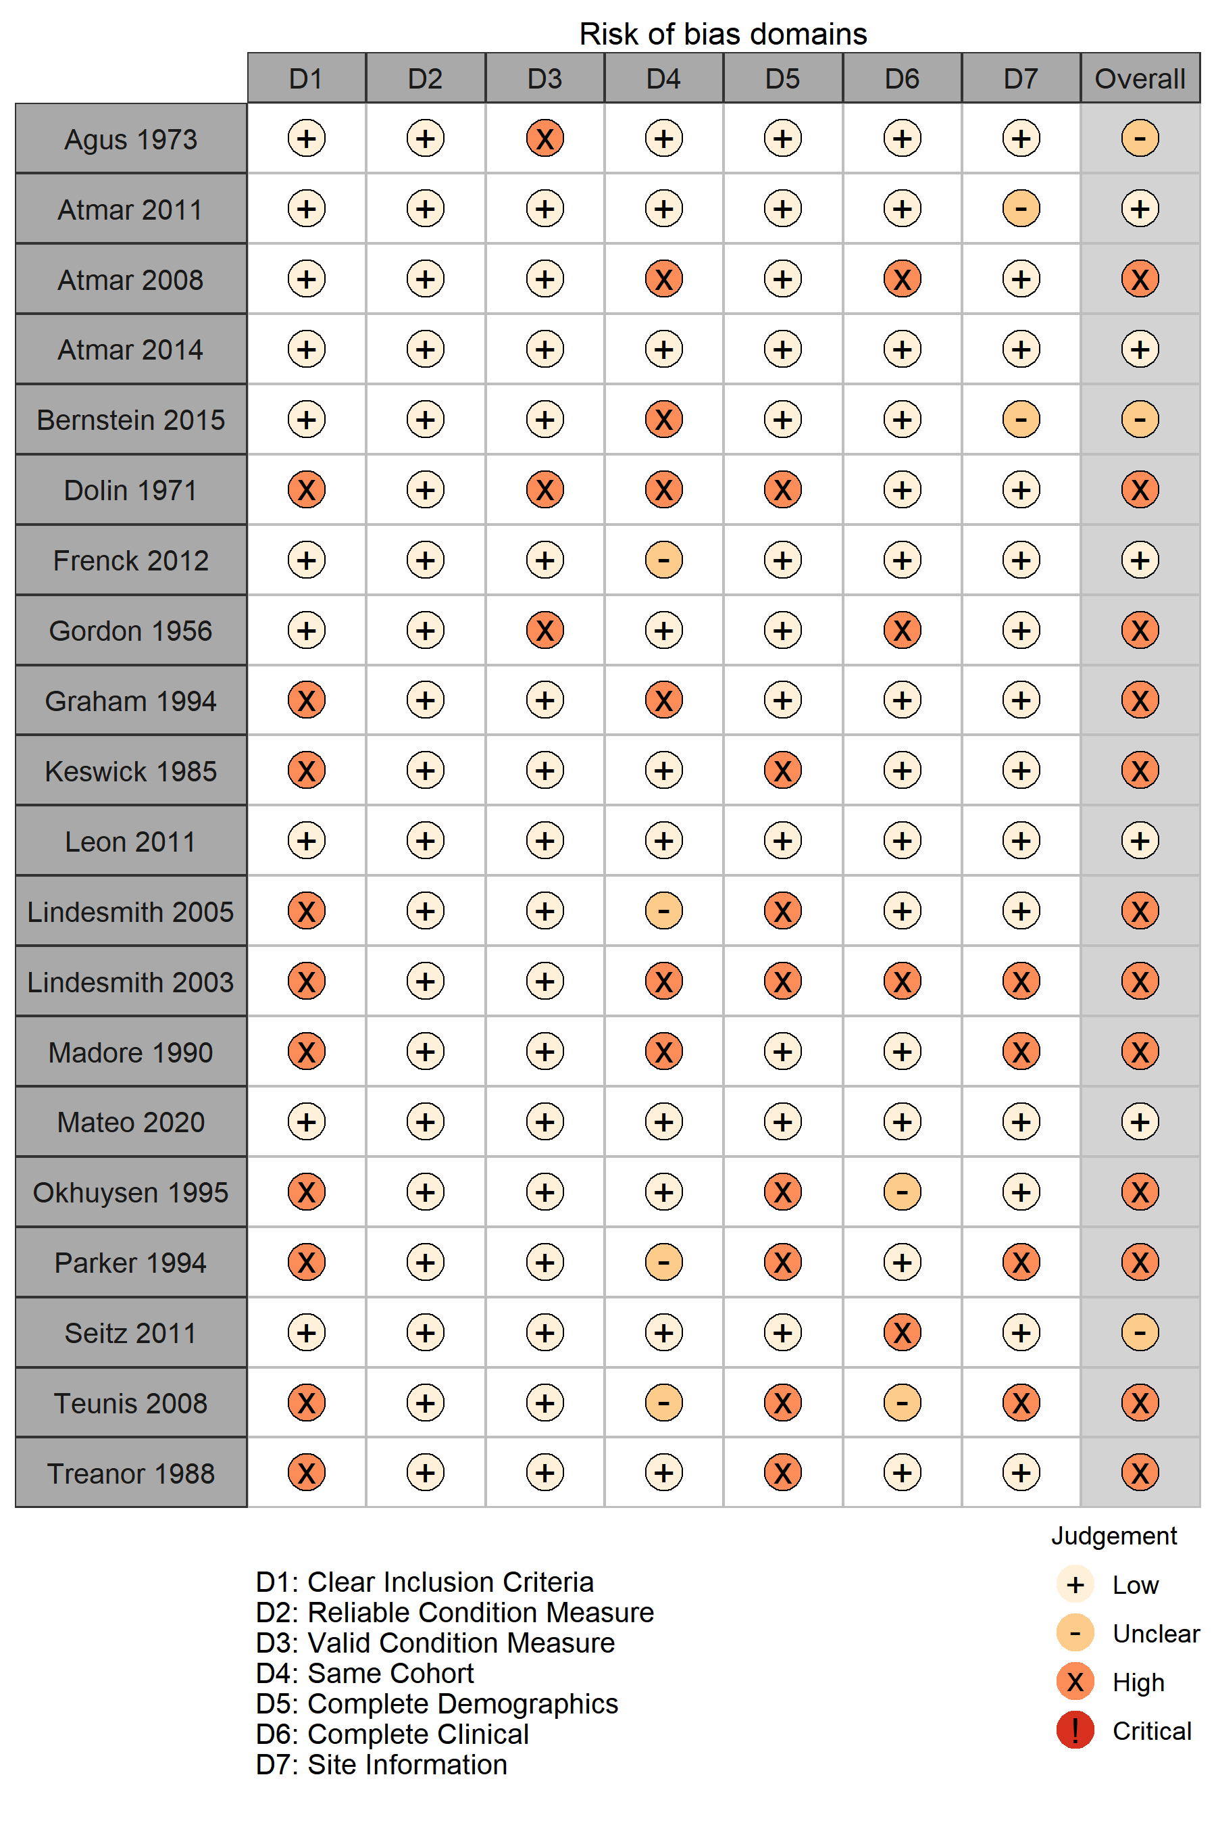

Figure 4: Individual risk of bias assessments in each domain for all included studies.

## Meta-analysis

(OVERALL)

(SUBGROUPS)

(INFLUENCE)

(SUMMARY TABLE)

# Discussion

# References

1. Atmar RL, Opekun AR, Gilger MA, et al. Determination of the 50% human infectious dose for Norwalk virus. *J Infect Dis*. 2014;209(7):1016-1022. doi:[10.1093/infdis/jit620](https://doi.org/10.1093/infdis/jit620)

2. Munn Z, Barker TH, Moola S, et al. Methodological quality of case series studies: An introduction to the JBI critical appraisal tool. *JBI Evidence Synthesis*. 2020;18(10):2127-2133. doi:[10.11124/JBISRIR-D-19-00099](https://doi.org/10.11124/JBISRIR-D-19-00099)

3. Stijnen T, Hamza TH, Özdemir P. Random effects meta-analysis of event outcome in the framework of the generalized linear mixed model with applications in sparse data. *Statistics in Medicine*. 2010;29(29):3046-3067. doi:[10.1002/sim.4040](https://doi.org/10.1002/sim.4040)

4. Harrer M, Cuijpers P, Furukawa TA, Ebert DD. *Doing Meta-Analysis in R: A Hands-On Guide*. Chapmann & Hall/CRC Press; 2021. Accessed December 2, 2021. <https://bookdown.org/MathiasHarrer/Doing_Meta_Analysis_in_R/>

5. Knapp G, Hartung J. Improved tests for a random effects meta-regression with a single covariate. *Statistics in Medicine*. 2003;22(17):2693-2710. doi:[10.1002/sim.1482](https://doi.org/10.1002/sim.1482)

6. Sidik K, Jonkman JN. A simple confidence interval for meta-analysis. *Statistics in Medicine*. 2002;21(21):3153-3159. doi:[10.1002/sim.1262](https://doi.org/10.1002/sim.1262)

7. IntHout J, Ioannidis JP, Borm GF. The Hartung-Knapp-Sidik-Jonkman method for random effects meta-analysis is straightforward and considerably outperforms the standard DerSimonian-Laird method. *BMC Medical Research Methodology*. 2014;14(1):25. doi:[10.1186/1471-2288-14-25](https://doi.org/10.1186/1471-2288-14-25)

8. Langan D, Higgins JPT, Jackson D, et al. A comparison of heterogeneity variance estimators in simulated random-effects meta-analyses. *Research Synthesis Methods*. 2019;10(1):83-98. doi:[10.1002/jrsm.1316](https://doi.org/10.1002/jrsm.1316)

9. Schwarzer G, Chemaitelly H, Abu-Raddad LJ, Rücker G. Seriously misleading results using inverse of Freeman-Tukey double arcsine transformation in meta-analysis of single proportions. *Res Synth Methods*. 2019;10(3):476-483. doi:[10.1002/jrsm.1348](https://doi.org/10.1002/jrsm.1348)

10. Borenstein M, Hedges LV, Higgins JPT, Rothstein HR. *Introduction to Meta-Analysis*. John Wiley & Sons; 2009.

11. Borenstein M, Higgins JPT. Meta-Analysis and Subgroups. *Prev Sci*. 2013;14(2):134-143. doi:[10.1007/s11121-013-0377-7](https://doi.org/10.1007/s11121-013-0377-7)

12. Baujat B, Mahé C, Pignon JP, Hill C. A graphical method for exploring heterogeneity in meta-analyses: Application to a meta-analysis of 65 trials. *Statistics in Medicine*. 2002;21(18):2641-2652. doi:[10.1002/sim.1221](https://doi.org/10.1002/sim.1221)

13. Viechtbauer W, Cheung MW-L. Outlier and influence diagnostics for meta-analysis. *Research Synthesis Methods*. 2010;1(2):112-125. doi:[10.1002/jrsm.11](https://doi.org/10.1002/jrsm.11)

14. Olkin I, Dahabreh IJ, Trikalinos TA. GOSH – a graphical display of study heterogeneity. *Research Synthesis Methods*. 2012;3(3):214-223. doi:[10.1002/jrsm.1053](https://doi.org/10.1002/jrsm.1053)

15. Hartigan JA, Wong MA. Algorithm AS 136: A K-Means Clustering Algorithm. *Journal of the Royal Statistical Society Series C (Applied Statistics)*. 1979;28(1):100-108. doi:[10.2307/2346830](https://doi.org/10.2307/2346830)

16. Schubert E, Sander J, Ester M, Kriegel HP, Xu X. DBSCAN Revisited, Revisited: Why and How You Should (Still) Use DBSCAN. *ACM Trans Database Syst*. 2017;42(3):19:1-19:21. doi:[10.1145/3068335](https://doi.org/10.1145/3068335)

17. Fraley C, Raftery AE. Model-Based Clustering, Discriminant Analysis, and Density Estimation. *Journal of the American Statistical Association*. 2002;97(458):611-631. doi:[10.1198/016214502760047131](https://doi.org/10.1198/016214502760047131)

18. Sterne JAC, Sutton AJ, Ioannidis JPA, et al. Recommendations for examining and interpreting funnel plot asymmetry in meta-analyses of randomised controlled trials. *BMJ*. 2011;343:d4002. doi:[10.1136/bmj.d4002](https://doi.org/10.1136/bmj.d4002)

19. Peters JL, Sutton AJ, Jones DR, Abrams KR, Rushton L. Contour-enhanced meta-analysis funnel plots help distinguish publication bias from other causes of asymmetry. *Journal of Clinical Epidemiology*. 2008;61(10):991-996. doi:[10.1016/j.jclinepi.2007.11.010](https://doi.org/10.1016/j.jclinepi.2007.11.010)

20. Egger M, Smith GD, Schneider M, Minder C. Bias in meta-analysis detected by a simple, graphical test. *BMJ*. 1997;315(7109):629-634. doi:[10.1136/bmj.315.7109.629](https://doi.org/10.1136/bmj.315.7109.629)

21. The EndNote Team. *EndNote*. Clarivate; 2013.

22. Center for History and New Media. *Zotero*. George Mason University; 2021.

23. R Core Team. *R: A Language and Environment for Statistical Computing*. R Foundation for Statistical Computing; 2021. <https://www.R-project.org/>

24. Schwarzer G. *Meta: General Package for Meta-Analysis*.; 2021. [https://github.com/guido-s/meta/
https://www.springer.com/gp/book/9783319214153](https://github.com/guido-s/meta/ https://www.springer.com/gp/book/9783319214153)

25. Balduzzi S, Rücker G, Schwarzer G. How to perform a meta-analysis with R: A practical tutorial. *Evidence-Based Mental Health*. 2019;(22):153-160.

26. Viechtbauer W. *Metafor: Meta-Analysis Package for r*.; 2021. <https://CRAN.R-project.org/package=metafor>

27. Viechtbauer W. Conducting meta-analyses in R with the metafor package. *Journal of Statistical Software*. 2010;36(3):1-48. <https://doi.org/10.18637/jss.v036.i03>

28. Cuijpers P, Furukawa T, Ebert DD. *Dmetar: Companion r Package for the Guide Doing Meta-Analysis in r*.; 2021. <https://dmetar.protectlab.org>

29. McGuinness L. *Robvis: Visualize the Results of Risk-of-Bias (ROB) Assessments*.; 2019. <https://github.com/mcguinlu/robvis>

30. Haddaway N, McGuinness L, Pritchard C. *Prisma2020: Make Interactive PRISMA Flow Diagrams*.; 2021. <https://CRAN.R-project.org/package=PRISMA2020>

31. Haddaway NR, Pritchard CC, McGuinness LA. *Prisma2020: R Package and ShinyApp for Producing PRISMA 2020 Compliant Flow Diagrams (Version 0.0.2)*.; 2021. doi:[10.5281/zenodo.5082518](https://doi.org/10.5281/zenodo.5082518)

32. Haddaway NR, Page MJ, Pritchard CC, McGuinness LA. PRISMA2020: An R package and Shiny app for producing PRISMA 2020-compliant flow diagrams, with interactivity for optimised digital transparency and Open Synthesis. Published online July 15, 2021:2021.07.14.21260492. doi:[10.1101/2021.07.14.21260492](https://doi.org/10.1101/2021.07.14.21260492)

33. Gohel D. *Flextable: Functions for Tabular Reporting*.; 2021. <https://CRAN.R-project.org/package=flextable>

34. Allaire J, Xie Y, McPherson J, et al. *Rmarkdown: Dynamic Documents for r*.; 2021. <https://CRAN.R-project.org/package=rmarkdown>

35. Xie Y, Allaire JJ, Grolemund G. *R Markdown: The Definitive Guide*. Chapman; Hall/CRC; 2018. <https://bookdown.org/yihui/rmarkdown>

36. Xie Y, Dervieux C, Riederer E. *R Markdown Cookbook*. Chapman; Hall/CRC; 2020. <https://bookdown.org/yihui/rmarkdown-cookbook>

37. Xie Y. *Knitr: A General-Purpose Package for Dynamic Report Generation in r*.; 2021. <https://yihui.org/knitr/>

38. Xie Y. Knitr: A comprehensive tool for reproducible research in R. In: Stodden V, Leisch F, Peng RD, eds. *Implementing Reproducible Computational Research*. Chapman; Hall/CRC; 2014. <http://www.crcpress.com/product/isbn/9781466561595>

39. Xie Y. *Dynamic Documents with R and Knitr*. 2nd ed. Chapman; Hall/CRC; 2015. <https://yihui.org/knitr/>

40. Xie Y. *Bookdown: Authoring Books and Technical Documents with r Markdown*.; 2021. <https://CRAN.R-project.org/package=bookdown>

41. Xie Y. *Bookdown: Authoring Books and Technical Documents with R Markdown*. Chapman; Hall/CRC; 2016. <https://bookdown.org/yihui/bookdown>

42. Müller K. *Here: A Simpler Way to Find Your Files*.; 2020. <https://CRAN.R-project.org/package=here>

43. Firke S. *Janitor: Simple Tools for Examining and Cleaning Dirty Data*.; 2021. <https://github.com/sfirke/janitor>

44. Ooms J. *Magick: Advanced Graphics and Image-Processing in r*.; 2021. <https://CRAN.R-project.org/package=magick>

45. Ooms J. *Rsvg: Render SVG Images into PDF, PNG, PostScript, or Bitmap Arrays*.; 2021. <https://github.com/jeroen/rsvg#readme>

46. Iannone R. *DiagrammeRsvg: Export DiagrammeR Graphviz Graphs as SVG*.; 2016. <https://github.com/rich-iannone/DiagrammeRsvg>

47. Wickham H, François R, Henry L, Müller K. *Dplyr: A Grammar of Data Manipulation*.; 2021. <https://CRAN.R-project.org/package=dplyr>

48. Agus SG, Dolin R, Wyatt RG, Tousimis AJ, Northrup RS. Acute infectious nonbacterial gastroenteritis: Intestinal histopathology. Histologic and enzymatic alterations during illness produced by the Norwalk agent in man. *Ann Intern Med*. 1973;79(1):18-25. doi:[10.7326/0003-4819-79-1-18](https://doi.org/10.7326/0003-4819-79-1-18)

49. Atmar RL, Bernstein DI, Harro CD, et al. Norovirus vaccine against experimental human Norwalk Virus illness. *N Engl J Med*. 2011;365(23):2178-2187. doi:[10.1056/NEJMoa1101245](https://doi.org/10.1056/NEJMoa1101245)

50. Atmar RL, Opekun AR, Gilger MA, et al. Norwalk virus shedding after experimental human infection. *Emerg Infect Dis*. 2008;14(10):1553-1557. doi:[10.3201/eid1410.080117](https://doi.org/10.3201/eid1410.080117)

51. Bernstein DI, Atmar RL, Lyon GM, et al. Norovirus vaccine against experimental human GII.4 virus illness: A challenge study in healthy adults. *J Infect Dis*. 2015;211(6):870-878. doi:[10.1093/infdis/jiu497](https://doi.org/10.1093/infdis/jiu497)

52. Dolin R, Blacklow NR, DuPont H, et al. Transmission of acute infectious nonbacterial gastroenteritis to volunteers by oral administration of stool filtrates. *J Infect Dis*. 1971;123(3):307-312. doi:[10.1093/infdis/123.3.307](https://doi.org/10.1093/infdis/123.3.307)

53. Frenck R, Bernstein DI, Xia M, et al. Predicting susceptibility to norovirus GII.4 by use of a challenge model involving humans. *J Infect Dis*. 2012;206(9):1386-1393. doi:[10.1093/infdis/jis514](https://doi.org/10.1093/infdis/jis514)

54. Gordon IG, Patterson PR, Whitney E. Immunity in volunteers recovered from non-bacterial gastroenteritis. *J Clin Invest*. 1956;35(2):200-205. doi:[10.1172/JCI103264](https://doi.org/10.1172/JCI103264)

55. Graham DY, Jiang X, Tanaka T, Opekun AR, Madore HP, Estes MK. Norwalk virus infection of volunteers: New insights based on improved assays. *J Infect Dis*. 1994;170(1):34-43. doi:[10.1093/infdis/170.1.34](https://doi.org/10.1093/infdis/170.1.34)

56. Keswick BH, Satterwhite TK, Johnson PC, et al. Inactivation of Norwalk virus in drinking water by chlorine. *Appl Environ Microbiol*. 1985;50(2):261-264. doi:[10.1128/aem.50.2.261-264.1985](https://doi.org/10.1128/aem.50.2.261-264.1985)

57. Leon JS, Kingsley DH, Montes JS, et al. Randomized, double-blinded clinical trial for human norovirus inactivation in oysters by high hydrostatic pressure processing. *Appl Environ Microbiol*. 2011;77(15):5476-5482. doi:[10.1128/AEM.02801-10](https://doi.org/10.1128/AEM.02801-10)

58. Lindesmith L, Moe C, Lependu J, Frelinger JA, Treanor J, Baric RS. Cellular and humoral immunity following Snow Mountain virus challenge. *J Virol*. 2005;79(5):2900-2909. doi:[10.1128/JVI.79.5.2900-2909.2005](https://doi.org/10.1128/JVI.79.5.2900-2909.2005)

59. Lindesmith L, Moe C, Marionneau S, et al. Human susceptibility and resistance to Norwalk virus infection. *Nat Med*. 2003;9(5):548-553. doi:[10.1038/nm860](https://doi.org/10.1038/nm860)

60. Madore HP, Treanor JJ, Buja R, Dolin R. Antigenic relatedness among the Norwalk-like agents by serum antibody rises. *J Med Virol*. 1990;32(2):96-101. doi:[10.1002/jmv.1890320206](https://doi.org/10.1002/jmv.1890320206)

61. Mateo R, Lindesmith LC, Garg SJ, et al. Production and clinical evaluation of norwalk GI.1 virus lot 001-09NV in norovirus vaccine development. *J Infect Dis*. 2020;221(6):919-926. doi:[10.1093/infdis/jiz540](https://doi.org/10.1093/infdis/jiz540)

62. Okhuysen PC, Jiang X, Ye L, Johnson PC, Estes MK. Viral shedding and fecal IgA response after Norwalk virus infection. *J Infect Dis*. 1995;171(3):566-569. doi:[10.1093/infdis/171.3.566](https://doi.org/10.1093/infdis/171.3.566)

63. Parker SP, Cubitt WD. Measurement of IgA responses following Norwalk virus infection and other human caliciviruses using a recombinant Norwalk virus protein EIA. *Epidemiol Infect*. 1994;113(1):143-151. doi:[10.1017/s0950268800051566](https://doi.org/10.1017/s0950268800051566)

64. Seitz SR, Leon JS, Schwab KJ, et al. Norovirus infectivity in humans and persistence in water. *Appl Environ Microbiol*. 2011;77(19):6884-6888. doi:[10.1128/AEM.05806-11](https://doi.org/10.1128/AEM.05806-11)

65. Teunis PF, Moe CL, Liu P, et al. Norwalk virus: How infectious is it? *J Med Virol*. 2008;80(8):1468-1476. doi:[10.1002/jmv.21237](https://doi.org/10.1002/jmv.21237)

66. Treanor JJ, Madore HP, Dolin R. Development of an enzyme immunoassay for the Hawaii agent of viral gastroenteritis. *J Virol Methods*. 1988;22(2-3):207-214. doi:[10.1016/0166-0934(88)90103-6](https://doi.org/10.1016/0166-0934(88)90103-6)

67. Ajami NJ, Barry MA, Carrillo B, et al. Antibody responses to norovirus genogroup GI.1 and GII.4 proteases in volunteers administered Norwalk virus. *Clin Vaccine Immunol*. 2012;19(12):1980-1983. doi:[10.1128/CVI.00411-12](https://doi.org/10.1128/CVI.00411-12)

68. Atmar RL, Bernstein DI, Lyon GM, et al. Serological correlates of protection against a GII.4 norovirus. *Clin Vaccine Immunol*. 2015;22(8):923-929. doi:[10.1128/CVI.00196-15](https://doi.org/10.1128/CVI.00196-15)

69. Ball JM, Graham DY, Opekun AR, Gilger MA, Guerrero RA, Estes MK. Recombinant Norwalk virus-like particles given orally to volunteers: Phase I study. *Gastroenterology*. 1999;117(1):40-48. doi:[10.1016/s0016-5085(99)70548-2](https://doi.org/10.1016/s0016-5085(99)70548-2)

70. Brinker JP, Blacklow NR, Estes MK, Moe CL, Schwab KJ, Herrmann JE. Detection of Norwalk virus and other genogroup 1 human caliciviruses by a monoclonal antibody, recombinant-antigen-based immunoglobulin M capture enzyme immunoassay. *J Clin Microbiol*. 1998;36(4):1064-1069. doi:[10.1128/JCM.36.4.1064-1069.1998](https://doi.org/10.1128/JCM.36.4.1064-1069.1998)

71. Brinker JP, Blacklow NR, Jiang X, Estes MK, Moe CL, Herrmann JE. Immunoglobulin M antibody test to detect genogroup II Norwalk-like virus infection. *J Clin Microbiol*. 1999;37(9):2983-2986. doi:[10.1128/JCM.37.9.2983-2986.1999](https://doi.org/10.1128/JCM.37.9.2983-2986.1999)

72. Czako R, Atmar RL, Opekun AR, Gilger MA, Graham DY, Estes MK. Serum hemagglutination inhibition activity correlates with protection from gastroenteritis in persons infected with Norwalk virus. *Clin Vaccine Immunol*. 2012;19(2):284-287. doi:[10.1128/CVI.05592-11](https://doi.org/10.1128/CVI.05592-11)

73. Czako R, Atmar RL, Opekun AR, Gilger MA, Graham DY, Estes MK. Experimental human infection with Norwalk virus elicits a surrogate neutralizing antibody response with cross-genogroup activity. *Clin Vaccine Immunol*. 2015;22(2):221-228. doi:[10.1128/CVI.00516-14](https://doi.org/10.1128/CVI.00516-14)

74. Dai YC, Zhang XF, Xia M, et al. Antigenic relatedness of norovirus GII.4 variants determined by human challenge sera. *PLoS One*. 2015;10(4):e0124945. doi:[10.1371/journal.pone.0124945](https://doi.org/10.1371/journal.pone.0124945)

75. Erdman DD, Gary GW, Anderson LJ. Serum immunoglobulin A response to Norwalk virus infection. *J Clin Microbiol*. 1989;27(6):1417-1418. doi:[10.1128/jcm.27.6.1417-1418.1989](https://doi.org/10.1128/jcm.27.6.1417-1418.1989)

76. Erdman DD, Gary GW, Anderson LJ. Development and evaluation of an IgM capture enzyme immunoassay for diagnosis of recent Norwalk virus infection. *J Virol Methods*. 1989;24(1-2):57-66. doi:[10.1016/0166-0934(89)90007-4](https://doi.org/10.1016/0166-0934(89)90007-4)

77. Gary GW, Anderson LJ, Keswick BH, et al. Norwalk virus antigen and antibody response in an adult volunteer study. *J Clin Microbiol*. 1987;25(10):2001-2003. doi:[10.1128/jcm.25.10.2001-2003.1987](https://doi.org/10.1128/jcm.25.10.2001-2003.1987)

78. Gray JJ, Cunliffe C, Ball J, Graham DY, Desselberger U, Estes MK. Detection of immunoglobulin M (IgM), IgA, and IgG Norwalk virus-specific antibodies by indirect enzyme-linked immunosorbent assay with baculovirus-expressed Norwalk virus capsid antigen in adult volunteers challenged with Norwalk virus. *J Clin Microbiol*. 1994;32(12):3059-3063. doi:[10.1128/jcm.32.12.3059-3063.1994](https://doi.org/10.1128/jcm.32.12.3059-3063.1994)

79. Griffin SM, Converse RR, Leon JS, et al. Application of salivary antibody immunoassays for the detection of incident infections with Norwalk virus in a group of volunteers. *J Immunol Methods*. 2015;424:53-63. doi:[10.1016/j.jim.2015.05.001](https://doi.org/10.1016/j.jim.2015.05.001)

80. Grohmann GS, Murphy AM, Christopher PJ, Auty E, Greenberg HB. Norwalk virus gastroenteritis in volunteers consuming depurated oysters. *Aust J Exp Biol Med Sci*. 1981;59:219-228. doi:[10.1038/icb.1981.17](https://doi.org/10.1038/icb.1981.17)

81. Harrington PR, Lindesmith L, Yount B, Moe CL, Baric RS. Binding of Norwalk virus-like particles to ABH histo-blood group antigens is blocked by antisera from infected human volunteers or experimentally vaccinated mice. *J Virol*. 2002;76(23):12335-12343. doi:[10.1128/jvi.76.23.12335-12343.2002](https://doi.org/10.1128/jvi.76.23.12335-12343.2002)

82. Hesse S, Neill FH, Estes MK, et al. Serological responses to a norovirus nonstructural fusion protein after vaccination and infection. *Clin Vaccine Immunol*. 2016;23(2):181-183. doi:[10.1128/CVI.00595-15](https://doi.org/10.1128/CVI.00595-15)

83. Hutson AM, Atmar RL, Graham DY, Estes MK. Norwalk virus infection and disease is associated with ABO histo-blood group type. *J Infect Dis*. 2002;185(9):1335-1337. doi:[10.1086/339883](https://doi.org/10.1086/339883)

84. Hutson AM, Airaud F, LePendu J, Estes MK, Atmar RL. Norwalk virus infection associates with secretor status genotyped from sera. *J Med Virol*. 2005;77(1):116-120. doi:[10.1002/jmv.20423](https://doi.org/10.1002/jmv.20423)

85. Jiang X, Wang J, Graham DY, Estes MK. Detection of Norwalk virus in stool by polymerase chain reaction. *J Clin Microbiol*. 1992;30(10):2529-2534. doi:[10.1128/jcm.30.10.2529-2534.1992](https://doi.org/10.1128/jcm.30.10.2529-2534.1992)

86. Jiang X, Wang J, Estes MK. Characterization of SRSVs using RT-PCR and a new antigen ELISA. *Arch Virol*. 1995;140(2):363-374. doi:[10.1007/BF01309870](https://doi.org/10.1007/BF01309870)

87. Kavanagh O, Estes MK, Reeck A, et al. Serological responses to experimental Norwalk virus infection measured using a quantitative duplex time-resolved fluorescence immunoassay. *Clin Vaccine Immunol*. 2011;18(7):1187-1190. doi:[10.1128/CVI.00039-11](https://doi.org/10.1128/CVI.00039-11)

88. Kirby AE, Shi J, Montes J, Lichtenstein M, Moe CL. Disease course and viral shedding in experimental Norwalk virus and Snow Mountain virus infection. *J Med Virol*. 2014;86(12):2055-2064. doi:[10.1002/jmv.23905](https://doi.org/10.1002/jmv.23905)

89. Kirby AE, Streby A, Moe CL. Vomiting as a symptom and transmission risk in norovirus illness: Evidence from human challenge studies. *PLoS One*. 2016;11(4):e0143759. doi:[10.1371/journal.pone.0143759](https://doi.org/10.1371/journal.pone.0143759)

90. Kirby AE, Kienast Y, Aldeco M, et al. Snow Mountain Virus recovery by synthetic human histo-blood group antigens is heavily influenced by matrix effects. *Sci Rep*. 2020;10(1):4661. doi:[10.1038/s41598-020-60639-6](https://doi.org/10.1038/s41598-020-60639-6)

91. Lindesmith LC, Donaldson E, Leon J, et al. Heterotypic humoral and cellular immune responses following Norwalk virus infection. *J Virol*. 2010;84(4):1800-1815. doi:[10.1128/JVI.02179-09](https://doi.org/10.1128/JVI.02179-09)

92. Lindesmith LC, Beltramello M, Swanstrom J, et al. Serum immunoglobulin a cross-strain blockade of human noroviruses. *Open Forum Infect Dis*. 2015;2(3):ofv084. doi:[10.1093/ofid/ofv084](https://doi.org/10.1093/ofid/ofv084)

93. Lindesmith LC, McDaniel JR, Changela A, et al. Sera antibody repertoire analyses reveal mechanisms of broad and pandemic strain neutralizing responses after human norovirus vaccination. *Immunity*. 2019;50(6):1530-1541 e8. doi:[10.1016/j.immuni.2019.05.007](https://doi.org/10.1016/j.immuni.2019.05.007)

94. Liu P, Escudero B, Jaykus LA, et al. Laboratory evidence of norwalk virus contamination on the hands of infected individuals. *Appl Environ Microbiol*. 2013;79(24):7875-7881. doi:[10.1128/AEM.02576-13](https://doi.org/10.1128/AEM.02576-13)

95. Liu P, Rahman M, Leon J, Moe C. Less severe clinical symptoms of Norwalk virus 8fIIb inoculum compared to its precursor 8fIIa from human challenge studies. *J Med Virol*. 2021;93(6):3557-3563. doi:[10.1002/jmv.26578](https://doi.org/10.1002/jmv.26578)

96. LoBue AD, Lindesmith L, Yount B, et al. Multivalent norovirus vaccines induce strong mucosal and systemic blocking antibodies against multiple strains. *Vaccine*. 2006;24(24):5220-5234. doi:[10.1016/j.vaccine.2006.03.080](https://doi.org/10.1016/j.vaccine.2006.03.080)

97. Messner MJ, Berger P, Nappier SP. Fractional poisson–a simple dose-response model for human norovirus. *Risk Anal*. 2014;34(10):1820-1829. doi:[10.1111/risa.12207](https://doi.org/10.1111/risa.12207)

98. Moe CL, Sair A, Lindesmith L, Estes MK, Jaykus LA. Diagnosis of norwalk virus infection by indirect enzyme immunoassay detection of salivary antibodies to recombinant norwalk virus antigen. *Clin Diagn Lab Immunol*. 2004;11(6):1028-1034. doi:[10.1128/CDLI.11.6.1028-1034.2004](https://doi.org/10.1128/CDLI.11.6.1028-1034.2004)

99. Newman KL, Marsh Z, Kirby AE, Moe CL, Leon JS. Immunocompetent adults from human norovirus challenge studies do not exhibit norovirus viremia. *J Virol*. 2015;89(13):6968-6969. doi:[10.1128/JVI.00392-15](https://doi.org/10.1128/JVI.00392-15)

100. Newman KL, Moe CL, Kirby AE, Flanders WD, Parkos CA, Leon JS. Human norovirus infection and the acute serum cytokine response. *Clin Exp Immunol*. 2015;182(2):195-203. doi:[10.1111/cei.12681](https://doi.org/10.1111/cei.12681)

101. Newman KL, Moe CL, Kirby AE, Flanders WD, Parkos CA, Leon JS. Norovirus in symptomatic and asymptomatic individuals: Cytokines and viral shedding. *Clin Exp Immunol*. 2016;184(3):347-357. doi:[10.1111/cei.12772](https://doi.org/10.1111/cei.12772)

102. Parker S, Cubitt D, Jiang JX, Estes M. Efficacy of a recombinant Norwalk virus protein enzyme immunoassay for the diagnosis of infections with Norwalk virus and other human "candidate" caliciviruses. *J Med Virol*. 1993;41(3):179-184. doi:[10.1002/jmv.1890410302](https://doi.org/10.1002/jmv.1890410302)

103. Patin NV, Pena-Gonzalez A, Hatt JK, Moe C, Kirby A, Konstantinidis KT. The role of the gut microbiome in resisting norovirus infection as revealed by a human challenge study. *mBio*. 2020;11(6). doi:[10.1128/mBio.02634-20](https://doi.org/10.1128/mBio.02634-20)

104. Ramani S, Neill FH, Opekun AR, et al. Mucosal and cellular immune responses to norwalk virus. *J Infect Dis*. 2015;212(3):397-405. doi:[10.1093/infdis/jiv053](https://doi.org/10.1093/infdis/jiv053)

105. Ramani S, Neill FH, Ferreira J, et al. B-cell responses to intramuscular administration of a bivalent virus-like particle human norovirus vaccine. *Clin Vaccine Immunol*. 2017;24(5). doi:[10.1128/CVI.00571-16](https://doi.org/10.1128/CVI.00571-16)

106. Reeck A, Kavanagh O, Estes MK, et al. Serological correlate of protection against norovirus-induced gastroenteritis. *J Infect Dis*. 2010;202(8):1212-1218. doi:[10.1086/656364](https://doi.org/10.1086/656364)

107. Swanstrom J, Lindesmith LC, Donaldson EF, Yount B, Baric RS. Characterization of blockade antibody responses in GII.2.1976 Snow Mountain virus-infected subjects. *J Virol*. 2014;88(2):829-837. doi:[10.1128/JVI.02793-13](https://doi.org/10.1128/JVI.02793-13)

108. Teunis PFM, Le Guyader FS, Liu P, Ollivier J, Moe CL. Noroviruses are highly infectious but there is strong variation in host susceptibility and virus pathogenicity. *Epidemics*. 2020;32:100401. doi:[10.1016/j.epidem.2020.100401](https://doi.org/10.1016/j.epidem.2020.100401)

109. Treanor JJ, Jiang X, Madore HP, Estes MK. Subclass-specific serum antibody responses to recombinant Norwalk virus capsid antigen (rNV) in adults infected with Norwalk, Snow Mountain, or Hawaii virus. *J Clin Microbiol*. 1993;31(6):1630-1634. doi:[10.1128/jcm.31.6.1630-1634.1993](https://doi.org/10.1128/jcm.31.6.1630-1634.1993)

110. Williams AM, Ladva CN, Leon JS, et al. Changes in micronutrient and inflammation serum biomarker concentrations after a norovirus human challenge. *Am J Clin Nutr*. 2019;110(6):1456-1464. doi:[10.1093/ajcn/nqz201](https://doi.org/10.1093/ajcn/nqz201)

111. Wyatt RG, Dolin R, Blacklow NR, et al. Comparison of three agents of acute infectious nonbacterial gastroenteritis by cross-challenge in volunteers. *J Infect Dis*. 1974;129(6):709-714. doi:[10.1093/infdis/129.6.709](https://doi.org/10.1093/infdis/129.6.709)

# Other information

The review has not been registered and no formal protocol was prepared before the review process began. The authors wish to declare that they have no competing interests. Financial support was provided to WZB by the University of Georgia Graduate School, an entity wholly unrelated to the review.

All data sheets, along with cleaning and analysis code, are available on [GitHub](link), and the code at time of writing is archived on Zenodo: [doi url](link).

# R session information

**R version 4.1.1 (2021-08-10)**

**Platform:** x86_64-w64-mingw32/x64 (64-bit)

**locale:** *LC_COLLATE=English_United States.1252*, *LC_CTYPE=English_United States.1252*, *LC_MONETARY=English_United States.1252*, *LC_NUMERIC=C* and *LC_TIME=English_United States.1252*

**attached base packages:** *stats*, *graphics*, *grDevices*, *utils*, *datasets*, *methods* and *base*

**other attached packages:** *dplyr(v.1.0.7)*, *DiagrammeRsvg(v.0.1)*, *rsvg(v.2.1.2)*, *magick(v.2.7.3)*, *janitor(v.2.1.0)*, *here(v.1.0.1)*, *dmetar(v.0.0.9000)*, *metafor(v.3.0-2)*, *Matrix(v.1.3-4)*, *meta(v.5.0-0)*, *robvis(v.0.3.0)*, *PRISMA2020(v.0.0.3)*, *flextable(v.0.6.9)*, *knitr(v.1.36)*, *bookdown(v.0.24)* and *rmarkdown(v.2.11)*

**loaded via a namespace (and not attached):** *nlme(v.3.1-153)*, *lubridate(v.1.7.10)*, *rprojroot(v.2.0.2)*, *prabclus(v.2.3-2)*, *tools(v.4.1.1)*, *utf8(v.1.2.2)*, *R6(v.2.5.1)*, *DBI(v.1.1.1)*, *colorspace(v.2.0-2)*, *nnet(v.7.3-16)*, *netmeta(v.2.0-1)*, *tidyselect(v.1.1.1)*, *gridExtra(v.2.3)*, *curl(v.4.3.2)*, *compiler(v.4.1.1)*, *xml2(v.1.3.2)*, *officer(v.0.4.0)*, *diptest(v.0.76-0)*, *scales(v.1.1.1)*, *DEoptimR(v.1.0-9)*, *robustbase(v.0.93-9)*, *systemfonts(v.1.0.2)*, *stringr(v.1.4.0)*, *digest(v.0.6.28)*, *minqa(v.1.2.4)*, *base64enc(v.0.1-3)*, *pkgconfig(v.2.0.3)*, *htmltools(v.0.5.2)*, *MuMIn(v.1.43.17)*, *lme4(v.1.1-27.1)*, *highr(v.0.9)*, *fastmap(v.1.1.0)*, *rlang(v.0.4.11)*, *generics(v.0.1.0)*, *jsonlite(v.1.7.2)*, *mclust(v.5.4.7)*, *zip(v.2.2.0)*, *magrittr(v.2.0.1)*, *modeltools(v.0.2-23)*, *Rcpp(v.1.0.7)*, *munsell(v.0.5.0)*, *fansi(v.0.5.0)*, *abind(v.1.4-5)*, *gdtools(v.0.2.3)*, *lifecycle(v.1.0.1)*, *stringi(v.1.7.4)*, *yaml(v.2.2.1)*, *CompQuadForm(v.1.4.3)*, *snakecase(v.0.11.0)*, *mathjaxr(v.1.4-0)*, *MASS(v.7.3-54)*, *flexmix(v.2.3-17)*, *grid(v.4.1.1)*, *parallel(v.4.1.1)*, *ggrepel(v.0.9.1)*, *crayon(v.1.4.2)*, *lattice(v.0.20-45)*, *splines(v.4.1.1)*, *pander(v.0.6.4)*, *poibin(v.1.5)*, *pillar(v.1.6.4)*, *uuid(v.0.1-4)*, *boot(v.1.3-28)*, *fpc(v.2.2-9)*, *stats4(v.4.1.1)*, *magic(v.1.5-9)*, *glue(v.1.4.2)*, *evaluate(v.0.14)*, *V8(v.3.4.2)*, *data.table(v.1.14.2)*, *vctrs(v.0.3.8)*, *png(v.0.1-7)*, *nloptr(v.1.2.2.2)*, *gtable(v.0.3.0)*, *purrr(v.0.3.4)*, *kernlab(v.0.9-29)*, *assertthat(v.0.2.1)*, *ggplot2(v.3.3.5)*, *xfun(v.0.26)*, *class(v.7.3-19)*, *tibble(v.3.1.4)*, *cluster(v.2.1.2)* and *ellipsis(v.0.3.2)*

# Study quality rubric

1. (Clear Inclusion Criteria) Were there clear criteria for inclusion in the case series?
   * Yes: Inclusion criteria are stated clearly in the study.
   * No: Study was sampled by convenience or without clear exclusion criteria.
   * Unclear: Criteria for inclusion are not described.
2. (Reliable Condition Measure) Was the condition measured in a standard, reliable way for all participants included in the case series?

* Yes: The same method was used to assess norovirus infection for all patients.
* No: Participants were assessed for infection in different ways.
* Unclear: Method of assessing infection was not reported.

1. (Valid Condition Methods) Were valid methods used for identification of the condition for all participants included in the case series?

* Yes: Infection was assessed using any molecular method (e.g. serology, PCR, etc.).
* No: Infection was assessed using clinical symptoms alone.
* Unclear: Method of assessing infection is not reported.

1. (Same Cohort) Were all participants sampled from the same underlying population at the same time? (I.e. did the participants form a single cohort?)

* Yes: All participants were sampled from the same general population, or if multiple cohorts were pooled together during the study, the results are stratified by cohort. All patients were infected with the same inoculum, or stratified by inoculum.
* No: Participants were recruited heterogeneously, or pooled cohort results were not stratified. Or patients with different inocula were pooled.
* Unclear: Impossible to tell from given information whether participants were pooled from various cohorts without stratification or not.

1. (Complete Demographics) Was there clear reporting of the demographics of the participants included in the study?

* Yes: Age range of participants was reported and medical history of patients was mentioned.
* No: Age range is not reported or medical history not mentioned.

1. (Complete Clinical) Was there clear reporting of clinical information of the participants?

* Yes: Infection outcome is reported for the same number of patients who were recruited. Or, if numbers are different, the loss of participants is explained.
* No: Number of recruits reported does not match results, or number of total recruits is not reported.

1. (Site Information) Was there clear reporting of the presenting site or clinic demography?

* Yes: authors describe the target population and state where the trial was conducted.
* No: authors do not describe the study population or do not state where the trial was conducted.
* Unclear: authors briefly describe the study site without detail, or describe the study site only as “multiple centers” or equivalent.

1. Overall risk of bias

* Low: Yes in at least six domains, No in zero domains.
* Moderate: Yes in at least five domains, No in at most one domain.
* High: Yes in fewer than five domains, or No in more than one domain.