# Initial Project:

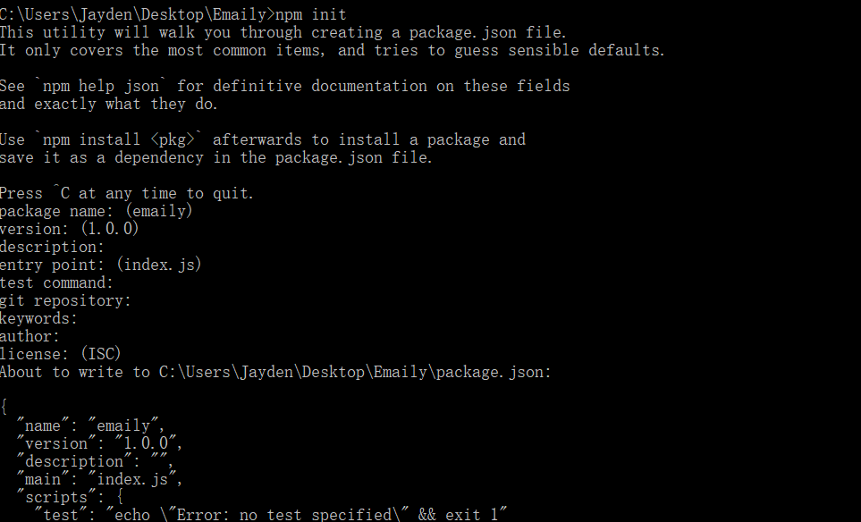

# Install express

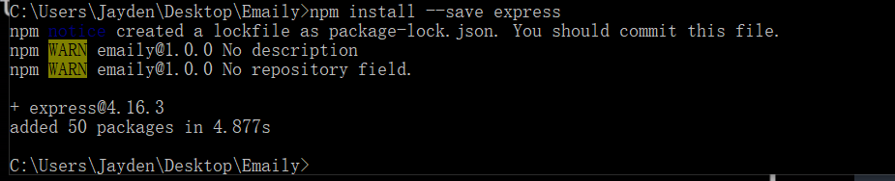

# Development Project

## Heroku

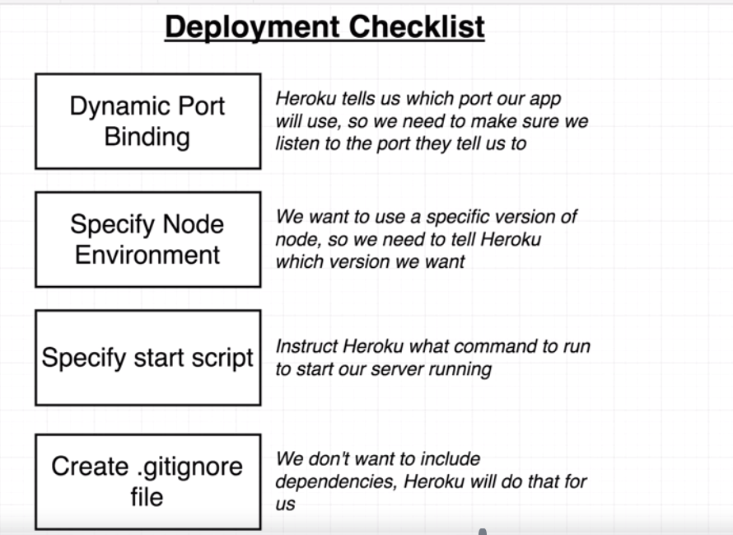

### Let heroku knows which node version we are using.

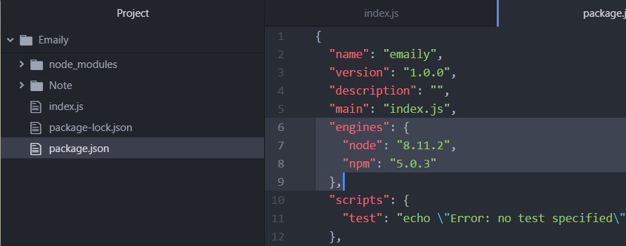

### Let Heroku knows which command to run our app.

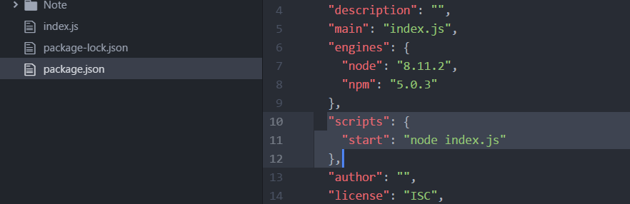

### Ignore dependencies when push to git

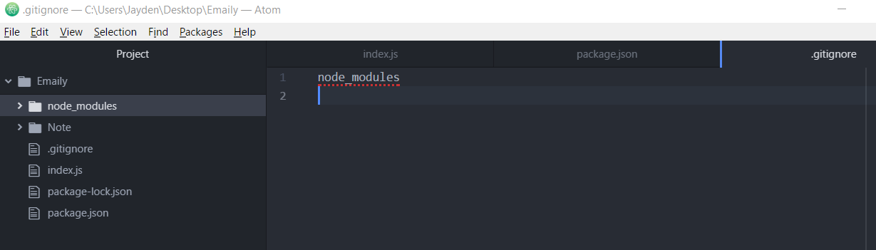

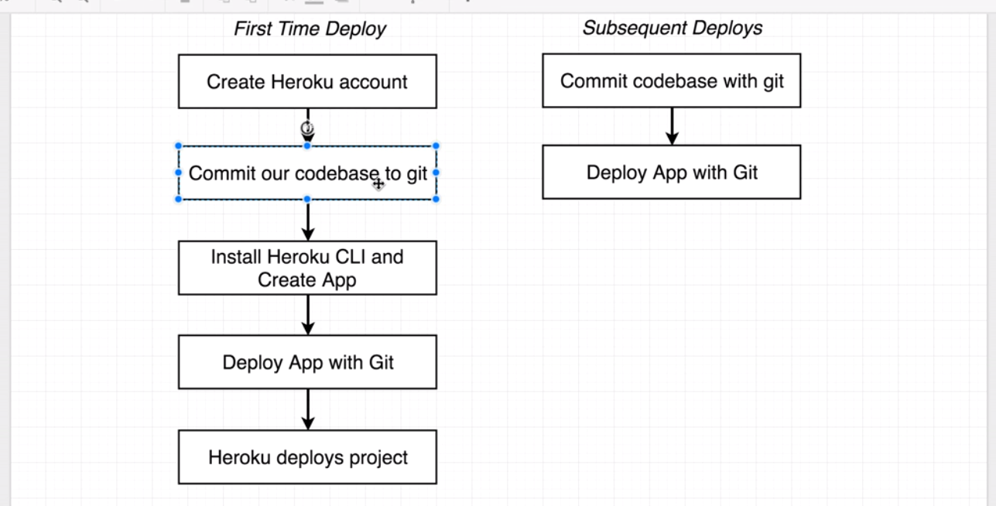

## Commit code to git

<https://github.com/wzbjmgs/emaily>

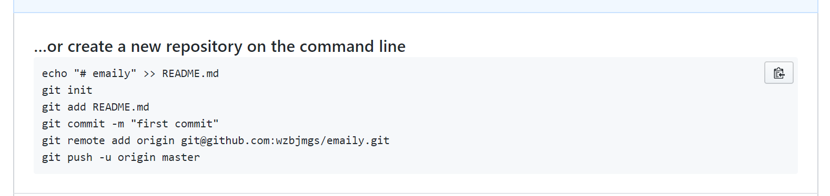

### Generate git SSH

<https://help.github.com/articles/checking-for-existing-ssh-keys/>

<https://help.github.com/articles/generating-a-new-ssh-key-and-adding-it-to-the-ssh-agent/>

