1. 老客户支付比例目的：  
   评估客户忠诚度：老客户支付比例越高，通常表示老客户的购买活跃度高，反映出较强的客户忠诚度。反之，如果老客户支付比例低，可能需要加强客户维系策略。

**优化营销策略**：通过了解老客户的支付占比，企业可以更有针对性地制定营销策略，例如加大对老客户的回馈力度，推出老客户专属的优惠活动，以提升老客户复购率。

1. 老客户支付比例定义：



3.数据源设计：

从ods层获取，order_info_inc，user_info_inc，payment_info_inc,由于数据是增量，我们把表转换为维度表，dim_order_info, dim_user_info, dim_payment_info

CREATE TABLE IF NOT EXISTS dim_user_info  
(  
 id STRING,  
 login_name STRING,  
 nick_name STRING,  
 passwd STRING,  
 name STRING,  
 phone_num STRING,  
 email STRING,  
 head_img STRING,  
 user_level STRING,  
 birthday STRING,  
 gender STRING,  
 create_time STRING,  
 operate_time STRING,  
 status STRING,  
 dt STRING  
) COMMENT '用户信息表'  
 ROW FORMAT DELIMITED FIELDS TERMINATED BY '\t'  
 LOCATION '/warehouse/gmall/ods/ods_user_info/';

CREATE TABLE IF NOT EXISTS dim_order_info  
(  
 id STRING,  
 consignee STRING,  
 consignee_tel STRING,  
 total_amount DECIMAL(10, 2),  
 order_status STRING,  
 user_id STRING,  
 payment_way STRING,  
 delivery_address STRING,  
 order_comment STRING,  
 out_trade_no STRING,  
 trade_body STRING,  
 create_time STRING,  
 operate_time STRING,  
 expire_time STRING,  
 process_status STRING,  
 tracking_no STRING,  
 parent_order_id STRING,  
 img_url STRING,  
 province_id STRING,  
 activity_reduce_amount DECIMAL(10, 2),  
 coupon_reduce_amount DECIMAL(10, 2),  
 original_total_amount DECIMAL(10, 2),  
 freight_fee DECIMAL(10, 2),  
 freight_fee_reduce DECIMAL(10, 2),  
 refundable_time STRING,  
 dt STRING  
) COMMENT '订单信息表'  
 ROW FORMAT DELIMITED FIELDS TERMINATED BY '\t'  
 LOCATION '/warehouse/gmall/ods/ods_order_info/';

CREATE TABLE IF NOT EXISTS dim_payment_info  
(  
 id STRING,  
 out_trade_no STRING,  
 order_id STRING,  
 user_id STRING,  
 payment_type STRING,  
 trade_no STRING,  
 total_amount DECIMAL(10, 2),  
 subject STRING,  
 payment_status STRING,  
 create_time STRING,  
 callback_time STRING,  
 callback_content STRING,  
 operate_time STRING,  
 dt STRING  
) COMMENT '支付信息表'  
 ROW FORMAT DELIMITED FIELDS TERMINATED BY '\t'  
 LOCATION '/warehouse/gmall/ods/ods_payment_info/';

INSERT INTO TABLE ods_user_info  
SELECT data.id AS id,  
 data.login_name AS login_name,  
 data.nick_name AS nick_name,  
 data.passwd AS passwd,  
 data.name AS name,  
 data.phone_num AS phone_num,  
 data.email AS email,  
 data.head_img AS head_img,  
 data.user_level AS user_level,  
 data.birthday AS birthday,  
 data.gender AS gender,  
 data.create_time AS create_time,  
 data.operate_time AS operate_time,  
 data.status AS status,  
 dt  
FROM ods_user_info_inc;  
INSERT INTO TABLE ods_order_info  
SELECT data.id AS id,  
 data.consignee AS consignee,  
 data.consignee_tel AS consignee_tel,  
 *CAST*(data.total_amount AS DECIMAL(10, 2)) AS total_amount,  
 data.order_status AS order_status,  
 data.user_id AS user_id,  
 data.payment_way AS payment_way,  
 data.delivery_address AS delivery_address,  
 data.order_comment AS order_comment,  
 data.out_trade_no AS out_trade_no,  
 data.trade_body AS trade_body,  
 data.create_time AS create_time,  
 data.operate_time AS operate_time,  
 data.expire_time AS expire_time,  
 data.process_status AS process_status,  
 data.tracking_no AS tracking_no,  
 data.parent_order_id AS parent_order_id,  
 data.img_url AS img_url,  
 data.province_id AS province_id,  
 *CAST*(data.activity_reduce_amount AS DECIMAL(10, 2)) AS activity_reduce_amount,  
 *CAST*(data.coupon_reduce_amount AS DECIMAL(10, 2)) AS coupon_reduce_amount,  
 *CAST*(data.original_total_amount AS DECIMAL(10, 2)) AS original_total_amount,  
 *CAST*(data.freight_fee AS DECIMAL(10, 2)) AS freight_fee,  
 *CAST*(data.freight_fee_reduce AS DECIMAL(10, 2)) AS freight_fee_reduce,  
 data.refundable_time AS refundable_time,  
 dt  
FROM ods_order_info_inc;  
INSERT INTO TABLE ods_payment_info  
SELECT data.id AS id,  
 data.out_trade_no AS out_trade_no,  
 data.order_id AS order_id,  
 data.user_id AS user_id,  
 data.payment_type AS payment_type,  
 data.trade_no AS trade_no,  
 *CAST*(data.total_amount AS DECIMAL(10, 2)) AS total_amount,  
 data.subject AS subject,  
 data.payment_status AS payment_status,  
 data.create_time AS create_time,  
 data.callback_time AS callback_time,  
 data.callback_content AS callback_content,  
 data.operate_time AS operate_time,  
 dt  
FROM ods_payment_info_inc;

4.指标的表创建：

--老客支付金额占比:  
CREATE TABLE IF NOT EXISTS ads_old_customer_payment_ratio  
(  
 calculation_date DATE,  
 old_customer_total DECIMAL(10, 2),  
 total_amount_tb DECIMAL(10, 2),  
 old_customer_payment_ratio DECIMAL(10, 2),  
 customer_payment_ratio decimal(10, 2)  
) COMMENT '老客支付金额占比'  
 ROW FORMAT DELIMITED FIELDS TERMINATED BY '\t'  
 LOCATION '/warehouse/gmall/ads/ads_old_customer_payment_ratio/';

每日数据：

insert into table ads_old_customer_payment_ratio  
SELECT '2024-10-13' AS calculation_date,  
 *COALESCE*(old_customer_total, 0) AS old_customer_total,  
 *COALESCE*(total_amount_tb, 0) AS total_amount_tb,  
 (*COALESCE*(old_customer_total, 0) / *NULLIF*(total_amount_tb, 0)) * 100 AS old_customer_payment_ratio,  
 100 - (*COALESCE*(old_customer_total, 0) / *NULLIF*(total_amount_tb, 0)) * 100 AS customer_payment_ratio  
FROM (SELECT *SUM*(*CAST*(oi.total_amount AS DECIMAL(10, 2))) AS old_customer_total  
 FROM ods_order_info oi  
 JOIN ods_user_info ui ON oi.user_id = ui.id  
 WHERE ui.create_time < *DATE_SUB*(*CURRENT_DATE*(), -20) -- 注册时间在一天之前  
 AND oi.id IN (SELECT pi.order_id  
 FROM ods_payment_info pi  
 WHERE pi.payment_status = '1602' -- 只计算支付成功的记录  
 )) AS old_customer_payments,  
 (SELECT *SUM*(*CAST*(oi.total_amount AS DECIMAL(10, 2))) AS total_amount_tb  
 FROM ods_order_info oi  
 WHERE oi.id IN (SELECT pi.order_id  
 FROM ods_payment_info pi  
 WHERE pi.payment_status = '1602' -- 只计算支付成功的记录  
 )) AS total_payments;

#### 指标效果：

#### 指标展示：

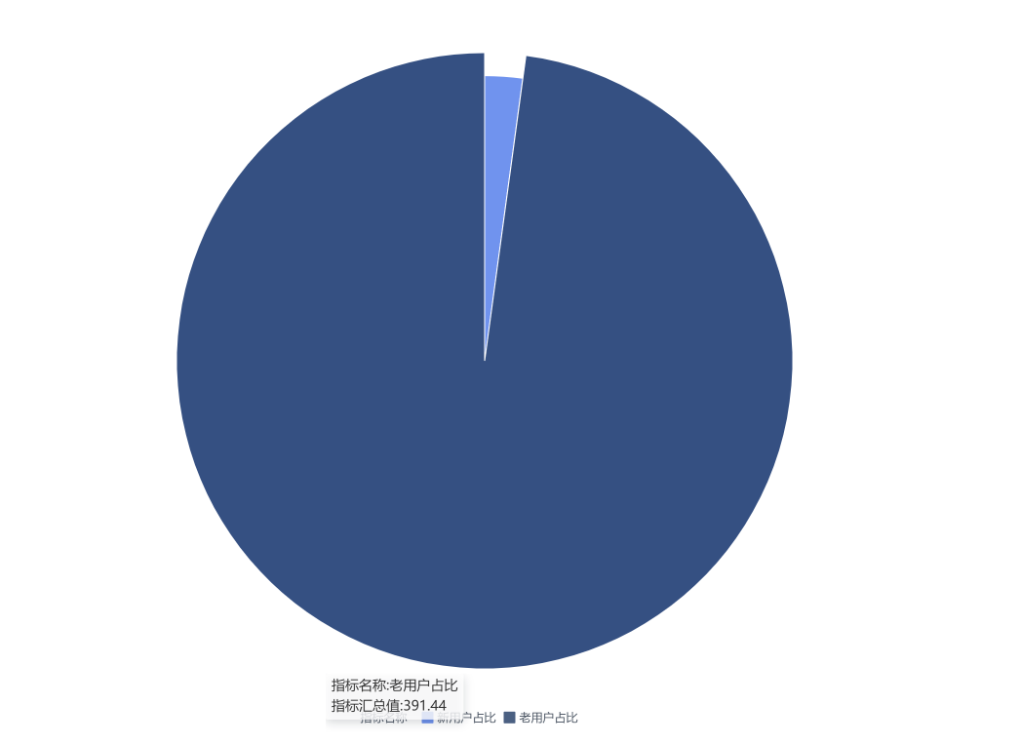

#### 临时sql:

SELECT  
 *CURRENT_DATE*() AS calculation_date,  
 *COALESCE*(old_customer_total, 0) AS old_customer_total,  
 *COALESCE*(total_amount_tb, 0) AS total_amount_tb,  
 (*COALESCE*(old_customer_total, 0) / *NULLIF*(total_amount_tb, 0)) * 100 AS old_customer_payment_ratio,  
 100 - (*COALESCE*(old_customer_total, 0) / *NULLIF*(total_amount_tb, 0)) * 100 AS customer_payment_ratio  
FROM (  
 SELECT  
 *SUM*(*CAST*(oi.total_amount AS DECIMAL(10, 2))) AS old_customer_total  
 FROM  
 ods_order_info oi  
 JOIN ods_user_info ui ON oi.user_id = ui.id  
 WHERE  
 ui.create_time < *DATE_SUB*(*CURRENT_DATE*(), -1) -- 注册时间在一天之前  
 AND oi.id IN (  
 SELECT pi.order_id  
 FROM ods_payment_info pi  
 WHERE pi.payment_status = '1602' -- 只计算支付成功的记录  
 )  
 ) AS old_customer_payments,  
 (  
 SELECT  
 *SUM*(*CAST*(oi.total_amount AS DECIMAL(10, 2))) AS total_amount_tb  
 FROM  
 ods_order_info oi  
 WHERE  
 oi.id IN (  
 SELECT pi.order_id  
 FROM ods_payment_info pi  
 WHERE pi.payment_status = '1602' -- 只计算支付成功的记录  
 )  
 ) AS total_payments;