Please read chapter 9 and then do the following exercise.
（1）Under what circumstances do page faults occur? Describe the actions taken by the operating system when a page fault occurs.
- 地址映射过程中，在页表中发现所要访问的页不在内存，则产生缺页中断。缺页中断是在指令执行期间，发现所要访问的指令或数据不在内存时所产生和处理的
- 操作系统接到此中断信号后，就调出缺页中断处理程序，根据页表中给出的外存地址，将该页调入内存，使作业继续运行下
缺页中断的过程：
1. 如果有对页面引用，第一次引用交给操作系统，产生缺页中断。
2. 检查该进程的内页表，看看该引用是否是合法的内存访问空间,如果不合法，终止该进程；
如果合法，但是没有调入到内存，需要将该进程放入该页中。
3. 查找一个空闲页框.
4. 将该页与空闲页框交换。调度磁盘操作来读取请求的页，将其放入新的分配的页框中。
5. 当磁盘读取操作完成时，重新设置该进程的页表，表明该页在内存中。validation bit = 1（重新设置页表，把位设为1）.
6. 重新启动中断的指令。该进程现在能够访问该页，因为它一直在内存中。
（2）Consider the page table shown in the Figure 9.30 for a system with 12-bit
virtual and physical addresses and with 256-byte pages. The list of free
page frames is D, E, F (that is, D is at the head of the list, E is second,
and F is last).
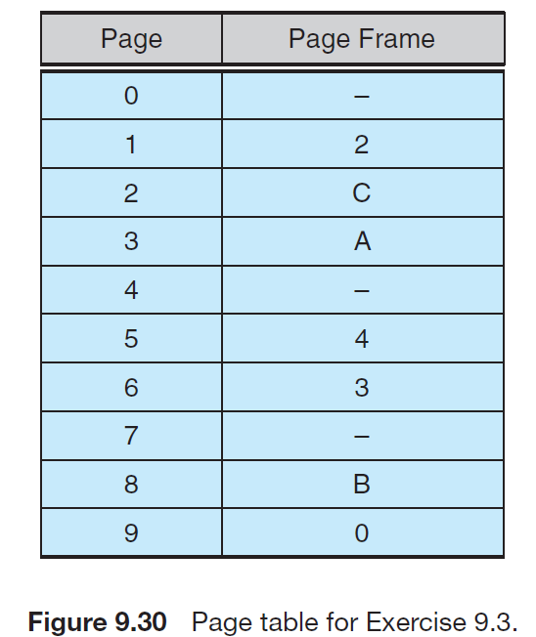
Convert the following virtual addresses to their equivalent physical
addresses in hexadecimal. All numbers are given in hexadecimal. (A
dash for a page frame indicates that the page is not in memory.)
• 9EF
- 9EF地址化为二进制： 9（1001）E（1110）F（1111）
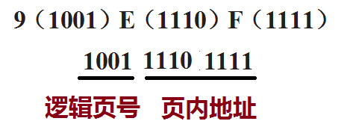
9号页面---查表，对应0号页框，页内地址不变，因此，物理地址为：
000011101111，即9EF的物理地址为 0EF
其它下面各个地址也类似变换，结果：
• 111 - 211
• 700 - D00
• 0F F - EF F
（3）Consider the following page reference string:
1, 2, 3, 4, 2, 1, 5, 6, 2, 1, 2, 3, 7, 6, 3, 2, 1, 2, 3, 6.
How many page faults would occur for the following replacement
algorithms, assuming three and five frames?
Remember that all frames are initially empty, so your first unique pages
will cost one fault each.
• LRU replacement
• FIFO replacement
• Optimal replacement
Number of frames | LRU | FIFO | Optimal
3  5 | 15  8 | 16  10 | 11  7

（4）A certain computer provides its users with a virtual memory space of
232 bytes. The computer has 222 bytes of physical memory. The virtual
memory is implemented by paging, and the page size is 4,096 bytes.
A user process generates the virtual address 11123456. Explain how
the system establishes the corresponding physical location. Distinguish
between software and hardware operations
11123456H = 0001 0001 0001 0010 0011 0100 0101 0110(虚拟地址的二进制形式)------ 32位
4096 = 2¹²(页内地址) 因此页面大小为2¹² , 32-12 =20，页表大小为2²⁰,
0001 0001 0001 0010 0011 0100 0101 0110 (20bit+12bit)
0001 0001 0001 0010 0011 0100 0101 0110
因此前20bits用来表示在页表中的位置, 后12bits用来表示在页中的偏移量。

（5）Consider the following page reference string:
7, 2, 3, 1, 2, 5, 3, 4, 6, 7, 7, 1, 0, 5, 4, 6, 2, 3, 0 , 1.
Assuming demand paging with three frames, how many page faults
would occur for the following replacement algorithms?
• LRU replacement
• FIFO replacement
• Optimal replacement
红色标注代表没有发生缺页中断。
7 2 3 1 2 5 3 4 6 7 7 1 0 5 4 6 2 3 0 1
7 7 7 1 1 1 3 3 3 7 7 7 7 5 5 5 2 2 2 1
2 2 2 2 2 2 4 4 4 4 1 1 1 4 4 4 3 3 3
3 3 3 5 5 5 6 6 6 6 0 0 0 6 6 6 0 0
LRU：缺页次数为18

7 2 3 1 2 5 3 4 6 7 7 1 0 5 4 6 2 3 0 1
7 7 1 1 1 1 1 1 6 6 6 6 0 0 0 6 6 6 0 0
2 2 2 2 5 5 5 5 7 7 7 7 5 5 5 2 2 2 1
3 3 3 3 3 4 4 4 4 1 1 1 4 4 4 3 3 3
FIFO：缺页次数为17

7 2 3 1 2 5 3 4 6 7 7 1 0 5 4 6 2 3 0 1
7 7 7 1 1 1 1 1 1 1 1 1 1 1 1 1 1 1 1 1
2 2 2 2 5 5 5 5 5 5 5 5 5 4 6 2 3 3 3
3 3 3 3 3 4 6 7 7 7 0 0 0 0 0 0 0 0
Optimal：缺页次数为13

