1. 一个文件系统中有一个20MB大文件和一个20KB小文件,当分别采用连续、链接、链接索引、二级索引和UNIX System V 分配方案时(每块大小为4096B,每块地址用4B表示)，问:
（1）各文件系统管理的最大的文件是多少?
（2）每种方案对大、小两文件各需要多少专用块来记录文件的物理地址(说明各块的用途) ?
（3）如需要读大文件前面第5.5KB和后面（16M＋5.5KB）信息，则每个方案各需要多少次硬盘I/O操作?
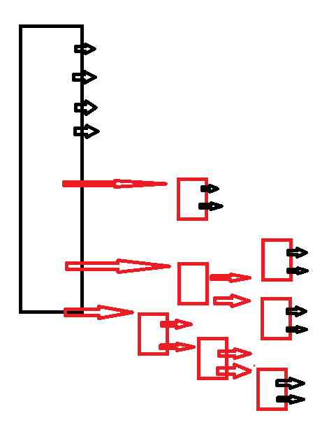

2. Some file systems allow disk storage to be allocated at different levels of granularity. For instance, a file system could allocate 4 KB of disk space as a single 4-KB block or as eight 512-byte blocks. How could
we take advantage of this flexibility to improve performance? What
modifications would have to be made to the free-space management
scheme in order to support this feature?

3. Consider a file system that uses inodes to represent files. Disk blocks are 8 KB in size, and a pointer to a disk block requires 4 bytes. This file system has 12 direct disk blocks, as well as single, double, and triple indirect disk blocks. What is the maximum size of a file that can be
stored in this file system?

