1. Under what circumstances do page faults occur? Describe the actions taken by the operating system when a page fault occurs.

**2.** Consider the page table shown in the following Figure for a system with 12-bit virtual and physical addresses and with 256-byte pages. The list of free page frames is *D*, *E*, *F* (that is, *D* is at the head of the list, *E* is second, and *F* is last).

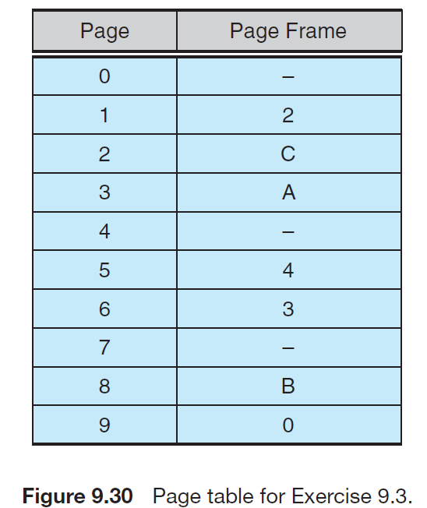

Convert the following virtual addresses to their equivalent physical

addresses in hexadecimal. All numbers are given in hexadecimal. (A

dash for a page frame indicates that the page is not in memory.)

• 9EF

• 111

• 700

• 0F F

**3.** Consider the following page reference string:

1, 2, 3, 4, 2, 1, 5, 6, 2, 1, 2, 3, 7, 6, 3, 2, 1, 2, 3, 6.

How many page faults would occur for the following replacement

algorithms, assuming three and five frames?

Remember that all frames are initially empty, so your first unique pages

will cost one fault each.

• LRU replacement

• FIFO replacement

• Optimal replacement

**4．** A certain computer provides its users with a virtual memory space of

232 bytes. The computer has 222 bytes of physical memory. The virtual

memory is implemented by paging, and the page size is 4,096 bytes.

A user process generates the virtual address 11123456. Explain how

the system establishes the corresponding physical location. Distinguish

between software and hardware operations

**5.** Consider the following page reference string:

7, 2, 3, 1, 2, 5, 3, 4, 6, 7, 7, 1, 0, 5, 4, 6, 2, 3, 0 , 1.

Assuming demand paging with three frames, how many page faults

would occur for the following replacement algorithms?

• LRU replacement

• FIFO replacement

• Optimal replacement