Comparison of models with:
In circle:
Density= 11
Viscosity= 1
Page 1: LitModDyn code simulations
Page 2: Aspect code simulations
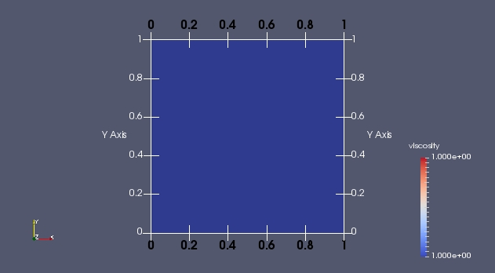 | 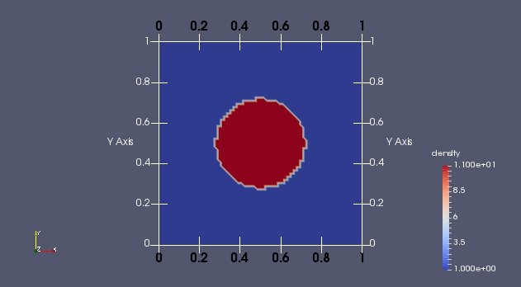
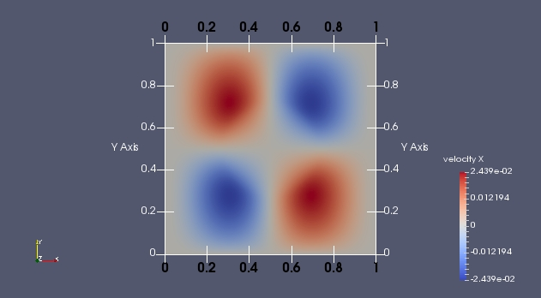 | 