**Lab 4 report**

**1. For the assignment part 1, I used recommendation systems. I upload the dataset, here is screenshot for output:**

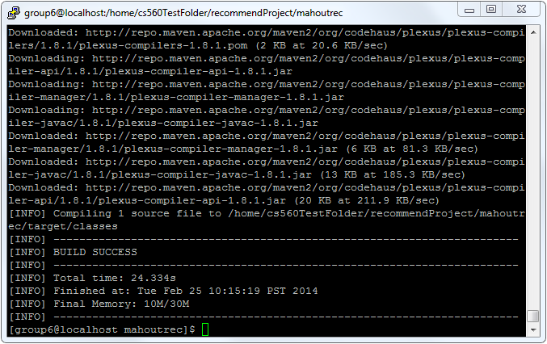

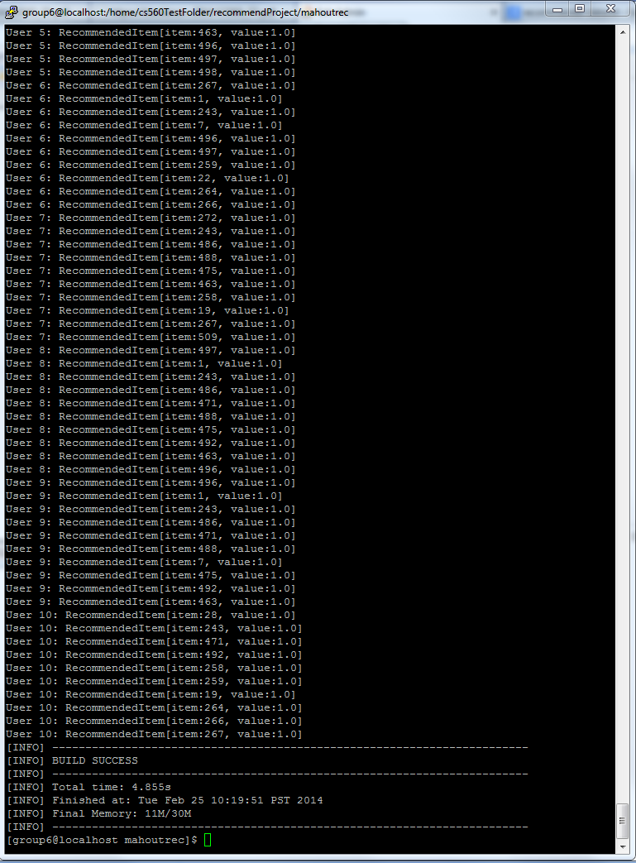

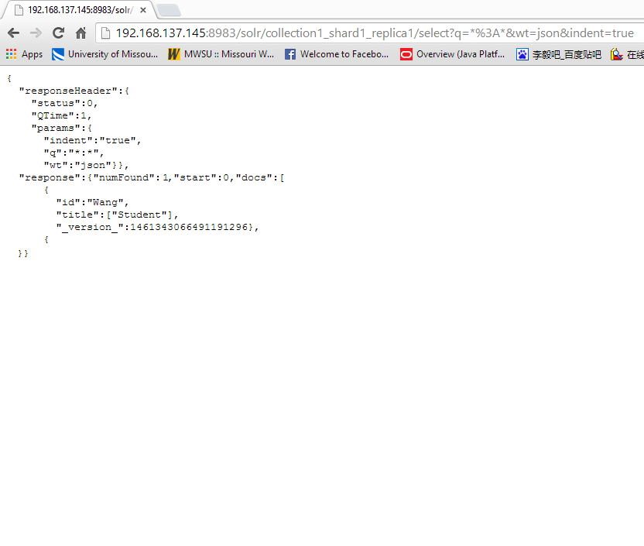

**Output from solr**

**2.**

**Basically, extract the id and title information from solr and display it on app. but it only work on local, haven’t figure out how to do it. Here is screenshot:**

