# Source code for "Clustering Single-Cell Multi-Omics Data via Weighted Distance Penalty and Adaptive Consistent Graph Regularization".

To make it easier for readers to run the program using Python, we have provided an interface that enables them to execute the scWDAC method through a Python program in PyCharm. The specific steps are as follows:

1. Check the Python version supported by your MATLAB.
Typically, you can find this information in the MATLAB installation directory under extern → engines → python. As shown in the image below, the example MATLAB version supports Python versions 3.8, 3.9, and 3.10.
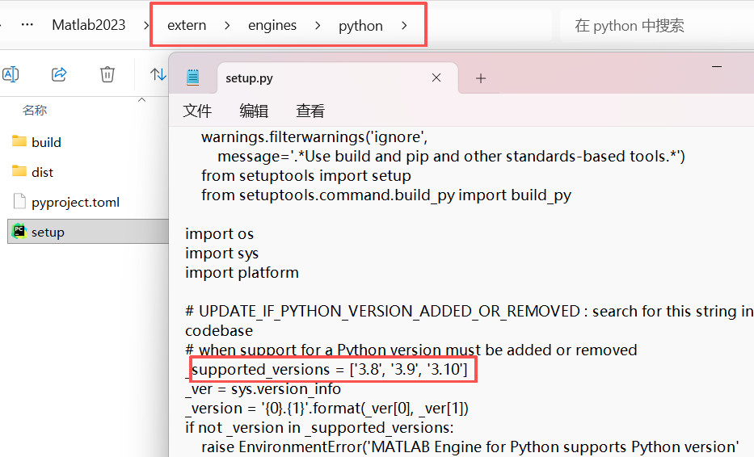

2. Adjust the Python environment and install the MATLAB engine.
Create a virtual environment in anaconda that matches the supported Python version (Note: The scWDAC.m file must be located in the same project directory as the main.py file):
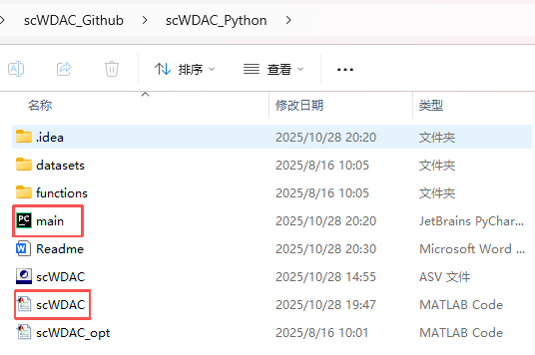
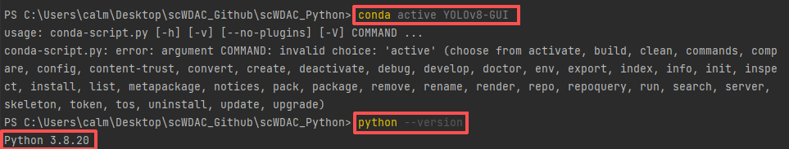
Switch to the directory where the Python folder from Step 1 is located, and then use the command python setup.py install to install the setup.

During the installation process, you will see many messages. As long as there are no red errors, the installation is successful. If matlabengineforpython is displayed, it means the installation has completed successfully.
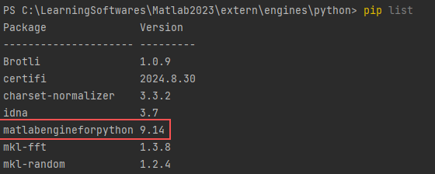

3. Next, simply activate the virtual environment created earlier in PyCharm, and run the main.py file to successfully execute the scWDAC method. Example datasets are provided in the "datasets" folder. Each dataset consists of multi-view data (X), where the dimension of each view X{v} is n×m (samples×features), along with the true labels (true_label).
