1b. these factors are not highly correlated. They are less correlated than HW1

1c There are not stable. Hw1 is much more stable.

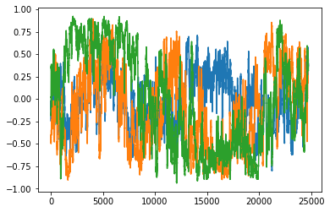

1d they are not nomal

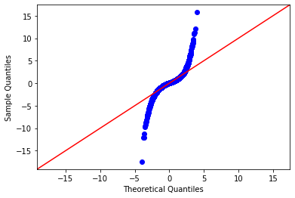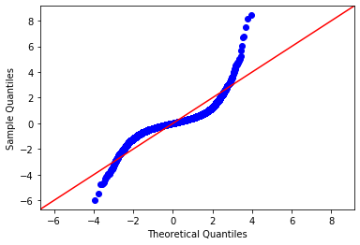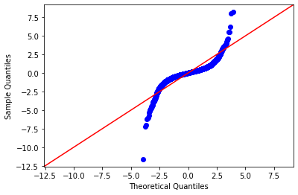

1e

These beta are consistent compare with hw1 beta.

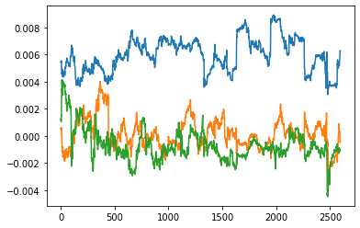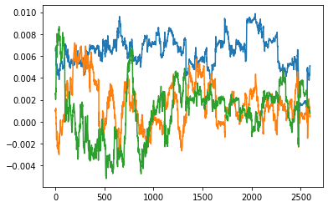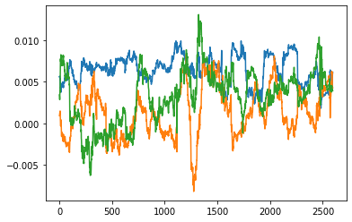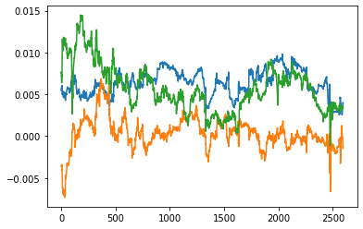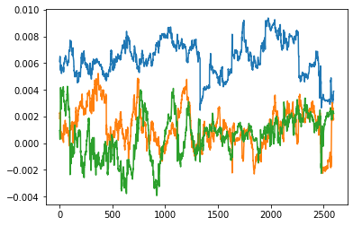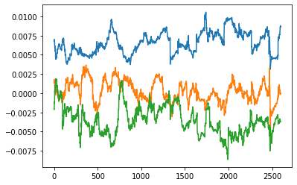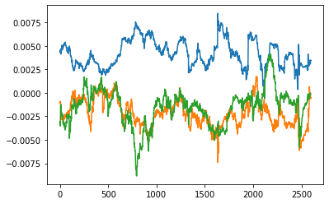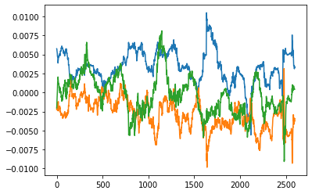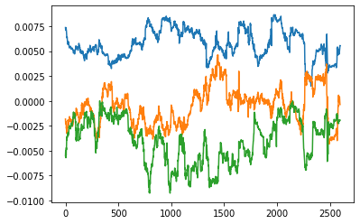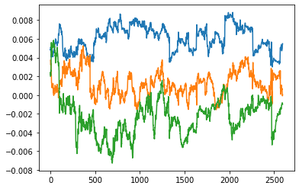

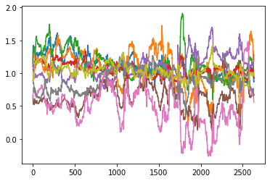

1f

What is their mean and variance? Do they appear to be normal? What does this tell you about the appropriateness of the model? Can you think of any other tests of the residuals that would help you judge the model?

They are not perfect normal but it is close to normal according to qqplot. The model is good since the mean and variance are pretty small. I think maybe we can test data in other time interval to test the model.

mean: -9.5007697558211e-05 variance: 2.4706874679666153e-05

mean: -0.00011709518498906006 variance: 6.737581115544456e-05

mean: -0.0004359039249426479 variance: 9.134272558963917e-05

mean: -0.0001284282182931741 variance: 5.776206568059115e-05

mean: -4.3524047672780124e-05 variance: 4.247636289261486e-05

mean: -0.0001263481586887456 variance: 3.9965711351116745e-05

mean: 0.00015616642628531107 variance: 3.363543692464839e-05

mean: 0.0001458757566708891 variance: 6.626368563222143e-05

mean: -0.00010259837343953457 variance: 3.92551572673976e-05

mean: -3.851306141489644e-05 variance: 3.919658493174634e-05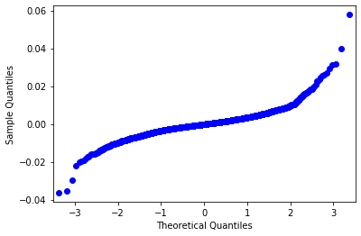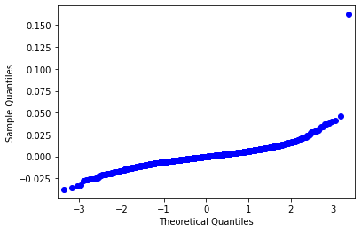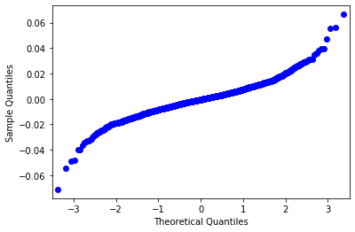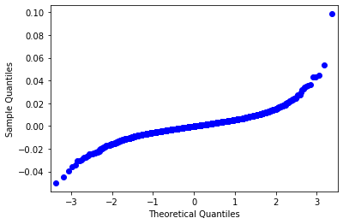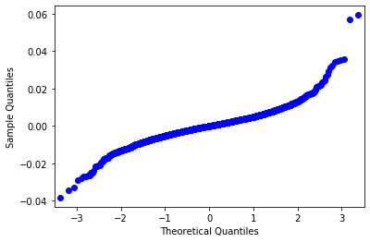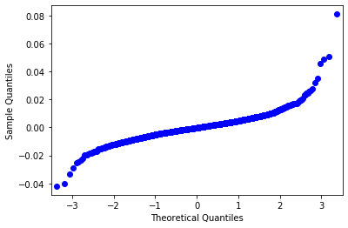

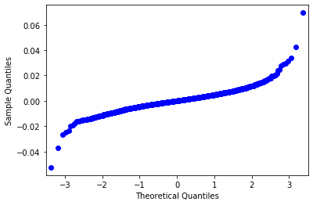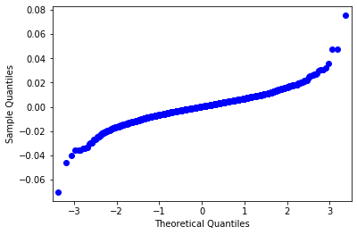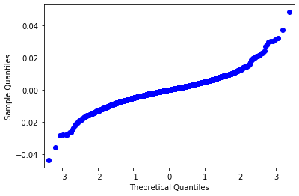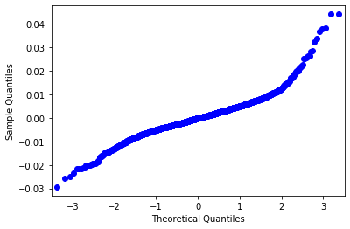

2a

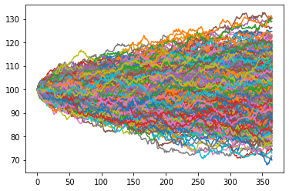

2b it is normally distributed by looking at the qqplot

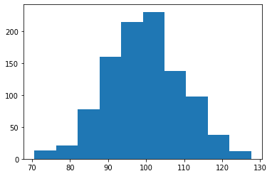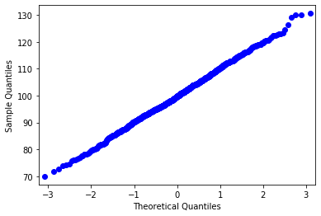

2c the price is around 7.6 which is lower than hw1 about 9

2d I think epsilon could equals 0.2. Because the delta seems stable when epsilon go up to 0.2. Epsilon smaller than 0.2 will lead to great error since the option price variate between different simulation. The delta seems -1 for put option.

