1.

(b).

^VIX

According to the p value. I think there are autocorrelation. The SPY seems has more evidence of autocorrelation, since the p-value is 0.000<0.001. I think it is not reasonable because people’s mood may continue to the next day.

(c)

Daily_Correlation: -0.10551693640061713 P-value: 3.5293040478493084e-08

Monthly_Correlation: -0.09965993850541109 P-value: 0.2592630569784917

Both correlation seems small.

Correlation of daily data is significant. Correlation of monthly data is not significant since daily pvalue smaller than 0.05 but monthly pvalue greater than 0.05. This imply that the fixed sigma is not good with price change.

(d)

-0.38322580529207323, -0.34728937458722725, -0.3238445643651352, -0.30899849405727176, -0.28308753021903643, -0.24271403676489803, -0.2114095482072201, -0.17210514094204726, -0.16355257017260616, -0.09249538645232944, -0.044640276282329326, -0.015555603556371861, 0.023661475875588808, 0.0413048159074203]

The correlation deviates the most from its long-run average when 2018.

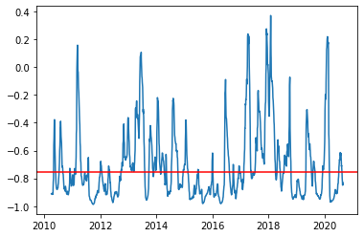

(e)

Premium

Date

2010-04-07 0.027459

2010-04-08 0.026005

2010-04-09 0.022130

2010-04-12 0.016687

2010-04-13 0.022979

2020-08-25 0.028812

2020-08-26 0.042231

2020-08-27 0.054405

2020-08-28 0.039172

2020-08-31 0.073347

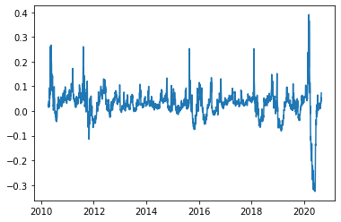 The premium generally positive.

The recent drop because of covid is the highest and the period after that is the lowest.

(f)

Put+call option price

Date

2010-01-04 4.221748

2010-01-05 4.087219

2010-01-06 4.049945

2010-01-07 4.045820

2010-01-08 3.861263

2020-08-25 17.388643

2020-08-26 18.551177

2020-08-27 19.550100

2020-08-28 18.462646

2020-08-31 21.158686

(g)

Average of P&L is -1.1536733039605822

Payoff

P&L

SPY ^VIX Payoff P&L

Date

2010-01-04 91.475693 20.040001 2.825050 -1.396698

2010-01-05 91.717857 19.350000 5.803520 1.716302

2010-01-06 91.782425 19.160000 5.690460 1.640515

2010-01-07 92.169884 19.059999 6.699493 2.653673

2010-01-08 92.476562 18.129999 5.932632 2.071370

... ... ... ...

2020-07-27 321.931305 24.740000 20.816681 2.475806

2020-07-28 319.889496 25.440001 26.294739 7.554766

2020-07-29 323.823730 24.100000 23.117462 5.145827

2020-07-30 322.668365 24.760000 26.513855 8.116134

2020-07-31 325.218140 24.459999 22.699158 4.380636

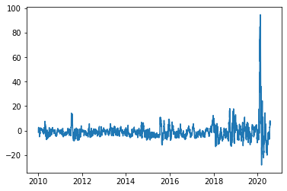

(h) There is no strong relationship. I don’t think there is a strong relationship because no one should be able to predict future volatility very well.

