1.

(a) The forward rate is 0.028438.

Find R1 first, then use the formula get forward rate.

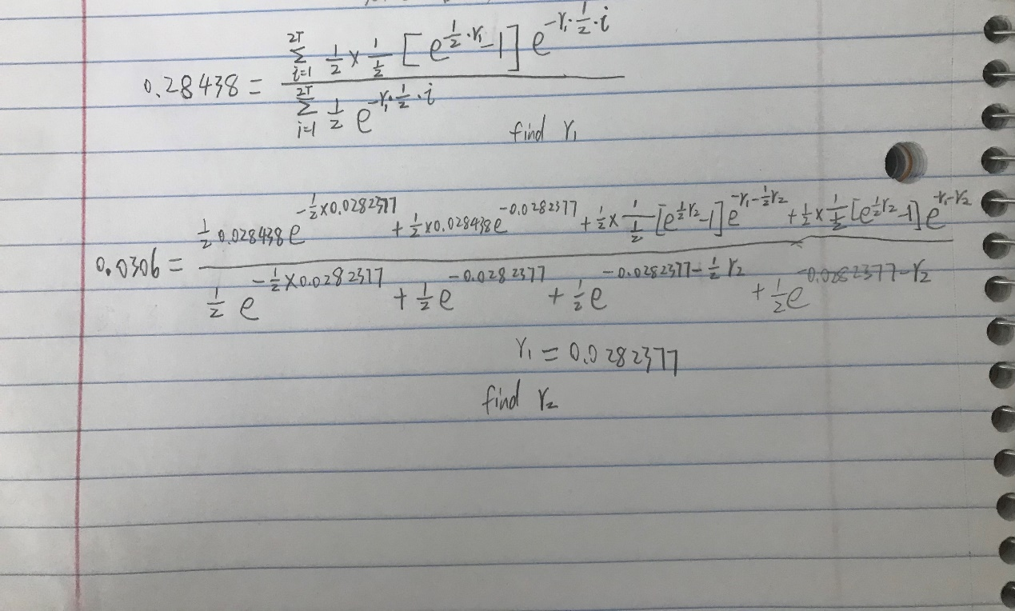

(b)

The forward rate for one year to two year is 0.032811.

(c)

Forward rates are always higher than swap rates at the same time except the first year. Forward rates are not stable with time.

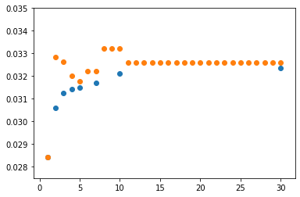

(d)

The swap rate of a 15Y swap is 0.03223673.

(e). Zero rates are always higher than swap rates at the same time. Zero rates are not stable with time.

No, It is not directly. The swap rates increase less than 100bps.

(g).

(h)

The difference shows that the increasing of forward rate is greater than swap rates increasing, but the difference smaller with the swap rates difference increase.

(i)

(j)

By the difference, we can see that the forward rate decrease only at the beginning, The forward rate change wield when swap rate change. There are almost no change for long term forward rate.