1. implementation of breeden-Litzenberger

(a).

(b).

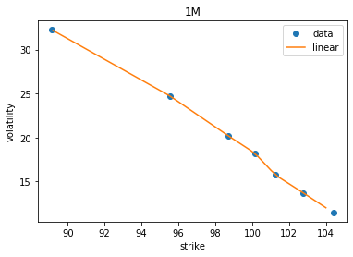

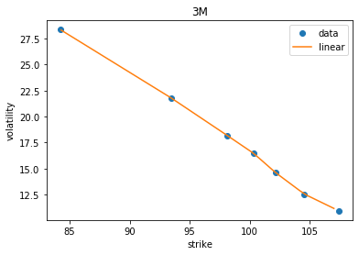

(c).

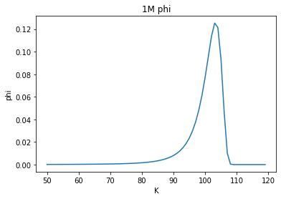

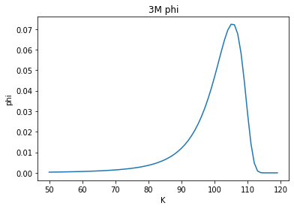

It seems that 3 month has bigger variance than 1 month which make sense. Longer time interval leads more change.

(D)

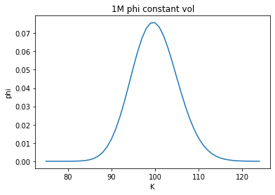

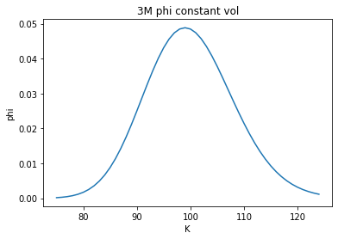

When use constant volatility, the distribution seems no skewness. For the same T, constant volatility leads to a bigger variance distribution.

(e)

(1)

Digital put=Φ（K）

Price=0.9984998779842045

(2)

Digital call

Price = 0.3308543479578533

(3)

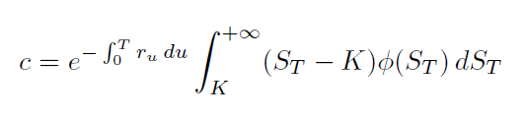

2M call 100 price = 2.646949186641023