Problem 1,

I get the data with DataReader. If there is any error, I remove the wrong ticker from my list.

I choose to use s&p500 as my tickers list.

If I find Nan, I will use the mean of the previous price and the next price as the missing data.

Eigen values are all positive.

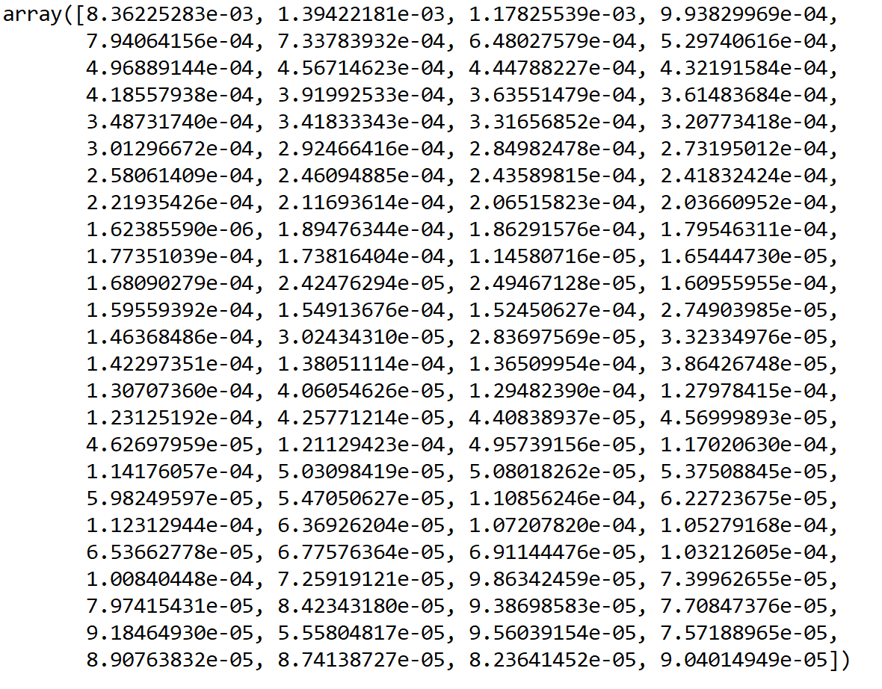

8 eigenvalue is required to account for 50% of the variance.

55 eigenvalues are required to account for 90% of the variance.

I think it make sense, since at the same period, stocks in the same market tend to have similar returns.

5.

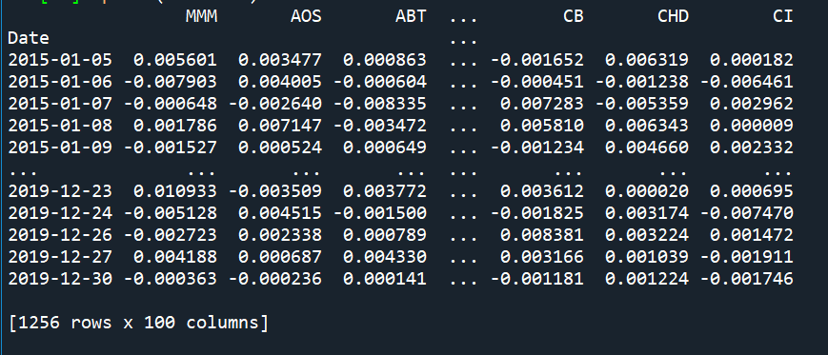

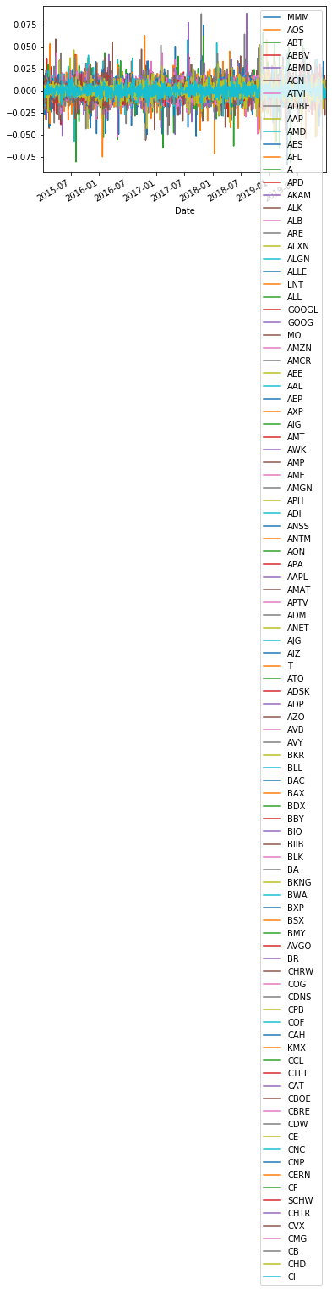

Problem 2

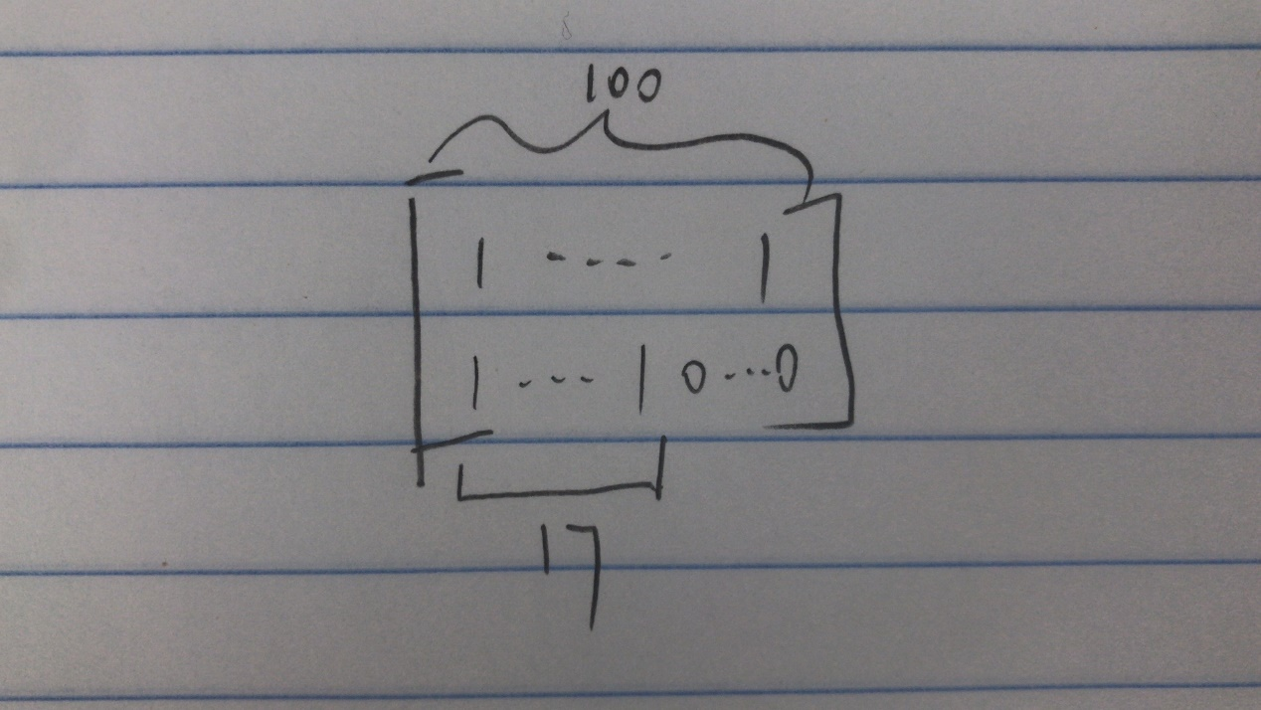

2.

Let a =1

It looks ok for mutual fund.