SPY close price Mar 3 = 381.42

1. The difference is that the call spread cannot exercise before expiry date, but the two American call option can exercise before expiry date which means can exercise at different time.
2. The rate is 0.05. I got it from the treasury website. It is a government website, so I consider it is precise. <https://www.treasury.gov/resource-center/data-chart-center/interest-rates/pages/textview.aspx?data=yield>
3. <https://quant.stackexchange.com/questions/35194/estimating-the-historical-drift-and-volatility>

From the answer, I think the sigma can find from history price.





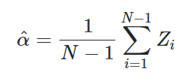

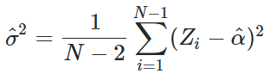

And take the square root of sigma hat to two is the daily sigma.

We need to multiply by square root of 252 to get yearly sigma.

By the past one-year history data, I get the sigma which is 0.32720182458452696.

1. I choose s max = 500

Hs=120/252/100

Ht=500/700

The reason to choose these number is that abs(sig2*x_max**2*dt/dx**2)<1 which fulfill the requirement.

When the price of SPY is 381.42, the price of 385 strike call is 36.43.

When the price of SPY is 381.42, the price of 390 strike call is 34.20.

So the price of call spread is 36.43-34.20=2.23

1. All the eigenvalues are below 1.

When the price of SPY is 381.9095477386935, the price of 385 strike call is 36.43.

When the price of SPY is 381.9095477386935, the price of 390 strike call is 34.20.

So the price of call spread is 36.43-34.20=2.23

I find the nearest SPY with today SPY.

7.

When the price of SPY is 381.9095477386935, the price of 385 strike call is 36.43549905840704.

When the price of SPY is 381.9095477386935, the price of 390 strike call is 34.20054373092242.

So the price of call spread is 36.43-34.20=2.23

The European option has the same price as American option.

8.

There is no premium. I think it make sense since we always have time value so the intrinsic option price always greater than exercise before maturity.