Weekly Stock Market Data

(a).

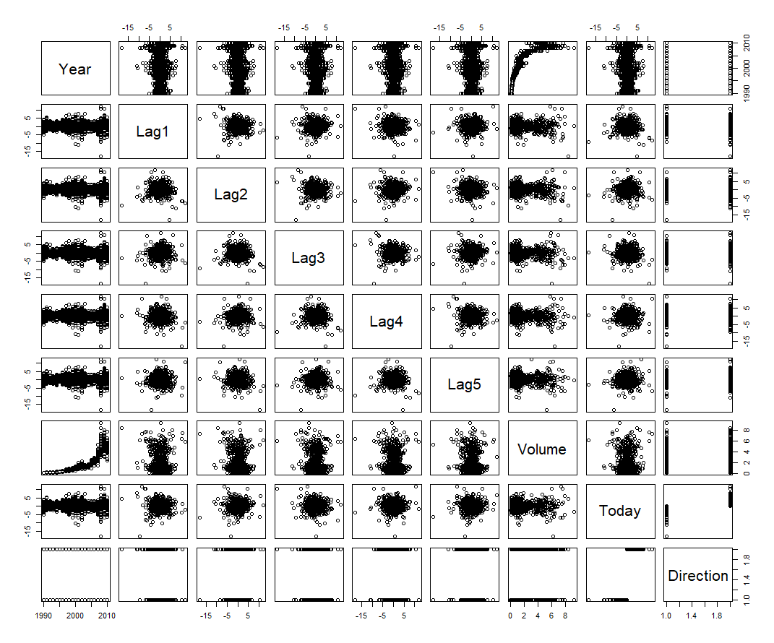

There are no apparent patterns.

(b).

There is only Lag2 appear to be statistically significant.

(c). 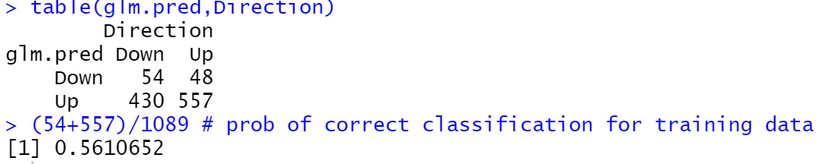

The overall fraction of correct predictions is 0.56.

False positive rate: 430/(54+430)= 0.8884298

False negative rate: 48/(48+557)= 0.07933884

(d)

Confusion matrix

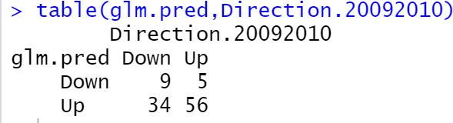

Overall fraction of correct predictions for the hold out data is 0.625.

(e)

Confusion matrix

Overall fraction of correct predictions for the hold out data is 0.625.

(f)

The optimal k is 125 that minimized the test misclassification error rate. The correct fraction is 0.6442308.

(g)

The knn has the best result on this data.

(h)

LDA

KNN

From these ROC curves, it is hard to say which method is better than the other.