Problem 1

a)

Table 1

|  |  |  |  |  |
| --- | --- | --- | --- | --- |
|  | Estimate | Std.Error | Std.Error(NeweyWest) | Std.Error(vcovHAC) |
| α | 0.00067124 | 0.00039071 | 0.00049762 | 0.00046913 |
| β | 0.70650089 | 0.01830426 | 0.05192860 | 0.05049130 |

On the view of the OLS and HAC standard errors, I think proper GLS should have a better estimate because the OLS standard error for β is much smaller than HAC’s.

b)

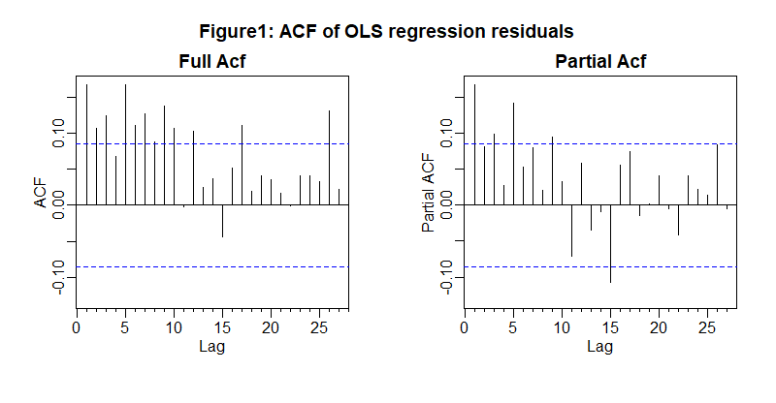

It could be AR(3)

The standard error is T-0.5= 522-0.5=0.438.

Table 2

|  |  |  |  |
| --- | --- | --- | --- |
| Lag1 | Lag2 | Lag3 | Lag4 |
| 0.1676 | 0.1075 | 0.1253 | 0.0681 |

The first row of C is [1.0000 0.1676 0.1075 0.1253 and 518 zeros]

Residual variance is 7.9267e-05.

Table 3



I need 5 iteration.

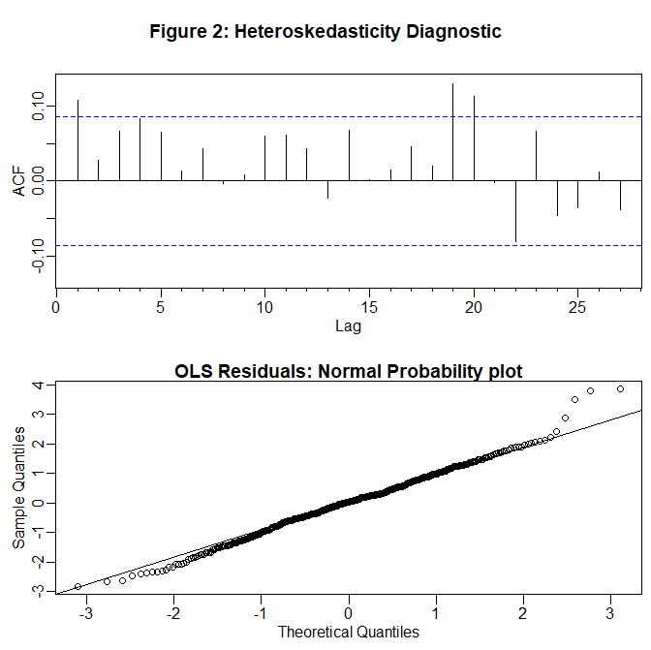

Plot a) shows a very weak persistence of absolute values which is not a significant sign of predictable time varying variance.

Plot b) shows that the strong nonnormality of residuals.

|  |  |  |  |
| --- | --- | --- | --- |
|  | α0 | α1 | β1 |
| Estimate | 0.00001293 | 0.23687198 | 0.61441178 |
| Standard Error | 4.942e-06 | 6.100e-02 | 9.711e-02 |

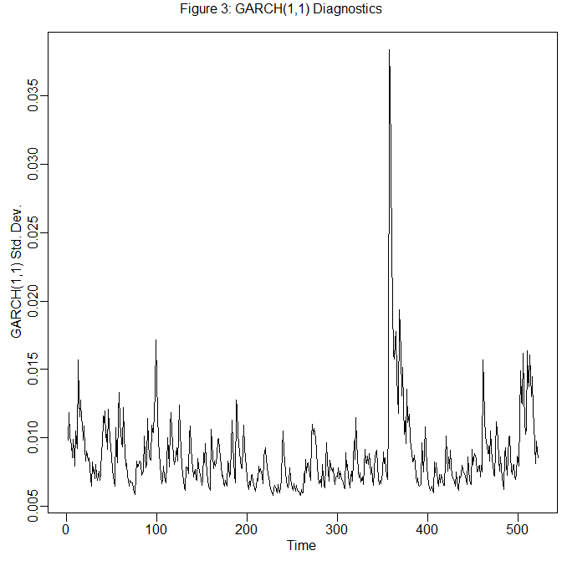

Estimate Standard error

Alpha 0.0006669717 0.0003496324

Beta 0.6800181164 0.0173932149

Table 4



(d)

I think we can do autocorrelation and heteroskedasticity in two different steps. For example, we can do MA(3) iteration and then do GARCH(1,1) iteration.