**William Zicha**

**Student ID: 40127016**

**Does my program work correctly, or does it misbehave! WHY?**

**PART 1**

My program behaves as intended. The output of my program is as follows:

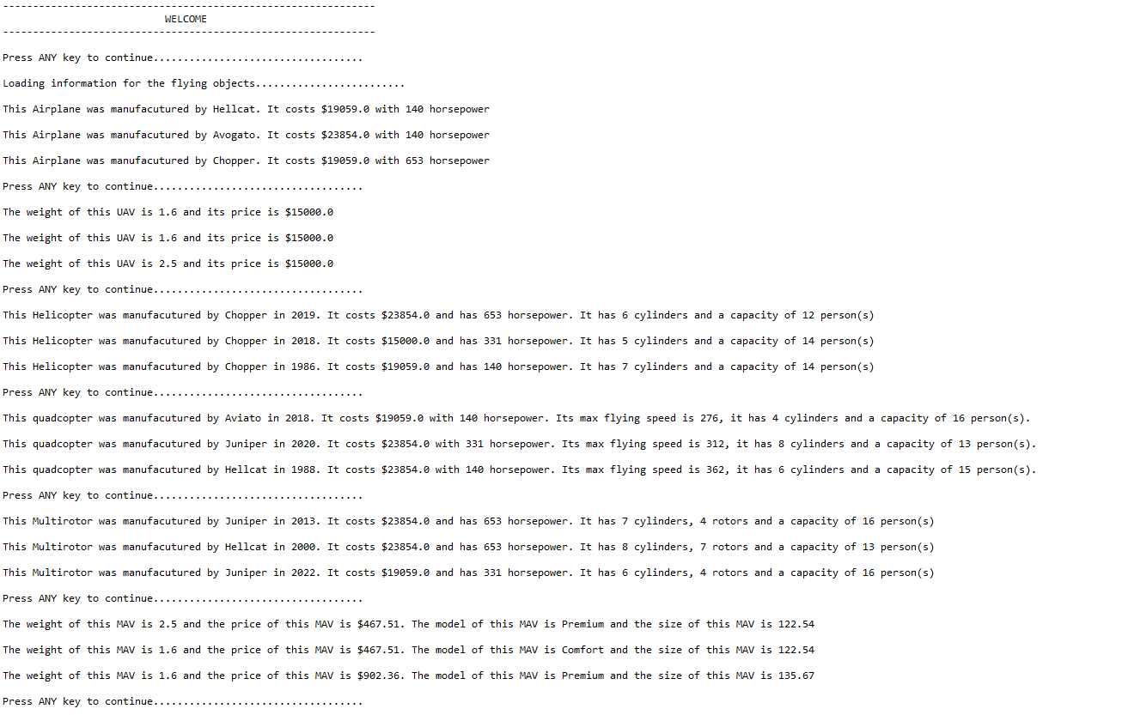

The program correctly identifies objects that are unequal/different.

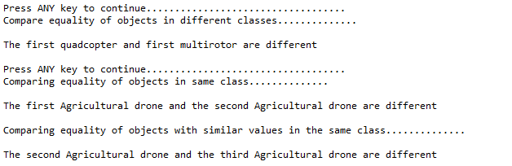

It correctly identifies the least and most expensive UAV and notifies the user when the prices of the UAV are the same.

(Run 1)

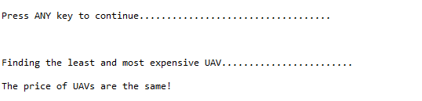

(Run 2)

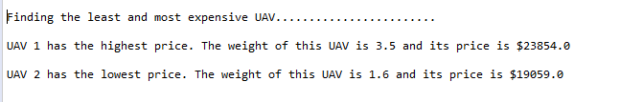

**PART 2**

The program runs as intended. Here are the outputs from running the program three times.

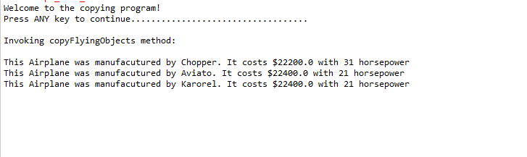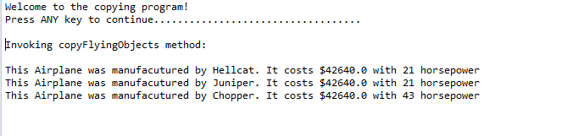

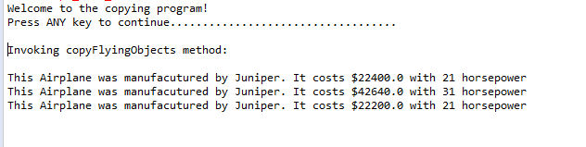

The program successfully returns an array of the copyFlyingObjects method.