

CENTENNIAL COLLEGE PROGRESS CAMPUS

COURSE COMP125 Winter 2025

ASSIGNMENT #4

Form Validation

- On the navbar of your existing application create a navbar element called Member
- Create an HTML document called assignment4.html that collects the following information from the user:
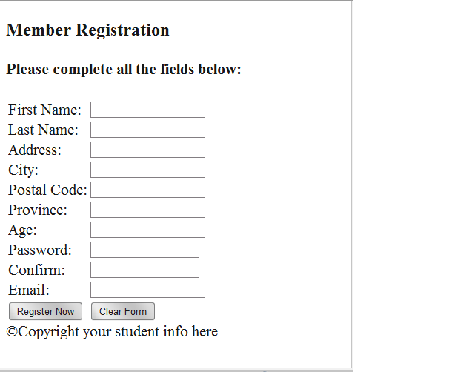

- Next modify assignment4.html to include the JavaScript code required for field validation.

The following are the guidelines for validating the user input:

→ All fields are mandatory (cannot be left blank)

→ The postal code must be in the a0a0a0 format – (research it on the internet)

→ Province is one of QC, ON, MN, SK, AB, BC.

→ Age must be at least 18 yrs. old.

→ The Email field must contain the @ and . characters
(5% of the mark for using a regular expression – research it on the internet)

→ The Confirm Password and Password fields should have identical input.

→ Passwords must have at least 6 characters and must contain at least one digit and one upper-case character.
(5% of the mark for using a regular expression – research it on the internet)

When the form fields pass validation, an alert message is displayed to show a confirmation message (e.g. “Thanks for registering with our website, your customer record was created successfully.”).

(10% of the mark) Customize/design your page using a CSS style sheet and graphics of your choice. Include a banner area with graphics and a title of your choice, add additional visual enhancements to the page as you consider suitable.

Upload the html document and supporting picture files to the studentweb server and create a hyperlink called Assignment 4 from your home page to point to the assignment4.html file.

Also zip and upload the entire folder to the submission box in Luminate.

This assignment is due on March 16th at 11:59 pm. Late assignments are accepted two more days after the due date, and they are marked out of 80%. Submit your assignment to Assignment 4 drop box. ALSO PUBLISH IT on the student web.

