

CENTENNIAL COLLEGE PROGRESS CAMPUS

COURSE COMP125 Winter 2025

Assignment 5

Using your existing application and the form created in Assignment 4.

- Create a query string to store the form data. Provide the screen snapshot of the query string.

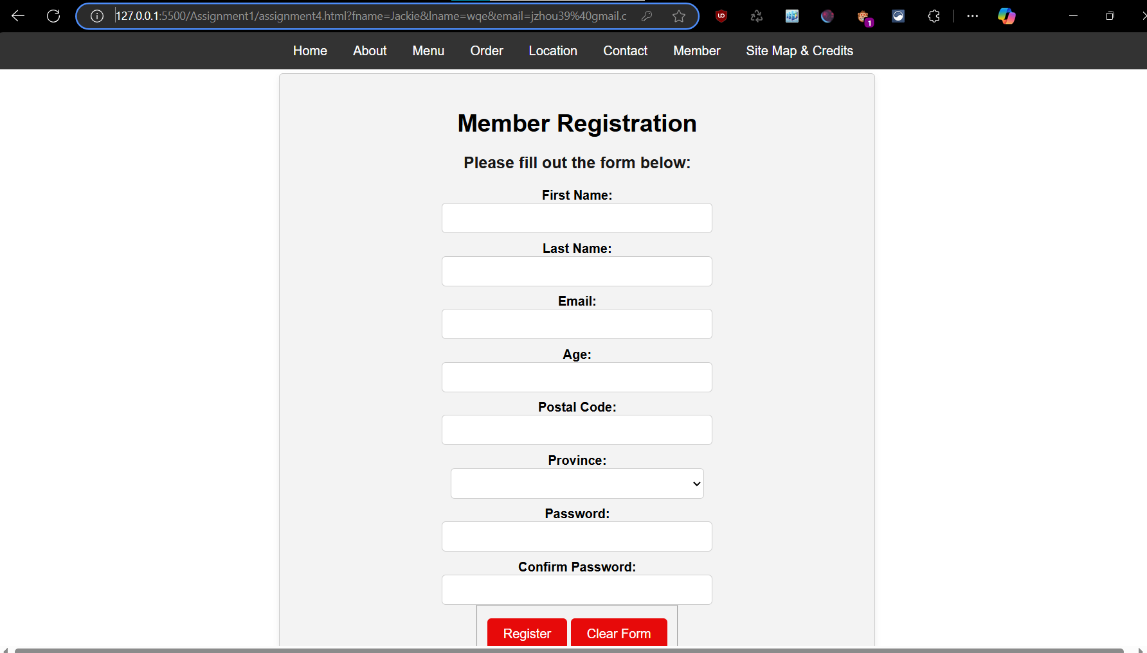
- Write the data into a Cookie. Provide the screen snapshot.

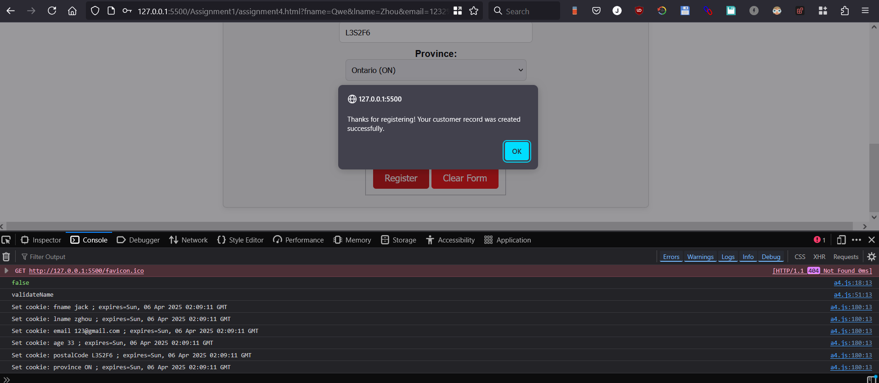

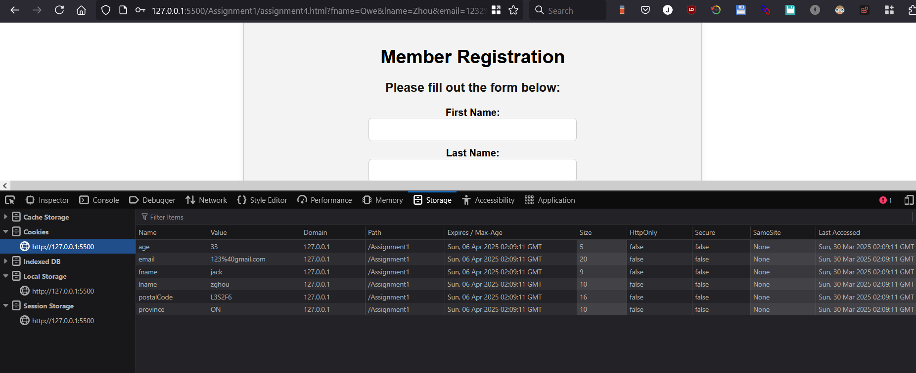

- Retrieve the data from web storage. Provide the screen snapshot.

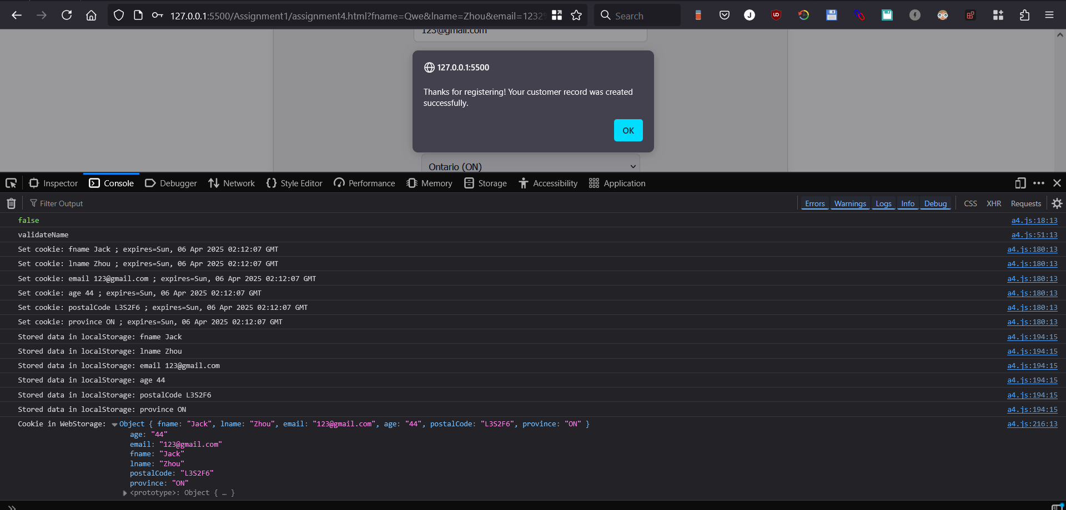

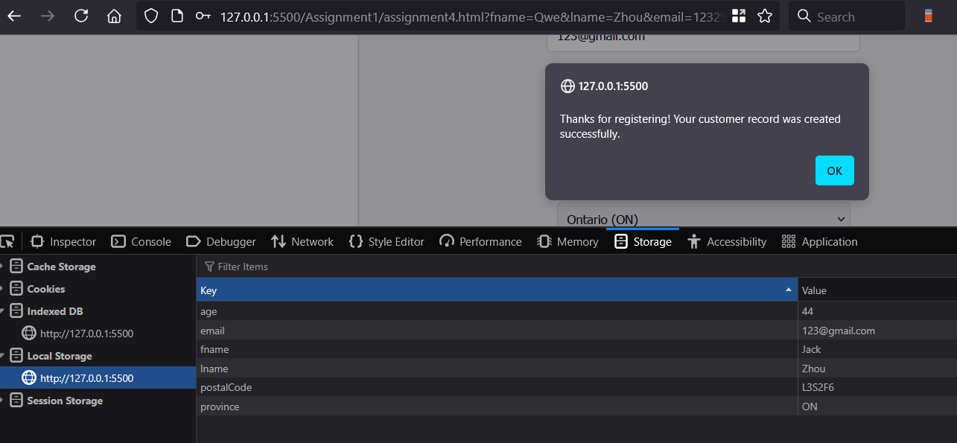

- Create a file named location.html and a JavaScript file called location.js. In the JavaScript file write the script to display assumed image of the location of the restaurant and the google maps of the assumed location. You are free to use any assumed latitude and longitude.
- Display the driving, walking and rail/train route on the map from the user’s location to the restaurant location based on the latitude and longitude of the restaurant provided. Provide the screen snapshot of the output in the browser as shown below.

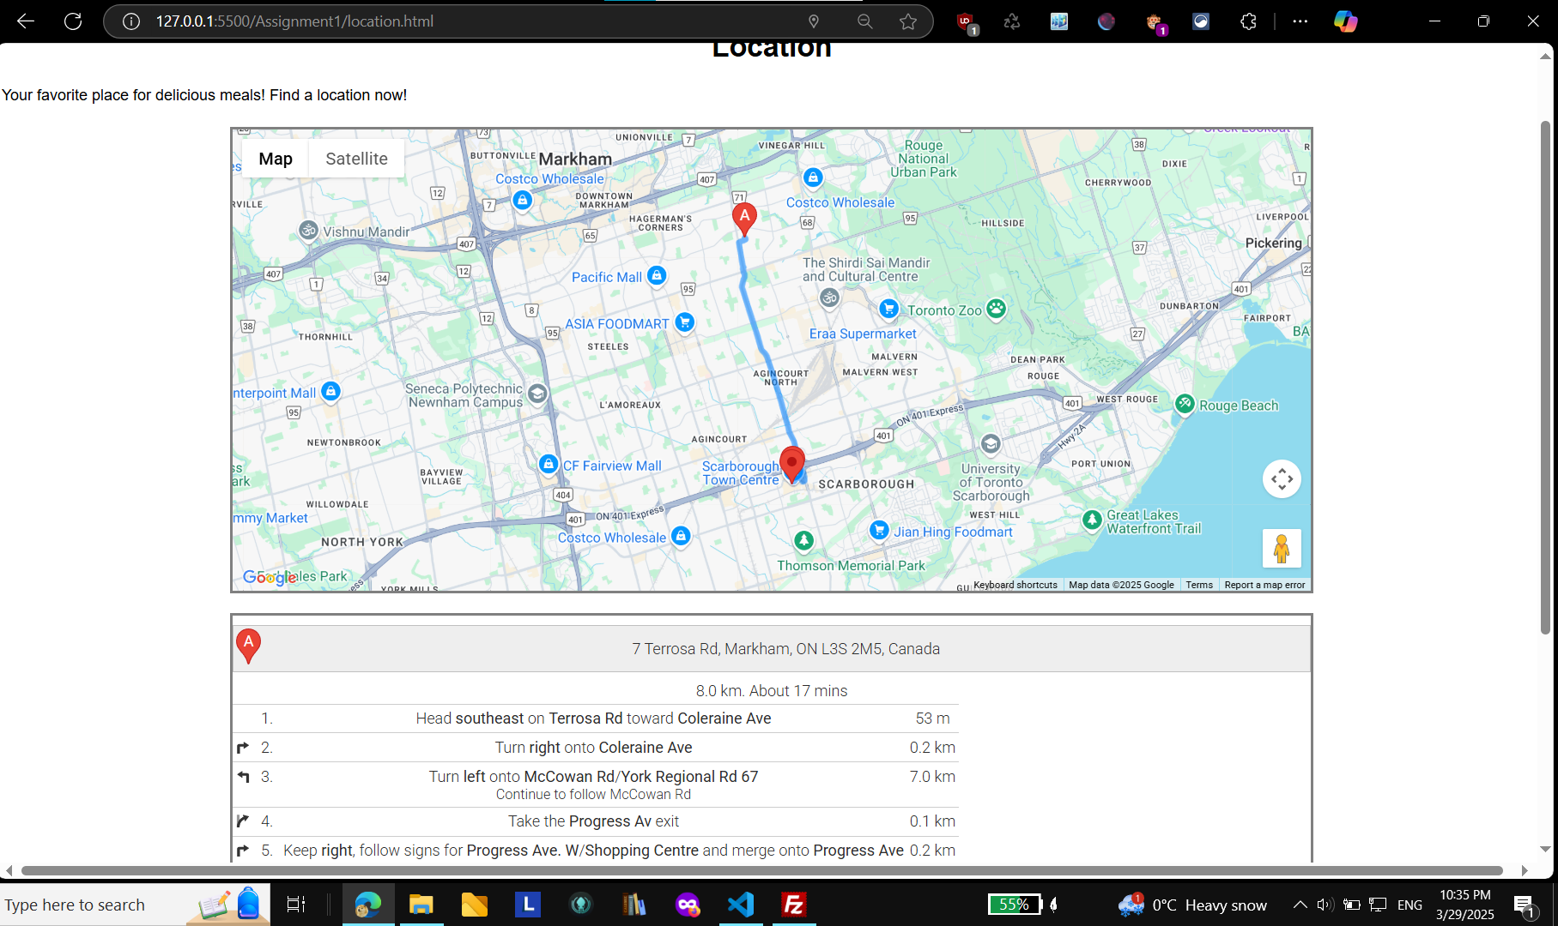

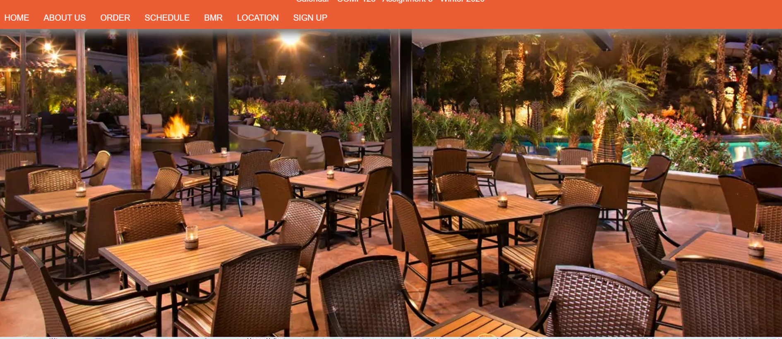
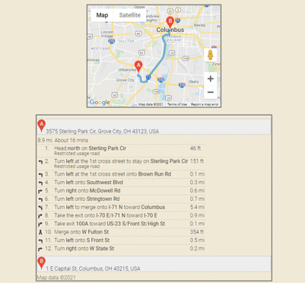

- Link the location.js file to the location.html.
- Link the location.html file to the location element on the navbar
Ensure to obtain an API key from google clouds or leaflet to make your google maps visible.
This assignment is due on March 30th. at 11:59 pm. Late assignments are accepted two more days after the due date, and they are marked out of 80%. Submit your assignment to Assignment 5 drop box. ALSO PUBLISH IT to the student web and provide the link to your student web.

