Surgical Decision-Making Exam
Breast Surgery | PMC3070675
Immediate breast reconstruction with a saline implant and AlloDerm, following removal of a Phyllodes tumor.

Clinical Images
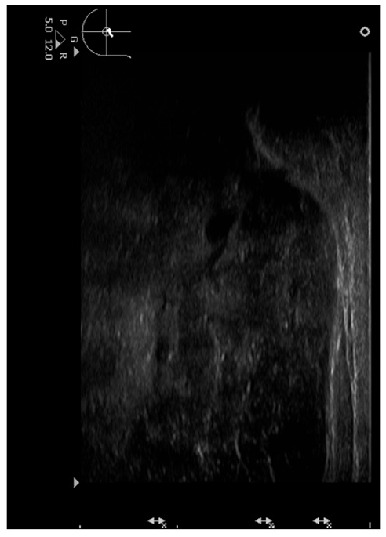
Figure 1
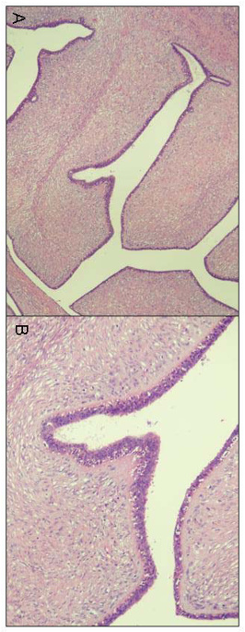
Figure 2
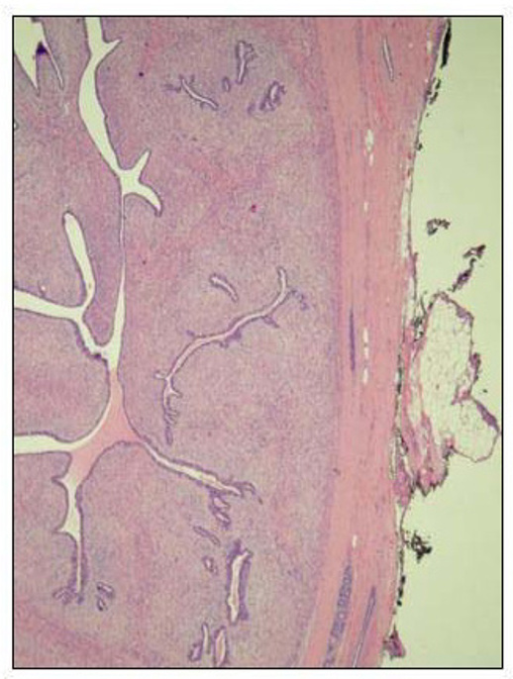
Figure 3
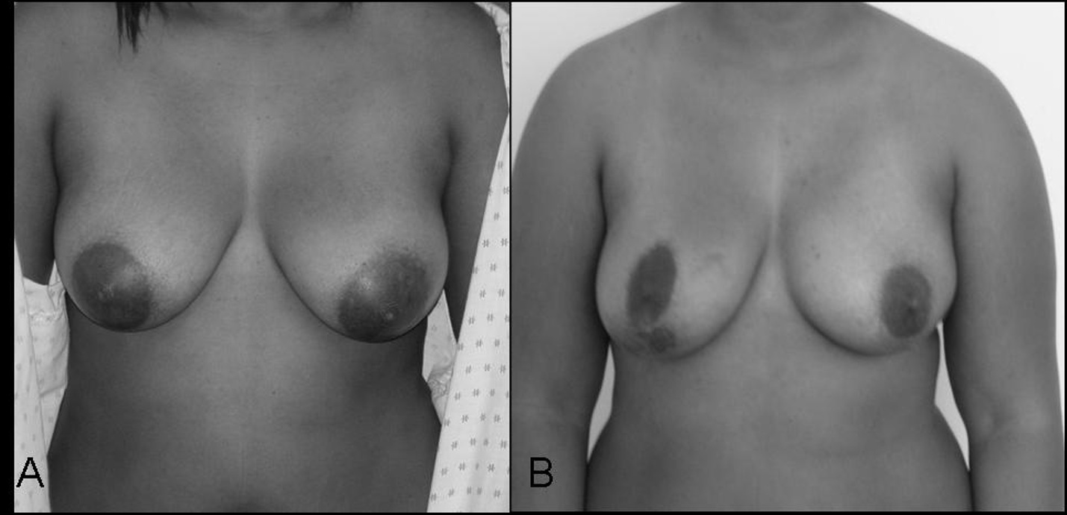
Figure 4

Question 1: Intraoperative Decision-Making
Clinical Vignette
A 22-year-old African American woman undergoes surgery for a rapidly enlarging left breast mass present for 3 months with clear nipple/skin leakage and 1 week of aching pain radiating down the left arm. Family history includes a paternal aunt with breast cancer at age 39. Exam showed a visibly enlarged left breast with a firm dominant mass and no palpable axillary lymphadenopathy. Targeted ultrasound demonstrated a 9.0 × 9.0 × 4.5 cm heterogeneous hypoechoic mass with small cystic areas at the 12–1 o’clock position; the anterior margin was within 1 cm of the skin and the posterior margin abutted the pectoralis muscle; no other breast or axillary lesions were identified (BI-RADS 4b). A core needle biopsy (22-gauge, four passes) was reported as fibroadenoma, but the team remained concerned for under-sampled phyllodes tumor given the size, rapid growth, and imaging features, and planned an oncologic resection aiming for adequate margins with reconstruction considerations discussed preoperatively. Intraoperatively, after removing a giant, well-encapsulated tumor, you find the inferior skin flap is markedly thinned compared with the upper pole, and the posterior aspect of the specimen is essentially at the pectoralis fascia/muscle plane. You must judge nipple–areolar complex and surrounding skin perfusion, and decide whether additional skin or chest-wall-side margins are required before proceeding with reconstruction.
Question
How would you make real-time intraoperative decisions to prioritize oncologic safety (adequate margins, including posterior and skin margins if needed) while minimizing risks of inferior-flap necrosis, implant/tissue-expander visibility and rippling, and postoperative contour deformity—specifically, what key steps would you take for margin management, flap handling/assessment, and immediate versus staged reconstruction strategy, and what pitfalls must be avoided?
Please deliver your answer as a structured DOCX document containing: (1) Clinical Analysis — key findings and their significance; (2) Decision & Reasoning — your recommended approach with detailed justification; (3) Evidence Basis — relevant guidelines, literature, or clinical data supporting your decision; (4) Step-by-Step Action Plan — concrete, ordered steps for implementation.

Your Answer:

Question 2: Postoperative Complication Management
Clinical Vignette
A 22-year-old woman is seen on postoperative day 2 after surgery for a very large left breast mass that had been rapidly enlarging for several months. Preoperatively, the mass occupied a substantial portion of the breast and was close to the overlying skin and the chest wall on imaging. She has no major comorbidities, does not smoke, and has no history of bleeding disorders. A closed-suction drain is in place.
Over the last 12 hours she reports worsening, deep left breast pain and a sense of pressure. Nursing notes show increasing firmness of the lower breast mound. On exam, the inferior breast skin is cool with progressive duskiness and sluggish capillary refill compared with the upper pole; the nipple–areola complex appears less affected. The breast mound is tense and tender to palpation. Drain output has decreased despite the increasing fullness. She is afebrile with stable vital signs. Laboratory tests show a mild drop in hemoglobin compared with the immediate postoperative value; white blood cell count is normal.
Bedside assessment must determine whether this represents threatened skin-flap perfusion with evolving necrosis versus another early postoperative complication causing secondary ischemia.
Question
What is the most likely postoperative complication, how would you confirm the diagnosis and distinguish it from hematoma or early infection, and what stepwise evidence-based management should be instituted to salvage viable skin/soft tissue and prevent exposure of underlying reconstruction? Additionally, what perioperative prevention strategies would you apply in future patients with a large tumor-to-breast ratio and variable skin-flap thickness?
Please deliver your answer as a structured DOCX document containing: (1) Clinical Analysis — key findings and their significance; (2) Decision & Reasoning — your recommended approach with detailed justification; (3) Evidence Basis — relevant guidelines, literature, or clinical data supporting your decision; (4) Step-by-Step Action Plan — concrete, ordered steps for implementation.

Your Answer:

